Aussie literature resources

As we redevelop our curriculum in line with ACARA: English, it is great to know that Reading Australia is supporting teachers with quality resources, written by English teachers.
Reading Australia’s website offers a series of quality resources on a range of Australian literature at http://readingaustralia.com.au/Secondary.aspx
ETAQ encourages teachers to check out what is on offer now including classics such as My Brilliant Career and Seven Little Australians as well as modern classics like Looking for Alibrandi, Taronga and the poetry of Gwen Harwood.
Senior texts are included with Blackrock, Cloudstreet, The White Earth and Swallow the Air.
Non-fiction texts make an appearance in the hardhitting Stasiland and The Tall Man, the investigation of the death of Cameron Doomadgee.
With the inclusion of the picture book The Arrival and Nam Le’s short story collection, The Boat, there is something for every school’s needs.
The units of work on the website have been created by AATE members across Australia. You are strongly encouraged to both use them and complete the survey to feed back on their usefulness.
AATE is in the process of signing up for the development of further Australian literature units. Keep an ear out for opportunities to be paid to write further materials.
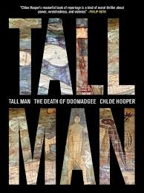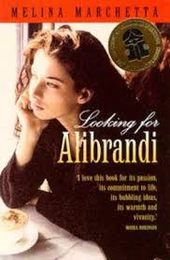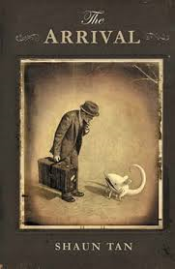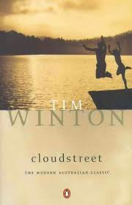

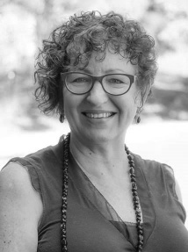
Seminar 2 offered fascinating insights into teaching the visual

Renewal of membership

Our strength is our members
When the QSA needs advice on English, they come to ETAQ. When a new curriculum is introduced, ETAQ is offering PD to support its implementation. What do we need to be able to keep representing our members? Teachers, students and academics joining. If you know a colleague who hasn’t joined, let them know what they are missing. Go to the website or contact Trish for help at trish.purcell@bigpond.com.
In this issue
Reading Australia website 1

Seminar 2 – for country members 2
From the President 2
Branch news – Cairns & Toowoomba 3

Grammar course 3

English for ESL
Poetry competition 4

Fiona Laing
ETAQ President

QLD’s system of assessment is up for review at present, with Dr Gabrielle Matters’ proposal for the replacement of our current OP system imminent. The significant proposed changes include losing the QCS test in favour of a common assessment task for each subject, counting for up to 50 %.
Thanks are due to the Independent Education Union for organizing a forum around these changes.
See you at state conference either in person or virtually as ETAQ aims to share the love with more of our members!

Sharing the ETAQ love with teachers outside the south-east corner of QLD
Catherine Beavis and Michael Dezuanni began seminar 2, The Power of the Visual, with fascinating insights into their research around the use of games in classrooms. The recording and sharing on ETAQ website of the keynote was the first of the efforts to share quality inservice with members outside the SE corner of our vast state.
The other strategy was offering a Google Hangout ‘On Air’ session for two of the workshops. This technology offers participants a real-time experience where participants appear on screen in front of the presenter, can view the slides and a video of the presenter, as well as ask questions live, along with those in the room.
The Google Hangout is available for up to 10 participants. Further participants are able to view the live stream, without the ability to ask questions of the presenter.
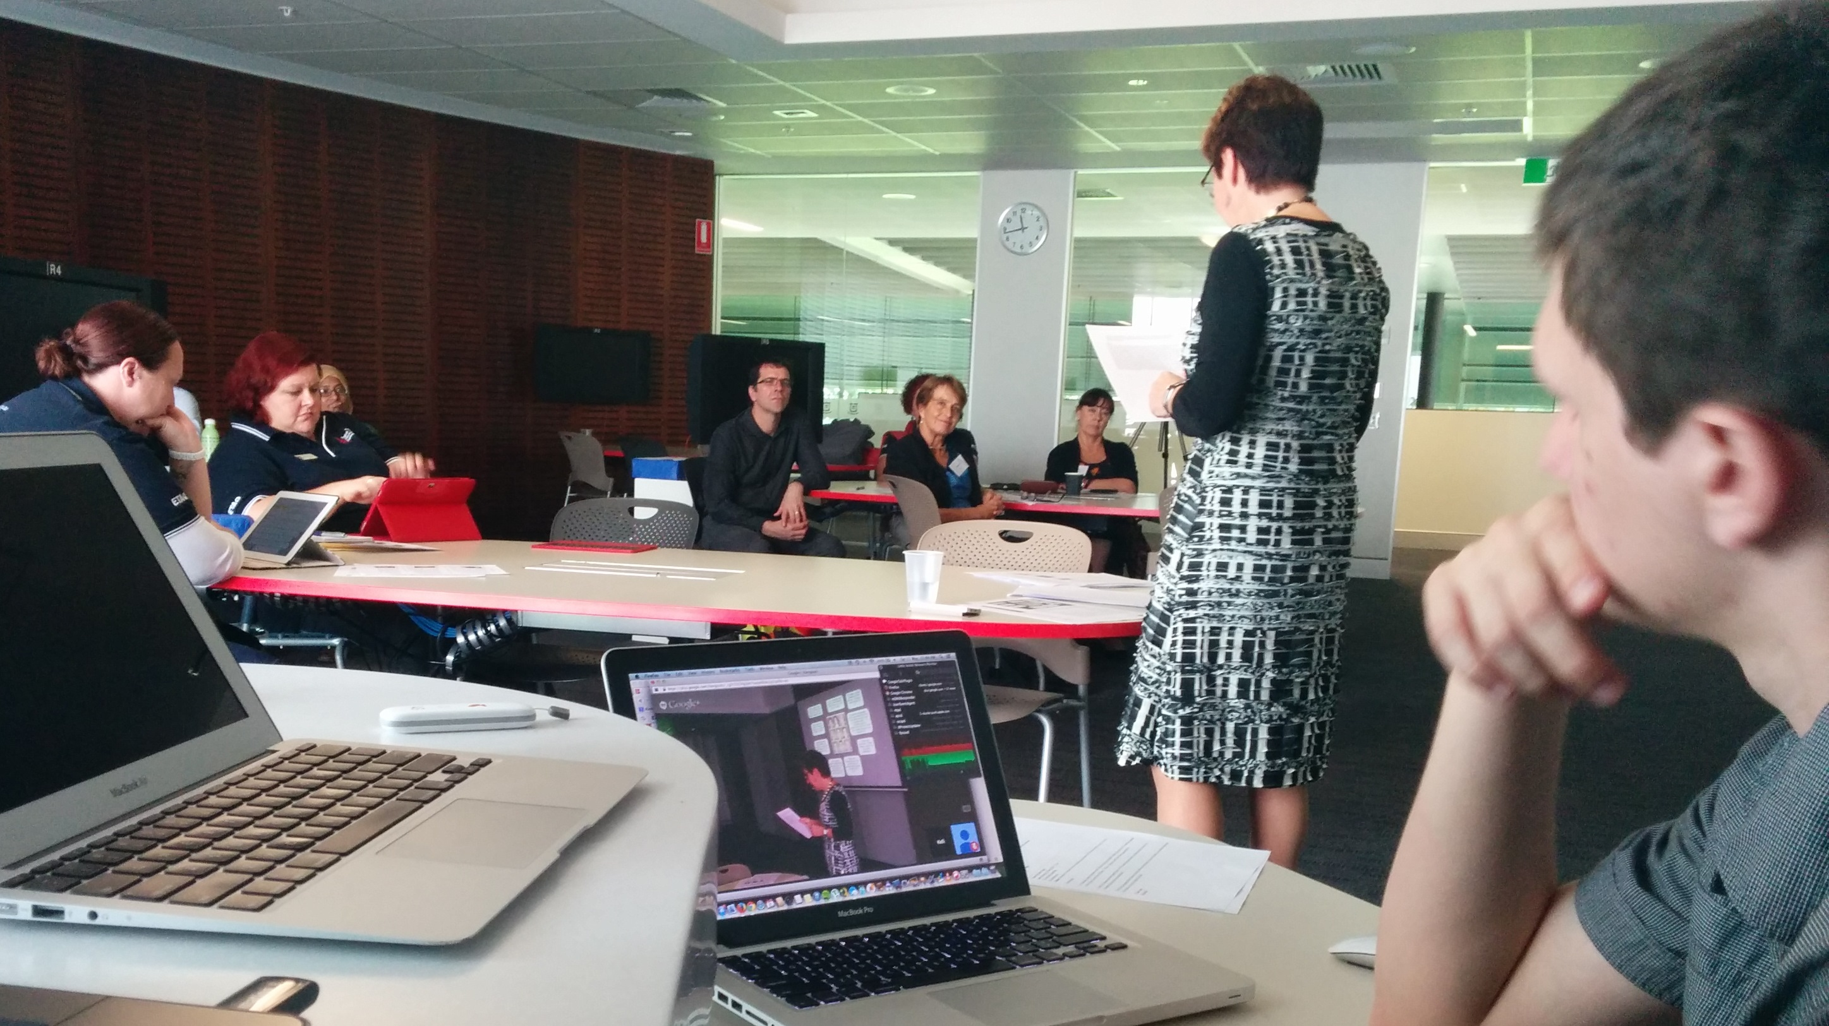
Di Laycock’s session on Graphic Novels was recorded, along with Kelli McGraw’s session on ‘Digital Stories. All members outside the south-east corner were offered the opportunity to access the Google Hangout free of charge.
The other advantage of this technology is that the session was ‘captured’ on Youtube and loaded to the ETAQ website for member only access.
We are planning to repeat the Google Hangout at the ETAQ Annual State Conference for some sessions and encourage members to sign up and try it out
You can join the ETAQ Online PD Community on Google Plus here: https://plus.google.com/u/0/communities/111552381732466724239

Branch News
Next PD

Saturday 26 July

Grammar Refresher Course

You need to be very quick with this one! Garry Collins has developed this one-day course to upskill teachers on all aspects grammar.
When: 26 July 2014
Where: Room 303, Building 24, Uni of Qld, St Lucia
The program is entitled Grammar for the Australian Curriculum: English, A One-Day Crash Course.
Registrations for this day are capped at 27 only. We know of a number of people keen to attend so be quick to register. If this is as popular as we think, a repeat session later in the year will be considered.

Cairns branch begins its year with Appraisal

Wordsmart English teaching consultant Lindsay Williams gave a one hour presentation to ETAQ members at Trinity Bay SHS on Wednesday afternoon, 14th May, 2014. Lindsay’s topic was Texts with Attitude: Using Appraisal for reading and writing.

He explained that Appraisal was a system based on the inter-personal meta-function of the Text in Context model (a central framework in the Australian Curriculum: English) which allows students to explore how text producers position readers/viewers to adopt certain attitudes to the public figures, fictional characters, things and so on represented in texts.

Those teachers present at the meeting agreed that the close reading of texts implied by the use of Appraisal would improve students’ reading and writing.

A second meeting for 2014 is planned for August, 2014
.

Toowoomba Branch breakfasts on journalism

May 31 saw the Toowoomba branch share breakfast with two local journalists Alley Martell and Merryl Miller who offered enlightenment on the way the media actually works.
The audience was very much engaged with the presentation, given much pause for thought.
The event coincided with Toowoomba branch's AGM which warmly thanked Donna Jones for her service as president and welcomed new president, Paul Irwin, Head of English at Toowoomba Grammar School.

Support for teachers of English for ESL Learners
Upcoming PD dates
Please keep the following in your diary:

Saturday 26 July – Grammar Refresher Day
(new event – see pg 1)
Saturday 16 August – State Conference

Sunday 19 October – Literary Breakfast: Roly Sussex

Thursday October 16 – ENC After-school Forum
If you are teaching English for ESL Learners in senior, read on for Jennifer Alford’s opportunity for support:

‘We are called ‘TESS’- Teaching EAL/D Senior Syllabus network and have 21 members so far, from both ETAQ and ACTA as well as non-members in schools who have joined. There’s room for more!
I’ve created a database of members (growing daily!), and a Facebook group where I’ll upload articles and documents of interest and where people can chat about things. People just need to email me and then I can invite them to join. Another meeting will be coming up.’
Jennifer Alford Lecturer; EAL/D Studies QUT, Kelvin Grove jh.alford@aut.edu.au

.

Red Room Poetry competition

Red Room Poetry Object is a free national poetry-writing competition for Australian students in Years 3-10. Created by The Red Room Company and supported by ABC Radio National, the project invites young writers and their teachers to submit poems about objects that are special to them. Register your school at: http://redroomcompany.org/poetry-object/register/. Also found on ETAQ website under competitions.

Contact

Please direct payments and enquiries to:
Trish Purcell
ETAQ – Administration Officer & Treasurer
Email: trish.purcell@bigpond.com
Telephone: (07) 3284 3718

www.etaq.org.au

Postal address: PO Box 3375
STAFFORD DC QLD 4053
Physical address:
46 Tainton Street, CLONTARF QLD 4019

