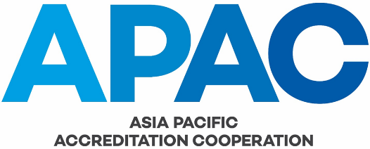

CORRECTIVE AND PREVENTIVE ACTION REQUEST NO:
 |  |  |  |  |  |  |  |  | Internal Audit No:
 | Corrective  Action |  |  | Preventive  Action |  |  |  |  | Complaint No:
 | Audit |  |  | Improvement Suggestion |  |  |  |  |  | Complaint |  |  |  | Other
1. Description of non-conformity/Improvement Suggestion |  |  |  |  |  |  |  |  |  |  |  |  | Reported by:
 |  |  |  |  |  |  |  |  |  |  |  |  | Date:
Send to APAC Quality Manager when completed to this point
2 a) Investigation, determination of cause(s), and correction of non-conformity
Assigned {by APAC QM} to: |  |  |  |  |  |  |  |  |  |  |  | For completion by:
2 b) Verification of Corrective/preventive action implemented
Completed by (sign/initial and date)
Send to APAC Quality Manager when completed to this point
3 a) Review effectiveness of corrective/preventive action
Assigned {by APAC QM} to: |  |  |  |  |  |  |  |  |  |  |  | For completion by:
3 b) Additional cause analysis required
Assigned {by APAC QM} to: |  |  |  |  |  |  |  |  |  |  |  | For completion by:
APAC Chair: |  |  |  |  |  |  |  |  |  |  | Date CPAR closed:

