Palmer GP., Brown GW., Gibson MS., Pigott JP., Tolsma AD., Wainer, J. & Yen AL. (2010). Box–Ironbark Ecological Thinning Trial: Integrated Analysis and Projected Changes. *Parks Victoria Technical Series* No. 58. Parks Victoria, Melbourne.

**Executive summary**

In 2002, Parks Victoria established a management-scale experiment to examine the effectiveness and feasibility of ecological thinning as a means for restoring Victoria’s Box–Ironbark forests. The Box–Ironbark Ecological Thinning Trial (the Trial) took an adaptive experimental management approach to investigate how ecological thinning may be used to restore a greater diversity of habitat types to the Box–Ironbark landscape and therefore allow improved functioning and persistence of key communities and species populations.

The Trial was implemented in four Parks Victoria reserves (the Sites) in the Box–Ironbark region of central Victoria (Castlemaine Diggings National Heritage Park, Pilchers Bridge Nature Conservation Reserve, Spring Plains Nature Conservation Reserve and Paddys Ranges State Park). At each Site, treatments with varied rates of tree removal and retained patchiness (Control, Isolated Patchy 1 and Patchy 2) were implemented in 30-ha Plots. Within these Plots, three coarse-woody-debris manipulations were applied: 100% removal; 50% retention; and 100% retention of bole material.

As part of the Trial, a research and monitoring program (Phase 1), focusing on forest structure, selected biodiversity elements and habitat features, was established to examine the impacts that ecological thinning and the different experimental treatments had on key components of Box–Ironbark forests. This report documents the experimental design, the pre- and post-thinning monitoring results of selected biodiversity and habitat attributes across all Sites and discusses the implications of these results and their potential future trajectories. As the Trial used an adaptive experimental approach, changes or additions to the ongoing monitoring design to enhance outcomes are also discussed.

Before ecological thinning commenced, Plots were dominated by high numbers of coppice-generated trees (up to approximately 1500 stems per hectare). Less than 3% of trees were considered large (>60 cm diameter) and only 3% were hollow-bearing, implying limited availability of habitat for a number of threatened fauna. Pre-thinning, Plots contained very small amounts of coarse woody debris, particularly large pieces (>10 cm diameter).

As a result of ecological thinning:

* **Stem density** was significantly reduced;
* **Mean stem diameter** increased;
* **Coarse woody debris** increased across all thinned Plots, including significant increases in large pieces of coarse woody debris;
* Changes to other habitat features post thinning, including **fine debris**, were measurably higher than pre-thinning values;
* Vegetation responses to thinning included **increased herb and tussock-grass cover**;
* **More profuse flowering of herbs and shrubs**;
* There was also a **decrease in perennial-shrub cover**;
* An initial, probably temporary, **increase in annual weed grasses**.
* Among vertebrate fauna, thinning affected the occurrence of **some diurnal birds** as well as **some other vertebrate groups**;
* **Species richness** **was greater among bird assemblages** (esp. understorey birds) after thinning, although this may have been influenced by the timing of surveys;
* **Bat activity was greater** in Plots after thinning;
* Other vertebrates, including **terrestrial and arboreal mammals, appeared to remain stable or displayed positive responses**; and
* Ground invertebrate assemblages were dominated by ants in species richness and total abundance, which in turn were dominated by a small number of **opportunistic ant species which responded positively** to disturbance associated with thinning.

The results presented in this report document the pre-thinning conditions and initial post-thinning conditions and provide a benchmark for the ongoing monitoring of the Trial. These results have been used to predict the future trajectories of biodiversity and habitat features for the Trial. As such, this report will make an important contribution to the future management of Victoria’s Box–Ironbark parks and reserves system.

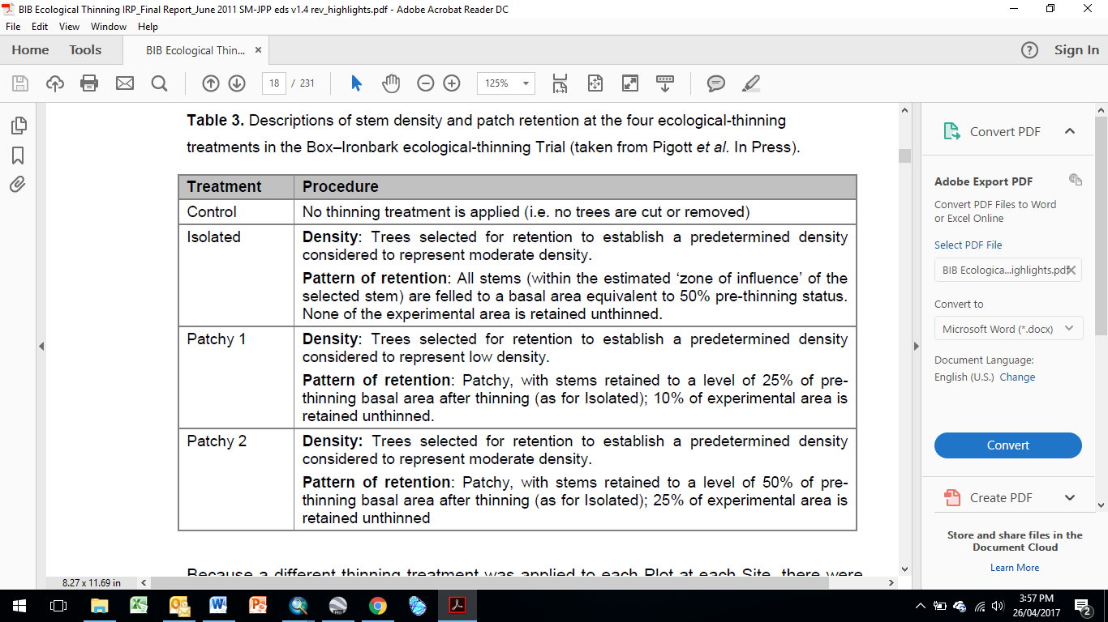

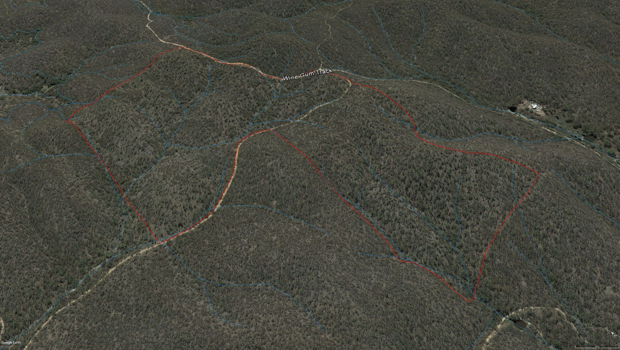

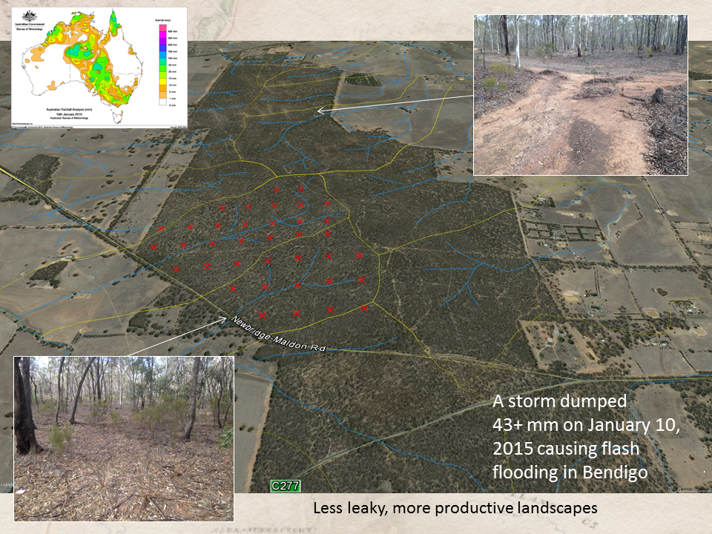

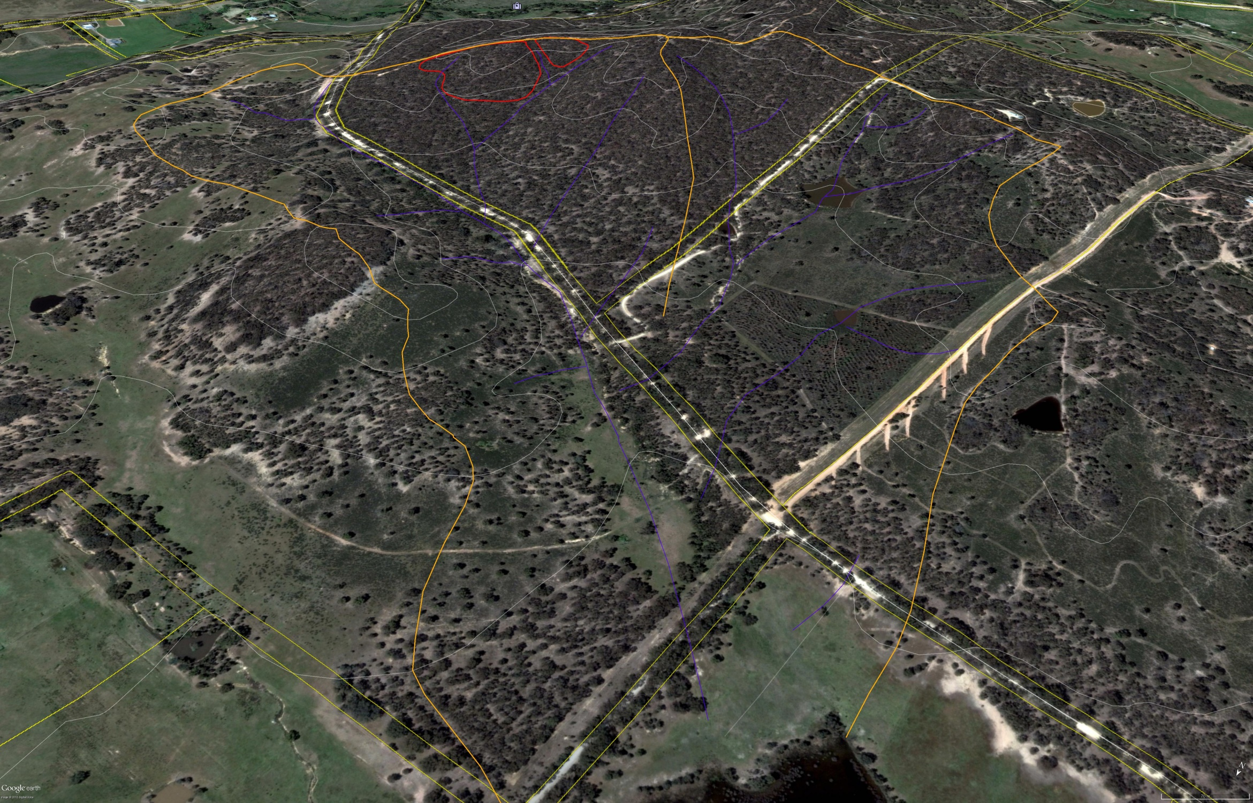

**Site: Date:**



**Sub-quadrats**

