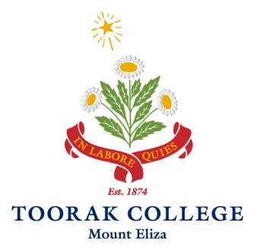

2020 TERM DATES

TERM 1
Staff Conference Days Thursday 23rd & Friday 24th January
Australia Day Holiday Monday 27th January
Classes Commence Tuesday 28th January
Labour Day (Public Holiday) Monday 9th March
Classes Conclude Friday 27th March

TERM 2
Easter Monday (Public Holiday) Monday 13th April
Classes Commence Tuesday 14th April
Anzac Day (Public Holiday*) Saturday 25th April (no school day)
Queens Birthday (Public Holiday) Monday 8th June
Semester 2 classes begin Tuesday 9th June
Classes Conclude Friday 19th June

TERM 3
Staff Conference Days Monday 13th & Tuesday 14th July
Classes Commence Yr 12 Monday 13th July
Classes Commence ELC –Yr 11 Wednesday 15th July
Classes Conclude Friday 18th September

TERM 4
Classes Commence Monday 5th October
Mid Term Break Monday 2nd November
Melbourne Cup Weekend (Public Holiday) Tuesday 3rd November
Early Start Begins Monday 23rd November
Classes Conclude Tuesday 8th December
Staff Professional Learning Days Wednesday 9th – Friday 11th December
Term Concludes for Teaching Staff Friday 11th December

Term Concludes for General Staff Wednesday 23rd December 2020

