The City of Adelaide invites

Registration of Interest
Victoria Park / Pakapakanthi - Sports Facilities
Winter Season 2019

Consultation closes 5:00pm, Monday, 28 January 2019

Project Summary
The City of Adelaide is seeking registrations of interest from sporting organisations and educational institutions to use the sports facilities located within Victoria Park / Pakapakanthi over the 2019 Winter Season (1 April - 1 September 2019).
Hire agreements will ideally be available for ten or twenty weeks/games commencing in April 2019. Registrations will close on 28 January 2019 with allocations confirmed in February 2019.
Registrations close 5pm, 28 January 2019

Included in this information pack:
- Project Information
- Frequently Asked Questions
- Registration Form
For enquiries, please call Tom Beales, Coordinator, Recreation Planning and Capacity Building on 08 8203 7791

Project Information
Purpose
A strategic aim of the City of Adelaide is to enhance the role of the Park Lands in increasing levels of physical activity and wellbeing through formal and informal sport and recreation opportunities. To support this aim, Council is offering seasonal hire agreements for the facilities within Victoria Park / Pakapakanthi. Interested organisations need to submit a registration of interest form for proposed use during winter 2019. Council will confirm allocations in February 2019.
Background
The Master Plan for Victoria Park was adopted in 2008 with the vision to:
‘Create a vibrant, flexible and sustainable recreational open space within the iconic Adelaide Park Lands to serve all South Australians, supporting a variety of community activities whilst preserving the unique landscape and heritage qualities of the place.’

The Master Plan included an extension to the Criterium track, the creation of the Premium Sports Field to facilitate a variety of events from Adelaide 500 and 3-day Horse event to sporting matches and carnivals and the creation of a series of sports fields to the south of the park. These facilities are now complete and available for use.
In April 2017 Council endorsed the construction of a new change room and public toilet facility to support the use of the Victoria Park southern sports facilities. The new facility is now open and available to hire.
Benefits of the project
Optimal use of Victoria Park / Pakapakanthi facilities to increase levels of physical activity and wellbeing.
Project Impacts
All requests for formal use of the premium sports field, criterium track and southern sports fields need to be submitted as part of this registration process. Any additional requests outside of this process will be treated as a casual booking, subject to availability and charged accordingly.

For safety reasons, the premium field will not be programmed at the same time as the criterium track.
On occasion, there will be ad hoc event requests for use of Victoria Park / Pakapakanthi which will impact use of facilities. Due to the number of events, only ten-week agreements will be available for the premium sports field.
Events already confirmed mean the premium sports field will be unavailable on the following dates:
- Adelaide 500 Declared Major Event Zone until 29 April 2019
- 14 April 2019 RSB Lapdogs
- 5 May 2019 Wings for Life World Run
- 19 May RSPCA Million Paws Walk
- 15-16 June 2019, International Pedal Prix
- 28-29 July 2019, International Pedal Prix
- 9 August 2019, Walk a Mile in My Boots
- 25 August 2019, Vision Challenge
Criterium Track usage is often impacted from November through to April due to various major events including the Australian International 3 Day Event (horse trials), Adelaide Motorsport Festival and Adelaide 500.
The 2019/20 event dates are not yet confirmed but we expect the following months will have limited or no access to the track:
- November & December
Facilities Available

Criterium Track & Premium Sports Field
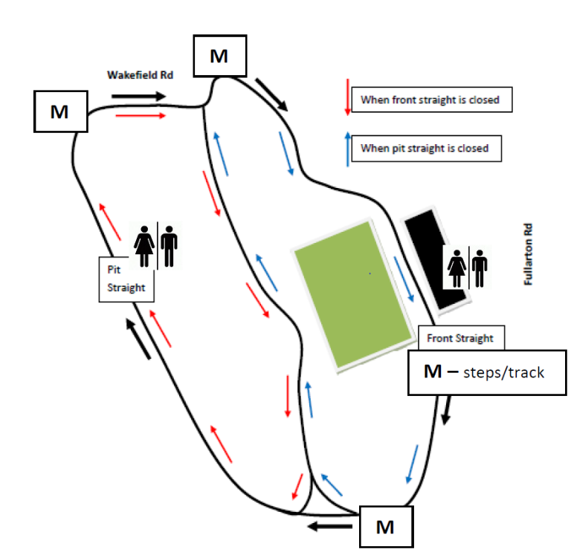
(located in front of the Heritage Grandstand)
The Criterium Track is a 1.3km race track predominantly used for cycling during the summer months, it makes up a significant part of the Adelaide 500 Circuit. It can be broken in to two loops, the pit straight and the front straight which are both approximately 1.2km in length. The track is available all year round with limited access during major events in the park.
Organisers of race events on the track are responsible for providing appropriate signage and marshals to inform the wider community that the track is closed for the event.

The following instructions apply when using the track:
- Always use the track in a clockwise direction.
- Only Authorised vehicles are permitted in Victoria Park
please close park entry gate behind
you.
- Organisers of a closed cycling event may change this procedure at their discretion
- If a cycling event is in progress hi-vis marshals will advise/ direct (see areas marked “M” on map above).
- Cyclists are required to wear an approved bicycle helmet.
- Lights must be used before sunrise or after sunset.
- Keep to the left if travelling slowly; avoid sudden braking or changing direction.
- Unauthorised motor vehicles and remote-control equipment are not permitted on the track.

The premium sports field is located adjacent to the Heritage Grandstand and is bordered by the Criterium Track. The field is approximately 120m x 85m and has flood lighting.

The Heritage Grandstand features two change rooms with toilets and showers. It is accessible and has a disabled toilet. Public toilets are located at the back of the grandstand.

The premium field has capacity to accommodate two senior soccer matches or four junior matches (based on soccer, subject to change depending on sport and its impact) per week and up to five hours of training.

Soccer/Rugby goals and any line marking required may be provided as part of the hire agreement, to be negotiated.

Southern Sports Fields
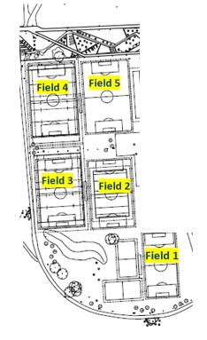
Within the southern sports fields, four full size soccer pitches (100m x 65m) and one three quarter size pitch (75m x 45m) are located on the western side of the park. New public toilet facilities including three unisex toilets (one with disability access), two locked change rooms with toilets and showers and a storage area are now available for use.

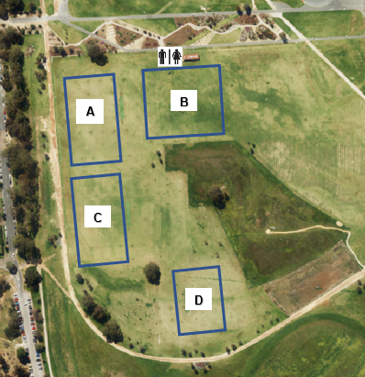
To maximise use of the area, we will consider dividing the space for multiple groups as shown below.
These fields will each have capacity to accommodate 3 hours of junior soccer per week with preferred usage being for under 11’s (mini roos). Goals will not be provided, any line marking required may be provided as part of the hire agreement, to be negotiated.

These pitches are also home to three hard wicket cricket ovals (shown below), use of these ovals for winter cricket will be considered.

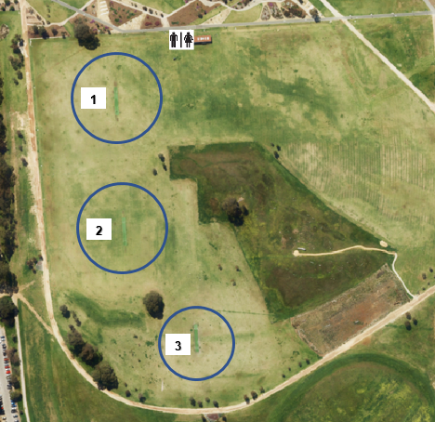

When applying you must indicate the space required nominating the preferred area (s) either A, B, C or D for winter sports or 1,2 or 3 for Cricket.

Frequently Asked Questions

What can we apply for?

Premium Sports Field – Matches and training for five or ten weeks between 1 April – 1 September 2019.
Southern Sports Fields – Matches for ten or twenty weeks between 1 April – 1 September 2019.

Criterium Track – Ten or twenty sessions (races and training dates up to 4 hours long) from 1 April – 31 December 2019.

What is Council looking for?
The main aim for the City of Adelaide is to activate Victoria Park / Pakapakanthi with sporting activities, the following principles will inform the selection process.
- Priority will be given to City based sports organisations, and education institutions
- Priority will be given to community sporting activities over elite sporting activities
- Activities that are complimentary to the Victoria Park / Pakapakanthi facilities and sports pitch carrying capacity
- Activities that target people from underrepresented groups

Who can apply?
Applications will be considered from:
- Organisations or groups that are legally constituted as an incorporated association
- Not for profit companies limited by guarantee
- Aboriginal and Torres Strait Islander Corporations (under the Aboriginal and Torres Strait Islander Act 2006)
- Educational Institutions
- Commercial Organisations and Social Enterprises demonstrating a clear benefit for the community

How do we apply?
Applicants must provide:
- Completed registration of interest form within this pack or online via yoursay.cityofadelaide.com.au
- Evidence of $20m public liability insurance

How will allocations be selected?
All applications will be assessed against the following criteria:

Community Benefit (30%)
- The application is for community level sport (15%)
- There is significant demand for the sport(s) (10%)
- Number of participants per session (5%)
- Whilst not exclusive, the application caters for City residents or people from underrepresented groups (5%)

Activation (40%)
- The application results in the facilities being used frequently (10%)
- The activities complement the existing facilities and sports pitch carrying capacity in Victoria Park /Pakapakanthi (15%)
- The dates/days/times requested don’t clash with other activities/events (10%)
- The application does not adversely impact on residents or other users of the park. (5%)

Management/Governance/Risk (30%)
- The applicant is a City based sports organisation or educational institution (10%)
- The applicant is a not for profit organisation or educational institution (10%)
- The applicant is financially reliable and has no outstanding debt or grant acquittals with Council (10%
Will all applicants be successful?
This will depend on the number of applicants and their suitability to the assessment criteria. The City of Adelaide retains sole discretion as to who it offers hire agreements.

Is my organisation required to undertake the maintenance of the hired facilities?
No, Council will be responsible for maintenance of the facilities.

How much will it cost my organisation to hire the requested facilities?
The following fees will apply subject to Council endorsement on 1 July 2019. Any bookings in addition to those included in the hire agreement will be charged as a casual booking (facility dependant) and may incur a separate booking fee. Fees will be applied per number of sessions. Sessions are up to 3 hours each.

E.G. An organisation applying to use the criterium track for 10 sessions on a Tuesday and 10 sessions on a Thursday will be charged the 20-session fee. An organisation applying to us the track for 20 sessions on both a Tuesday and Thursday will be charged the 20-session fee twice.

Premium Sports Field (excluding GST)
Seasonal Hire of Pitches & Facilities | Full Share (10 weeks) | Half Share (5 weeks)
Premium Sports Field (matches) | $420 | $210
Premium Sports Field Training (per session) | $42 | $42
Change Room Hire (including cleaning fee) | $805.20 | $402.50
Lights | $500 | $250
One off Casual Sports Field Booking | $42

Southern Sports Fields (excluding GST)
Seasonal Hire of Pitches & Facilities | Full Share (20 weeks) | Half Share (10 weeks)
Sports Field (Matches only)) | $630 | $315
Change Room Hire (including cleaning fee & storage space) | $1500 | $750
One off Casual Sports Field Booking | $31.50

Criterium Track (excluding GST)
Seasonal Hire of Track | 20 Sessions | 10 Sessions
Criterium Track (weekdays) | $940 | $470
Criterium Track (weekends) | $1380 | $690
Change Room Hire (including cleaning fee) | $1342 | $671
Casual Track Booking (weekdays) | $47
Casual Track Booking (weekends) | $69

Can the change rooms be hired for single events or for single weeks?
Yes, the change rooms will be available to book for one off events or casual bookings, however these won’t be considered as part of this registration of interest process. Please apply separately through the Park Lands Booking Form.

Can I park my car in or on Victoria Park / Pakapakanthi when hiring facilities?
No, hire agreements do not permit organisations to park their car on the Park Lands: all users will be required to use the available on-street parking. Vehicle access permits (enabling loading and unloading of equipment) may be issued upon request.

I want to use the Sports Fields in the Summer; can I apply now?
No, a separate registration process will take place for the summer season with registrations opening in July 2019.

Can I book the Criterium Track beyond December 31, 2019?
No, criterium track bookings for Jan-March 2019 will need to be submitted as part of the summer season registrations in July 2019.

Where are the facilities located within the park?
Please refer to the map below for further details.
Map of Sports Facilities in Victoria Park / Pakapakanthi
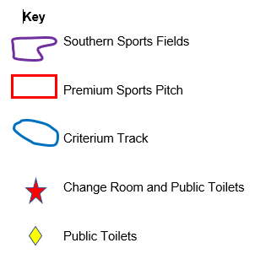

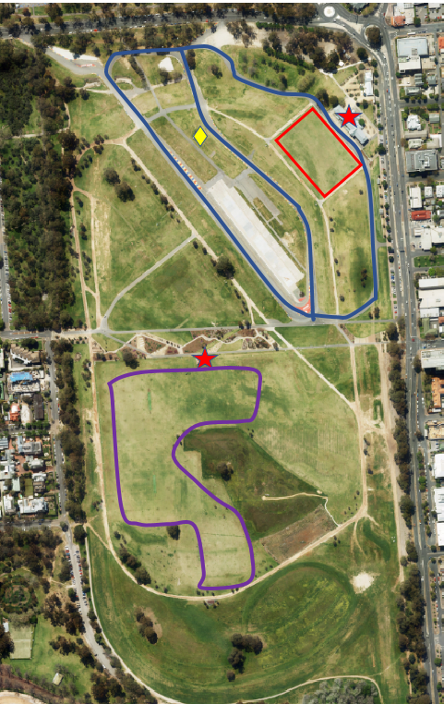

How do I submit an application?
Online / Website
Visit yoursay.cityofadelaide.com.au to complete and submit a registration of interest form online or
Email
Download the form and email directly to t.beales@cityofadelaide.com.au ,or
Written submissions
Complete the registration of interest form in this pack and return it for the attention of Tom Beales at:
Registration of interest – Victoria Park Sporting Facilities: Winter 2019
GPO Box 2252
Adelaide SA 5001

All submissions must be received by: 5pm, Monday 28 January 2019
What happens next?
December 2018 Registration Opens
28 January 2019 Registration Closes
February 2019 Review of Submissions
February 2019 Allocations Confirmed
1 April 2019 Hire Agreements Commence
Contact Person
For more information, please contact:
Name: Tom Beales
Title: Coordinator, Recreation Planning and
Capacity Building
Phone: 08 8203 7791
Email Address: t.beales@cityofadelaide.com.au

REGISTRATION OF INTEREST FORM
Winter 2019 START 1 April 2019 – END SEPTEMBER 2019
APPLICATIONS CLOSE MONDAY 28 JANUARY 2019

SECTION 1: ORGANISATION DETAILS
1.1 | Organisation /Club Name
1.2 | Type of Organisation | (Tick multiple boxes if required)  - Not for Profit Organisation  - Aboriginal and Torres Strait Islander Entity  - Educational Institution (Public)  - Educational Institution (Private)  - Commercial Organisation  - Social Enterprise
1.3 | Is your organisation? | - Based in the city  - Active in the city  - Not currently based or active in the City
1.4 | Is your organisation registered or affiliated with any of the following? | - STARCLUB Club Development Program  - Good Sport Program  - A Peak Body (State or National). Please state name of Peak Body:
1.5 | Website Address
1.6 | Postal Address | Unit |  |  |  |  |  |  | Street Number
 |  | Street Name
 |  | Suburb |  |  |  |  |  |  | Postcode
1.7 | Contact Details | Primary Contact Person |  |  |  |  |  | Secondary Contact Person
 | First Name
 | Surname
 | Position Title
 | Mobile
 | Email Address
1.8 | Public Liability Insurance | A current copy of my organisations Public Liability Insurance Certificate (minimum $20 million) is attached YES NO
SECTION 2: ACTIVITY AND PARTICIPANT DETAILS
2.1 | Sport or Activity
2.2 | Level of competition | (For example - entry/community level or grade level or elite)
2.3 | What demand is there for your sport/activity within Adelaide? | (Please provide statistics where possible)
2.4 | Participation Information – Figures may be approximate but must reflect the total number of players participating in activities on sport fields applied for in this application for the length of the season
 |  | Junior |  |  |  |  |  | Senior
 | Number of male participants
 | Number of Female Participants
 | Total Number of participants
 | Number of Male Teams
 | Number of Female Teams
 | Total Number of Teams
 | Will your activity cater for City residents or people from underrepresented population groups? | e.g. women and girls, people with a disability, multi-cultural groups  YES NO  If Yes, please provide details:
SECTION 3: FACILITY REQUIREMENTS (MATCHES/TRAINING)
3.1 | Please insert your competition requirements (examples provided below) | Start Date must be on or after 1 April 2019  End date must be on or before 1 September 2019  Following conditions apply:  Maximum of 6 matches per week & 5 hours training per week – Premium Sports Pitch  Maximum 3 hours per week – Southern Sports Fields
 | Facility Required | Day of the week |  | Date From - To |  |  | Start Time (AM/PM) |  | Finish Time (AM/PM) |  | Number of sessions/matches/races
 | E.G. Southern Sports Field – Area A and C  Southern Sports Field Oval 1 & 2 Training  Southern Sports Field Area C & D | Saturday  Wednesday  Sunday |  | 13 October – 15 December  10 October – 12 December  14 October – 24 March |  |  | 10am  3.30pm  9.00am |  | 11.30am  6.30pm  6.00pm |  | 10 Senior matches  10 training sessions  20 Junior matches
 | Facility Required | Day of the week |  | Date From - To |  |  | Start Time (AM/PM) |  | Finish Time (AM/PM) |  | Number of sessions/matches/races
SECTION 4: ADDITIONAL FACILITIES
5.1 | Do you require the use of change rooms? | YES NO  If yes, please provide details? E.G. Matches only/male and female
5.2 | Additional Comments
SECTION 5: DECLARATION
- I confirm that the information I have provided in this form is accurate and complete.
- I understand that submission of a registration of interest does not guarantee that my application will be successful.
- I understand that if successful I will be required to enter an application of credit with Council agreeing to its payment terns. Hire fees will be payable by invoice in keeping with the fees and charges schedule approved by Council each financial year. Any requests for fee waivers, refunds and disputed accounts must be made in writing prior to payment of the account becoming overdue.
- I understand that to have this application considered, a certificate of Insurance is required.
- I understand that on approval of the application, I am required to provide a fixture of dates for approved competition in the format requested by Council.
- I have read and understood the Park Lands Conditions of Hire for the use of the Adelaide Park Lands and agree to comply with all conditions set out therein.
First Name |  |  |  |  |  | Surname
Signature |  |  |  |  |  | Submission Date
Written submissions must be received by: 5pm, Monday 28 January 2019
Tom Beales
Registration of interest – Victoria Park Winter 2019
GPO Box 2252 Adelaide SA 5001
or
t.beales@cityofadelaide.com.au
For all enquiries, please call:
Name: Tom Beales
Title: Coordinator, Recreation Planning and Capacity Building
Phone:08 8203 7791

Email Address: t.beales@cityofadelaide.com.au

