Expression of interest - scholarship in Certificate IV in Mental Health Peer Work
Brisbane North PHN (and the Partners in Recovery program) holds central to its core business being consumer/carer and community led. As such, the PHN has created a Consumer and Carer Participation Coordinator Position. This position aims to support a regionally coordinated and collaborative response to ‘support the active involvement of people with a lived experience in the planning, implementation and evaluation of mental health, alcohol and other drug services and supports in the Brisbane North region’. A key component of this work is to support the development of a skilled peer workforce and peer leaders in the region.
This is a call for expressions of interest (EOI) from people with a lived experience of mental illness and recovery as a consumer and/or carer who wish to gain a national qualification in this area. The scholarship will cover the course fees, valued at over $2,500. Participants (or their employer) must cover all other costs including travel.
There are currently other existing subsidies available for people who do not hold any Certificate IV or higher qualifications. The Certificate IV in Mental Health Peer Work as of January this year is one of these subsidised courses.
This EOI is aimed at people who do not meet the above requirement (i.e. already have a Certificate IV or Higher and/or are not eligible through the above subsidy) but are keen to pursue a career in mental health peer work.

Eligibility
To be eligible for a scholarship you must:
- have a lived experience of mental illness and personal recovery
- be a resident and/or working (paid or volunteering) in the Brisbane North PHN region (Brisbane north of the river and areas around Strathpine, Redcliffe, North Lakes, Caboolture, Deception Bay and Kilcoy)
- not already have the current qualifications
- agree to be an active peer participant in regional activities including attending Network meetings, sharing information about your learnings and involvement in future working groups related to peer participation.
- agree to commit to completing the course, including attending all monthly one day workshops (6-8 in total) and undertake 80 hours of relevant volunteering, work placement or employment linked to mental health.

Qualification details
The qualification consists of the following core units (and there are seven elective units):
- CHCDIV001 - Work with diverse people
- CHCMHS007 - Work effectively in trauma informed care
- CHCMHS008 - Promote and facilitate self advocacy
- CHCMHS011 - Assess and promote social, emotional and physical wellbeing
- CHCPWK001 - Apply peer work practices in the mental health sector
- CHCPWK002 - Contribute to the continuous improvement of mental health services
- CHCPWK003 - Apply lived experience in mental health peer work
- HLTWHS001 - Participate in workplace health and safety.
Mode of delivery
- Induction/Orientation – 30 May 2017
- 6 to 8 Workshops – commencing June 2017 – each month – location/s to be negotiated and confirmed with successful scholarship applicants
- Each workshop – 6 hours duration – will include; content/units covered, experiential activities, group discussion, assessment tasks
- Study support – phone/email and peer support from Spectrum Training and past scholarship graduates, establishment of a “study circles” arrangement with fellow scholarship students which can contribute to the 80 hours workplace requirements and an invitation to attend a fortnightly Mental Health Community of Practice group that involves past graduates who are now employed as peer workers.
- Work Placement/Employment opportunities – linking with potential organisations to undertake required placement hours and linking with the Peer Participation in Mental Health Services Network where opportunities are shared
- RPL and Credit Transfer options – individual meetings will be arranged with scholarship students to determine competencies from previous prior learning, work experience and qualifications for consideration.

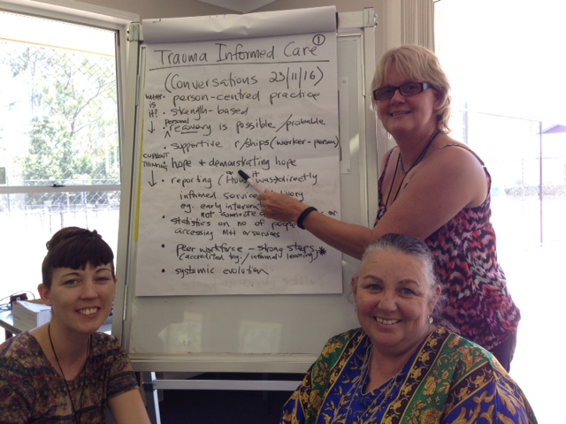
Applications
If you are interested in applying please complete the attached EOI.
A selection panel made up of a past Scholarship Applicant, Brisbane North PHN representative and a representative from the Registered Training Organisation will review all applications.
Expression of Interest forms must be submitted by 9.00 am Monday 22 May 2017 to paula.arro@brisbanenorthphn.org.au marked with subject heading ‘EOI Mental Health Peer Work’, faxed to 07 3630 7437 or posted to PO Box 929, North Lakes QLD 4509 ATT Paula Arro.
For further information please contact Paula Arro, Consumer and Carer Participation Coordinator | Mental Health, Alcohol and Other Drugs Program on phone 07 3490 3437 or email Paula.Arro@brisbanenorthphn.org.au.

Expression of interest

Scholarship - Certificate IV in Mental Health and Certificate IV in Mental Health Peer Work
Name:

Residential address:

Telephone number:

Email address:

Are you currently employed in the Brisbane North region YES NO (PLEASE CIRCLE)

If currently employed or volunteering:

Role:

Organisation:

Suburb organisation is in:

Manager and contact details:

Please respond to the following Selection Criteria (each one no more than 200 words)
Criteria 1: Why do you want to undertake this study? (weighting 30%)

Criteria 2: How do you plan to use the skills you have gained from the study in the future? (weighting 30%)

Criteria 3: How can you demonstrated your ability to commit to undertaking study of this nature? (weighting 20%)

Criteria 4: Please provide any other relevant information that will inform the panel about your reasons for wanting to complete this qualification? (weighting 20%)

I have NO (1), SOME (2) or LOTS (3) of experience with (please rate your current level of knowledge/skill in each area.
( ) Work with diverse people
( ) Work effectively in trauma informed care
( ) Promote and facilitate self advocacy
( ) Assess and promote social, emotional and physical wellbeing
( ) Apply peer work practices in the mental health sector
( ) Contribute to the continuous improvement of mental health services
( ) Apply lived experience in mental health peer work
( ) Participate in workplace health and safety

Please provide two Referees including name, position, organisation and telephone/email contacts

1.

2.

I __________________________________(insert name):

Please tick
- have a lived experience of mental illness and personal recovery
- be a resident and/or working (paid or volunteering) in the Brisbane North PHN region (Brisbane north of the river and areas around Strathpine, Redcliffe, North Lakes, Caboolture, Deception Bay, Bribie Island and Kilcoy)
- not already have the current qualifications
- Agree to be an active peer participant in regional activities including attending Network meetings, sharing information about your learnings and involvement in future working groups related to peer participation.
- Agree to commit to completing the course, including attending all monthly one day workshops (6-8 in total), participation in study circles and undertake 80 hours of relevant volunteering, work placement or employment linked to mental health peer work.
All of the information provided in this Expression of Interest is truthful and accurate.
Signature: Date:

Expression of Interest forms must be submitted by 9.00 am Monday 22 May 2017 to paula.arro@brisbanenorthphn.org.au marked with subject heading ‘EOI Mental Health Peer Work’, faxed to 07 3630 7437 or posted to PO Box 929, North Lakes QLD 4509 ATT Paula Arro.
For further information please contact Paula Arro, Consumer and Carer Participation Coordinator | Mental Health, Alcohol and Other Drugs Program on phone 07 3490 3437 or email Paula.Arro@brisbanenorthphn.org.au.

