The Change Curve
The Change Curve is useful model to understand the stages we, and our employees may go through when personally transitioning through change. The model helps us to predict how our team may react to the changes at various times; and provides an understanding as to their behaviour and how you can help them make their personal transition, ensuring that they have the support they need.
The Change Curve model (figure 1) highlights the main stages most people go through as they adjust to change.
Given we all experience change differently, it is not uncommon for our team members to be at different stages at any particular time. Depending on the nature and duration of the change, we could oscillate between particular stages, progress through some quickly or stagnate in others.
Inevitably, performance will be impacted through times of change. However, our goal is ultimately to progress ourselves and our team as quickly through the less helpful emotional stages. This will reduce the impact the change has on business performance and employee well-being.
Figure 1
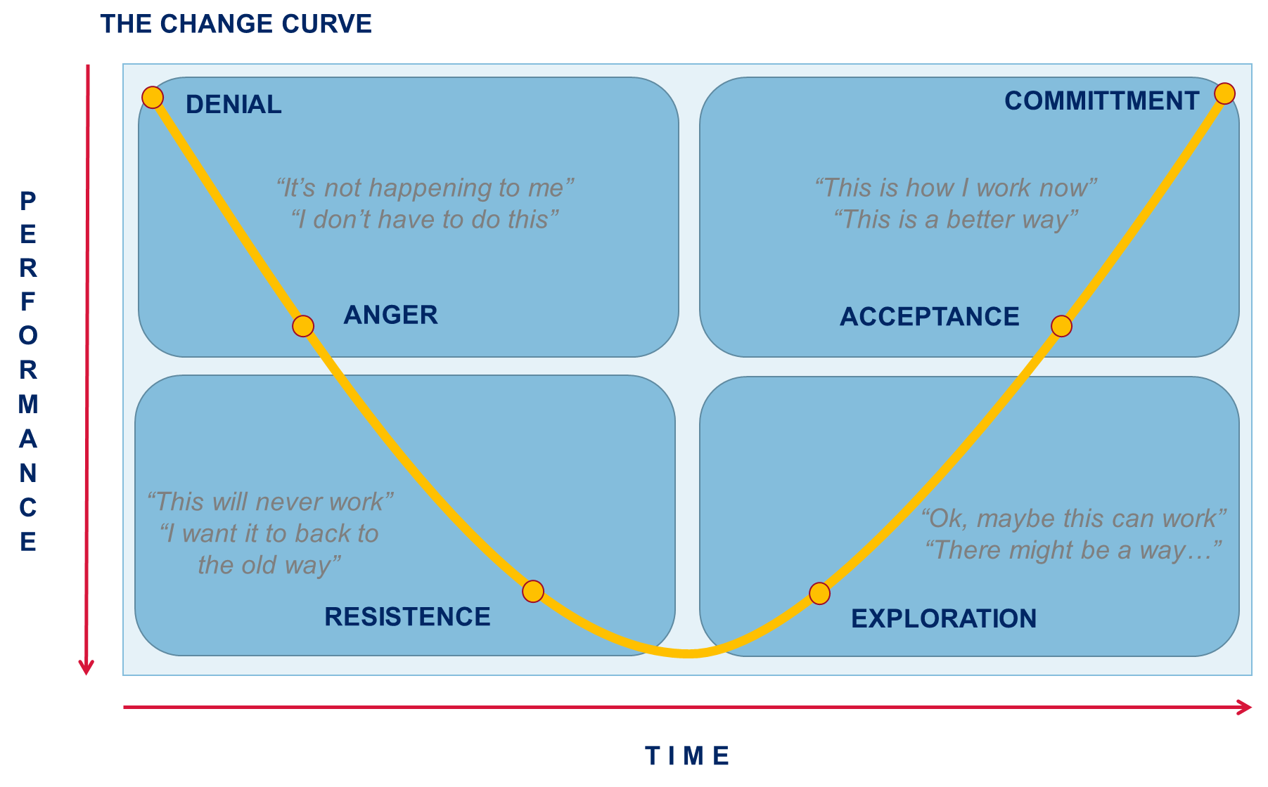

Change Curve Stages
Below provides a description of how each stage of the change curve plays out:
Change Stage | Description
Denial | - Keeps on doing things as per usual - Highlighting why the change won’t work - False optimism  “Following a brief period of shock, it’s common to experience denial. We may deny the change is taking place, that we will be affected or that the change will last – at this stage you’re likely to experience people still cracking on like nothing has changed, false optimism or on the other end of the scale, vocalising why and how the change won’t really happen as ‘they’ve been here before’”.
Resistance (including anger) | - Visible frustration - Refusal to participate / cooperate - Negative more often than not  “It’s common for morale to be low at this stage and for self-doubt and anxiety levels to peak. We may display signs of frustration and anger (e.g. fist slamming on tables, eye rolling, audible sighs) or withdraw and see absenteeism and/or depressives moods. Individuals may refuse to cooperate with the changes or set-out to disprove new ways of working. Comments we may commonly hear during this stage include, ‘this is a waste of time…it won’t work, why are they doing this again, this is not fair…I’ve worked so hard and everything was working fine before”.
Exploration | - Curious, asks more questions - Looks at things from different perspectives and offers suggestions - Asks questions about the change and the impacts it will have  “A more optimistic and enthusiastic mood begins to emerge. We start to show the first signs that we accept that change is inevitable, and begin to work with the changes rather than against it”.
Acceptance | - Acknowledges what is within their control - More open and willing to take on new tasks - Helps others understand the big picture  “The focus now shifts towards the future and there is a sense that real progress can be made We may start to ask more questions and be curious about the possibilities and opportunities of our new ways of working, We refocus on delivering our work, instead of the change happening around us and normal topics of conversation begin to resume. The primary feelings now include acceptance, hope and trust along with enthusiasm and energy”.
Commitment | - Actively participants in and actions the change - Increased productivity - Positive energy  “At this stage we are now ready and willing to action the change… and depending on how quickly we moved through the change curve we may even have team members who can role model what needs to be done to change and mentor others still transitioning”.

Change and Behaviours Activity
Examples for the Change and Behaviours brainstorming activity:
Change Stage | Obvious Behaviours | Less Obvious Behaviours
Denial | - False optimism  - Highlights how changes like this have been made in the past but never really happened  - Highlights why the change won’t work | - Keeps on doing things as per usual  - Focussed on self  - Won’t engage in conversations around the changes at hand
Resistance (including anger) | - Visible frustration  - Refusal to participate / cooperate  - Resists getting involved  - Negative more often than not  - Aggressive outbursts | - Increased absenteeism  - Dips in performance  - Withdrawal from the team  - Makes excuses  - Lethargy
Exploration | - Curious, asks more questions  - Looks at things from different perspectives and offers suggestions | - Quietly trials news ways of working  - Seeks out input from others  - Asks questions about the change and the impacts it will have
Acceptance | - Acknowledges what is within their control  - More open and willing to take on new tasks  - Helps others understand the big picture | - Quiet calmness  - Refocused and centred on tasks and delivery  - Increase in energy and positivity
Commitment | - Actively participates in and actions the change  - Increased productivity  - Engages in conversations about what’s great about the changes – for self, team and customers | - Provides support for others to bring them along (focussed on others)  - Positive energy

