Suzanne Johnson
308/177-219 Mitchell Rd
Erskineville 2043

maidendale@gmail.com
0407536 970
My objective
To work for or contract to, a well-respected training organisation offering outstanding training and management skills in;
- Foundation skills, Retail, Business, Computing, Management.
- Experienced in working with mainstream students, migrants, students at risk of leaving school, women returning to the workforce and people with disabilities.

My skills
- Teaching and training skills
“ as a teacher she is highly motivated”, ”uses creative method of delivery”-(Head Teacher)
- Oral and written communication
“ability to communicate effectively with people at every level”(project manager LLNP)
- Organisation , coordination and management
“Without exception, any task that Sue has undertaken has been very well co-ordinated” (project manager LLNP)
“outstanding in managing all aspects of co-ordination of courses” – (Head Teacher)
- Program development
“developed a highly innovative program” ( director of Equity and Aboriginal services)
- Workbook development and preparation of assessment tools
“in learning materials.takes into consideration the diversity of needs of the students ( H.T)
- Timetabling of courses
- Computer skills – Microsoft office suite, Spark post
- People skills
“ability to communicate effectively with people at every level and her empathy for students is evident in the way she works”

Qualification
Tertiary:
TAESS00009 Address Foundation skills in Vocational Practice – Blue print 2020
TAEASS502 – Design and develop assessment tools – Kiama community college- 2019
FSK20113 Cert II in skills for work & vocational pathways- Riverina College2017
TAELLN401 Fortress learning – 2014
TAE40110 Penrith community college – 2012
Diploma in Management – WSI 2010
Training Plan Systems – Additional modules to TAE40110 – 2006
TAE40110 Assessment methods and tools for business services WSI - 2006
Cert 3 Retail Operations - WSIT 2004
Cert 3 in Business Administration WSIT -2012
Cert. 4 Work-place trainer and assessor - WSIT 2000

My professional experience

2020 max Solutions trainer and assessor casual
- Deliver F2F and online training and assessment.
- Compliance and validation of course assessments in preparation for auditing.
- Training delivered to long term unemployed clients of Max Employment

2016-2019 JOBQUEST trainer and assessor Penrith – contract position

- Developing training materials and assessments and delivering project based learning to mainstream and students with disabilities.
- Compliance and validation of course assessments in preparation for auditing.
- Teaching computing to seniors. Assisting NDIS recipients in preparing for funding reviews.

2015 J2S Retail trainer - Penrith -contract position

1999 – 2014 WSI TAFE Part-time teacher

- Delivered Retail and Customer Service courses to mainstream and students with disabilities.
- Taught computing to TPC students preparing for university
- Developed, co-ordinated and taught a pilot program for Sudanese migrants
- Teaching introduction to computer classes at Richmond TAFE to seniors, co-ordinated and
teaching an ESOL vocational program
- Developed, coordinated and taught a program for students at risk of leaving school.
- Involved in coordinating and teaching WOW courses at Richmond.
- Developed a number of workbooks and assessment tools for mainstream students and those with special needs undertaking retail and customer service courses
- Taught TVET students –retail Outreach and Get Skilled program, teaching all modules of the Cert II and III in Retail Operations as well as personal effectiveness and job seeking.
- I have worked with and assessed trainees both on the job and those attending TAFE classes.
- Liaised with employers in the retail sector for student work placements and with employers of trainees.
- Coordinated many courses over my time at TAFE, this involves organizing teachers, classrooms, course content, timetabling, workbook publication, CLAMS management of the courses and student supervision and counselling.
- I have been involved with tutorial support for students with disabilities who have undertaken courses, in General Education, Nursing, TVET Retail Operations course and TAE Cert 4
- I have facilitated a course for people who are training as educational support aides

1998-1999 Teacher’s aide and Job Coach: Niland SSP.

1994-1997 Training and Placement Officer : Western Sydney Jobnet.

Professional development
Cultural competence -2018
LLN podcast -2018
Project based learning Jobquest -2017
ACSF training update Jobquest 2107
TESOL online course-Global leadership college -2014

Community involvement

Involved in local church activities; currently working with children and organising community events

Personal interests
Home decorating Reading Photography
Gardening My wonderful family

Referee

Current referee - Anne Becht - JobQuest Training manager 0421311436
The following written references are from previous employees who have passed away or have retired I have included them as they the speak to the skills and abilities I have and have used in varied work roles at TAFE

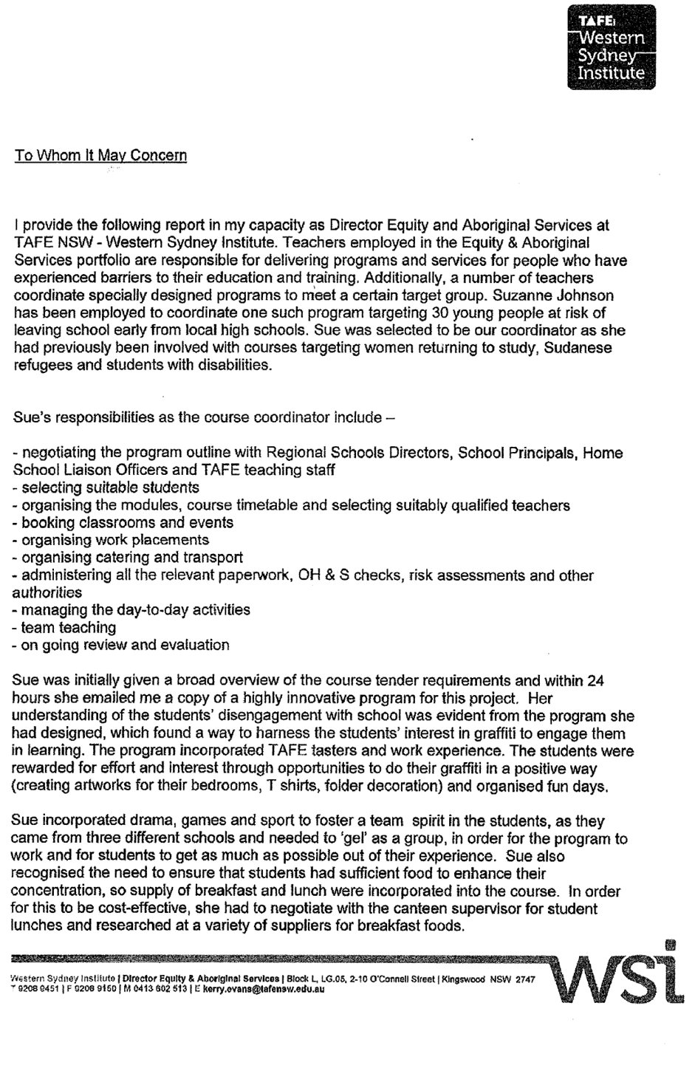
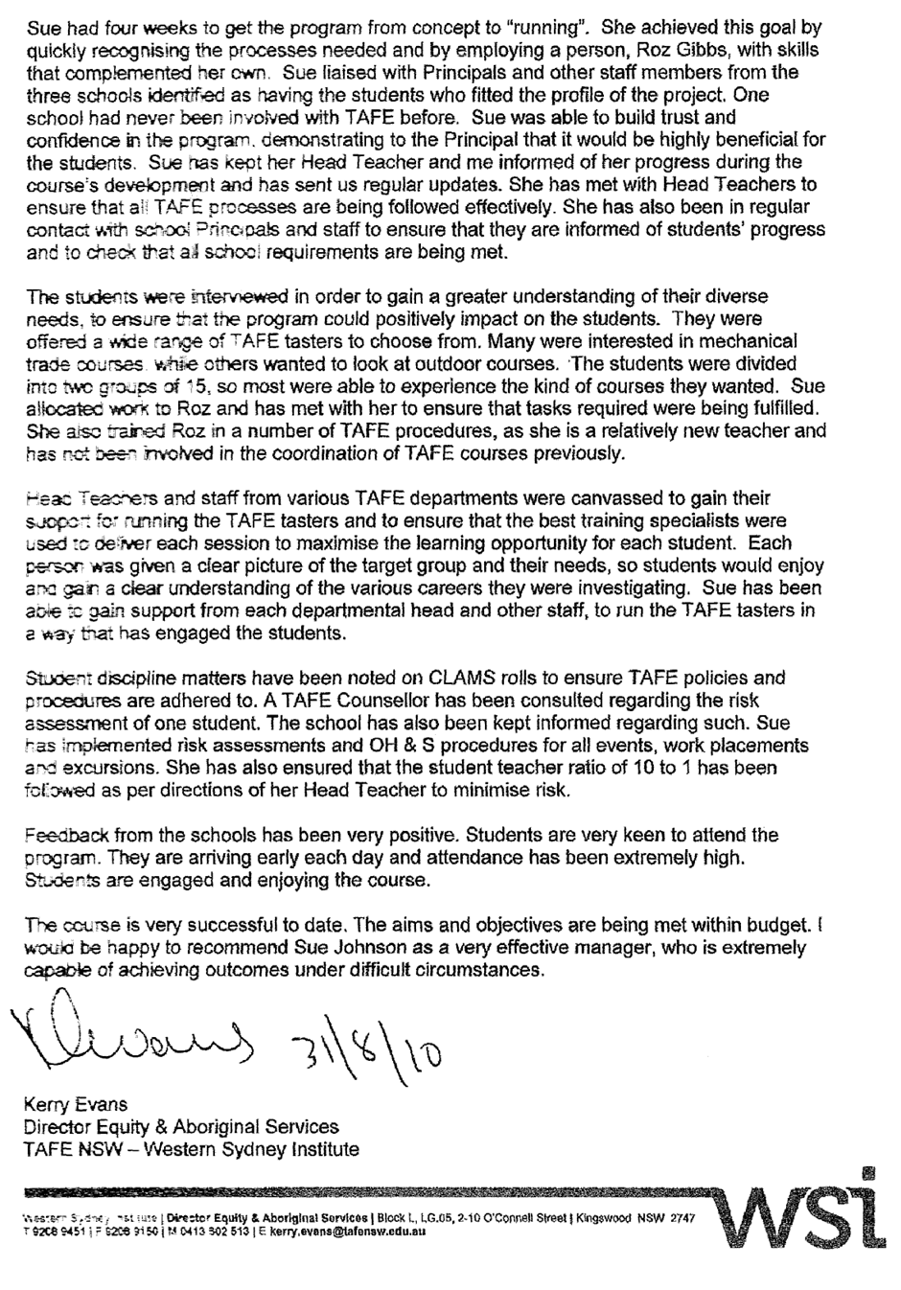

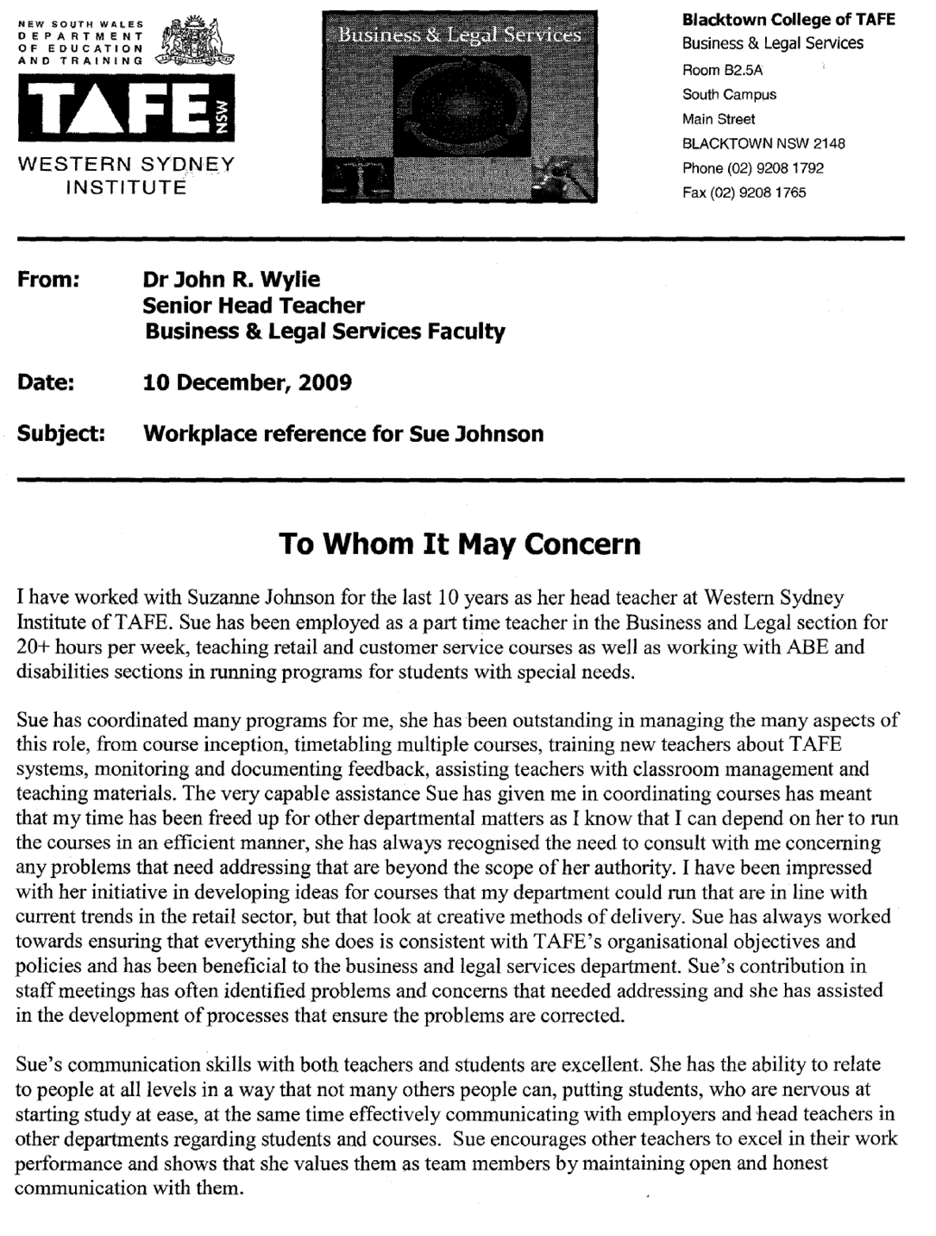

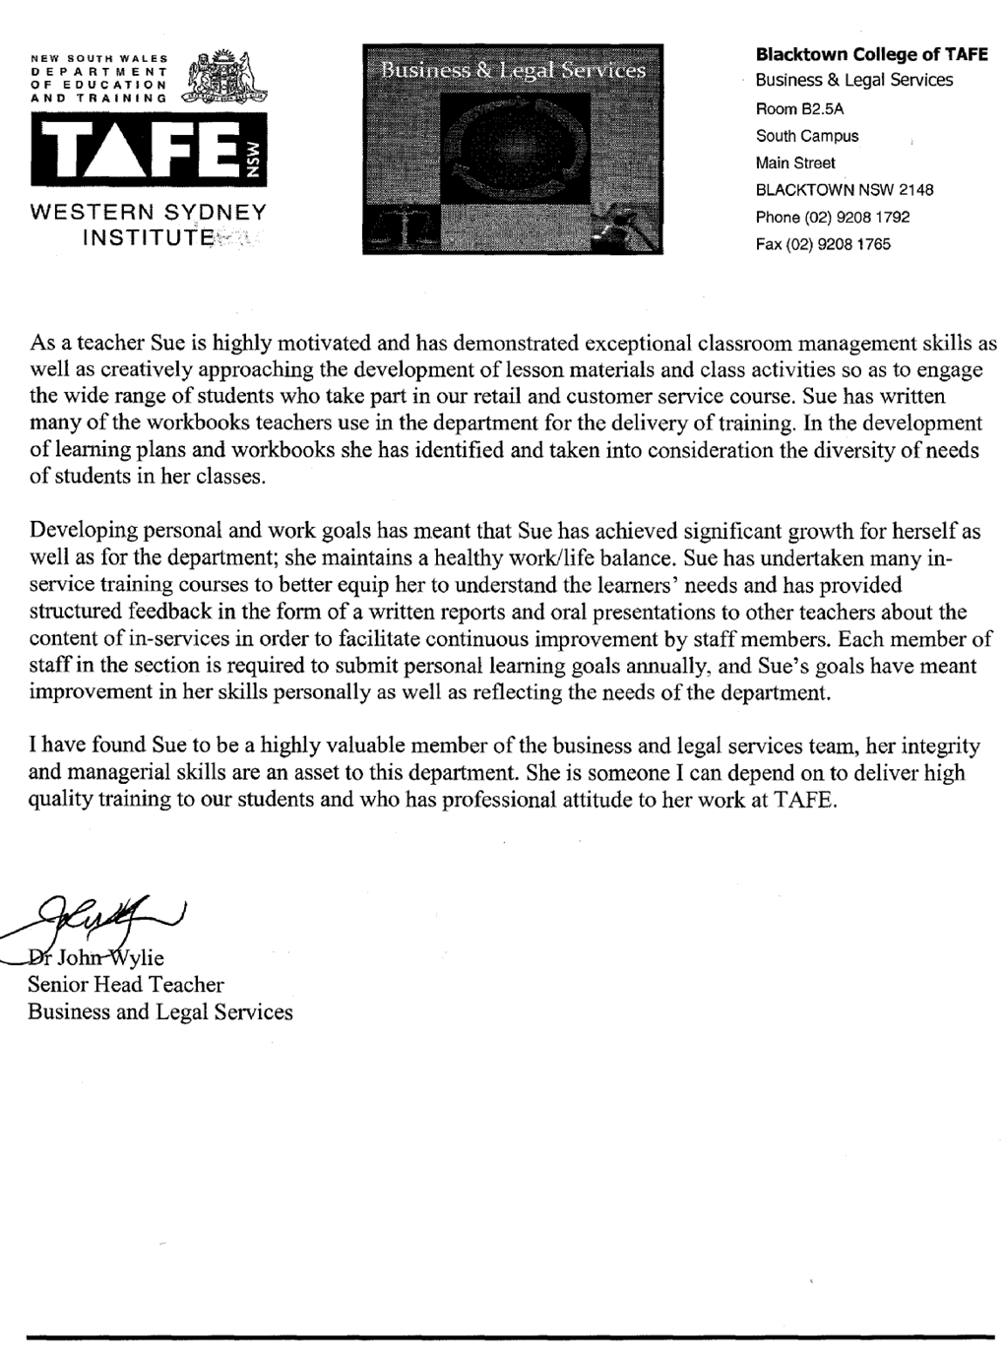
To whom it may concern
I have worked with Suzanne Johnson on a number of occasions in the last few years, with LLN courses and a Sudanese program. In the LLN programs Sue has worked with teachers from ABE section and was able to understand the language, literacy and numeracy aspects of the course as well as assisting the ABE teachers to understand the retail aspects of the course and how both aspects could be melded effectively and efficiently.
Sue was given responsibility for the educational development of a pilot program for Sudanese refugees, she carefully planned the course to meet the requirements of all stakeholders, ensuring quality delivery to both students and employment agencies. She developed strategies to monitor the effectiveness of the various components of the program and managing the team of teachers involved in the program, supporting them with lesson material development and understanding the needs of the clients.
Prior to undertaking the Sudanese program Sue identified the learning needs of each of the students through discussion with students and case workers. The use of informal and formal learning opportunities allowed all students to access the information in the way that best suited their learning style. Students were encouraged to support each other in their learning process.
The program was developed in accordance with TAFE policies and procedures and in consultation with language teachers, me and members of the funding body and employment agencies ensuring that the program used the physical, financial and human resources to meet the projects parameters.
Sue has remained in close communication with me by phone and email in order to report on budgeting issues, to provide feedback and to deal with any problems as they arose. This informal communication has been used in conjunction with formal meetings prior to and at the conclusion of the course to ensure the project is managed well.
Sue has always demonstrated a personal commitment to her work and has worked tirelessly to ensure a successful conclusion to each of the programs we have worked on together. Without exception, any task that Sue has undertaken has been very well co-ordinated , she is a wonderful role model of leadership to students and staff. Sue uses her initiative to come up with ideas for me to consider for future courses, always carefully considering the needs and parameters of any task that she undertakes.
Sue has the ability to communicate effectively with people at every level and her empathy for students is evident in the way she works to develop programs that are suited to the literacy needs of the students, she has used resources appropriately and has always carefully reflected on the effectiveness of what she has done.
I would happily commend Sue Johnson to anyone considering using her organisational and
leadership skills in a training environment.




