Materials List – Jody Graham – yellow highlighted items basic requirement for workshop
*Prices are estimates – (as of September 2024)

1 | Artline black pen |  |  | $4.00
2 | Charcoal drawing pencil |  |  | $4.00
3 | Warm white soft pastel |  | Art Spectrum fine | $5.50
4 | Compressed charcoal |  | charcoal sticks prefer soft x 2 sticks – 1 minimum | generals or compressed faber castell  $4.60 each
5 | Sennelier soap eraser | 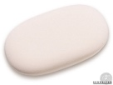 | If you can’t get this eraser, try and get a hard one, kneadable is not strong enough | Highly recommend this brand/type  $10.00
6 | Faber Castell grip eraser | 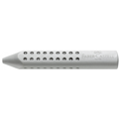 | If you can’t get this eraser, try and get a hard one, kneadable is not strong enough | Highly recommend this brand/type  $4.50
7 | Black or Sepia ink | 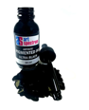 | suggest 50ml Art Spectrum or similar – 36ml Derivan | $6.80 - $13.50
8 | Sketch Pad – A2/ A3 cartridge paper | 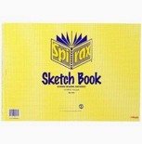 |  | Sketch Pad – A3 cartridge paper – suggest Quill Premium, Spirax or similar  A2 - $22.00 – Officeworks
9 | Mixed media paper pad - A3 smooth 300gsm  Or approx. 6 sheets or A3 heavier weight paper | 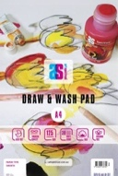 | Suggest – A3 Art Spectrum Draw and Wash - smooth  (Bigger scale okay too) | Best to get smooth paper  *Possible to share approx. 6 sheets needed each participant  $36.00
10 | Watercolour paper  Saunders Waterford and or Archers |  | Smooth - Hot presses | 1 sheet of 300gsm watercolour paper  $10.00
11 | Blue painters tap |  |  | $5 - $8.00
Other general art material
- Notebook
- A brush– suggest Chinese drawing brush - $4.00 - optional
- Several containers for ink and water
- Watercolour-coloured pencils 4 – 6, any colour $10.25 – Faber Castel – tutor will bring some
- Box cutter utility knife or sharpener - $2.00
- 2B OR 4B pencils - $2.00
- Paper towel - $2.00
- Bull dog clips to attach paper to art board. $3 - $5.00
- Optional – more quality paper, coloured ink, coloured pastels, electric eraser, kneadable eraser
- Fountain pen

