DELEGATE ASSESSMENT REPORT

DATE: | 8 April 2015 | Property Key: 238346
REFER TO: | Council's Delegate
REPORT BY: | John Gibson
DECISION DUE BY: | 15 September 2015 | Doc Id: 9836513

Development Application Details
Application Number: | MCUI/21/2015
Lodgement Date: | 2 April 2015
Proposed Development: | Material Change of Use – Shop (Retail Showroom), Retail Plant Nursery and Food Outlet
Type of Approval sought: | Development Permit
Site Address: | 115 Compton Road, UNDERWOOD QLD 4119
Real Property Description: | Lot 2 SP 145157
Site Area: | 37,240.00m²
Owner Details: | HYDROX NOMINEES PTY LTD
Applicant Details: | HYDROX NOMINEES PTY LTD
Applicable Legislation: | Sustainable Planning Act 2009

Planning Instrument Details
State Planning Regulatory Provisions: | N/A
Regional Plan: | South East Queensland Regional Plan 2009-2031
State Planning Policy: | N/A
Planning Scheme: | Logan Planning Scheme 2006 (Superseded)  Logan Planning Scheme 2015 (Current)
Zone: | Logan Planning Scheme 2006:  - Springwood Sub Area 9 Zone (96%)  - Non Urban Sub Area 4 Zone (4%)  Logan Planning Scheme 2015:  - Mixed Use Zone (96%)  - Recreation and Open Space Zone – Recreation Parks Precinct (4%)
Applicable Codes: | Logan Planning Scheme 2006:  - Centres Locality and Zones Code (Section 3.3.9)  - Rural Related Uses Code (Section 5.2.29)  - Work Codes (Section 5.3.1)  Logan Planning Scheme 2015:  - Mixed Use Zone Code (Section 6.2.10)  - Filling and Excavation Code (Section 9.4.2)  - Infrastructure Code (Section 9.4.3)  - Landscape Code (Section 9.4.4)  - Servicing, Access and Parking Code (Section 9.4.7)
Applicable Overlays: | Logan Planning Scheme 2006:  - OL6 - WETLAND AND WATERWAY AREA  - OL1B - VEGETATION MANAGEMENT AREA 1B  - TLPI – FLOODING TLPI2015 (expired)  Logan Planning Scheme 2015:  - OM-02.01 Vegetation Management Areas  - OM-02.04 Matters of State and Local Significance  - OM-05.00 Flood Hazard Trigger  - OM-08.01 Landslide Hazard and Steep Slopes  - OM-10.01 Strategic Airport and Environs Overlay  - OM-13.01 Waterways  - OM-13.02 Wetlands
Applicable Preliminary Approval: | N/A
Level of Assessment: | Impact Assessable
Consistency of Development: | Inconsistent

Executive Summary

Council is in receipt of an application for a Development Permit for Material Change of Use to establish a combined Shop (Retail Showroom), Retail Plant Nursery and Food Outlet development under the superseded Logan Planning Scheme 2006 at Lot 2 SP 145157, 115 Compton Road, UNDERWOOD QLD 4119.

The development is for a Masters Home Improvement Centre with a gross floor area (GFA) of 13,444m² and a maximum building height of 11.0 metres. The development will include retail space, a timber yard, and a garden centre which will be collocated with a café within the building. Primary vehicle access to the development for customers and staff is proposed via an upgraded four (4) way Compton Road/North Road intersection. Service vehicle and secondary customer/staff access is proposed at the rear of the development along the future alignment of Perrin Drive (as identified on Structure Plan Map 1B under the Logan Planning Scheme 2006). The applicant has not included the extension of Perrin Drive, and associated infrastructure, as part of this proposal.

Impact Assessment is triggered by the development under the Logan Planning Scheme 2006. Accordingly, public notification was carried out for the development from the 25 June 2015 to the 20 July 2015. During this period two (2) properly made submissions were received objecting to the proposal. Submitters concerns will be satisfied by imposing standard conditions where applicable.

The development has been assessed against the Logan Planning Scheme 2006 and has been identified as conflicting with Centres Locality and Zones Code (Specific Outcomes O11, O23, O30, and Overall Outcomes 16, 19, 23, 38, 39), Springwood Sub Area 9 Code (Specific Outcomes O1-O9), and Non Urban and Conservation Locality and Zones Code (Specific Outcome O10).

On the 18 May 2015 the current Logan Planning Scheme 2015 commenced, superseding the assessable Logan Planning Scheme 2006. Significant weight has been given to the provisions of the current Logan Planning Scheme 2015 as part of the assessment of this development application. Accordingly, it has been determined that the proposal complies with planned intent for the site under the Logan Planning Scheme 2015. Conditions requiring the extension of Perrin Drive, and associated infrastructure, will be imposed.

Accordingly, it is recommended that this application be approved, with conditions.

Background/ History

On 1 May 2014 a prelodgement meeting was held with the Planning Assessment team (Council Reference PLM/83/2014).

On 5 December 2014, a subsequent meeting was held and further advice was provided to the Applicant based on preliminary drawings.

On 2 April 2015, development application (MCUI/21/2015) lodged with Council and deemed Properly Made.

On 9 April 2015, Acknowledgement Notice was issued.

On 22 April 2015, Information Request issued to applicant. Council requested that the proposal be amended to include the extension of Perrin Drive and its associated infrastructure.

On 18 May 2015, the new Logan Planning Scheme 2015 commenced, superseding the Logan Planning Scheme 2006, Gold Coast Planning Scheme 2003 (v1.2) and Beaudesert Shire Planning Scheme 2007.

On 25 May 2015, Concurrence Agency response received by Council, with no requirements.

On 19 June 2015, Information Request Response received by Council. The applicant did not include Perrin Drive extension as requested.

On 25 June 2015, Council receive the notice of commencement for public notification. Public notification period to conclude on 12 July 2015, with signs to be removed on the 18 July 2015.

On 20 July 2015, Council received the notice of compliance for the public notification period. The notice confirmed that signs were removed on the 18 July 2015. During this period Council received two (2) properly made submissions objecting to the proposed development.

On 21 July 2015, application entered Decision Stage.

On 17 August 2015, the Decision Making Period was extended to 15 September 2015.

Site Description

The subject site is described as Lot 2 SP 145157 with an area of 37,240.00m². The premises fronts Compton Road along its southern boundary, adjoins Brookevale Park along its northern boundary, and connects to Perrin Drive on its eastern boundary (Figure 1). Perrin Drive will be extended through the subject site as identified by Structure Plan Map 1B – Springwood Zone and Public Open Space Zone PO5 Sub-Area (Compton Road) (SP Map 1B) under the assessable Logan Planning Scheme 2006 (Figure 2). The site is currently unimproved with minor patches of vegetation.

Figure 1: Subject Site

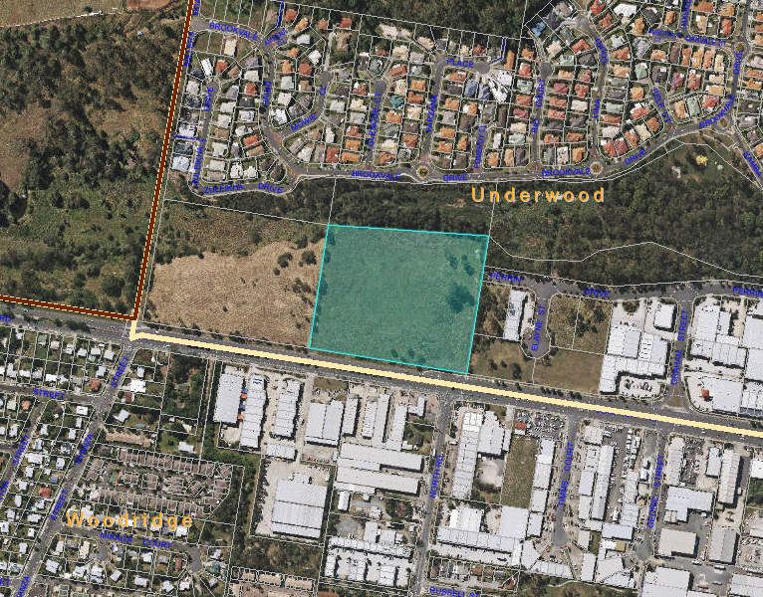
Figure 2: Structure Plan Map 1B - Springwood Zone and Public Open Space Zone PO5 Sub-Area (Compton Road) – Logan Planning Scheme 2006
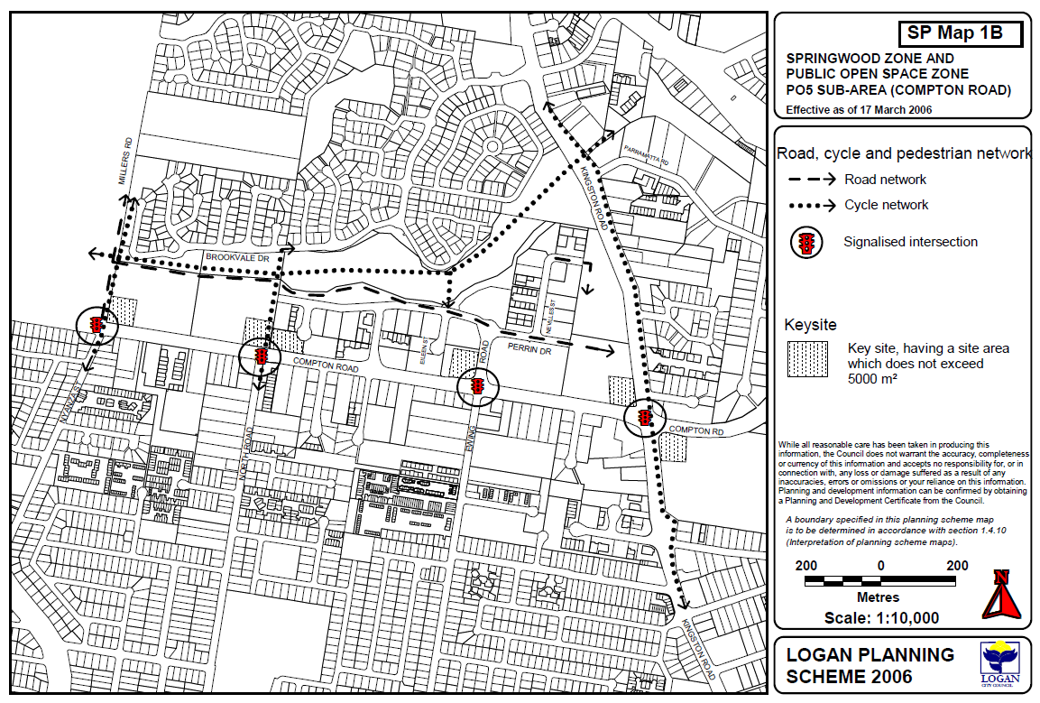
Subject Site

Logan Planning Scheme 2006
The site contains multiple zones under the Logan Planning Scheme 2006 (Figure 3), being the Centres Springwood Zone and Non Urban Zone.

Figure 3: Logan Planning Scheme 2006
- Centres Locality – Springwood Sub Area 9 Zone (96%)
- Conservation & Non Urban Locality – Non Urban Sub Area 4 Zone (4%)

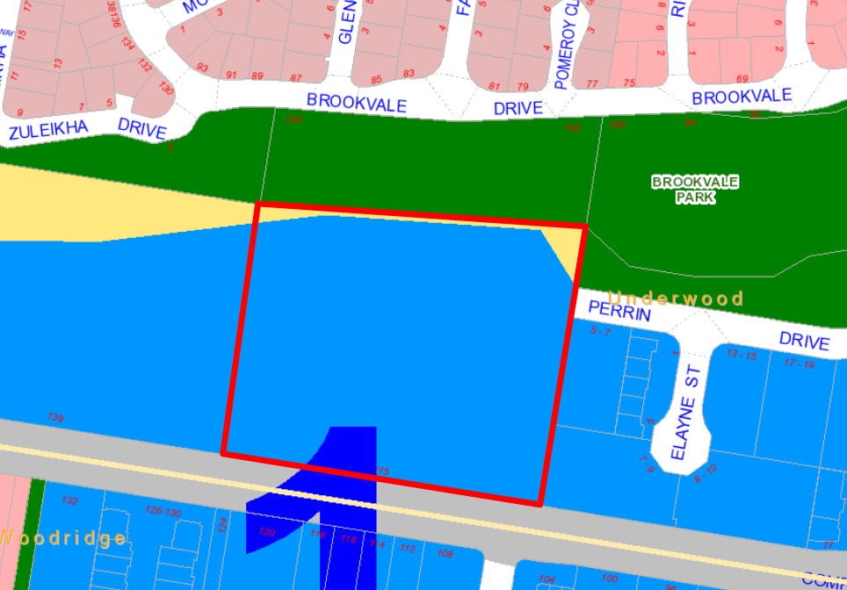

Logan Planning Scheme 2015
The site contains multiple zones under the current Logan Planning Scheme 2015 (Figure 4), being the Mixed Use Zone and Recreation and Open Space Zone - Recreation Parks Precinct.

Figure 4: Logan Planning Scheme 2015
- Mixed Use Zone (96%)
- Recreation and Open Space Zone – Recreation Parks Precinct (4%)
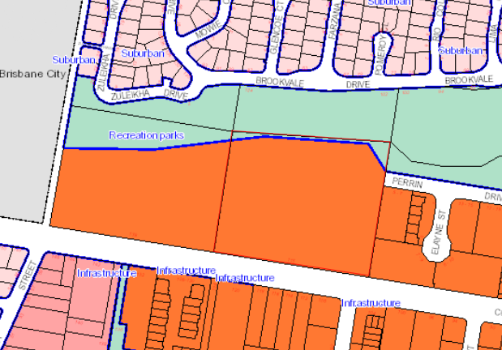

Description of Proposal

The proposed development is for a Masters Home Improvement Centre (see Figure 5 and 6), comprising of Shop (Retail Showroom), Retail Plant Nursery and Food Outlet land uses. The application was lodged under, and is assessable against, the now superseded Logan Planning Scheme 2006. The development is Impact Assessable and includes the following components:
- Floor Area of 13,444m² which includes a retail space, a timber yard, and a garden centre which will be collocated with a café within the building.
- Maximum building height of 11.0 metres.
- Private driveway access from existing Perrin Drive road stub for trucks and loading purposes. This access will be gated and locked outside of trading hours.
- Customer access from Compton Road, including a new four (4) way intersection.
- 383 car parking spaces (including disabled parking).
- Private stormwater quality infrastructure (bioretention basin) at the north-eastern corner of the site, adjoining Brookvale Park. Stormwater detention is located under the car park and will drain to Brookvale Park through the bioretention basin.

The development is wholly contained within the Springwood Sub Area 9 Zoning, with the exception of stormwater quality infrastructure which will be located within private land in the Non Urban Sub Area 4 Zoning. The same applies to the corresponding zones prescribed by the current Logan Planning Scheme 2015.
Figure 5: Proposed Plan of Development (Site Plan)
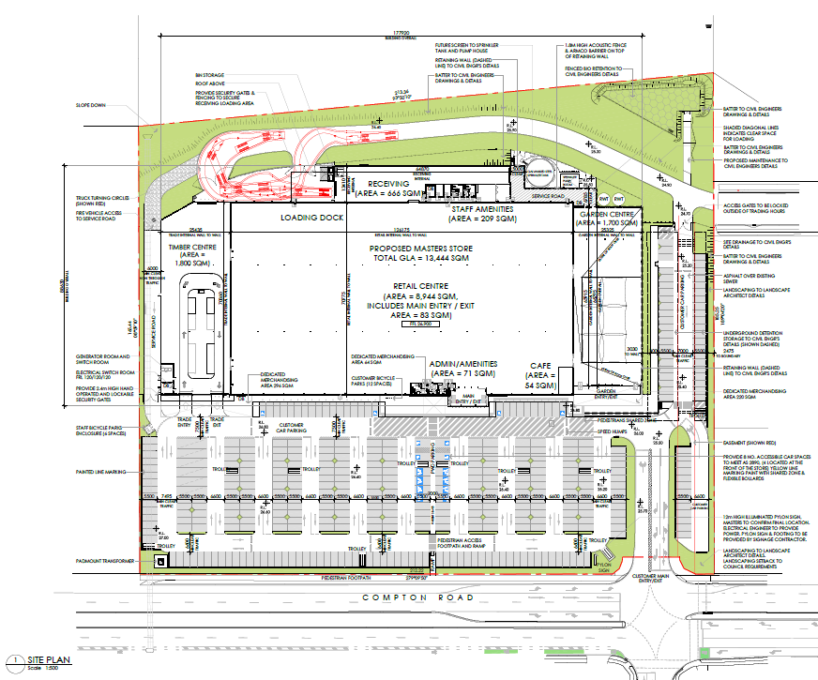
Figure 6: Proposed Plan of Development (Site Plan)
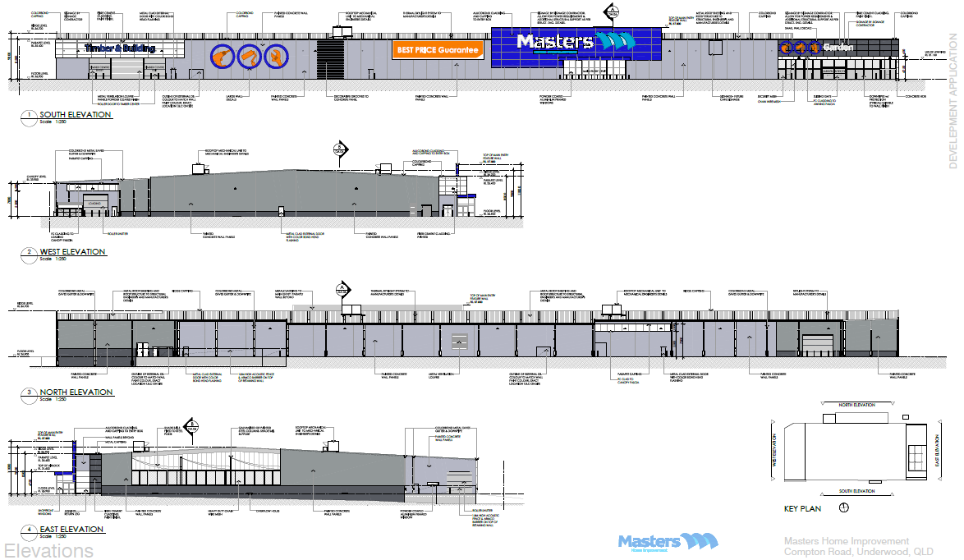

Planning Assessment

This application is Impact Assessable and has been assessed, in accordance with S314 of the Sustainable Planning Act 2009 against the following:
- the State Planning Regulatory Provisions;
- the South East Queensland Regional Plan 2009-2031;
- any State Planning Policy that is not appropriately reflected in the regional plan or planning scheme;
- applicable within a structure plan;
- applicable within a master plan;
- applicable within a temporary local planning instrument;
- applicable within a S242 preliminary approval;
- applicable within a planning scheme; and
- the Priority Infrastructure Plan.
State Planning Regulatory Provisions
Not Applicable
South East Queensland Regional Plan 2009-2031
The subject site is located within the "Urban Footprint" of the South East Queensland Regional Plan. The use proposed by this application is defined as an 'Urban Activity', which "means a residential, industrial, retail, or commercial activity. …"
The intent of the Urban Footprint is to identify "… land that can meet the region’s urban development needs to 2031 in a more compact form". This proposal is consistent with same.
State Planning Policy
Not Applicable
Structure Plan
There are no declared Structure Plans within the Logan Planning Scheme areas.
Master Plan
There are no declared Master Plans within the Logan Planning Scheme areas.
Temporary Local Planning Instrument
A new planning instrument (Temporary Local Planning Instrument (TLPI) - Logan Interim Flooding Response 2015) commenced on 27 March 2015 dealing with flooding. In accordance with the TLPI the proposed development is located outside of the mapped area and satisfies the TLPI requirements accordingly.
The TLPI has now expired with the inception of the Logan Planning Scheme 2015. The assessment against the TLPI remains applicable to the Flood Overlay mapping under the Logan Planning Scheme 2015. Accordingly, no further requirements are necessary.
S242 Preliminary Approval
Not Applicable
Logan Planning Scheme 2006 (Superseded)
The following is an assessment of the application against the applicable codes of the Planning Scheme.
Centres Locality and Zones Code
The development has been assessed against the applicable provisions of the Centres Locality and Zones Code and conflicts have been identified against the following Specific Outcomes:
- O11 – Protection and Enhancement of Character Areas;
- O23, O26 and O27 – Protection of the Retail Centre Hierarchy;
- O30 – Consolidation of Development;
Accordingly, an assessment has been carried out against the applicable Overall Outcomes and further non-compliance has been identified as follows:
- (16) - Predominant Land Uses - Mixed Industry and Business Area;
- (19) - Retail Centre Hierarchy - Hierarchy of Retail Centres;
- (23) - Retail Centre Hierarchy - Service Centre;
- (38) - Protection and Enhancement of Existing and Planned Infrastructure; and
- (39) - Inconsistent development and impact assessable consistent development.

Overall Outcomes (16), (19) and (23) relate to the planned intent for this zone under the Logan Planning Scheme 2006 with regards to intended land uses, scale of development, and function of identified centres hierarchy. Overall Outcomes (38) and (39) relate to the provision and protection of the planned capacity of infrastructure networks.

The proposal represents a retail activity, in excess of the prescribed gross leasable area (GLA) for this zoning, which is not envisaged within this centre. The proposal also excludes the extension of Perrin Drive, and associated infrastructure, which has been identified on SP Map 1B for the safety, efficiency and legibility of the road network.

The development therefore conflicts with the Centres Locality and Zones Code and sufficient grounds are further required to justify supporting the proposed development. Sufficient grounds are detailed further below in this report.
Springwood Sub Area 9 Code
Further to the above, the proposal does not comply with the intent of the Springwood Sub Area 9 Code and the following Specific Outcomes:
- O1, O2 and O3 – Protection of the Retail Centre Hierarchy and Consolidation of Development;
- O4, O5 and O6 – Protection against Development of an Inconsistent Scale, Form and Intensity and Protection and Enhancement of Amenity and Character;
- O7, O8 and O9 – Provision of a Safe, Efficient and Legible Road Network, Cycleway Network and Pedestrian Network and Protection of the Road Hierarchy.

Similarly, sufficient grounds are detailed further below in this report to justify supported the development.
Non Urban and Conservation Locality and Zones Code
The development has been assessed against all of the Specific Outcomes from the Non Urban and Conservation Locality and Zones Code. The extent of the proposal located within this zoning is considered to comply in full with the applicable provisions. However, further discussions is warranted with regards to Specific Outcome 10 (Protection and Enhancement of Character Areas).

Specific Outcome 10 seeks to maximise public access to public recreation and conservation areas. The proposed development seeks to retain land zoned Non Urban and Conservation, adjoining Brookevale Park, as private land for the purposes of establishing stormwater quality infrastructure for the development. Council’s Parks Branch and Environment and Sustainability Branch confirmed that although zoned for Non Urban and Conservation they were agreeable to allowing the land remain in private ownership and would not pursue the land for public purposes. As such, corresponding Overall Outcome 13 (Protection and Enhancement of Character Areas) is deemed to be complied with.

Accordingly, the development is considered to comply with the Non Urban and Conservation Locality and Zones Code.
Non Urban Sub Area 4 Code
It is considered that the aspects of the development proposed within the Non Urban Sub Area 4 designation is generally compliant with the relevant Specific Outcomes. Standard conditions of approval will be imposed to ensure rectification works are carried out as part of any disturbance created during the construction phase.
Overlay Codes
The development has been assessed against all of the Specific Outcomes of the applicable Overlay Codes as follows:
OL6 - WETLAND AND WATERWAY AREA
An assessment has been carried out by Council’s Environment and Sustainability branch against the provisions of the Wetland and Waterway Area Overlay Code. The extent of the development is located outside of the mapped area. Therefore the Wetland and Waterway Area Overlay Code has been satisfied. Standard conditions will be imposed where necessary.
OL1B - VEGETATION MANAGEMENT AREA 1B
An assessment has been carried out by Council’s Environment and Sustainability branch against the provisions of the Vegetation Management Area Overlay Code. The proposed development is wholly located outside of the mapped area with the exception of the proposed bio-retention system to be located within the north eastern corner of the development site. Despite this, it has been determined that conditions relating to vegetation clearing are not required at this stage, and should further assessment be required it can be carried out as part of a further Operational Works application.
Use Codes
An assessment has been undertaken against the applicable Specific Outcomes of the following Use Codes:
Rural Related Uses Code
The Retail Plant Nursery component of the development triggers assessment against the Rural Related Uses Code. Accordingly, an assessment has been carried out and it has been determined that the proposal complies in full with these provisions.
Works Codes
An assessment has been undertaken against all of the Specific Outcomes of the applicable Works Codes and …
Parking Code
The proposed development is made up of three (3) integrated land uses, Shop (Retail Showroom), Retail Plant Nursery and Food Outlet. The applicable parking rates prescribed for each land use are described as follows:
- Shop (Retail Showroom) = one (1) space per 50m² of GLA (11,690m² - excluding garden centre and food outlet uses) = 234 parking spaces.
- Retail Plant Nursery = one (1) space per 300m² of site area (37,240m²) = 124 parking spaces.
- Food Outlet = one (1) space per 10m² of GLA (54m²) = 5 parking spaces.
A total of 383 car parking spaces (including disabled parking space) have been provided in excess of the minimum prescribed requirements. All access, manoeuvring areas and pedestrian connections will also be provided and designed in accordance with the relevant provisions of the Code. Accordingly, the proposed development complies in full with the relevant Specific Outcomes of the Parking Code.
Landscaping Code
Landscaping has been assessed as part of this application and conditions will be provided to meet relevant landscaping requirements. This will be implemented through a Compliance Certificate process.
Earthworks Code
Earthworks will be carried out in accordance with any subsequent application for Operational Works. Conditions of approval will be provided to ensure compliance with the provisions of this Code.
Advertising Device Code
Standard conditions will be imposed upon the development to ensure that any advertising devices comply with the provisions of the Advertising Device Code, unless otherwise approved as part of a separate Operational Works application.
Infrastructure Code
The necessary services will be provided to the subject sites via the new roads to be constructed. Conditions of approval have been provided to ensure compliance with the provisions of this Code. Where necessary, conditions have also been imposed to require easements be provided over infrastructure which runs through private property to the benefit of Council and to the benefit of adjoining land owners where relevant. Specifically, conditions will be imposed requiring the Perrin Drive and associated infrastructure be extended to the property boundary of 139 Compton Road.
Logan Planning Scheme 2015 (Current)
During the assessment of this development application the Logan Planning Scheme 2015 commenced on the 18 May 2015. The Logan Planning Scheme 2015 represents consistent, modernised planning requirements for the whole city, replacing the requirements within the three (3) existing Planning Schemes.

Accordingly, significant weight has been given to the provisions under the Logan Planning Scheme 2015 to justify conflicts identified under the assessable Logan Planning Scheme 2006. An assessment against the Logan Planning Scheme 2015 has been carried out as follows:
Mixed Use Zone Code
As previously detailed in this report, the subject site is identified within the Mixed Use Zone (96%) and the Recreation and Open Space Zone – Recreation Parks Precinct (4%). The development is wholly located within the Mixed Use Zone, with the exception of stormwater quality infrastructure located within Recreation and Open Space Zoning.

The Purpose of the Mixed Use Zone Code is to provide for a mix of activities that may include business, retail, residential, tourist accommodation and associated services, Service Industry and low impact industrial uses. The Code seeks to achieve this by accommodating for land uses categorised as Mixed Use Activities. The Logan Planning Scheme 2015 defines the proposal as “Hardware and Trade Supplies” and “Garden Centre” land uses. These land uses are categorised as Mixed Use Activities. Accordingly, the proposal is compliant with the zoning intent for the subject site.

Further discussion is warranted with regards to the extension of Perrin Drive captured on SP Map 1B of the superseded Logan Planning Scheme 2006. Purpose statement (3)(d) of the Mixed Use Zone Code states that “development facilitates a safe, legible and connected movement network”. Council officers have determined, having regard to the above and s665 of SPA 2009, that it is reasonable and relevant to require Perrin Drive and associated infrastructure to be provided. Accordingly, conditions will be imposed requiring Perrin Drive be extended to the property boundary of 139 Compton Road.
Sufficient Grounds
There are sufficient grounds to justify the approval of the proposed development for the following reasons:
- The development complies with all the relevant Specific Outcomes and Overall Outcomes prescribed by the Rural Related Uses Code.
- The development complies with all the relevant Overall Outcomes prescribed by the Non Urban and Conservation Locality and Zone Code, and Non Urban Sub Area 4 Zone Code.
- The development can be conditioned to comply with all the relevant Specific Outcomes and/or Overall Outcomes prescribed by the Works Codes.
- Significant weight has been given to the current Logan Planning Scheme 2015. The proposed land use upholds the intent of the Mixed Use Zone under the current Logan Planning Scheme 2015.
- The development will be conditioned to extend Perrin Drive and associated infrastructure through the development site to the property boundary of 139 Compton Road to secure a safe, efficient and legible infrastructure network. This will be conditioned in accordance with:
  - Section 665 of the Sustainable Planning Act 2009;
  - Structure Plan Map 1B – Springwood Zone and Public Open Space Zone PO5 Sub-Area (Compton Road) (SP Map 1B) under the assessable Logan Planning Scheme 2006; and
  - Purpose statement (3)(d) of the Mixed Use Zone Code under the current Logan Planning Scheme 2015.
- The development will be conditioned to upgrade Compton Road in accordance with the design standards under the Logan Planning Scheme 2015. These upgrades will include a minimum 2.5 metre wide shared path along the frontage of the development site.

Referrals
Referral Agencies
Concurrence agencies can impose conditions or direct the Assessment Manager to refuse an application. Advice agencies can recommend conditions and provide advice on the assessment of an application.

This application was referred to the following referral agencies:

Concurrence Agency – (former) DEPARTMENT OF STATE DEVELOPMENT, INFRASTRUCTURE & PLAN
The response from the agency was received by Council on the 25 May 2015, with no requirements for the proposed development.
Internal Referrals
This application was referred to the following internal Council Branches/Units for consideration and approval conditions of development:
- Development Assessment (Engineering)
- Environment and Sustainability
- Parks (Planning and Landscaping)
- Infrastructure Charges Unit
- Roads Infrastructure Planning (Transport, Design and Traffic)
- Water Infrastructure Branch

Public Notification and Submissions

In accordance with S301 of the Sustainable Planning Act 2009, the applicant has informed Council that public notification was undertaken in accordance with S297, S298 and S299 of the Act.
State Date: | 25 June 2015
End Date: | 18 July 2015
Date of Final Notice: | 18 July 2015
Number of Properly Made Submissions: | 2

A total of two (2) properly made submission were received by Council in objection to the proposed development. Figure 7 shows how the submitter's properties are located in relation to the proposed development site. The issues raised in the submissions are outlined below in Table 1 and 2.

Figure 7: Submitter’s property in relation to development site
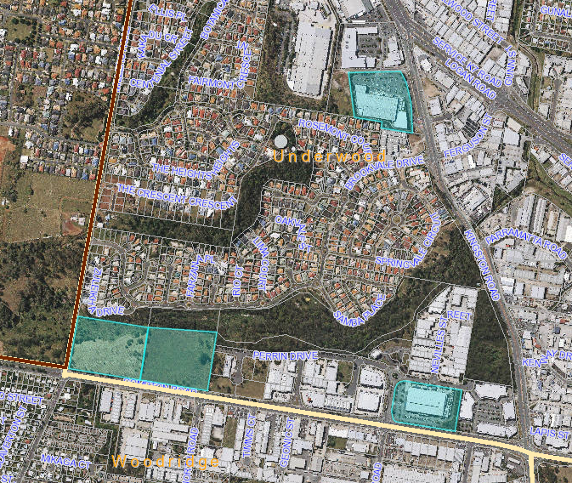
Submitter 2
Submitter 1
Subject Property

Table 1: Submitter 1 Issues and Comments
Issue | Submitter's Concern | Council Comments
Road Network | “The width of the existed[ing] Service Road [Perrin Drive] is 12 metres (excluded[ing] footpath [road verge]), so the width of this east boundary connection should be exact same.”  “The width of the Service Road (Perrin Drive Road) will [should] be built between east and west boundary [and] should be built at least 12 metres in this development. The size of this Service Road should be exact same as existed[ing] Perrin Drive Road.”  “The Service Road [Perrin Drive] should be built to the West Boundary and leave a 12 metres wide connection on the boundary for the future Service Road [Perrin Drive] connecting from the adjoining property on 139 Compton Road.” | The described extension of Perrin Drive is reflected by Structure Plan Map 1B (SP Map 1B) under the assessable Logan Planning Scheme 2006.  Further, consideration has been given to s665 of SPA 2009 which details when it is reasonable or relevant to require non-trunk infrastructure to be provided.  Council officers have determined, having regard to the above, that it is reasonable and relevant to require Perrin Drive and associated infrastructure to be provided as part of the development.  Accordingly, conditions will be imposed requiring Perrin Drive be extended to the property boundary of 139 Compton Road.

Table 2: Submitter 2 Issues and Comments
Issue | Submitter's Concern | Council Comments
Conflicts with Centres Locality Code | “The proposal undermines and conflicts with this overall outcome [Overall Outcome 16 of Mixed Industry and Business Area]. In particular, regarding the land use:  - At 37,240m2 in area, the subject site is the largest remaining land holding within sub-area S9, and represents one of the last substantial opportunities for establishment of new MIBA activities within the sub-area.  - The proposal, however, does not comprise any industrial uses, commercial premises, or commercial services of the sort predominantly intend to make up the sub-area.  - The proposal directly conflicts with part (a) of the overall outcome in this respect and significantly undermines achievement of the overall outcome across the sub-area.”  “The proposal also conflicts with other aspects of the overall outcome in that:  - The proposal conflicts with part (b) in that the proposal involves a large expanse of car parking in front of the building. Rather that contributing to a ‘park like’ setting the car parking arrangement will dominate the site when viewed from Compton Road and site configuration does not contribute to creation of a park like environment.  - The proposal makes no attempt at or provision for integration within the sub-area (such as for shared accesses, for example).  - In particular, the proposal does not provide for extension of Perrin Drive through the site, which will be necessary for any future development on the site to the west to be connected to the balance of the sub-area to the east.” | Significant weight has been given to the current Logan Planning Scheme 2015 which commenced as of the 18 May 2015. Accordingly, it has been determined that the proposal is compliant with the current zoning intent for the subject site.  Further discussion is warranted with regards to the noted extension of Perrin Drive. Purpose statement (3)(d) of the Mixed Use Zone Code states that “development facilitates a safe, legible and connected movement network”.  Council officers have determined, having regard to the above and s665 of SPA 2009, that it is reasonable and relevant to require Perrin Drive and associated infrastructure to be provided.  Accordingly, conditions will be imposed requiring Perrin Drive be extended to the property boundary of 139 Compton Road.
Conflicts with Sub-area Code | “The proposal is in clear conflict with O1 as it comprises no industrial uses, no commercial uses, and far exceeds the scale (and nature) of retail activities intended for a service centre.”  “Similarly, the proposal is in clear conflict with O2 as it does not comprise any commercial premises or commercial services, does not comprise any general or light industrial uses, and far exceeds the scale of retail activities intended for a shop (whether or not for a retail showroom).” | Significant weight has been applied to the current Logan Planning Scheme 2015 which commenced as of the 18 May 2015. Accordingly, it has been determined that the proposal complies zoning intent for the subject site.  Therefore, there is no conflict with the Logan Planning Scheme 2015 and further economic needs assessment is not required.
Inconsistent Land Uses | “Chapter 3, Part 3 – Centres Locality includes at section 3.3.7 Consistent development table.”  “Table 3.3.7 indicates that uses are ‘consistent uses’ where involving a material change of use that is code assessable in the centre locality and, for impact assessable use are ‘consistent uses’ only where specifically identified in the table.”  “While Food outlet is a code assessable (and therefore consistent use) on the site, Shop and Retail plant nursery are both impact assessable and are both inconsistent uses on the basis of table 3.3.7.”
Economic or Community Need | “No assessment has been provided to substantiate that the loss of this land for industrial and/or commercial purposes will not be detrimental to the economic development, continued growth, employment generation and ability for Logan City to meet needs to industrial and commercial land uses”  “No evidence has been provided that the demand for retailing of the sort proposed warrants the approval of the proposal despite the conflicts with the Planning Scheme.”

Further Development Permits Or Compliance Permits Required Under the Sustainable Planning Act 2009
- Operational Works - Civil/Electrical/Earthworks/Water & Sewer Design
- Building Works
- Plumbing and Drainage Works
Further Compliance Certificates Required Under the Sustainable Planning Act 2009

Documents or works  requiring compliance assessment | Matters or things against which the document or work must be assessed | Compliance assessor | When the request for compliance assessment must be made
Landscape Plan - Documents | Development Conditions and any other relevant approval.  Landscape Development Manual  Logan Planning Scheme 2006 | Logan City Council | To be complied with prior to commencement of building works on site.
Landscape Plan - Works | Development Conditions and any other relevant approval or if not done have been bonded to ensure their compliance | Logan City Council | Prior to the commencement of use of the development.

Conclusion
Conflict with Planning Laws and Policies
It has been identified that the proposed development will conflict with parts of the Logan Planning Scheme 2006. The identified conflicts are as follows:
- Centres Locality and Zones Code –
- Specific Outcomes:
  - O11 – Protection and Enhancement of Character Areas;
  - O23, O26 and O27 – Protection of the Retail Centre Hierarchy;
  - O30 – Consolidation of Development;
- Overall Outcomes:
  - (16) - Predominant Land Uses - Mixed Industry and Business Area;
  - (19) - Retail Centre Hierarchy - Hierarchy of Retail Centres;
  - (23) - Retail Centre Hierarchy - Service Centre;
  - (38) - Protection and Enhancement of Existing and Planned Infrastructure; and
  - (39) - Inconsistent development and impact assessable consistent development.
- Springwood Sub Area 9 Code –
- Specific Outcomes:
  - O1, O2 and O3 – Protection of the Retail Centre Hierarchy and Consolidation of Development;
  - O4, O5 and O6 – Protection against Development of an Inconsistent Scale, Form and Intensity and Protection and Enhancement of Amenity and Character; and
  - O7, O8 and O9 – Provision of a Safe, Efficient and Legible Road Network, Cycleway Network and Pedestrian Network and Protection of the Road Hierarchy.
- Non Urban and Conservation Locality and Zones Code –
- Specific Outcomes:
  - O10 – Protection and Enhancement of Character Areas.
Reasons for Decision that Conflicts with Planning Laws and Policies
In accordance with S326 of the Sustainable Planning Act 2009 there are sufficient grounds to justify the approval of the proposed development, despite conflicting with parts of the Planning Scheme described above. The sufficient grounds are as follows:
- The development complies with all the relevant Specific Outcomes and Overall Outcomes prescribed by the Rural Related Uses Code.
- The development complies with all the relevant Overall Outcomes prescribed by the Non Urban and Conservation Locality and Zone Code, and Non Urban Sub Area 4 Zone Code.
- The development can be conditioned to comply with all the relevant Specific Outcomes and/or Overall Outcomes prescribed by the Works Codes.
- Despite being lodged under the Logan Planning Scheme 2006, significant weight has been given to the current Logan Planning Scheme 2015. The development will comply with the current zone intent of the Mixed Use Zone under the current Logan Planning Scheme 2015.
- The development will be conditioned to extend Perrin Drive and associated infrastructure through the development site to the property boundary of 139 Compton Road to secure a safe, efficient and legible infrastructure network. This will be conditioned in accordance with:
  - Section 665 of the Sustainable Planning Act 2009;
  - Structure Plan Map 1B – Springwood Zone and Public Open Space Zone PO5 Sub-Area (Compton Road) (SP Map 1B) under the assessable Logan Planning Scheme 2006; and
  - Purpose statement (3)(d) of the Mixed Use Zone Code under the current Logan Planning Scheme 2015.
- The development will be conditioned to upgrade Compton Road in accordance with the design standards under the Logan Planning Scheme 2015. These upgrades will include a minimum 2.5 metre wide shared path along the frontage of the development site.
After considering the development application against the applicable legislation, planning instruments, submissions, referral agency responses and the above sufficient grounds, it is recommended that the development application be approved, subject to conditions.
IT IS RECOMMENDED:-
That the Development Application MCUI/21/2015 be approved and a Development Permit for a Shop (Retail Showroom), Retail Plant Nursery and Food Outlet at 115 Compton Road, UNDERWOOD QLD 4119 more accurately described as Lot 2 SP 145157 be granted, subject to the following conditions.

This submission is referred to the Delegated Officer to exercise all associated powers to manage and decide development applications made under the relevant planning legislation in accordance with the approved Delegations of Authority procedure under delegation;

Integrated Planning Act 1997 and Sustainable Planning Act 2009 - Management of Integrated Development Assessment System and Dispute Resolution

CONSULTATION WITH DIVISIONAL COUNCILLOR AND/OR CHAIRPERSON OF THE PLANNING AND DEVELOPMENT COMMITTEE

In accordance with the delegation, a Delegated Officer can determine an application after having referred the draft report to the Divisional Councillor and Chairperson of the Planning and Development Committee who can choose to have the application referred to Council for it to make the decision instead of a Delegated Officer. Confirmation is sought that the application is not required to be referred to Council for a decision.

This application is not required to be referred to Council for a decision.

Cr Russel Lutton Dated: September 2015
Division Two Councillor

Cr Cherie Dalley Dated: September 2015
Chairperson of the Planning and Development Committee

DECISION

I am satisfied having considered the above application, matters set out in this submission and the recommendation of the officer, this application accords with relevant standards and the Sustainable Planning Act 2009 (where applicable) and approve the application subject to the attached conditions.

Dated the day of September 2015

Adam Avalos
Major Developments Program Leader
Strategy and Sustainability
AS DELEGATE OF THE COUNCIL

