Healthcare Professionals Referral Form
Please read below before submitting this referral

Referrals: Healthcare professionals can refer by Healthlink, Medtech, or email this form to reception@anxiety.org.nz. Client and whānau/family can refer directly. No diganosis needed. All ages. We don’t offer ADHD / Autism diagnosis or ADHD medications. We do support neurodivergent clients. Peer Groups are free for people in Auckland aged 18+.

Therapy costs: $185 for each therapy session with a psychologist, or $78 with a training psychotherapist or counsellor, $250 for a 1-hour psychiatric assessment, $185 for a 30 min follow-up. Mental Health GP services are for people engaging in therapy with us. A missed or late cancelled appointment will incur a fee.

Funding: Our clinical services are not automatically government funded. People may receive financial assistance for therapy if they are low-income, part time workers, students, children or young people (up to $80 a week). Please check if eligible before referring. Further information at www.anxiety.org.nz/services/funding.

- For clients on a benefit the GP signs the disability allowance form AND disability certificate for counselling form.
- Tertiary Students, GP signs student disability allowance form and disability certificate for counselling form.
- Under 18yrs, caregivers Child Disability Allowance - Work and Income and disability certificate for counselling form.
- For new WINZ clients, GP signs the Extra Help form and disability certificate for counselling form

The completed forms will need to be submitted to WINZ using the MSD portal or dropped off at their nearest WINZ service centre. The client receives the allowance into their bank account and pays Anxiety NZ for each session.

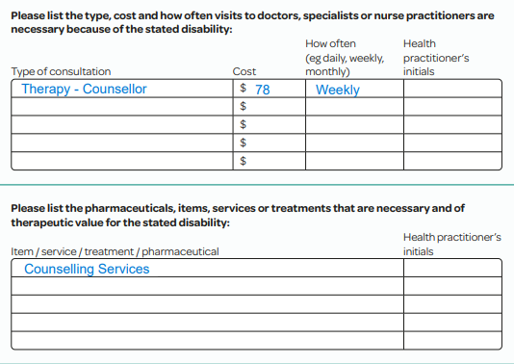
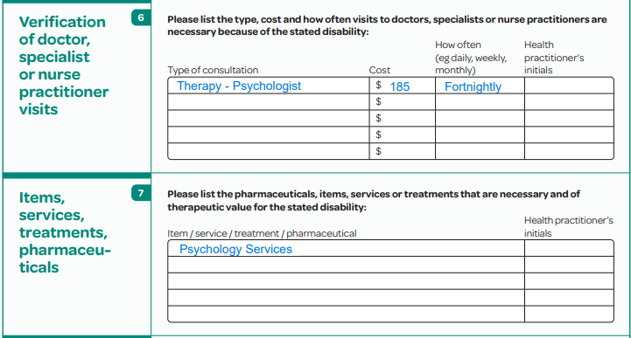
Disability Allowance Form Example:

Anxiety NZ offers several services:
- Free online ‘Empowered Programme’ https://anxiety.org.nz/empowered self-sign-up.
- Free 24/7 national 0800 Anxiety Helpline (0800 269 4389) www.anxiety.org.nz/helpline
- Free eNewsletter Sign up to our newsletter | Anxiety NZ free Resources | Anxiety NZ

Service limitations:
- Anxiety NZ may not be able to provide therapy or peer support services to all people, based on our resources at any time, space available, and the support we can offer.
- Anxiety NZ is not a crisis service, or for people currently experiencing high risk to self or others. We encourage people in crisis to visit I Need Help Now | Mental Health Foundation

Please tick if appliable and affirmative:
- Has the client consented to this referral? *

- Who is the best person to contact regarding this referral (the client / caregiver etc) ?* ______________

- Has that contact person consented to being contacted (if applicable)?

Date:
*Your first name:
*Your last name:
*Your email address:
*Your phone number:
*Your role:
*Your organisation:
*How did you hear about Anxiety NZ:
Your organisation address:
__________________________________________________

*Client's first name:
*Client's last name:
*Client's email address:
*Client’s phone number:
*Client's date of birth:
Client’s home address:
Client’s ethnicity
Client's NHI:
___________________________________________________
If the person to be contacted about this referral is not the person being referred:
Alternative contact’s name:
Alternative contact’s email address:
Alternative contact’s phone number:
Alternative contact’s relationship to person being referred:
____________________________________________________
Referral information:

- *What is the person experiencing?

- *How long has it been happening?

- Current and past medications (mental health related only)

- Have they previously engaged with mental health or psychological services? If so, please outline when and with who.

- Are they currently engaged with mental health or addiction services? If so, please provide detail.

- Does the client have a history of self-harm or suicide risk? If so, please describe in detail.

- Is the client currently at risk of harming themselves or others? If so, please describe in detail. If someone is in immediate danger, please dial 111 for ambulance assistance. Or phone your local DHB Mental Health Crisis Team (CATT Team) see local numbers here Get Mental Health Support Now - Yellow Brick Road or call the Crisis Team on 0800 800 717. As mentioned earlier, please note that Anxiety NZ is not a crisis service.

- Please comment on other forms of risk, including alcohol and other drug use, eating disorder, etc.

- Psychometric test scores and dates (BAI, BDI …) if applicable.

- *Will your client need funding to attend sessions? Yes / No / Not sure. Please see financial assistance information earlier in this form

- Which Anxiety NZ service/s are you referring to? (please tick all that apply)

□ Psychologist for assessment and therapy ($185)
□ Counsellor for counselling therapy ($78)
□ Mental Health GP for psychiatric assessment and medication monitoring ($250/$185)
*Please note our mental health GP services are for people engaging in therapy at Anxiety NZ

□ Peer Support Groups | Anxiety NZ

Please tick all Peer Groups that are of interest (if known)
□ Social Anxiety Peer Support Group – Saturdays
□ Social Anxiety Peer Support Group – Wednesdays
□ General Peer Support Group – Thursdays
□ Balance Peer Support Group – Thursdays
□ North Shore Peer Support Group - Tuesdays

Thank you for completing this referral form. We invite you to sign up for Anxiety NZ’s eNewsletter (click this link). To receive free copies of our 0800 ANXIETY Helpline flyer (or other resources) to distribute to your clients, please email us at reception@anxiety.org.nz with your name and postal address and the number of flyers you would like to receive for distribution. For softcopy resources, we invite you to visit Anxiety NZ’s website – www@anxiety.org.nz

