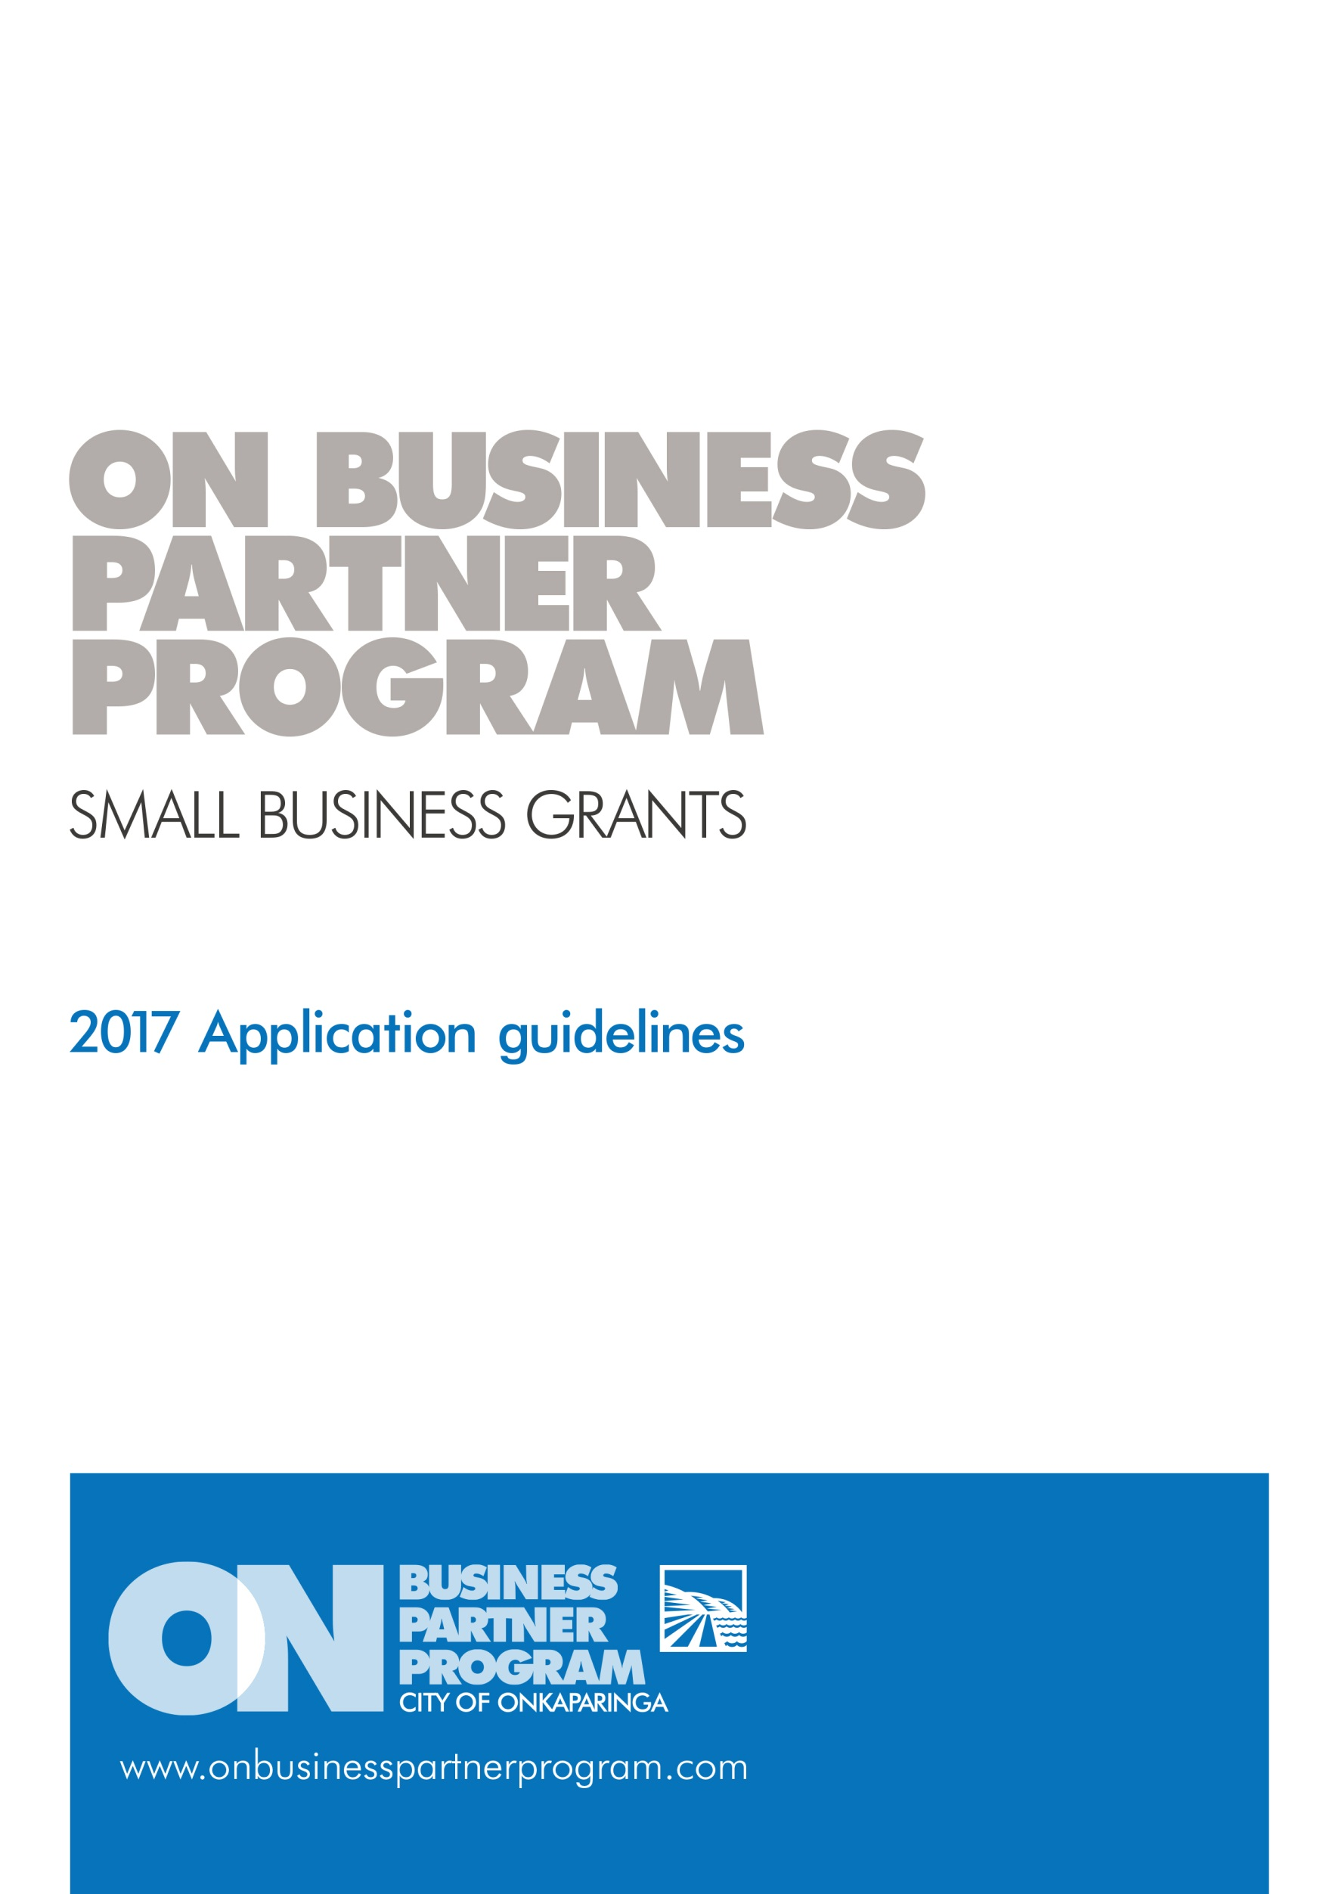

Marketing and Communication Grant Application Form

Prior to completing your application please note the following:

* We highly recommend you read the 2018 Application Guidelines.
* You may include additional attachments if there is not enough space available, if doing so please clearly mark which question the attachments relate to.
* We recommend you contact the Business Growth & Innovation team on (08) 8384 0666 to discuss your project.

|  |  |  |  |  |  |  |  |  |  |  |  |  |  |  |  |  |  |
| --- | --- | --- | --- | --- | --- | --- | --- | --- | --- | --- | --- | --- | --- | --- | --- | --- | --- |
| APPLICANT DETAILS | | | | | | | | | | | | | | | | | |
| 1 | Name of contact person | | |  | | | | | | | | | | | | | |
| 2 | Position in business | | |  | | | | | | | | | | | | | |
| 3 | Contact email | | |  | | | | | | | | | | | | | |
| 4 | Contact mobile | | |  | | | | | | | | | | | | | |
| 5 | Name of business | | |  | | | | | | | | | | | | | |
| 6 | Address of business | | |  | | | | | | | | | | | | | |
| 7 | Website/facebook | | |  | | | | | | | | | | | | | |
| 8 | Business registration number | | |  | | | | | | | | | | | | | |
| 9 | ABN/ACN number | | |  | | | | | | | | | | | | | |
| 10 | Are you registered for GST? | | | | | | | | | | | Yes | |  | | No |  |
| 11 | What are the aims and objectives of your business? (100 words) | | | | | |  | | | | | | | | | | |
| 12 | How long has your business been in operation? | | | | | |  | | | | | | | | | | |
| 13 | Please demonstrate that majority (70%) of your business is operating within the region. | | | | | |  | | | | | | | | | | |
| 14 | Does your business have current Public Liability Insurance (minimum $20 million)? | | | | | | | | | | | Yes | |  | | No |  |
| 15 | Does your business have a current Work Health and Safety Plan? | | | | | | | | | | | Yes | |  | | No |  |
| 16 | Does your business have procedures in place that ensure compliance with the Children’s Protection Act 1993 and Children’s Protection Regulations 2010? For further information please contact the Department for Education and Child Development via email at [DECDChildSafe@sa.gov.au](mailto:decdchildsafe@sa.gov.au) | | | | | | | | | | | Yes | |  | | No |  |
| PROJECT DETAILS | | | | | | | | | | | | | | | | | | |
| 17 | | Will the project/initiative take place within the City of Onkaparinga? | | | | Yes |  | No |  | If no, the project is not eligible | | | | | | | | |
| 18 | | Please describe your businesses current marketing and communication activities? (100 words) | | | |  | | | | | | | | | | | | |
| 19 | | What improvements would you like to make as part of this project/initiative? (100 words) | | | |  | | | | | | | | | | | | |
| 20 | | What has prevented you from undertaking this project/initiative previously? (100 words) | | | |  | | | | | | | | | | | | |
| 21 | | What impact would this project/initiative have on your business? (100 words) | | | |  | | | | | | | | | | | | |
| 22 | | Will this impact on your staffing levels? | | | |  | | | | | | | | | | | | |
| 23 | | Do you have a budget to contribute to ongoing marketing and communication costs? How much roughly per annum? | | | |  | | | | | | | | | | | | |
| 24 | | Please describe how you plan to spend the cash component of this grant ($1000)? | | | |  | | | | | | | | | | | | |
| 25 | | Will you engage or source local products and services? If known, who? | | | |  | | | | | | | | | | | | |
| 26 | | Do you have a business plan/marketing strategy? Please provide a copy or exert. | | | |  | | | | | | | | | | | | |
| 27 | | What impact do you believe this project will have on the economic growth of the region (if known)? | | | |  | | | | | | | | | | | | |
| 28 | | Will the project be initiated within the 2018 calendar year?  Start date:  Completion date: | | | | | | | | | Yes | |  | | No | |  | |
| 29 | | Is this your only City of Onkaparinga grant application for this funding period?  If no, what are the others? | | | | | | | | | Yes | |  | | No | |  | |
| 1. | | | | | | | | |
| 2. | | | | | | | | |
| 30 | | Has your business/organisation received a grant from council in the last two financial years?  If yes, please provide the details in the below table | | | | | | | | | Yes | |  | | No | |  | |
|  | | Year | Name of grant program | | Name of project / event funded | | | Grant amount | | | Has the grant been acquitted? | | | | | | | |
|  |  | |  | | | $ | | | Yes | |  | | No | |  | |
|  |  | |  | | | $ | | | Yes | |  | | No | |  | |
|  |  | |  | | | $ | | | Yes | |  | | No | |  | |
|  |  | |  | | | $ | | | Yes | |  | | No | |  | |
|  |  | |  | | | $ | | | Yes | |  | | No | |  | |
| 31 | | How did you hear about the ON Business Partner Program?  (eg. discovery sessions, portal, social media, brochure, business association, ON team member, word of mouth) | | | | | | | | |  | | | | | | | |
| 32 | | Do you have any further information that is relevant to your application? | | | | | | | | |  | | | | | | | |

DECLARATION

|  |  |  |  |  |
| --- | --- | --- | --- | --- |
| I have read and understand the ON Business Partner Program Grant Guidelines. | Yes |  | No |  |
| I have contacted the Business Growth & Innovation team and/or the Business Advisor to discuss my proposal. | Yes |  | No |  |
| I authorise Council to use my business name and project details for promotional purposes. | Yes |  | No |  |
| I have attached a copy of my business plan/ marketing strategy. | Yes |  | No |  |
| I accept responsibility for the implementation of this project/business initiative in line with council awarded funds and the details outlined within this application form. | Yes |  | No |  |
| I have provided a certificate of currency for Public Liability Insurance  (minimum of $10M however council may require some businesses to have up to $20M cover).  *Please note, recipients of funding will indemnify and keep indemnified the council, its employees and agents and each of them from and against all actions, costs, claims, charges and expenses whatsoever which may be brought or made to claim against them or any of them out of or in relation to the ON Business Partner Program.* | Yes |  | No |  |
| I have answered all questions in the application  (please note all questions must be answered to be eligible for the grant) | Yes |  | No |  |

|  |  |  |  |  |
| --- | --- | --- | --- | --- |
| Authorised signature of applicant | | | | |
| Name |  | | | |
| Signature |  | | | |
| Position |  | | Date: | |
| Counter signatory of Management Committee or Principal *(where applicable)* | | | | |
| Name | |  | | |
| Signature | |  | | |
| Position | |  | | Date: |

Please refer to grant guidelines for information on assessment. Note we recommend you keep a copy for your records and contact us if you have not received a receipt acknowledgment within 14 days.