Start-up Grant Application Form

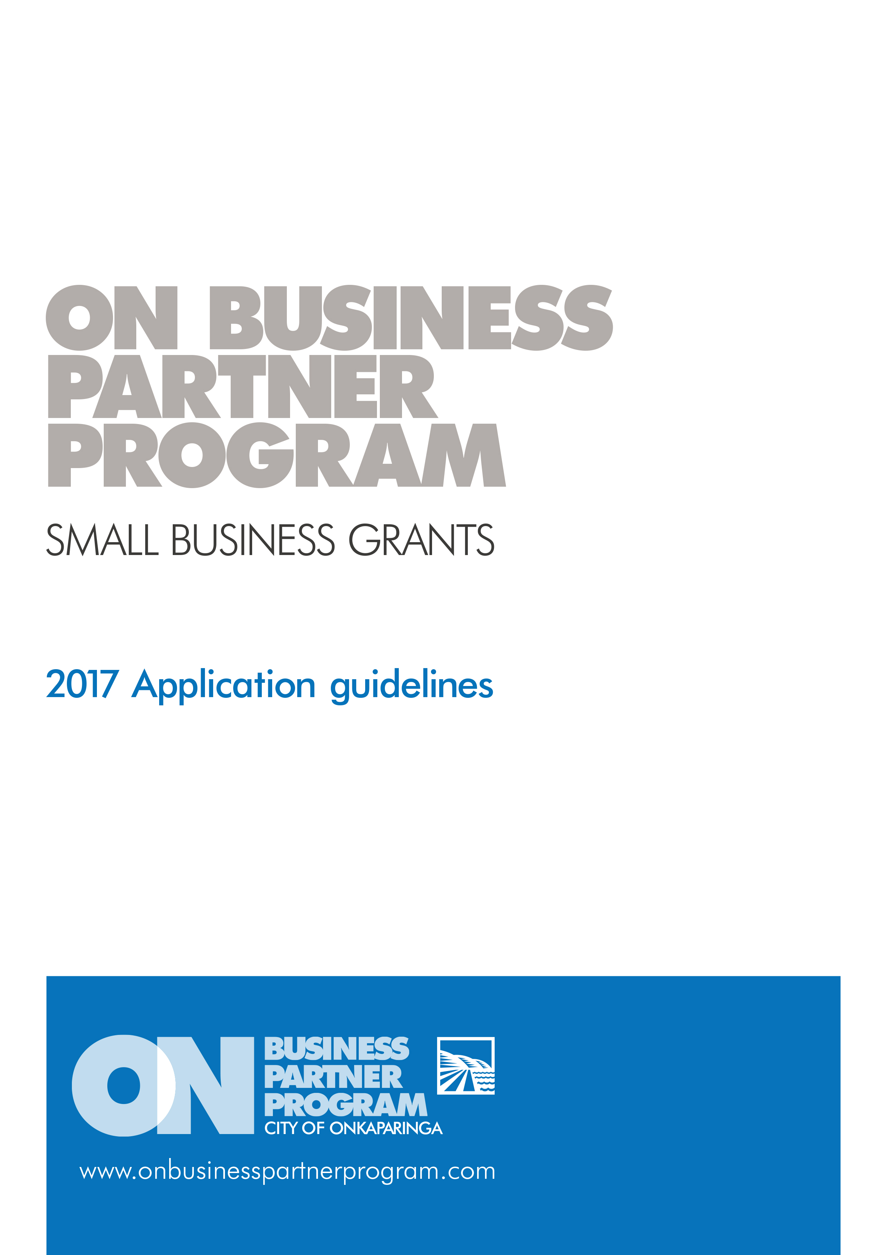

Prior to completing your application please note the following:

* We highly recommend you read the 2018 Application Guidelines.
* You may include additional attachments if there is not enough space available, if doing so please clearly mark which question the attachments relate to.
* We recommend you contact the Business Growth & Innovation team on (08) 8384 0666 to discuss your project.

|  |  |  |  |  |  |  |  |  |  |  |  |  |  |  |  |  |  |  |  |  |  |  |  |  |  |
| --- | --- | --- | --- | --- | --- | --- | --- | --- | --- | --- | --- | --- | --- | --- | --- | --- | --- | --- | --- | --- | --- | --- | --- | --- | --- |
| APPLICANT DETAILS | | | | | | | | | | | | | | | | | | | | | | | | | |
| 1 | Name of contact person | | |  | | | | | | | | | | | | | | | | | | | | | |
| 2 | Position in business | | |  | | | | | | | | | | | | | | | | | | | | | |
| 3 | Contact email | | |  | | | | | | | | | | | | | | | | | | | | | |
| 4 | Contact mobile | | |  | | | | | | | | | | | | | | | | | | | | | |
| 5 | Name of business | | |  | | | | | | | | | | | | | | | | | | | | | |
| 6 | Address of business | | |  | | | | | | | | | | | | | | | | | | | | | |
| 7 | Website/facebook | | |  | | | | | | | | | | | | | | | | | | | | | |
| 8 | Business registration number | | |  | | | | | | | | | | | | | | | | | | | | | |
| 9 | ABN/ACN Number | | |  | | | | | | | | | | | | | | | | | | | | | |
| 10 | Are you registered for GST? | | | | | | | | | | | | | | | Yes | | |  | | | No | | |  |
| 11 | Does your business have current Public Liability Insurance (minimum $20 million)? | | | | | | | | | | | | | | | Yes | | |  | | | No | | |  |
| 12 | Does your business have a current Work Health and Safety Plan? | | | | | | | | | | | | | | | Yes | | |  | | | No | | |  |
| 13 | Does your business/organisation have procedures in place that ensure compliance with the Children’s Protection Act 1993 and Children’s Protection Regulations 2010? For further information please contact the Department for Education and Child Development via email at [DECDChildSafe@sa.gov.au](mailto:decdchildsafe@sa.gov.au) | | | | | | | | | | | | | | | Yes | | |  | | | No | | |  |
| PROJECT DETAILS | | | | | | | | | | | | | | | | | | | | | | | | | |
| 14 | | Will the project/ initiative take place within the City of Onkaparinga? | | | Yes | |  | No |  | | | If no, the project is not eligible | | | | | | | | | | | | | |
| 15 | | Please demonstrate that majority (70%) of your business is operating within the region. | | |  | | | | | | | | | | | | | | | | | | | | |
| 16 | | What is the location of the project/ business site? | | |  | | | | | | | | | | | | | | | | | | | | |
| 17 | | Name of project/ initiative | | |  | | | | | | | | | | | | | | | | | | | | |
| 18 | | Please define what stage of start-up your business is? | | | | | | Transition of hobby/market business into start-up  Start-up of new business  Expansion of a micro business | | | | | | | | | | | | | | | | | |
| 19 | | Description of the project/ business initiative for promotion (100 words) | | | | | |  | | | | | | | | | | | | | | | | | |
| 20 | | Is your business already in operation?  If yes, please provide further information  (When business was registered & commenced  operating) | | | | | | Yes | | |  | | | | No | | | | |  | | | | | |
|  | | | | | | | | | | | | | | | | | |
| 21 | | Please specify the proposed purpose of funds if awarded. | | | | | |  | | | | | | | | | | | | | | | | | |
| 22 | | How would these funds impact your business (100 words) | | | | | |  | | | | | | | | | | | | | | | | | |
| 23 | | How will success of your initiative or start-up business be measured? | | | | | |  | | | | | | | | | | | | | | | | | |
| 24 | | Do you have a business plan and/ or project plan? Please provide a copy or exert. | | | | | |  | | | | | | | | | | | | | | | | | |
| 25 | | What measures do you have to ensure business sustainability? (100 words) | | | | | |  | | | | | | | | | | | | | | | | | |
| 26 | | Do you have support from other individuals/groups/organisations to deliver this initiative? | | | | | |  | | | | | | | | | | | | | | | | | |
| 27 | | Will you engage or source local products and services to develop or deliver this project? Provide details. | | | | | |  | | | | | | | | | | | | | | | | | |
| 28 | | What impact do you believe this project will have on the economic growth of the region (if known)? | | | | | |  | | | | | | | | | | | | | | | | | |
| 29 | | Does your project require any other council, state or federal government approvals? | | | | | | | | | | | Yes | | | |  | | | | No | | |  | |
| 30 | | If yes, what are they and have the approvals been obtained?  Note: If your project requires any form of approval, the project will not commence until we have received confirmation of the approval. | | | | | |  | | | | | | | | | | | | | | | | | |
| 31 | | What is the total cost of the start-up? | | | | | | | | | | | | $ | | | | | | | | | | | |
| 32 | | What is the total grant amount you are seeking from council? | | | | | | | | | | | | $ | | | | | | | | | | | |
| 33 | | What is the total value of your contribution to the project/business? | | | | | | | | | | | | $ | | | | | | | | | | | |
| 34 | | Will the project/business initiative be initiated within the 2018 calendar year? If so when?  Start date:  Completion date: | | | | | | | | | | | | Yes | | | |  | | | No | |  | | |
| 35 | | Is this your only City of Onkaparinga grant application for this funding period?  If no, what are the others? | | | | | | | | | | | | Yes | | | |  | | | No | |  | | |
| 1. | | | | | | | | | | | |
| 2. | | | | | | | | | | | |
| 36 | | Has your business received a grant from council in the last two financial years?  If yes, please provide the details in the below table | | | | | | | | | | | | Yes | | | |  | | | No | |  | | |
|  | | Year | Name of grant program | | | Name of project / event funded | | | | Grant amount | | | | Has the grant been acquitted? | | | | | | | | | | | |
|  |  | | |  | | | | $ | | | | Yes | | | |  | | | No | |  | | |
|  |  | | |  | | | | $ | | | | Yes | | | |  | | | No | |  | | |
|  |  | | |  | | | | $ | | | | Yes | | | |  | | | No | |  | | |
|  |  | | |  | | | | $ | | | | Yes | | | |  | | | No | |  | | |
| 37 | | How did you hear about the ON Business Partner Program?  (eg. discovery sessions, portal, social media, brochure, business association, ON team member, word of mouth) | | | |  | | | | | | | | | | | | | | | | | | | |
| 38 | | Do you have any further information that is relevant to your application? | | | |  | | | | | | | | | | | | | | | | | | | |

DECLARATION

|  |  |  |  |  |
| --- | --- | --- | --- | --- |
| I have read and understand the ON Business Partner Program Grant Guidelines. | Yes |  | No |  |
| I have contacted the Business Growth and Innovation team and/or the Business Advisor to discuss my proposal. | Yes |  | No |  |
| I authorise Council to use my business name and project details for promotional purposes. | Yes |  | No |  |
| I have attached a copy of my business plan. | Yes |  | No |  |
| I accept responsibility for the implementation of this project/business initiative in line with council awarded funds and the details outlined within this application form. | Yes |  | No |  |
| I have provided a certificate of currency for Public Liability Insurance  (minimum of $10M however council may require some businesses to have up to $20M cover).  *Please note, recipients of funding will indemnify and keep indemnified the council, its employees and agents and each of them from and against all actions, costs, claims, charges and expenses whatsoever which may be brought or made to claim against them or any of them out of or in relation to the ON Business Partner Program.* | Yes |  | No |  |
| I have answered all questions in the application.  (please note all questions must be answered to be eligible for the grant) | Yes |  | No |  |

|  |  |  |  |  |
| --- | --- | --- | --- | --- |
| Authorised signature of applicant | | | | |
| Name |  | | | |
| Signature |  | | | |
| Position |  | | Date: | |
| Counter signatory of Management Committee or Principal *(where applicable)* | | | | |
| Name | |  | | |
| Signature | |  | | |
| Position | |  | | Date: |

Please refer to grant guidelines for information on assessment. Note we recommend you keep a copy for your records and contact us if you have not received a receipt acknowledgment within 14 days.