Herbert River Improvement Trust

ANNUAL REPORT 2024–25

Contents
1. General Information 4
1.1. Introductory Information 4
1.2. Role and main functions of the Trust 4
2. Non-financial performance 5
2.1. Government’s objectives for the community 5
2.2. Other whole-of-government plans / specific initiatives 5
2.3. Objectives and performance indicators 6
2.4. Service areas and service standards 6
2.5. Summary of operations 6
2.5.1. Administration 6
2.5.2. Review of operations 6
2.5.3. Capital works 7
2.5.4. Review of proposed forward operations 8
2.5.5. Improvement Notices 9
3. Financial performance 9
3.1. Summary of financial performance 9
3.2. Breakdown of funds spent on trust assets 10
4. Governance – management and structure 10
4.1. Organisational structure 10
4.2. Executive management 11
4.3. Meetings and remuneration 11
4.4. Public Sector Ethics 11
4.5. Human Rights 11
5. Governance – risk management and accountability 12
5.1. Risk management 12
5.2. Audit committee 12
5.3. Internal audit 12
5.4. External scrutiny 12
5.5. Information systems and recordkeeping 12
6. Governance – human resources 12
6.1. Strategic workforce planning and performance 12
6.2. Early retirement, redundancy and retrenchment 13
7. Open Data 13
7.1. Consultancies 13
7.2. Overseas travel 13
7.3. Queensland Language Services Policy (QLSP) 13
7.4. Charter of Victims’ Rights 13
8. Financial statements 13
8.1. Remuneration Disclosures 14
Attachment 1
BOARD REMUNERATION DETAILS 2024–25
Attachment 2
PRUDENTIAL ASSESSMENT QUESTIONNAIRE
Attachment 3
ENTITY INDEBTEDNESS STATEMENT
Attachment 4
Compliance Checklist
Attachment 5
Photos of Trust Projects Delivered in 2024–25

General Information

Introductory Information
The work of the Herbert River Improvement Trust (the trust) delivers outcomes with benefits for the Commonwealth, State and Local Governments. These outcomes include flood mitigation, restoration of flood damage and timely preventative removal of debris from water courses and drainage lines after cyclones and extreme rainfall events and associated flooding. The work of the trust includes riverbank restoration, stream re-alignment and revegetation of riverbanks, all of which contribute to water quality improvement for the downstream environment. These outcomes help address the current government objective to protect and enhance our natural environment through flood mitigation and natural resource management for the Hinchinbrook community.

Address of principal place of business: Hinchinbrook Shire Council, 25 Lannercost Street, Ingham Qld 4850
Postal address: PO Box 162, Ingham Qld 4850
Contact number: 0408 771 678
Contact email: admin@hrit.com.au
Contact officer: Ms Leigh Carr, Secretary

A copy of this report is available on request from the trust. Information from this report, along with the trust’s 2024–25 financial statements, will be used by the Department of Local Government, Water and Volunteers (DLGWV) to prepare a consolidated annual report for all Queensland river improvement trusts. A copy of the consolidated annual report will be made available on DLGWV’s website.

Role and main functions of the Trust
The Herbert River Improvement Trust is a statutory body constituted under the River Improvement Trust Act 1940 and was constituted by Order-in-Council dated 8 May 1942.
The trust’s main objectives have been to mitigate flooding for both urban and rural communities in the Hinchinbrook Shire, to protect and improve the condition of the rivers in the area, to repair flood damage, to prevent future flood damage, and to protect State and Local Government and rural industry infrastructure.
The Herbert River rises in the Atherton Tablelands before entering the Hinchinbrook Shire Local Government Area above Abergowrie, one hundred (100) kilometres from the coast. Major tributaries, Gowrie Creek and the Stone River, join the river upstream of Ingham. The Herbert River delta downstream of Ingham, discharges into Hinchinbrook Passage. The delta consists of the Herbert River, Anabranch, Gairloch and the Halifax Washaway with overflows into the Seymour River, Trebonne Creek, Palm Creek and Lagoon Creek. The trust’s area also extends forty (40) kilometres south of Ingham with Cattle and Frances Creeks, Waterview and Waterfall Creeks and others flowing directly to the coast.
Ingham is the main business centre and is located in the central area of an extensive flood plain that is mainly devoted to sugar cane production and grazing. Smaller communities surround Ingham in the Hinchinbrook shire. Since its inception, the trust has constructed river improvement and bank stabilisation works at over five hundred (500) sites in the Hinchinbrook Shire. Major flood mitigation works including the Ripple Creek and Catherina Creek floodgates, the Foresthome flood channel and the Halifax Town Levee have also been constructed over the past forty (40) years.

These bank stabilisation and flood mitigation works, again played no small part in helping to protect the urban and rural communities, the condition of the rivers and the State and Local Government and industry infrastructure during the recent flooding event in the Lower Herbert and Stone Rivers in early February 2025. The 2025 flooding event reached levels above the major 1967 flood event in areas of the Lower Herbert and Stone Rivers, and as the rainfall was most intense in coastal areas, flood levels in the more inland Abergowrie area were below the 1967 levels. The 1967 flood is regarded as having been about a major 1 in 40 recurrence interval flood event.

Both the Commonwealth and State Governments have continued to promote the need for on ground river improvement works to reduce bank erosion and the movement of sediment downstream to improve water quality in the inner Great Barrier Reef lagoon.

The trust remains well placed to play an effective role in the construction of the ongoing ground works required to achieve the above-mentioned objectives.

Non-financial performance

Government’s objectives for the community
The trust provides services that meet the government’s objective of:
- A better lifestyle through a stronger economy: Growing our economy to drive down the cost of living and give Queenslanders a better lifestyle and a place to call home.
- A plan for Queensland’s future: Planning for Queensland’s future.

The trust meets these objectives by:
- Ensuring sustainable management of natural resources.
- Water quality improvement.
- Promoting strategies and on ground works that improve the resilience of the community and rural industry and the condition of the rivers and their ability to recover from natural disasters.
- Ensuring the on ground works also contribute to environmental recovery from a natural disaster.
- Playing a major role in the recovery from natural disasters and particularly in the case of the community and industries of the Hinchinbrook Shire in 2025, recovery from the major flooding event that occurred in February.

The Government’s objectives for the community can be found at:
https://www.qld.gov.au/about/how-government-works/objectives-for-the-community

Other whole-of-government plans / specific initiatives
Where applicable, the trust provides services that are consistent with whole-of-government plans and specific initiatives addressing issues for Queensland.

Objectives and performance indicators
The trust’s objectives, as listed in its 2024–28 strategic plan, are:
- Strategic partnerships
- Improve riverine function and resilience
- Reduce flood risk and maintain essential assets
- Community engagement.

The trust measures its achievement of these objectives by using key performance indicators, consistent with the methods outlined in the 2024-28 strategic plan. Details of the key performance indicators are available within the strategic plan which is available on the Hinchinbrook Shire Council website.

The trust has had to review its priorities since the recent severe 2025 flood event. The operational review is ongoing as State Government funding assistance is sought. The trust has a close relationship with landholders, rural industry in the Hinchinbrook Shire, and State Agencies and values their feedback.

Service areas and service standards
This entity is self-funding and therefore funding ‘service areas’ and ‘service standards’ measures are not applicable.

Summary of operations

Administration
No significant changes in administration policy were implemented in 2024-25.

Review of operations
2025 Flooding Event

The February 2025 flooding event saw extensive inundation of urban and rural lands from the Herbert River, Stone River and the creeks to the south of Ingham. Much of the town of Ingham was inundated, including businesses and residences, with many having still not recovered. Roads were flooded and power was cut to most of the urban and rural areas for about two (2) weeks. Urban and rural drainage infrastructure was also flooded.

At the direction of the State Recovery Co-ordinator, the trust reported on flood damage to its essential public assets and inspected more than seventy (70) urban and rural properties with river and creek frontages, where new bank erosion and debris problems had been caused by the flood. The trust reported an estimated cost of at least $7.2M for the repair of the river and bank damage at those properties.

While some of the properties’ owners might be able to access Queensland Rural and Industry Development Authority (QRIDA) recovery grant funding to repair bank and farm headland damage, most will not because they have extensive flood damage to cropping and farming operations that they need to address in the first instance.
Most of these landholders will be looking to the trust for assistance with bank and farm headland damage in 2025-26. The trusts 2025-26 operations will have to consider this urban and rural need for assistance in the community. The recovery is expected to go on for several years.

The trust reported that there was little flood damage to its own extensive bank stabilisation works, its flood mitigation infrastructure at Halifax (town levee) and the major Ripple Creek and Catherina Creek flood gates. This infrastructure operated well during the flood event.

2025 Significant Undertakings under the 2024-25 Annual Works Program

Two (2) important projects that were in progress at the end of the 2023-24 financial year which were completed prior to the 2025 flood event were:

• Ripple Creek and Catherina Creek flood gates. After a successful project funding application under the NQ Telecommunications and Energy Improvement Grants Program (QRIDA/trust funded project), an upgrade of the Catherina Creek and Ripple Creek flood gates’ control systems was completed. This now allows remote operation of the flood gates in times of flooding when road access to them, at the Herbert River, is impassible. The benefit of this remote operation was evident for the first time during the 2025 flood event.

• Lower Herbert River flood mitigation. A stage of the DRF/QRA/trust funded project to improve the river channel flood flow capacity at Cordelia and Macknade was completed. It involved sand island reprofiling, and the removal of regrowth vegetation from the riverbed. The benefit of this improvement to flood flow capacity and the delay in any threat of overbank flooding of the river’s natural levees was also noticeable in the 2025 flood event (Attachment 5). The longer-term result for Cordelia and Macknade will be less frequent flooding of the towns and cane growing areas.

Capital works
Capital works and major maintenance projects completed in 2024-25 are summarised as follows:

Location | Type of works | Cause and effect
Ripple Creek and Catherina Creek flood gates at the junctions of Ripple Creek and Catherina Creek with the Herbert River at Bemerside and Cordelia respectively.  Major flood gate structures that, when closed, prevent the Herbert River back flowing out into cane farms in the Ripple Creek and Foresthome areas. | Flood mitigation. NQ Telecommunications and Energy Improvement Grants Program (QRIDA/trust funded).  Electronic instrument upgrade that will now allow remote operation by phone. | Remote operation of the flood gates in times when Herbert River flooding prevents access by road to the sites and control panels.  This will avoid the need to have to use nearby residents to try and raise or lower the flood gates.  Works Completed.
Lower Herbert River at Cordelia and Macknade.  Upstream of the natural Halifax Washaway that takes some of the upper stage floodwaters to lower wetlands and the coast.  Upstream of the town of Halifax. | Flood mitigation. A DRF/QRA/trust funded project to improve the river channel flood flow capacity at Cordelia and Macknade. Sand island reprofiling and the removal of regrowth vegetation from the riverbed. | Gradual build-up of Castorina Island in the bed of the river has continued to reduce the capacity of the river channel at that location.  Reprofiling that buildup and removal of the vegetation that had established on it, has greatly improved river channel capacity.  Stage completed.
2025 flood damage restoration.  Herbert River - Halifax levee in town of Halifax. | Work to repair flood damage from the February 2025 flood event. Cavity under concrete section of levee behind houses was filled with grout and select fill. | Prevent worsening of cavity in bank under the levee. Prevent failure of the levee and water entering town streets.  Restoration work completed.
Ripple Creek flood gate structure restoration. | Work to reinforce 3.3m diameter plate steel pipes with PVC and concrete liners (Attachment 5). | Structure constructed in 1988-89.  Steel plate pipes corroded and collapsing.  An important flood mitigation structure that helps protect cane land and the Bruce Highway from flooding.  Restoration work completed.
Investigations:  - Herbert River  - Halifax Washaway. | Vegetation removal in flood flow channel away from the river through the natural washaway. | Investigation and trial before final design of improved flood water capacity done to help reduce flooding of the State Government’s Ingham -Lucinda Road and cane railway to Lucinda Sugar Terminal.  Investigations ongoing.
Maintenance of flood mitigation infrastructure.  Various sites - Halifax town levee, major flood gates and flood channels in the Lower Herbert. | Spraying, mowing and management of regrowth vegetation. | Maintenance work needed to ensure reliable operation of flood mitigation and flood control infrastructure for the community.

Review of proposed forward operations
The 2025 weather event and the damage the flood caused in the rivers and creeks of the Hinchinbrook Shire will be the main influence in the formulation of the trust’s 2025-26 Annual Works Program and its forward operations as the area tries to recover.

As mentioned in Section 2.5.2, the trust has assessed bank erosion and vegetation loss at some seventy (70) rural properties that front rivers and creeks, and some in urban areas of Ingham, Trebonne, Cordelia and Macknade. Inspections and assessments were made following reports of the damage from landholders.

The preliminary estimate of the cost of repairs as presented to the State Government by the trust was at least $7.2M. Site estimates to repair damage varied from $16,000 to over $800,000. Over thirty (30) of the sites were assessed as needing repairs that will cost over $75,000.

The trust’s current revenue will not be sufficient to cover the cost of repairs of this bank and vegetation damage. In fact, it will fall well short of what is required. Submissions have been made for assistance to the State Government through the State’s appointed Recovery Co-ordinator for the 2025 flooding event. Advice regarding funding assistance from the State Government is awaited. Without it the trust will find it difficult to formulate works programs in the immediate future that meet the needs of the community.

The trust continues to maintain a working relationship with the Hinchinbrook Shire Council and the State Council of River Trusts Queensland Inc., which is vital to ensuring the revenue stream of the trust is sufficient to meet its annual capital works and maintenance obligations as expected by the local community. The trust also ensures it has sufficient liquid funds to cover any unforeseen and urgent expenditure.

The trust’s ongoing responsibility to maintain its flood mitigation infrastructure to ensure the reliable operation of that infrastructure in the next wet season must continue. It also needs to continue to maintain the condition of particularly the Herbert and Stone River channels. It may also continue its support for the Lower Herbert Water Management Authority’s (LHWMA) operations whose drainage systems outfall into the trust’s flood channels.

The trust may also be called on again to provide technical assistance to the State’s QRIDA, where landholders repair works involve headlands on the river and creek banks to restore their farming operations.

The trust does not propose to use loan borrowings to fund any capital works in 2024–25.

Improvement Notices
Under section 11A of the RIT Act, a trust may issue a notice prohibiting a person from doing or allowing any act, matter, or thing which the trust believes will cause, or contribute to, damage to any streambank in its benefited area, or is likely to cause such damage in the future. If damage has already occurred, the notice may require the person to remedy the damage and restore the surrounding area.
An improvement notice is registered as an encumbrance on the title to land affected by the improvement notice. This encumbrance remains in place until such time as the notice is complied with in full. Failure to comply with a notice is an offence for which a person may be prosecuted.
The trust issued no improvement notices during the 2024–25 financial year.

Financial performance

Summary of financial performance
Funding received by the trust during the 2024–25 year comprised of:

Funding source | Received from | Amount
Precept  Grant  Grant  Landholders | Hinchinbrook Shire Council  QRIDA  QRA  QRIDA | $250 000  $22 860  $123 362  $7 500

Expenditure by the trust during the 2024–25 year comprised of:

Expense | Amount
Administration  2025 Flooding - Rapid Assessments  Maintenance  Capital works | $98 641  $47 754  $73 363  $87 627

The flooding in February 2025 saw the trust complete rapid assessments, with the trust incurring $47 754, as noted in the summary table above, which influenced the trust’s financial position during the 2024–25 reporting period.

The trust has the ability to service its debts for the 2024–25 financial year and maintained its debt free status during the period. As the trust made no borrowings during the year, it has no outstanding loans as at 30 June 2025.

A completed Prudential Assessment Questionnaire (Attachment 2) and an Entity Indebtedness Statement (Attachment 3) are attached to this report.

Breakdown of funds spent on trust assets
Expenditure on trust assets during the 2024–25 year comprised of:

New capital works completed | Repairs due to flood | Restoration of assets (excl. flood) | Maintenance work on assets
$86 669 | $12 605 |  | $50 193

Governance – management and structure

Organisational structure
Composition of the trust:
- As per the River Improvement Trust Act 1940, the trust’s membership is made up of two councillors of the constituent local government (LG), Hinchinbrook Shire Council, and up to three persons (known as community representative members - CRMs) appointed by the Minister for Regional Development and Manufacturing and Minister for Water.
- The trust members nominate one of the existing members to be elected as chairperson.

Membership at 30 June 2025:
Name | Position | Current term dates | First appointed
Mr WG Skinner | Chairperson and Member (CRM) | 1 July 2024 to 30 June 2025 | 23 April 2024
Mr RA Bosworth | Member (CRM) | 1 July 2024 to 30 June 2025 | 11 April 2013
Ms TL Olsen | Member (CRM) | 1 July 2024 to 30 June 2025 | 23 April 2024
Cr AD Carr | Deputy Chairperson and  Member (LG) | 1 July 2024 to 30 June 2025 | 23 April 2024
Cr KS Milton | Member (LG) | 1 July 2024 to 30 June 2025 | 23 April 2024

No changes to membership have occurred during the 2024-25 reporting period.

Executive management
The trust is self-managed.

Meetings and remuneration
The trust held a total of eleven (11) meetings during the reporting period. Meetings were held on the following dates:
- 04/07/2024
- 15/08/2024
- 05/09/2024
- 03/10/2024
- 04/11/2024
- 05/12/2024
- 20/02/2025
- 06/03/2025
- 02/04/2025
- 01/05/2025
- 05/06/2025

The 2024–25 Annual State Conference of River Trusts Queensland was hosted by Stanthorpe Shire River Improvement Trust at Stanthorpe on 6-8 November 2024. The following trust representatives attended:
- Mr RA Bosworth
- Cr AD Carr
- Ms LF Carr (secretary)

Further information about the trust’s meetings and remuneration for the 2024–25 reporting period are outlined in Attachment 1.

Public Sector Ethics
When appointed, members of the trust are reminded of their obligations to the trust and are given access to the publication, Welcome Aboard: A Guide for Members of Queensland Government Boards, Committees and Statutory Authorities.

The trust has in place a Code of Conduct approved on 4 April 2019 and has complied with the Public Sector Ethics Act 1994.

Human Rights
The Human Rights Act 2019 (HR Act) is an Act to protect and promote human rights, to help build a culture in the Queensland public sector that respects and promotes human rights and to help promote a dialogue about the nature, meaning and scope of human rights. In accordance with section 97 of the HR Act, the trust is committed to:
- giving proper consideration to human rights in decision making and in the development of policy, programs, procedures, practices or services undertaken, and
- acting compatibly with the human rights of individuals in everyday operations and interactions with the community.

Actions taken by the trust in 2024–25 to further the objectives of the HR Act:
- Nil

The trust received no human rights complaints in 2024–25.

The trust undertook the following reviews for compatibility with human rights in 2024–25:
- Nil

Governance – risk management and accountability

Risk management
Refer to the Prudential Assessment Questionnaire provided at Attachment 2.

Audit committee
The trust undertakes the role of the audit committee ensuring the appropriate accounting standards are used and that there is proper examination of the trust’s financial arrangements.

Internal audit
When required, the trust undertakes internal audit functions. There is nothing in this regard to report for the 2024–25 reporting period.

External scrutiny
The trust has not been reviewed by any external entities (apart from the Auditor-General’s report on the financial statements) during the 2024–25 reporting period.

Information systems and recordkeeping
The trust has complied with all its obligations under the Public Records Act 2023, including making, managing, keeping and preserving public records.

The trust did not lose any records during 2024–25.

Governance – human resources

Strategic workforce planning and performance
The trust employed one (1) staff member during the 2024–25 financial year. There were no resignations and no retirements during the 2024–25 financial year.

Staff received the following training:
- Nil

The trust understands that people from different backgrounds bring unique contributions and perspectives and works in collaboration with DLGWV to develop strategies to attract and retain diverse and capable membership.

Early retirement, redundancy and retrenchment
No redundancy, early retirement or retrenchment packages were paid during the 2024–25 reporting period.

Open Data

Consultancies
The trust incurred the following consultancy costs during 2024–25 financial year:

Consultancy category | Expenditure (excluding GST)
Consultants - Professional/technical | $82 866
Total cost of consultancies | $82 866

Overseas travel
No overseas travel on trust business was undertaken by members of the trust during the 2024–25 financial year.

Queensland Language Services Policy (QLSP)
No Queensland language (interpreter) services were accessed by members of the trust during the 2024–25 financial year.

Charter of Victims’ Rights

No complaints related to general rights and rights relating to the criminal justice system under the victim’s charter were received by the trust during the 2024–25 financial year.

Financial statements

In accordance with the Financial Accountability Act 2009 and the Financial and Performance Management Standard 2019, general purpose financial statements have been prepared by the trust, certified by the chairperson and secretary, and submitted to the Queensland Audit Office for audit.

A copy of the auditor’s report will be submitted to the Department of Local Government, Water and Volunteers as soon as it is available.

Remuneration Disclosures
Approved remuneration fees for river improvement trusts as set on 28 July 2014 by the former Minister for Natural Resources and Mines are as follows:
 | Meetings of more than four hours duration | Meetings of four hours or less duration
Chairperson | $390 | $195
Member | $300 | $150

Total remuneration paid by the trust to members in 2024–25 financial year:
Member | Member fees | Out-of-pocket expenses
Mr WG Skinner | $4 875.00 | $444.00
Cr AD Carr | $3 645.00 | $588.30
Ms TL Olsen | $2 550.00 | $1 214.80
Mr RA Bosworth | $2 700.00 | $495.80
Cr KS Milton | $3 450.00 | $577.20

Further information on remuneration and meetings is provided at Attachment 1.

Mr Wallis G Skinner
Chairperson
Herbert River Improvement Trust

Signature: 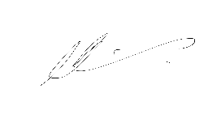

Date: 7 August 2025

Attachment 1

BOARD REMUNERATION DETAILS 2024–25

Herbert River Improvement Trust
Act or instrument | River Improvement Trust Act 1940
Function | To protect and improve rivers, repair and prevent damage to rivers and prevent or mitigate flooding of land by riverine floods. The primary role of a trust is to plan, design, finance, undertake and maintain stream improvement works for the benefit of Commonwealth, State and Local Government assets, the community and rural industry within its river improvement area.
Achievements | Remote operation of the Catherina and Ripple Creeks’ flood gates, reprofiling of sand build up and vegetation removal on Castorina sand island in the lower Herbert River, Ripple Creek flood gate structure restoration and 2025 flood damage restoration - Halifax levee, in the town of Halifax.
Financial reporting | Not exempted from audit by the Auditor-General.  Transactions of the entity are accounted for in the financial statements, which are audited by distance audit procedures.
Remuneration
Position | Name | Meetings attended  (insert number) |  | Approved sessional or daily fee  (half daily fee paid if under 4 hrs) | Approved  sub-committee fees (if applicable) | Actual fees received  (2024–25)
Chair  Member – CRM¹ | Wallis G Skinner | over  4 hrs | 7 | $390 | N/A | $4,875
Chair  Member – CRM¹ | Wallis G Skinner | under  4 hrs | 3 | $195 | N/A | $4,875
Deputy Chair  Member – LGA² | Cr Andrew D Carr | over  4 hrs | 7 | $300 | N/A | $3,645
Deputy Chair  Member – LGA² | Cr Andrew D Carr | under  4 hrs | 4 | $150 | N/A | $3,645
Member – CRM | Tania L Olsen | over  4 hrs | 6 | $300 | N/A | $2,550
Member – CRM | Tania L Olsen | under  4 hrs | 5 | $150 | N/A | $2,550
Member – CRM | Robert A Bosworth | over  4 hrs | 7 | $300 | N/A | $2,700
Member – CRM | Robert A Bosworth | under  4 hrs | 2 | $150 | N/A | $2,700
Member – LGA | Cr Kathrine S Milton | over  4 hrs | 7 | $300 | N/A | $3,450
Member – LGA | Cr Kathrine S Milton | under  4 hrs | 2 | $150 | N/A | $3,450
No. scheduled meetings | The trust held a total of eleven (11) meetings during the reporting period. Meetings were held on the following dates:  - 04/07/2024  - 15/08/2024  - 05/09/2024  - 03/10/2024  - 04/11/2024  - 05/12/2024  - 20/02/2025  - 06/03/2025  - 02/04/2025  - 01/05/2025  - 05/06/2025
Total out of pocket expenses³ | $3 320.10
1. CRM = Community Representative Member – appointed by the Minister for Regional Development and Minister for Water
2. LGA = Local Government Appointee – Councillor appointed by the local government
3. Chairs and members of government bodies (whether they are paid or unpaid) are eligible to be reimbursed for reasonable out-of-pocket expenses including domestic travel, accommodation costs, motor vehicle allowances and meals. The allowances, as approved by the Governor in Council are set out in attachment 3 of the Remuneration Procedures for part-time Chairs and members of Queensland Government bodies.

Attachment 2

PRUDENTIAL ASSESSMENT QUESTIONNAIRE
Annual Reporting 2024–25

Name of entity: Herbert River Improvement Trust

No. | Question | Response  (Yes/No/Other)
1 | Has the entity developed and attached its budget for the next financial year? | ☒ Yes  ☐ No, move to question 3
2 | Was there a material variation of actual results recorded in the financial statements compared with the budget forecasts made at the beginning of the financial year? | ☐ Yes, please state reason/s why  ☒ No  Comments:
3 | How frequently did the entity prepare bank reconciliation statements during the financial year? | ☐ Monthly  ☐ Quarterly  ☐ Biannually  ☒ Annually  ☐ Other  ☐ Not prepared, please state why  Comments:
4 | An entity requires the Treasurer’s approval to operate an account with an overdraft facility.
4 | - At any stage during the financial year was the entity overdrawn at the bank? | ☐ Yes, please state reason/s why  ☒ No, move to question 5  Comments:
4 | - Does the entity need to seek the Treasurer’s approval? | ☐ Yes  ☐ No
5 | Loan borrowings
5 | - Did the entity draw down any loan borrowings during the financial year? | ☐ Yes, from  ☐ Queensland Treasury Corporation (QTC)  ☐ Other, move to question 5c  ☒ No, move to question 6
5 | - Did the entity meet all its loan repayments on time? | ☐ Yes, please provide the following detail:  Date approved: _________________  Terms: _________________  Total repayments ($) _________________  ☐ No, please state reason/s why  Comments:
5 | - If debt was draw down from a provider other than QTC, was it approved by DLGWV? | ☐ Yes  ☐ No
6 | Risk management assessment
6 | - Considering the nature and scope of its operations and its size, has the entity undertaken a risk management assessment to ensure the entity is protected from unacceptable costs or losses? | ☐ Yes  ☒ No  Reason: Low risk identified – no requirement for formal plans.
6 | - Has the entity acted or put plans in place to avoid, minimise, control and manage any identified financial risks? | ☐ Yes (refer to section 5.1 of the Annual Report for details of actions taken and/or key elements of these plans)  ☒ No
7 | Public liability and professional indemnity insurance
7 | - Does the entity have current cover for public liability and professional indemnity insurance? | ☒ Yes  ☐ No, move to question 7
7 | - Are the entity’s insurance premiums paid up to date? | ☒ Yes  ☐ No, please state reason/s why  Comments:
7 | - Is the current level of insurance cover appropriate? | ☒ Yes  ☐ No
7 | - Has the entity recently reviewed the adequacy of its insurance cover?  (A copy of current policy may be requested) | ☐ Yes, please provide  Date last reviewed: ________________  ☒ No
8 | Accrual Accounting
8 | - Does your entity have a total gross revenue of $1,000,000 or more? | ☐ Yes  ☒ No, you have completed question 8
8 | - For how many years in succession has your entity’s gross revenue exceeded $1,000,000? | ☐ 1-2  ☐ 3-5  ☐ 6-10  ☐ 11+
8 | - Are there any specific and exceptional factors that account for gross revenue exceeding $1,000,000 that are unlikely to occur on an ongoing basis in future years?  For example a special two-year subsidy program that is not expected to be ongoing. | ☐ Yes, please outline the nature of these exceptional revenue factors and state when these factors will no longer have an observable effect on gross revenue in your balance sheets.  ☐ No, you have completed question 8  Comments:

Mr Wallis G Skinner
Chairperson
Herbert River Improvement Trust

Signature: Date: 7 August 2025

Attachment 3

ENTITY INDEBTEDNESS STATEMENT
Annual Reporting 2024–25

Herbert River Improvement Trust

Does the entity have outstanding loans?

(Indicate with a tick: ) Yes please respond to the below questions.

No no further action required for this form.

1 | The term of the loan when it was taken out and when final payment is due:
2 | The level of debt at the beginning of the current financial year (1 July):
3 | The level of debt at the close of the current financial year (30 June):
4 | State how the debt will be serviced in the coming financial year:
5 | How the payments will be split between interest and principal:
6 | Other commitments the entity may have for the current and coming financial years (e.g. financial commitments the entity might have under existing or proposed contractual arrangements):
7 | Additional information if required:

Mr Wallis G Skinner
Chairperson
Herbert River Improvement Trust
Signature: Date: 7 August 2025

Attachment 4

Compliance Checklist
Annual Reporting 2024–25

Summary of requirement |  | Basis for requirement | Annual report reference
Letter of compliance | - A letter of compliance from the accountable officer or statutory body to the relevant Minister/s | ARRs – section 7 | Submitted with annual report
Accessibility | - Table of contents included, and page numbers are correctly represented. | ARRs – section 9.1 | Pages 2-3
Accessibility | - Glossary | ARRs – section 9.1 | Not applicable.  Information to be included in the consolidated annual report developed by DLGWV.
Accessibility | - Public availability | ARRs – section 9.2
Accessibility | - Interpreter service statement | Queensland Government Language Services Policy  ARRs – section 9.3
Accessibility | - Copyright notice | Copyright Act 1968  ARRs – section 9.4
Accessibility | - Information Licensing | QGEA – Information Licensing  ARRs – section 9.5
General information | - Introductory Information  - Information about the trust and its operations | ARRs – section 10 | Section 1 and 2.5
Non-financial performance | - Government’s objectives for the community and whole-of-government plans/specific initiatives | ARRs – section 11.1 | Section 2.1 and 2.2
Non-financial performance | - Agency objectives and performance indicators | ARRs – section 11.2 | Section 2.3
Non-financial performance | - Agency service areas and service standards | ARRs – section 11.3 | Section 2.4
Financial performance | - Summary of financial performance | ARRs – section 12.1 | Section 3  Attachment 2 and 3
Governance – management and structure | - Organisational structure | ARRs – section 13.1 | Section 4.1
Governance – management and structure | - Executive management | ARRs – section 13.2 | Section 4.2
Governance – management and structure | - Government bodies (statutory bodies and other entities) | ARRs – section 13.3 | Section 4.3  Attachment 1
Governance – management and structure | - Public Sector Ethics | Public Sector Ethics Act 1994  ARRs – section 13.4 | Section 4.4
Governance – management and structure | - Human Rights | Human Rights Act 2019  ARRs – section 13.5 | Section 4.5
Governance – management and structure | - Queensland public service values | ARRs – section 13.6 | Not applicable.  Departments only
Governance – risk management and accountability | - Risk management | ARRs – section 14.1 | Section 5.1  Attachment 2
Governance – risk management and accountability | - Audit committee | ARRs – section 14.2 | Section 5.2
Governance – risk management and accountability | - Internal audit | ARRs – section 14.3 | Section 5.3
Governance – risk management and accountability | - External scrutiny | ARRs – section 14.4 | Section 5.4
Governance – risk management and accountability | - Information systems and recordkeeping | ARRs – section 14.5 | Section 5.5
Governance – risk management and accountability | - Information Security attestation | ARRs – section 14.6  (Departments only) | Not applicable
Governance – human resources | - Strategic workforce planning and performance | ARRs – section 15.1 | Section 6.1
Governance – human resources | - Early retirement, redundancy and retrenchment | Directive No.04/18 Early Retirement, Redundancy and Retrenchment  ARRs – section 15.2 | Section 6.2
Open Data | - Statement advising publication of information | ARRs – section 16 | Not applicable.  Information to be included in the consolidated annual report developed by DLGWV.
Open Data | - Consultancies | ARRs – section 31.1 | Section 7.1
Open Data | - Overseas travel | ARRs – section 31.2 | Section 7.2
Open Data | - Queensland Language Services Policy | ARRs – section 31.3 | Section 7.3
Open Data | - Charter of Victims’ Rights | VCSVRB Act 2024  ARRs – section 31.4 | Section 7.4
Financial statements | - Certification of financial statements | FAA – section 62  FPMS – sections 38, 39 and 46  ARRs – section 17.1 | Submitted to Queensland Audit Officer on 12 September 2025
Financial statements | - Independent Auditor’s Report | FAA – section 62  FPMS – section 46  ARRs – section 17.2 | To be supplied upon receipt from Queensland Audit Office
ARRs Annual report requirements for Queensland Government agencies
DLGWV Department of Local Government, Water and Volunteers
FAA Financial Accountability Act 2009
FPMS Financial and Performance Management Standard 2019
VCSVRB Victims’ Commissioner and Sexual Violence Review Board Act 2024

Attachment 5

Photos of Trust Projects Delivered in 2024–25
Herbert River Improvement Trust

Reprofiling Castorina Island, Lower Herbert River – November 2024 (Stage 1)
Image 1: Vegetation clearing, leveling of sand and steeping of the island batters (Image credit: Mr Keith Phillips, Trust Supervisor)
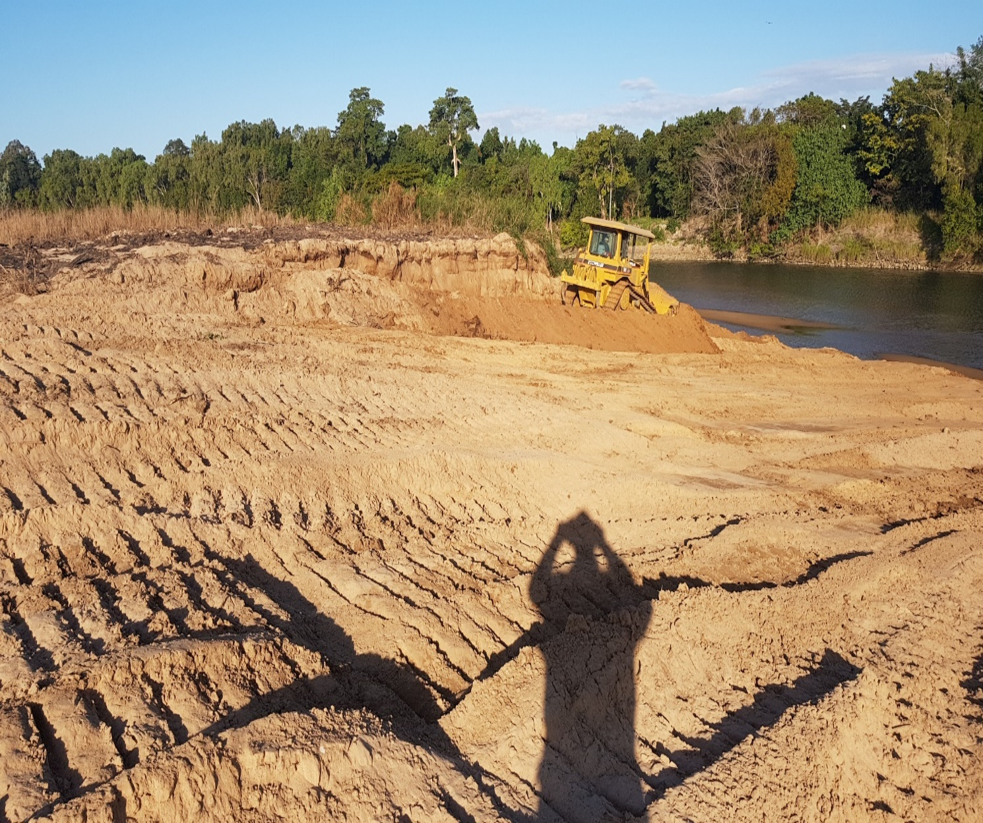

Ripple Creek Floodgate Structure Restoration – December 2024
Image 2: Work to reinforce 3.3m diameter plate steel pipes with PVC and concrete liners (Image credit: Mr Keith Phillips, Trust Supervisor)
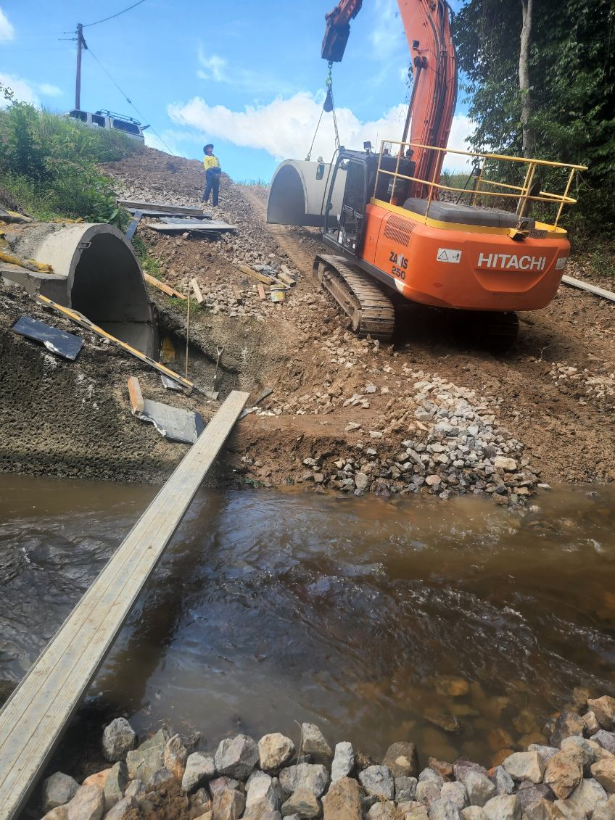

Entities may access guidelines at the following link: http://www.premiers.qld.gov.au/publications/categories/plans/assets/agency-planning-guidelines-nov-2015.pdf
Remuneration Procedures for part-time Chairs and members of Queensland Government bodies: https://www.qld.gov.au/__data/assets/pdf_file/0025/39481/remuneration-procedures.pdf
Also, note section 31 of the Statutory Bodies Financial Arrangements Act 1982. http://www.legislation.qld.gov.au/LEGISLTN/CURRENT/S/StatutryBodA82.pdf and “Overdraft Facilities—Operational Guidelines for the Public Sector”: https://www.treasury.qld.gov.au/publications-resources/overdraft/index.php A statutory body may operate a deposit and withdrawal account to the extent necessary or convenient for its day-to-day operations. However, the account may only be operated with an overdraft facility with the prior approval of the Treasurer.
The entity should contact statutoryauthorities@rdmw.qld.gov.au, for advice on procedure.

