This form is intended to assist Hinchinbrook residents in relation to the process for a referral agency response (response before application) for siting variation and includes information on how to complete an application for assessment by Hinchinbrook Shire Council and against the Hinchinbrook Shire Planning Scheme 2017 and Queensland Development Code (QDC).

To return your completed form or for further information, please contact Council’s Planning and Development Team via email, council@hinchinbrook.qld.gov.au, in person at Council’s Main Office, 25 Lannercost Street, INGHAM QLD, or via post PO Box 366, INGHAM QLD 4850.

WHAT IS A SITING VARIATION
There are rules governing the distances that singe detached housing and other associated structures can be set back from the front, rear and side property boundaries.

The Queensland Development Code (QDC) – Design and Siting Standard sets out where and how single dwellings and other associated structures can be located on a property. There are different setback requirements for lots under 450m² and for lots 450m² and over and these can be found within MP1.1 and MP1.2 of the QDC.

If your proposal complies with the acceptable solutions of the QDC, a referral agency response for siting variation is not necessary. If your proposal does not meet the acceptable solutions of the code, assessment is required by Hinchinbrook Shire Council against relevant performance criteria.

The following information included within the below application and checklist is to be submitted to Council in support of your application and relied upon for assessment purposes.

APPLICATION CHECKLIST
ATTACHMENTS | - Performance Criteria is to be addressed within this form  - QDC Performance Criteria is to be addressed on the attached form  - Extract from Queensland Development Code MP1.2 – Design and Siting Standard for Single Detached Housing on Lots 450m² and over
SUPPORTING INFORMATION | - Scaled site plan showing all structures (proposed & existing) including distances from boundaries  - Scaled elevation plan/s showing front, side and rear elevations of proposed structure(s).  - Signed letter from all adjoining owners  - Photographs of premises (OPTIONAL)  - Referral Assessment fee for siting variation

OFFICE USE ONLY – CUSTOMER SERVICE TO COMPLETE
RECEIPT NUMBER: |  | DATE |  | FEE PAID | $ | RECEIPT CODE | 889

APPLICATION DETAILS
1) Applicant details
Applicant name(s) (individual or company full name)
Contact name (only applicable for companies)
Postal address (P.O. Box or street address)
Suburb
State
Postcode
Country
Contact number
Email address (non-mandatory)
Mobile number (non-mandatory)
Fax number (non-mandatory)
Applicant’s reference number(s) (if applicable)

2) Street address and lot on plan
Street address AND lot on plan (all lots must be listed), or
Street address AND lot on plan for an adjoining or adjacent property of the premises (appropriate for development in water but adjoining or adjacent to land e.g. jetty, pontoon. All lots must be listed).
a) | Unit No. | Street No. | Street Name and Type | Suburb
a) | Postcode | Lot No. | Plan Type and Number (e.g. RP, SP) | Local Government Area(s)
b) | Unit No. | Street No. | Street Name and Type | Suburb
b) | Postcode | Lot No. | Plan Type and Number (e.g. RP, SP) | Local Government Area(s)

PROPOSED SITING VARIATION

These questions are required to be addressed for front, side and/or rear boundary setback variations.

(Please note – criteria is to be addressed in spaces provided, however further information can be attached)

How far is the proposed structure(s) to be constructed from the road frontage and what is the rationale behind the request?

What is the nature of the encroachment and how far is the proposed structure to be constructed from the side boundary and what is the rationale behind the request?

What is the nature of the encroachment and how far is the proposed structure to be constructed from the rear boundary and what is the rationale behind the request?

QUEENSLAND DEVELOPMENT CODE – MP1.2

The attached criteria, as stated within the Queensland Development Code MP1.2 (Design and Siting Standard fir Single Detached Housing on Lots 450m² and Over), must be addressed when making an application for siting dispensation.

FURTHER INFORMATION

For further information and assistance concerning Council’s Referral Agency Response process, please contact:

Hinchinbrook Shire Council

Development and Regulatory Services

PO Box 366

INGHAM QLD 4850

Telephone: 4776 4600

Fax: 4776 3233

Email: council@hinchinbrook.qld.gov.au

MP1.2

Design and Siting of Buildings and Structures
Performance Criteria | Acceptable Solution | Comment

Buildings and Structures
P1 The location of a building or structure facilitates an acceptable streetscape, appropriate for –  (a) the bulk of the building or structure; and  (b) the road boundary setbacks of neighbouring buildings or structures; and  (c) the outlook and views of neighbouring residents; and  (d) nuisance and safety to the public.  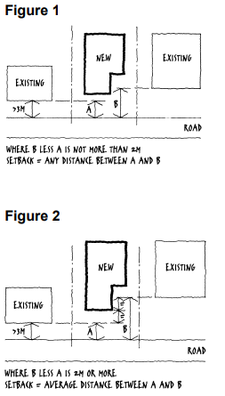 | A1 (a) For a detached dwelling, garage or a carport the minimum road setback is –  (i) 6m; or  (ii) where there are existing detached dwellings on both adjoining lots and at least one of the detached dwellings is setback from the road between 3m and 6m, and the difference between their road setbacks is-  (A) not more than 2m - a distance between the two buildings (Figure 1); or  (B) more than 2m- the average of the road setbacks of the adjacent buildings (Figure 2); and
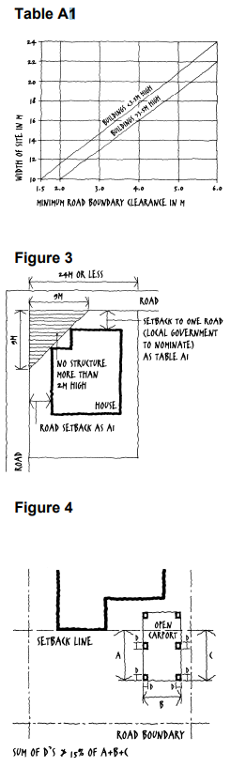 | (b) For a corner lot, the minimum road setbacks are-  (i) as for A1(a)(i); or  (ii) where the lot has an average depth of 24 m or less –  (A) for the nominated road frontage as in Table A1;and  (B) for the other road frontage - as for A1(a)(i); and Figure 3  (C) no building or structure over 2m high is built within a 9m by 9m truncation at the corner of the 2 road frontages (Figure 3).  (c) For open carports, the minimum road setback may be less than required by A(i)(a) if –  (i) the aggregate perimeter dimension of walls, solid screens, and supports located within the setback does not exceed 15% of the total perimeter dimension (along the line of supports) of that part of the carport within the same setback (Figure 4); and  (ii) there is no alternative on-site location for a garage or carport that-  (A) complies with A(i)(a);and  (B) will allow vehicular access having a minimum width of 2.5m; and  (C) has a maximum gradient of 1 in 5.  (d) For structures the minimum road setbacks are as for A1(a),(b), and  (c) except for –  (i) swimming pools, where the minimum distance from the water to the road frontage is –  (A) where the vertical distance to the coping above the finished ground level is not more than 1.2m – 1.5m; or  (B) where a solid wall or fence at least 1.8m high above finished ground level is constructed between the water and the road frontage and the top of the wall or fence is at least 1.0m above the top of the coping of the pool – no requirement; and  (ii) screens, fences, retaining walls or a combination of screens, fences or retaining walls not more than 2m in height; and  (iii) roofed gatehouses and arches having –  (A) a maximum area of 4m2 ; and  (B) not more than 2m wide elevation to street; and  (C) not more than 3m in height.
P2 Buildings and structures –  (a) provide adequate daylight and ventilation to habitable rooms; and (b) allow adequate light and ventilation to habitable rooms of buildings on adjoining lots.  (c) do not adversely impact on the amenity and privacy of residents on adjoining lots.  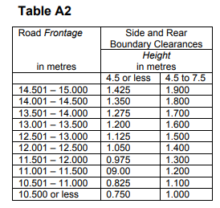 | A2 (a) The side and rear boundary clearance for a part of the building or structure is –  (i) where the height of that part is 4.5m or less - 1.5m; and  (ii) where the height of that part is greater than 4.5m but not more than 7.5m - 2m; and  (iii) where the height is greater that 7.5m - 2m plus 0.5m for every 3m or part exceeding 7.5m.  (b) For a rectangular or near rectangular narrow lot with a 15m or less frontage, the minimum side and rear setbacks for that part are –  (i) where the height is not more than 7.5m – in accordance with Table A2; and  (ii) where the height is more than 7.5m – 2m plus 0.5m for every 3m or part of 3m by which the height exceeds 7.5m.  (c) Structures may be exempted from A2 (a) and (b) where –  (i) the structure is not a deck, patio, pergola, verandah, gazebo or the like other than one permitted under A2 (c) (v)  (ii) the structure is not used for entertainment, recreational purposes or the like  (iii) a screen, fence or retaining wall or a combination of screens, fences or retaining walls is not more than 2m in height or  (iv) a rainwater tank, including any supporting structure such as a stand, is not more than 2.4m high.  (v) subject to (ii), it is a pergola or other structure which is-  (A) not enclosed by walls or roofed; and  (B) not more than 2.4m in height at the boundary; and  (C) primarily ornamental or for horticultural purposes.  (d) Subject to A2(c), class 10a buildings or parts may be within the boundary clearances nominated in A2(a) and (b) where –  (i) the height of a part within the boundary clearance is not more than 4.5m and has a mean height of not more than 3.5m; and  (ii) the total length of all buildings or parts, of any class, within the boundary clearance is not more than 9m along any one boundary; and  (iii) the class 10a buildings or parts within the boundary clearance are located no closer than 1.5m to a required window in a habitable room of an adjoining dwelling.  (e) Swimming pools may be within the boundary clearances nominated in A2(a) and (b) where –  (i) a solid wall or fence, constructed to prevent water entry onto adjoining lots, at least 1.8m high above finished ground level, is erected between the swimming pool and the boundary of the lot; and  (ii) the top of the wall or fence is at least 1.0m above the top of the coping of the pool.
P3 Adequate open space is provided for recreation, service facilities and landscaping. | A3 The maximum area covered by all buildings and structures roofed with impervious materials, does not exceed 50% of the lot area.
P4 The height of a building is not to unduly –  a) overshadow adjoining houses; and  (b) obstruct the outlook from adjoining lots. | A4 For lot slopes –  (a) up to 15%, the building height is not more than 8.5m; and  (b) of 15% or more, the building height is not more than 10m.
P5 Buildings are sited and designed to provide adequate visual privacy for neighbours. | A5 Where the distance separating a window or balcony of a detached dwelling from the side or rear boundary is less than 1.5 m –  (a) a permanent window and a balcony has a window/balcony screen extending across the line of sight from the sill to at least 1.5m above the adjacent floor level; or  (b) a window has a sill height more than 1.5m above the adjacent floor level, or  (c) a window has obscure glazing below 1.5m (Figure 5).
P6 The location of a building or structure facilitates normal building maintenance. | A6 A wall is –  (a) set back a minimum of 750mm from the side or rear boundary; or  (b) where less than 750mm to the boundary, maintenance free, such as unpainted or untreated masonry or prefinished steel sheeting.
P7 The size and location of structures on corner sites provide for adequate sight lines.  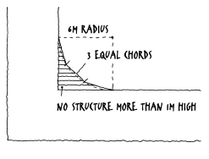 | A7 Fences, screens, and retaining walls and other structures are not more than 1m high within a truncation made by 3 equal chords of a 6m radius curve at the corner of the 2 road frontages (Figure 6).
P8 Sufficient space for on-site carparking to satisfy the projected needs of residents and visitors, appropriate for –  (a) the availability of public transport; and  (b) the availability of on-street parking; and  (c) the desirability of onstreet parking in respect to the streetscape; and (d) the residents likelihood to have or need a vehicle.  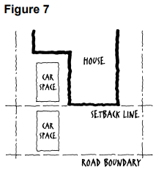 | A8 For each detached dwelling, space is provided for parking two vehicles on the lot and the space has –  (a) minimum dimensions as follows:  (i) for a single uncovered parking space- 4.9m by 2.6m wide; and  (ii) for a single covered parking space- 5m by 3m wide; and  (iii) for a double covered parking space 5 by 5.5m wide; and  (iv) for a single garage6m by 3m wide internally; and  (v) for a double garage6m by 5.7m wide internally.  (b) Car parking spaces may be in tandem, provided one space is behind the road setback required under Element 1(Figure 7).

