FORM OF NOMINATION

We the undersigned hereby nominate (block letters): ……………………………………………………………
 |  | (full name as per University roll)
for the position of ……………………………………………………………………… on the 2021 Student
Association Council.
3 NOMINATORS: (WHO MUST BE ORDINARY MEMBERS OF THE JCU STUDENT ASSOCIATION)
NAME (block letters) | STUDENT NUMBER | SIGNATURE
1.
2.

3.

**By signing this document I acknowledge that I have read and understood the collection statement (see reverse) and voluntarily consent to the Student Association confirming my enrolment status subject to the provisions of the Privacy Act 1988. This information is collected for the JCU Student Association’s own use in connection with this nomination.

ACCEPTANCE
I hereby accept nomination ………………………………………………………. Date: ………………………………….
(Signature required)
Nominee’s Student Number: ………………………………………………………………………………………………..

Nominee’s Address for posting of notices: ………………………………………………………………….……………...

Email: ………………………………………………….. Telephone no.: ………………………………………………….

IMPORTANT NOTICES
This form of nomination is required by Regulations, only for election by the JCUSA Ordinary Member Body. All names appearing on this form must be those of members of the Student Association - i.e. they must be students enrolled in any Subject, Course, or Degree programme of the James Cook University and be a current Ordinary member of the James Cook University Student Association.
No person shall nominate more than one person for the same position.

CONFIRMATION OF VALIDITY OF NOMINATION
Before nominations close, candidates are advised to seek written advice from the Electoral Officer confirming that their nomination is in order.

CORRECTIONS…ALTERATIONS…AMENDMENTS APPEARING ON THIS FORM WILL RESULT IN THE NOMINATION BEING DECLARED INVALID.

Electoral Officer to Complete:

Name of Nominee: ……………………………………………………………………………………………………………

Address: ………………………………………………………………………………………………………………………..

Nomination received at (date/time): ……………………………………………………………………………………….

Checked and found in order (signature): …………………………………………………………………………………...

FURTHER IMPORTANT INFORMATION FOR NOMINEES

Please note that the Regulations (8.4, Method of Nomination) state that:

“It shall be a requirement of nomination that a policy statement of no longer than 500 words in the case of Presidential candidates and no longer than 200 words for other candidates be submitted at the time of nomination. Failure to submit a policy statement shall automatically invalidate the nomination. The Policy statements shall be reproduced in an edition of The Bullsheet prior to the commencement of voting”

In other words, you must submit a policy statement with your nomination form. Because of the tight deadlines for producing policy statements, policy statements must be provided to us in electronic format.

DUTIES AND RESPONSIBILITIES OF OFFICE BEARERS

THE CAIRNS CAMPUS OFFICER

IMPORTANT Please refer to the current JCUSA document for the complete list of duties, responsibilities and expectations for the role which can be found here: https://www.jcusa.edu.au/about-us/elections/

The Cairns Campus Officer will

- recruit members of the Cairns Campus Committee in accordance with 5.6 of the Regulations;
- submit the list of Committee members to the President by no later than the second Friday after O week;
- submit a written report to each ordinary meeting of the Association Council on the activities/campaigns related to the Cairns Campus
- convene regular meetings of the Cairns Campus Committee;

- attend meetings of committees, organisations and bodies which he/she is a member by virtue of the Constitution or regulations or by resolution of the Association Council;

- present a written report to the last ordinary meeting of the Association Council reviewing the activities in the portfolio for the year and if appropriate making recommendations to the Association Council for the following year;

- perform any other duties imposed by the Constitution or Regulations or directed by the Association Council; and
- to act in accordance with the Association’s General Operations Policy.
- will, in consultation with the President, set Key Performance Indicators that will be presented at the first Ordinary Council meeting of the Association Council with a review by the President four (4) times annually.

Further information in relation to honorarium for Office Bearers can be found in the James Cook University Student Association Regulations

To obtain a copy of this document, please contact the James Cook University Student Association:

Townsville Student Association
JCU Student Association
James Cook University

TOWNSVILLE QLD 4814

Ph: (07) 4781 4400

Email: studentassociaiton@jcu.edu.au

Web: www.jcusa.edu.au

Cairns Student Association

JCU Student Association

PO Box 6811

James Cook University

CAIRNS QLD 4870

Ph: (07) 4232 1160

Email: theresa.priddle@jcu.edu.au
Web: www.jcusa.edu.au

COLLECTION STATEMENT

ADMINISTRATION

James Cook University Student Association is committed to protecting your privacy.

The Privacy Act 1988 (the Act) sets out a number of principles concerning the protection of your personal and sensitive information.

Personal Information – is any information, whether recorded by document or electronically, about you. It may include your name, date of birth, address, telephone number, email address or drivers licence number.

Sensitive Information – is a special category of personal information including details or opinion about a person’s:

- Racial or ethical origin;

- Political opinion;

- Political, religious or philosophical memberships, beliefs or affiliation;
- Membership of a professional association, trade association or trade union;
- Sexual preferences or practices;

- Criminal records;

- Health or disability (past or present); and

- Expressed wishes about the future provision of health services.

Who will be Collecting your Personal Information at JCU Student Association?

JCU Student Association, its agents and employees will collect your personal information only for its own use in connection with your service requirements.

If you wish to contact JCU Student Association about your personal information you should contact:

James Cook University Student Association

Secretary

By email: theresa.priddle@jcu.edu.au

By telephone: (07) 4232 1160

Or FREECALL: 1800 330 021

How JCU Student Association Collects Information?

Personal information is collected by JCU Student Association in document form when:

- You fill out and submit one of JCU Student Association Application or Registration forms;
- JCU Student Association receives any information about you from any other source.

Storage of Information by JCU Student Association

All personal information that JCU Student Association hold about you will be stored securely;
- By hardcopy; and/or

- Electronic filing.

All information stored electronically will be stored within secure software accessible only by or through authorised JCU Student Association personnel.

How your Information will be used by JCU Student Association? Your personal and sensitive information may only be used for the purpose for which it is collected which will include:

- The provision of the particular service which you require:

- The delivery and management of the services you require:

Accuracy of Personal Information

You should ensure that the personal information you provide to JCU Student Association is accurate, complete and up to date where possible.

Disclosure of your Information to Others

- Your personal information and (with your consent) your sensitive information may only be disclosed for the purpose for which it was collected and will only be disclosed to:

  - JCU Student Association’s staff and personnel:

  - JCU Student Association professional advisers including lawyers:
  - Government or regulatory authorities as required by law:
  - JCU Student Association related service providers

Failure to Provide Information to JCU Student Association

If you do not provide the information JCU Student Association requests from you. JCU Student Association may be unable or limited in its ability to provide the services you require.

Accessing and Correcting Your Information with JCU Student Association

Subject to some exceptions, which are set out in the National Privacy Principles (Principle 6 – Access and Correction), you have a right to access and obtain a copy of the information held by JCU Student Association about you.

Should you become aware that any information that JCU Student Association holds about you is not accurate, complete and up to date, please inform JCU Student Association and JCU Student Association will take responsibility steps to correct it so that it is accurate, complete and up to date.

Should JCU Student Association disagree that any information that JCU Student Association holds is not accurate, complete and up to date, you may submit to JCU Student Association a written statement by you stating that particular information is not accurate, complete and up to date.

If you wish to exercise your rights of access and correction you should contact JCU Student Association Privacy Officer whose details are indicated above.

In some cases JCU Student Association may impose a moderate charge for locating and providing access to your information.
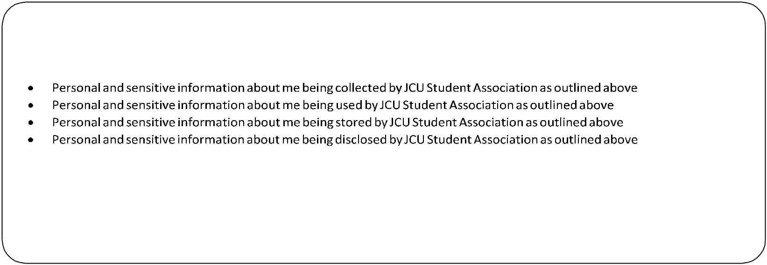

CONSENT TO COLLECTION AND STORAGE OF INFORMATION BY JCU STUDENT ASSOCIATION
I, ……………………………………………………………………………… of …………………………………………………………………………………………

Who can be identified by (student identification number) ………………………………………………………………………………………

Have read and understood the Collection Statement and voluntarily consent to:

Dated this day of 2019
Signed: ………………………………………………………………………………………………………………………………………………………………
Witness: ………………………………………………………………………………………………………………………………………………………………

Name: ………………………………………………………………………………………………………………………………………………………………………

Address: ………………………………………………………………………………………………………………………………………………………………

