Our Lady of the Sacred Heart
APPROVAL DATE: | Term 3 2026
NEXT REVIEW DATE: | Term 3 2028

Purpose
Sacred Heart is committed to providing a safe, inclusive and respectful learning environment for all students, staff, parents and visitors.
This Whole School Behaviour Support Plan describes the staff responsibilities and processes we use in our school to promote an effective research-based approach to developing and maintaining positive student behaviour.
Its purpose is to facilitate high levels of student engagement across the school, ensuring that successful learning outcomes are maximised and that our students are enabled to fully participate and experience success.

School Mission and Vision
To offer every student at Sacred Heart a world-class Catholic education enriched by a lived experience of Zenedth Kes culture.

Our School Context
Our Lady of the Sacred Heart School is located on two remote islands in the Torres Strait, Waiben (Thursday Island) and Kirriri (Hammond Island). We have a combined enrolment of 150 students. Most attend the main campus on Waiben which has seven classes (Prep to Year 6). There is a multi-age class of approximately 15 students (Prep to Year 2) on the Kirriri campus with students transitioning to Waiben for Year 3. We also offer a long transition for students aged 4 and above.
- 60% of students identify as Aboriginal and/or Torres Strait Islander (100% of students at Kirriri campus).
- The majority of our First Nation students have English as an Additional Language.
- All students identify as being from a very remote location. There are limited resources and access to medical, therapy and support services.
- Our school ICSEA value of 916 is lower than the Australian average. This means that our community is socially and economically disadvantaged.
- Trauma-informed practices are essential in our context.
- Attendance - In 2023, our Kirriri campus had zero students attending at least 90% of the time. Our Waiben campus had 30% of students attending at least 90% of the time. When this data is analysed further, 44% of non-First Nation students reach attendance targets compared to 17% of First Nation students.
- Transient population - Each year a significant number of students relocate to the mainland. One third of our students are newly enrolled. The transition of students from Yr 2 Kirriri campus to Yr 3 Waiben campus is a challenge requiring careful planning and year-long opportunities for integration.

Consultation and Review Process
Sacred Heart developed this plan in consultation with the school community. The school engaged in the MTSS-E (Multi-Tiered Systems of Support – Engagement) project in 2022, 2023 and 2024 to help guide this process. Consultation occurred through staff meetings, MTSSe committee meetings, meetings with the Parents and Friends Committee and Student representative council. We acknowledge the work of Catholic Education Services Cairns in developing the Template for Whole School Behaviour Support Plan.

SECTION A: Our Student Behaviour Support Systems

Our Beliefs About Student Behaviour
Our beliefs about teaching and learning socially at school, student behaviour supports, and responding to students to meet their needs, unify us and direct our actions.
At Sacred Heart School we believe: Behaviour is a learning process where positive learning behaviours are taught as part of the curriculum. There must be a warm, disciplined, safe, and supportive classroom environment where students and teachers develop positive relationships. Students are always asked to do the best they can. The teacher’s role is to teach and facilitate this behaviour. Respect, safety and learning is central to everything we do. Students have the right to receive constructive feedback about their behaviour and learning.

Our Whole-School Approach; a Multi-tiered Systems of Support (MTSS)

What is Multi-tiered Systems of Support?
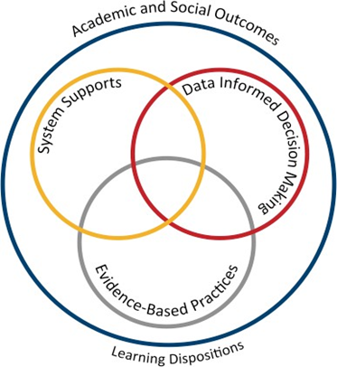
MTSS is a framework (Diagram 1) for schools that use a systematic approach to positive behaviour supports for all students. The aim of implementing the framework is to achieve increased academic and social progress and achievement for all students by using evidence-based practices. One of the focus areas is explicit teaching of behaviours that assists students to access learning – academically and socially - at all stages of development throughout their education.

Continuum of Support and Key Features
An important component of MTSS is the adoption of a continuum of behavioural supports (Diagram 2) that, like academic instruction, acknowledges that students will need differing levels of behavioural interventions and supports to be successful at school. Within the continuum there are three levels of support.
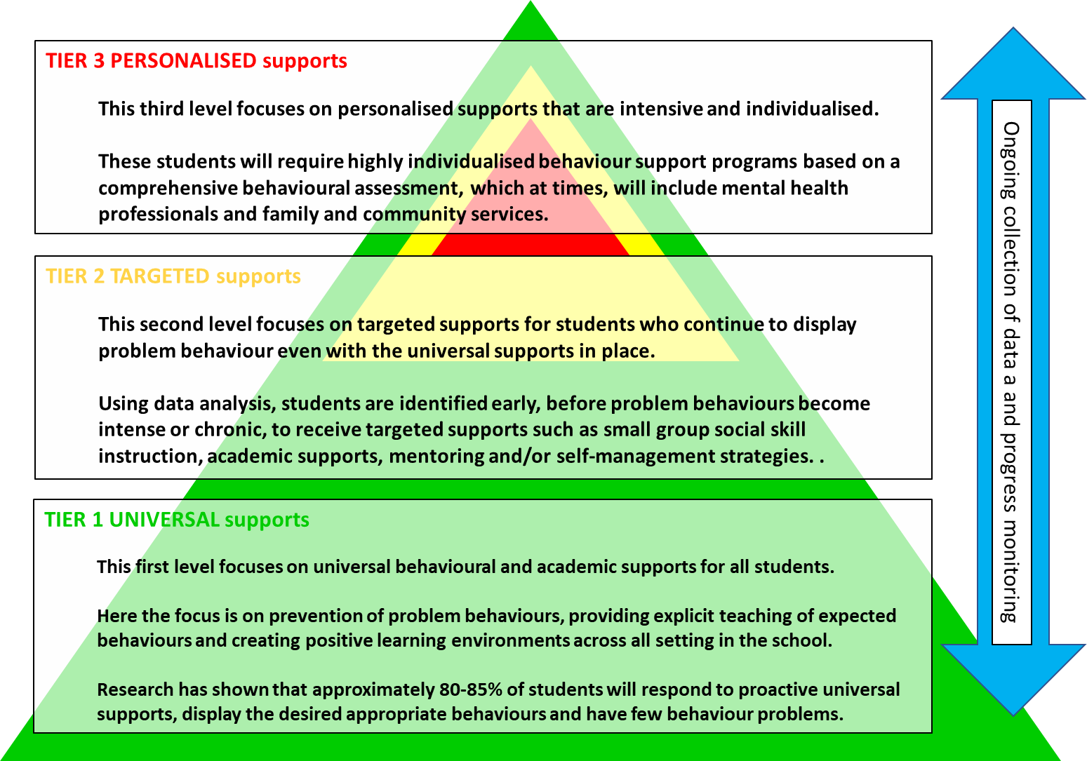
Diagram 2: Multi-Tiered Systems of Support (MTSS)
By building a connected continuum, everyone in the school is aware of how each level of support is connected to the universal systems i.e. every targeted and individualised intervention uses the universal set of behavioural expectations to increase the likelihood of maintenance and generalisation to other contexts.

Student Behaviour Support Leadership & Professional Learning for School Staff
At Sacred Heart, our Student Behaviour Support Leadership structures include:
- Our School Leadership team consisting of Principal, Assistant Principal Religious Education, Leader of Learning and Teaching and Leader of Diversity
- Our Diverse Learning team which consists of our leadership team along with our Guidance Counsellor and Indigenous Liaison Officer
- Consultant in Diversity – Student Engagement
- School MTSSe team which is composed of our Leadership team and teachers and school officers who have nominated their involvement.
Our staff have engaged in professional learning on MTSSe Multi-Tiered Systems of Support – Engagement. They have also received professional development in Mental Health First Aid, Maybo Restrictive Practices, ESCM Essential Skills for Classroom Management and the use of Engage.

SECTION B: Our Student Behaviour Support Practices
Tier 1: Universal Supports

Clarity: Our Expectations
School-wide expectations encourage consistent communications and establish a common language of expectations for all staff and students and across all settings. Agreed upon student expectations promote the school’s Catholic Identity and provide consistency across the staff and school community.
Our expectations are:
Our school expectations are to be…
• Safe
• Respectful
• Responsible
• Kind
Our school behaviour matrix is a teaching tool that outlines the expectations of behaviours we expect all students and staff to learn, practice and demonstrate. They allow us to teach proactively and to provide students and parents with a positive message about behaviours for learning at school.

Focus: Teaching Expected Behaviour
Effective instruction requires more than providing the rule – it requires instruction, practice, feedback, re-teaching and encouragement (Sprague & Golly, 2005). Instruction takes place each day, throughout the day, all year long.

Feedback: Encouraging Productive Behaviours for Learning
Feedback should cause thinking (Dylan Wiliam, 2011). In education, we use the term “feedback” for any information given to students about their current achievements (Wiliam, 2011 p.122). Feedback to students provides them with the way to move their learning forward and make progress in their learning.
Our school encourages and motivates students, both as they are learning the expected behaviours and then to maintain those skills and dispositions as students become more fluent with their use.
Our school encouragement system utilises effective, specific positive feedback, adult attention (contingent and non- contingent) and a tangible reinforcement system.
The encouragement strategies in place for school and classroom include:

School practices that encourage expected behaviours | Classroom practices that encourage expected behaviours
Weekly awards based on Gratitude, Empathy, Mindfulness or for following The Heart Way | Individual – tickets in weekly draw, sticker charts,
Class encouragers | Points systems for class rewards
The Heart Way tickets and prize draw | Newsletter shout outs and positive messages home
Intrinsic & student-led activities through Genius Hour, Love tags (chalk messages), weekly focus on specific expectations/positive behaviours | Intrinsic and student led activities including acts of kindness, practicing gratitude empathy and mindfulness (Resilience Project).

Tier 2: Targeted Supports
Targeted evidence-based interventions play a key role in supporting students at risk of academic and social problems and may prevent the need for more intensive interventions (Sailor et.al., 2009). These students consistently have trouble with low level but disruptive behaviours that interfere with instruction and hinder student learning. Targeted interventions should be timely and responsive and use similar strategies and social curriculum across a group of students.
Students are identified proactively, using academic, behaviour and attendance data accompanied by teacher nomination or through a screening process. Our targeted supports have systems in place to monitor student progress, make modifications, and gradually decrease support as student behaviour and engagement improves.
The evidence-based targeted supports currently available for students in the school include:
- During 2023, Sacred Heart is establishing Tier 2 interventions. Social Skills Clubs/Groups. This type of intervention involves directly teaching social skills to enhance a student’s ability to interact with peers and adults. Whilst social skill instruction may be part of the work done in universal supports this type of targeted support occurs in smaller groups with students who require additional practice and feedback on their behaviour. A teacher or guidance counsellor facilitates this type of group.

Tier 3: Personalised Supports
Successful outcomes for students whose behaviour has not responded to Universal or Targeted supports are dependent on our ability to intervene as early as possible with appropriate evidence–based interventions. A function-based approach is an essential feature of MTSS-E.
Personalised supports currently on offer at the school include:
- Individual Behaviour Support Plan
- Pro-active, Collaborative Problem-Solving process (Dr Ross Greene)
- School Counsellor support services
- Diverse Learning Team case management - planning and implementation of individualised support plans and monitoring data
- Partnerships with outside support agencies and specialists

Feedforward: Responding to Unproductive Behaviours
Even with our positive approach to teaching and supporting expected behaviours for learning, student behaviour will still occur. For some students, they do not know how to perform the expected behaviour, or don’t know it well enough to routinely use it at the appropriate times. For some students, the behaviours they are using appear to meet their needs. When responding to behaviours, all staff take a positive, supportive approach that builds, maintains, and sustains relationships with students.
To feedforward when responding to student behaviours, we have a system in place that enables staff to respond to minor behaviours efficiently and effectively, to chronic persistent minor behaviours and to major behaviours that hinder learning. In this continuum, thinking begins with clarity between minor behaviours (that can and should be managed by teachers, within the context of the classroom and non-classroom settings) and major behaviours (that are best managed in a more private setting with the class teacher and leadership in partnership). The definitions of teacher managed behaviours (Minor) and teacher plus leadership managed behaviours (Major) have been included in Appendix A.
Although the teacher is the key problem solver when responding to minor behaviours, they collaborate, and share creative strategies, with colleagues. Teachers respond to minor behaviours using best practices that consider:
- consistency
- least intrusive strategy
- specific, yet brief
- quiet, respectful interaction with the student
- refocus class if needed
The positive, support strategies currently in place for responding to unproductive behaviours at our school can be classified under 4 evidence-based approaches:
Least  Intrusive  Most  Intrusive | INDIRECT  Instructional strategies | - Selective attending to the behaviour (ESCM 7): strategically choosing not to intervene immediately  - Proximity (ESCM 5): strategic placement or movement by the teacher in order to encourage positive behaviour.  - Non-verbal cue (ESCM 5): techniques include eye contact, hand gestures, picture cues. These indicate that the teacher is aware of the behaviour and prepared to intervene when necessary.  - Cueing with parallel acknowledgement (ESCM 4): uses the power of specific positive feedback (see also ESCM 6). This involves praising a student behaving student appropriately who is nearby to a student behaving inappropriately. Praise the student after behaviour has been corrected.
Least  Intrusive  Most  Intrusive | DIRECT Instructional strategies  Direct strategies are used after indirect strategies have been used | - Verbal redirection - this interaction should ideally use the language of the school’s expectations, matching the response to the frequency and severity of the behaviour  - Redirect to the learning (using the learning task to refocus behaviour) (ESCM 8)  - Questioning to redirect  - Rule reminder  - Re-teach behavioural expectations.  - Provide choice (ESCM 9) (provide statement of two alternatives, the preferred behaviour and a less preferred choice).  - Follow-through (ESCM 10) – supervised time-out in/out of classroom, logical consequence applied (leads to problem-solving and restorative steps outlined below)
Least  Intrusive  Most  Intrusive | Problem-solving | - Teacher – student conversation  - Work it out together plan  - Teacher – student – parent meeting  - Teacher – student – leadership conversation
Least  Intrusive  Most  Intrusive | Restorative | - Student apology  - Restitution / repair  - Restorative conversation
De-Escalation |  | - Supervised calm time in a safe space in the classroom  - Supervised calm time in a safe space outside of the classroom  - Set limits  - Individual IBSP and management of escalated behaviour plan
N.B. The above table shows examples of the ways in which we respond and are not designed as a list of prescribed approaches to unproductive behaviours. The responses may include examples from one or all domains.

Disciplinary Consequences / Sanctions
Major behaviours or behaviours which have persisted despite intervention may result in a decision to implement more serious consequences or sanctions. Decisions to implement these additional sanctions will take into account the student’s individual circumstances (as outlined on page 2 above).
These additional sanctions comprise:
- Detention
- Suspension
- Exclusion

Bullying and Cyberbullying – Information, Prevention, and School/ College Responses
Our school’s response to bullying is guided by the following documents – Student Bullying: Prevention and Response Policy and the Student Bullying Prevention and Responses in Schools Guidelines.
DEFINING BULLYING –
Our Lady of the Sacred Heart defines bullying as Bullying/Harassment as behaviours that target an individual or group due to a particular characteristic; and that offends, humiliates, intimidates, or creates a hostile environment. It may be a single or ongoing pattern of behaviour. Bullying involves the misuse of power by an individual or group towards one or more persons. Forms of Bullying may include: Physical, Verbal, Emotional , Racial, Sexual, and Cyber bullying.
PROCEDURAL STEPS IN RESPONDING TO BULLYING INCIDENTS
• Prevent, de-escalate and/or stop any continuation of harmful behaviour;
• React to incidents and reports/concerns of students or parents in a reasonable, proportionate and consistent manner;
• Protect the student who has experienced the bullying behaviour and provide appropriate
support for all students involved;
• Apply the appropriate school wide positive behaviour framework procedure for the student/s who has engaged in bullying behaviour and ensure that there is a positive outcome, adequate follow up and that relationships are restored for all involved.
• Record incidents of bullying Major Behaviour – Bullying/Harassment via our Engage Student Support System.
• Communicate effectively with parents regarding incidents or the results of investigations into concerns and record these conversations on Engage.

SECTION C: Our Student Behaviour Support Data

Data Informed Decision Making
The CES Engage Student Support System is the database all CES schools are required to use to collect behavioural data for analysis and decision-making. The Engage Student Support System has capacity to record minor and major behavioural incidents so that schools can make data informed decisions about student supports. It also has capacity for schools to record, store and analyse Tier 2 Targeted and Tier 3 Personalised supports, information, and data.

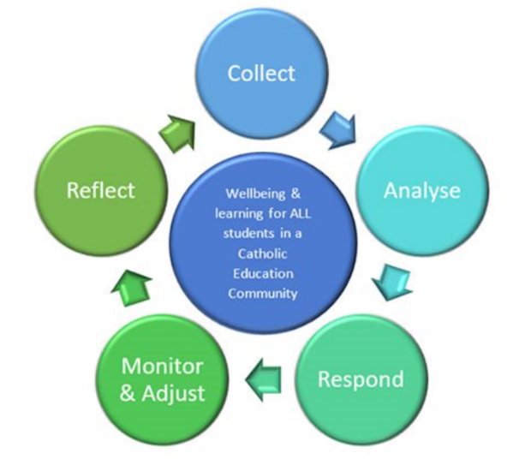 | Draft March 2023: Sacred Heart uses behavioural data, together with other data sources, to make data informed decisions. Students with repeated Major behaviours may be identified through Requests for Support to the Diverse Learners Team. These students may be referred to counselling, Tier 2 supports or development of a Individual Behaviour Support Plan.

Relevant Cairns Catholic Education Policies
- CES Student Protection Processes
- Management of Drug Related Incidents
- Management of Weapons in Schools
- Code of Conduct
- Student Attendance policy
- Inclusion policy
- Student Behaviour Support policy

Relevant Legislation that informs CCE Policies
- Anti-Discrimination Act 1991 (Qld)
- Child Protection Act 1999 (Qld)
- Commonwealth Disability Discrimination Act 1992
- Commonwealth Disability Standards for Education 2005
- Criminal Code Act 1899 (Qld)
- Education (General Provisions) Act 2006
- Education (General Provisions) Regulation 2017
- Human Rights Act 2019 (Qld)
- Information Privacy Act 2009 (Qld)
- Judicial Review Act 1991 (Qld)
- Right to Information Act 2009 (Qld)

References
Carr, E. G., Dunlap, G., Horner, R. H., Koegel, R. L., Turnbull, A. P., & Sailor, W. (2002). Positive Behavior Support: Evolution of an applied science. Journal of Positive Behavior Interventions, 4, 4-16.
Crone, D. A., Horner, R. H., & Hawken, L. S. (2004). Responding to problem Behavior in schools. New York: Guilford Press.
Greene, R.W. (2014). Lost at school: Why our kids with behavioral challenges are falling through the cracks and how we can help them. New York: Scribner.
Horner, R. H. & Sugai, G. (2005) School-wide positive behavior support: An alternative approach to discipline in schools. In L. Bambara & L. Kern (Eds.), Positive behavior support (pp359-390). New York: Guilford.
Lewis, T. J., & Newcomer, L., Trussell, R., & Richter, M. (2006). School-wide positive behaviour support: Building systems to develop and maintain appropriate social behaviour. In C.S. Everston & C.M Weinstein (Eds.), Handbook of Classroom management: Research, practice and contemporary issues (pp833-854). New York: Lawrence Erlbaum.
Newton, S. J., Horner, R. H., Algozzine, R. F., Todd, A. W., & Algozzine, K. M. (2009). Using a problem-solving model to enhance data-based decision making in schools. In W. Sailor, G. Dunlap, G. Sugai & R. Horner (Eds.) Handbook of positive behavior support (pp. 551-580). New York, NY: Springer
Sailor, W., Dunlap, G., Sugai, G., & Horner, R., Eds. (2009). Handbook for positive behavior support. New York: Springer Science and Business Media.
Sprague, J. & Golly, A. (2005). Best behavior: Building positive behavior support in schools. Boston, MA: Sopris West Educational Services.
Sugai, G., & Horner, R.H. (2002). The evolution of discipline practices: School-wide positive behaviour supports. Child and Family Behaviour Therapy, 24. 23-50.
Witt, J. C., Daly, E. J., & Noell, G. (2000). Functional Behaviour Assessment: A Step by Step Guide to Solving Academic and Behaviour Problems. New York: Sophis West.

Appendix A – Our commitments and expectations (example)
Aligned with our commitment to teaching students how to be respectful and safe learners, the table below explains how we apply the same standards to ourselves, and our expectations for parents visiting our school, talking with their children about school, or supporting the successful engagement of their child with their educational program.
 | What you can expect from us | What we expect of you
Be safe | We will create a safe, supportive and inclusive environment for every student. | You ensure your child interacts with and participates in their scheduled educational program (online / telephone / face to face) and notify the school promptly of any absences or changes in contact details.
Be safe | We will maintain confidentiality about information relating to your child and family | You respect the obligation of staff to maintain student and family privacy.
Be safe | We will act quickly to address social media issues that affect staff, students or families | You respect school, student and staff privacy in your online communications.
Be safe | We will work to quickly address any complaints or concerns about the behaviour of staff, students or other parents. | You approach the class teacher or principal if you are concerned about the behaviour of a staff member, another student or parent.
Be respectful | We will ensure positive behaviours are role modelled, and will be clear about our learning and behavioural expectations, including providing regular feedback about your child’s progress. | We will ensure positive behaviours are role modelled, and will be clear about our learning and behavioural expectations, including providing regular feedback about your child’s progress.
Be respectful | We will welcome and celebrate a diverse school community with recognition of significant social, cultural and historical events. | You recognise people are different and will be non-judgemental, fair and equitable to others in the school community.
Be Responsible | We will welcome you as partners in the learning process | You work collaboratively with us to ensure quality outcomes for our students.
Be Responsible | We will share relevant information with you about your child’s learning, and their social and behavioural progress at school. | To share relevant information about your child’s learning, social and behavioural needs with school staff.
Be Responsible | We will provide a suitable learning environment for students. | […….]

Appendix B - Behaviour Definitions
MINOR BEHAVIOURS
 | Descriptor | Definition | Example
1 | Inappropriate Verbal Language | Student engages in low intensity instance of inappropriate language | Calling someone an “idiot”, swearing if they kick their toe
2 | Physical contact | Student engages in non- serious, but inappropriate  contact | Pushing in the tuckshop line, horseplay
3 | Disrespect/ Non- compliance | Student engages in brief or low intensity failure to respond to reasonable adult  requests | Saying “No”, “Not going to do it”, “I don’t want to do that”
4 | Disruption | Student engages in low intensity, but inappropriate  disruption | Calling out, talking to peers in class
5 | Uniform Violation – Minor | Students wears clothing that is near but not within the  school’s dress code | Wrong socks, wrong shorts for sport
6 | Technology Violation – Minor | Student engages in non- serious but inappropriate (as defined by the school) use of mobile phone, mp3 player, camera and/or  computer | Making a mobile phone call  in breach of school’s policy
7 | Property Misuse | Student engages in low intensity misuse of property | Using equipment contrary to its design or purpose
8 | Late | Students arrive late to class | Tardy or late to class not late to school as this is  often beyond the control of a primary school student
9 | Out of Bounds | Student is in an area within the school grounds that has been designated “off limits”  at that particular time
10 | Lying/Cheating | Student engages in “White Lies” | “I came first”, “It wasn’t me!”, “I didn’t do it”
11 | Teasing | Isolated inappropriate comments (ongoing teasing  would fit under Bullying) | Laughing at someone’s  misfortune
12 | Sexual Behaviour | Sexual behaviours that are normal, age-appropriate, spontaneous, curious, mutual, light-hearted and  easily diverted experimentation. | Green light behaviours
13 | Incomplete  Tasks | Student has failed to complete a set piece of work in a clearly specified  time frame | Has difficulty starting learning task, continuing on task or completing learning  tasks

MAJOR BEHAVIOURS
 | Descriptor | Definition | Example
1 | Verbal Aggression | Language (both overt and covert) directed at others in a demeaning or aggressive manner intended to harm, distress coerce or cause  fear | Swearing, aggressive stance, language directed to hurt or show disrespect, intimidating body language,  intimidating tone of voice
2 | Physical Aggression | Actions (both overt and covert) involving serious physical contact where injury might occur that is directed towards another and intended to harm, distress, coerce or cause fear | Hitting, punching, hitting with an object, kicking, pulling hair, scratching
3 | Bullying/ Harassment | Bullying/Harassment are behaviours that target an individual or group due to a particular characteristic; and that offends, humiliates, intimidates or creates a hostile environment. It may be a single or ongoing pattern of behaviour.  Bullying involves the misuse of power by an individual or group towards one or more persons | Bullying may include: Physical: hitting, kicking, any form of violence; Verbal: name calling, sarcasm, spreading rumours, persistent teasing, intimidation; Emotional: excluding, tormenting, ridiculing, humiliating, intimidating; Racial: taunts, graffiti, gestures, intimidation; Sexual: unwanted physical contact, abusive comments, intimidation. Cyber bullying may include a combination of behaviours such as pranking calling, sending insulting text messages, publishing someone's private information, creating hate sites or implementing social exclusion campaigns in social networking sites.  Can also include 'flaming' and online hate sites/bash boards
4 | Defiance/ Non- compliance | Failure or refusal to comply or obey directions, a resistance to authority | Refusing a reasonable request of a teacher or supervisor, talking back in an angry and/or rude manner to staff,  ignoring/walking away from staff, running away
5 | Disruption | Persistent behaviour causing an interruption in a class or an activity | Sustained loud talking, yelling or screaming; repetitive noise with materials; and/or sustained out-of-seat  behaviour
6 | Dress Code Violation | Student wears clothing that does not fit within the dress  code of the school | “Gang” undershirts,  offensive T-shirts, steel capped shoes.
7 | Vandalism/Property Damage | Student participates in an activity that results in substantial destruction or  disfigurement of property | Throwing a computer, graffiti of school buildings, arson
8 | Truancy | Regular or persistent unexplained absences from school or from a class,  where the reason given is unsatisfactory | Students leaves class/school without permission or stays out  of class/school without permission
9 | Theft | Dishonestly appropriating another person’s property with the intent to destroy or permanently deprive the  person of it | Stealing school or personal property
10 | Forgery/Plagiarism | Student has signed a  person’s name without that person’s permission (forgery). Plagiarism is  submitting someone else’s work as your own. It occurs when a writer deliberately uses someone else’s language, ideas, or other original (not common knowledge) material  without acknowledging its original source. | Using someone else’s ideas or writing without acknowledging the source material. Signing another person’s name such e.g. a parent or teacher on a document.
11 | Technology Violation | Student engages in inappropriate (as defined by school) use of school technology including cell phone, music/video players,  camera, and/or computer | Accessing inappropriate websites, using someone else’s log in details, inappropriate additions to Facebook (written and  images)
12 | Drug-use or Possession | Student is in possession of or is using illegal drugs/substances or imitations or is using prescription drugs contrary  to their doctor’s directions | Cigarettes, cannabis, alcohol, prescription or other chemical drugs, drug related equipment
13 | Weapons  Use or Possession | A weapon is any object, device or instrument designed as a weapon that through its use is capable  of causing bodily harm | Knife, toy gun, gun
14 | Combustibles Use or Possession | Student is in possession of substances/objects readily capable of causing bodily harm and/or property  damage | Being in possession of or using matches, lighters, firecrackers, gasoline, lighter fluid
15 | Bomb Threat/ False Alarm | Student delivers a false message of possible explosive materials being on-school site, near school site, and/or pending explosion with the intent to  disrupt school | The intent is one of a “prank” to disrupt the school day and/or Emergency Services. May include pulling a fire alarm or written or  verbal bomb threat.
16 | Concerning Sexual Behaviour | Orange behaviours - Sexual behaviours that are outside normal behaviour in terms of persistence, frequency or inequality in age, power or ability  Red behaviours - Sexual behaviours that are problematic or harmful, forceful, secretive, compulsive, coercive or degrading | Explicit sexual talk or play, persistent nudity, repeated exposing of private parts to others and/or in public  Forcing others to be involved in sexual activity, using mobile phone and the internet which includes sexual images.
17 | eCrimes/Cyber exploitation | Illegal actions that are carried out through the use of a mobile device or technology to take  advantage of another | Stealing someone’s identity and impersonating them online, sending sexually  explicit images
18 | Academic Disengagement | Student does not complete and/or submit summative assessment pieces or avoids exams | Avoiding group assignment work, minimal drafting of assessment or has difficulty engaging with  learning over a period of time

