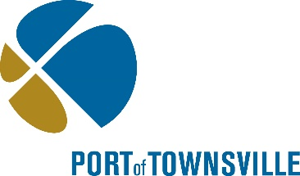
Long Term Maintenance Dredging Management Plan

SUBMISSION FORM
The Port of Townsville is currently seeking feedback on the ports’ Long Term Maintenance Dredge Management Plan for the ports of Townsville and Lucinda.
To assist us compile feedback please use the complete the submission form and email to environmentdg@townsville-port.com.au by 5pm Wednesday 12th December.
Submissions received outside of this period, or not on the submission form may be unable to be incorporated into this version of the Long Term Maintenance Dredging Management Plan.

Your Details

First Name |  | Surname |  | Individual | company | Name of company
Contact Number |  | Email

Section | Issue | Suggested solutions
E.g.  Schedule 2- Section 6 | E.g.  There is no risk assessment completed for the Port of Lucinda | E.g.  Include a risk assessment prior to any maintenance dredging is approved by the State and / or Commonwealth Governments, and ensure public consolation is undertaken prior to any works being undertaken

