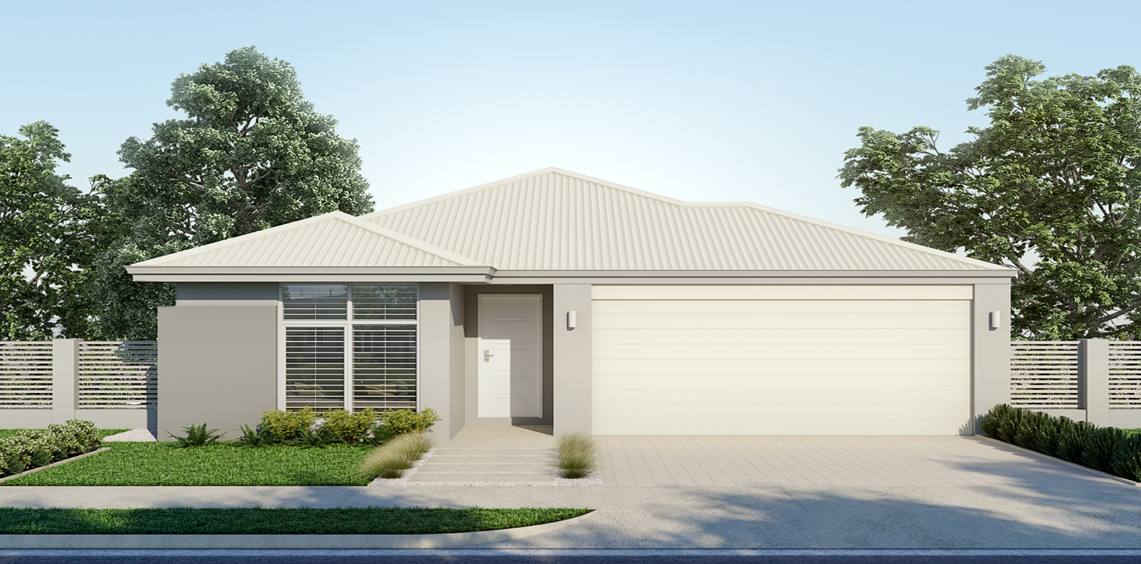

Call **Mark** – 0417 969 415

mark@wildecomhomes.com.au

www.wildecomhomes.com.au

**Lot 860 Jolly Rambler**

**Ravenswood**

**Total area 225m2**

Land area **456m2**

2

4

2

Marri 225

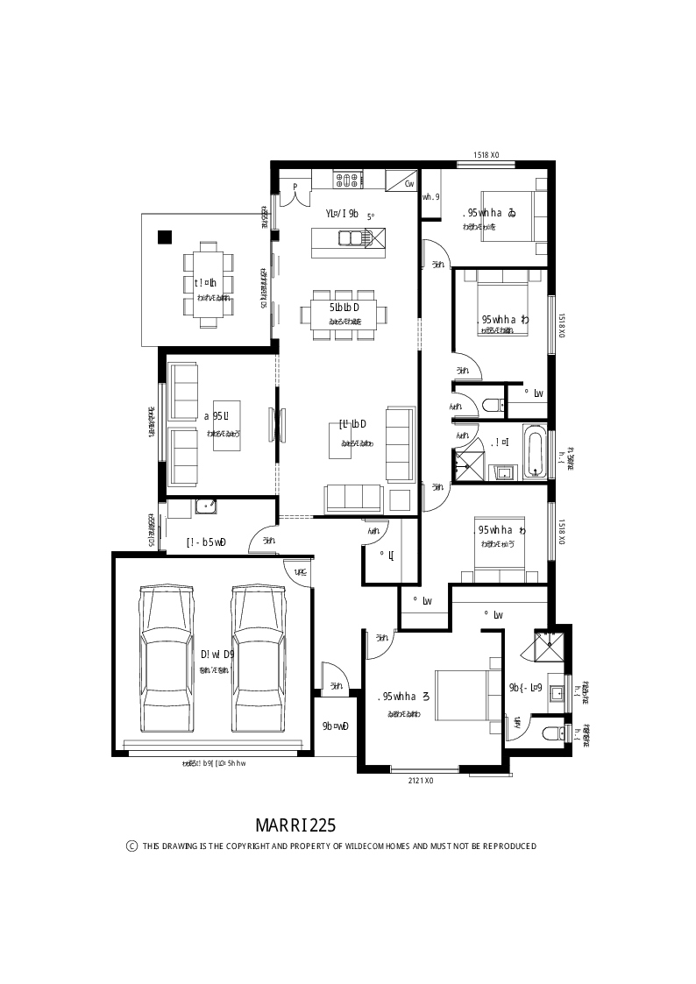

Price from

$339,225

HOUSE & LAND PACKAGE INCLUDES

- Stone benchtops to the Kitchen and Vanities

- Generous LED lighting and power point allowance

- 30c ceilings throughout the home.

-27c ceilings to the garage.

- Plus our superior building practices

**Come and see the Wildecom Difference**