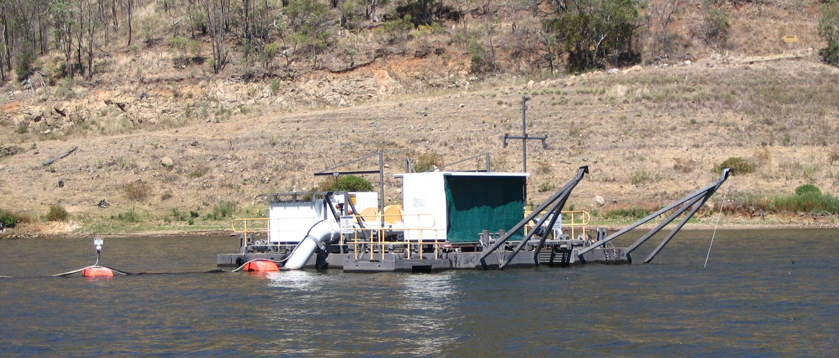
Case Study
Eungella Dam Maintenance Diving and Topside Works

Client Name: SunWater
Eungella Dam Maintenance Diving 2001 - 2013
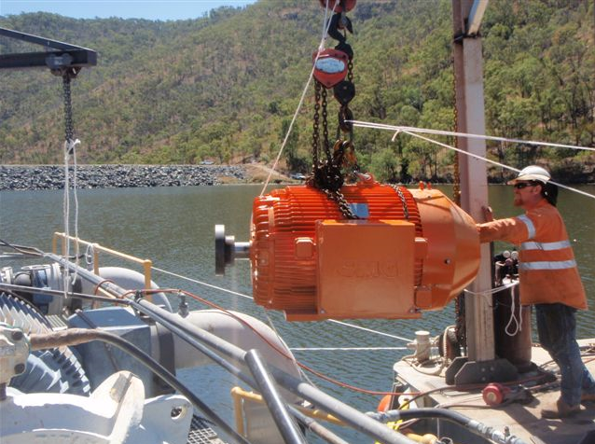
Description of Works: PMG has been working for SunWater on their Eungella Dam pontoon and mooring system - completing various maintenance diving tasks since 2001. The diving is quite challenging as the dives are 35m+ in depth, and the dive site is on top of a mountain range (Eungella Range), so the dive tables must incorporate an altitude correction. The site requires extensive use of in-water decompression with a decompression chamber set up on site ready for use. All equipment / dive vessels must be transported to the top of the mountain range, and set up adjacent to the dive site. Works completed have included:
- Mooring system inspection and maintenance
- Underwater valve maintenance and exercising
- Pump changeouts utilising pontoons / a-frames
- Pontoon underwater maintenance tasks
- Inspection / underwater NDT / photography /
video inspection

Time: 2001-2013
Contract Value: $400 000
Client Reference: SunWater - Rossano Minuzzo
Phone: (07) 4816 7501
Email: Rossano.Minuzzo@sunwater.com.au

