TYSS MENTAL HEALTH SERVICE REFERRAL FORM
PLEASE COMPLETE THIS FORM AND FORWARD TO:  EMAIL: YOUTHMENTALHEALTH@TAIHS.NET.AU |  |  | FOR MORE DETAILS PHONE: 47594048/ 0448558990  ADDRESS: 10-16 PEEL STREET GARBUTT  ACCESS VIA LONERGANNE STREET
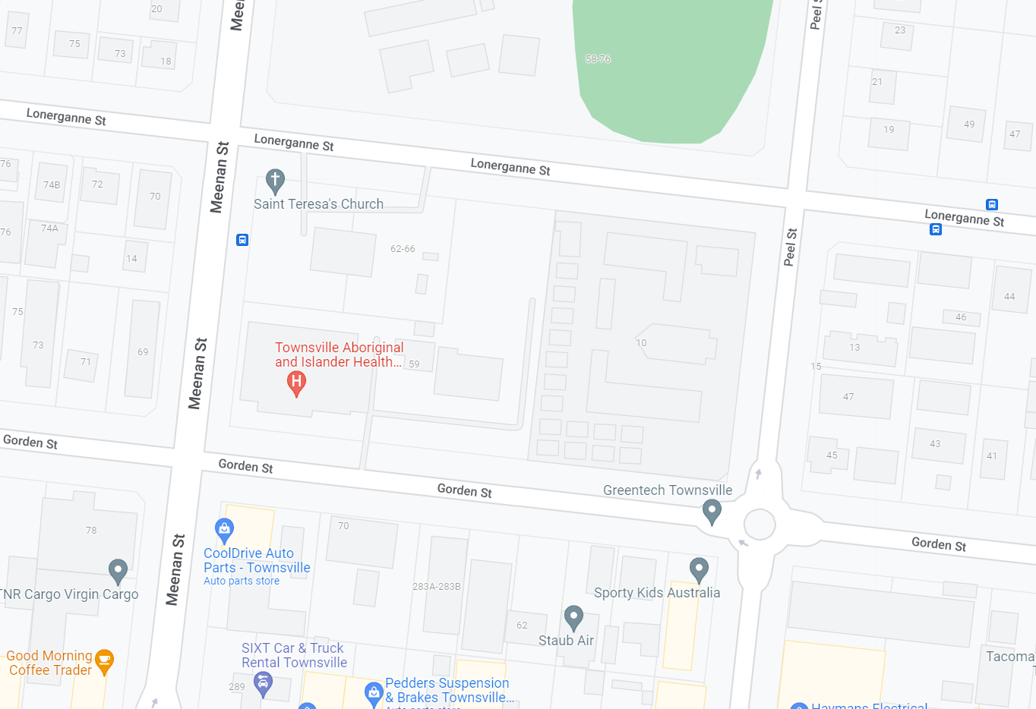
TYSS Mental Health Admin
Garbutt Primary School
REFERRERS INFORMATION
Completed Date: |  |  | Referral completed by:
Relationship to young person:
Contact Number: |  |  | Email:
Referred on a Mental Health Plan: ☐ Yes ☐ No |  |  | NDIS Participant: ☐ Yes ☐ No
YOUNG PERSONS PERSONAL DETAILS
Given Name: |  |  | Family Name:
Identified Gender: ☐ Female ☐ Male  ☐ Other Identifier: |  |  | DOB: |  | Current Age:
Cultural Identity | ☐ Aboriginal  ☐ Both Aboriginal & Torres Strait Islander  ☐ Australian, neither Aboriginal nor Torres Strait Islander |  | ☐ Torres Strait Islander  ☐ Australian South Sea Islander  ☐ Other :________________________________
Relationship Status: | ☐ Single  ☐ Married |  | ☐ De-facto  ☐ Divorced |  | ☐ Never married
Source of Income: | ☐ Centrelink |  | ☐ Employment |  | ☐ Other – Please specify
YOUNG PERSON’S CONTACT DETAILS
Phone Number: |  |  | Email:
Primary Address: |  |  | Lives With:
Homelessness Flag: ☐ |  |  | Postcode:
Alternative Phone Number:
Phone Number belongs to:
Alternative Address:
Belongs to:
EMERGENCY CONTACT DETAILS
Name:
Phone Number: |  |  | Relationship to young Person:
MEDICAL DETAILS
☐ Has a mental health professional ever diagnosed you with anything? ☐ Yes ☐ No ☐ Unsure
If Selected Yes, please provide diagnoses:

☐ Have you ever been prescribed medication for mental health concerns? ☐ Yes ☐ No ☐ Unsure
If yes, what medication/s:

Are you taking the medication/s correctly as prescribed by your Doctor? ☐ Yes ☐ No ☐ Unsure
If no, why not:

Do you have any health issues? (e.g., Asthma, allergies, diabetes) ☐ Yes ☐ No ☐ Unsure
Details:

Are you taking any medication for the above health issues? ☐ Yes ☐ No ☐ Unsure
If yes, what medication/s?

PRIMARY REASON FOR REFERRAL
☐ Aggression |  | ☐ Self-Harm |  | ☐ Lack of Motivation
☐ Suicidal thoughts / Attempts |  | ☐ Lack of engagement in family and social life |  | ☐ Substance use, please list substances:
☐ Behaviour |  | ☐ Moods |  | ☐ Family dysfunction
☐ Thoughts |  | ☐ Exposure to Domestic Violence |  | ☐ Trauma
☐ Other
Please elaborate on concerns – why are you wanting a referral to TYSS Mental Health:

Have you, the young person, ever been referred elsewhere for mental health and/or AOD services?
☐ Act for Kids | ☐ EVOLVE (Kirwan Hospital) | ☐ TAIHS Mental Health
☐ Aspire (Uniting care) | ☐ Headspace | ☐ Beyond Blue
☐ Lives Lived Well | ☐ CYMHS (Kirwan Hospital) | ☐ Relationships Australia
☐ Other
If not, why not?

If yes, When: ☐ less than 3 months ago ☐ 3 – 6 months ago ☐ More than a year ago

If less than 3 months ago, what is the status of your referral?

Have you ever engaged with another mental health service? ☐ Yes ☐ No

CONSENT
Do you, the young person consent to this referral being made to TYSS Mental Health Service? ☐ Yes ☐ No
I am aware that by signing this referral,
☐ My information will be shared with TYSS Mental Health so that a service can be provided.
☐ I have the right to privacy and confidentiality.
☐ I can ask to see the personal information recorded about me.
☐ Information about me will not be shared with others without my consent (except for duty of care reasons or as required by law).
☐ I can withdraw my consent at any time.
☐ I understand that my information will be stored on a online, secure client information system which is only accessible by TYSS Mental Health staff
☐ Each party is consenting to non-identifying information being provided to relevant department for research, reporting and statistical purposes only. Non-identifying information means that your personal details are not provided.

Date: __________________ Referrer’s Name: __________________________ Signature: ___________________

Date: __________________ Young Person’ Name: _______________________Signature: ___________________

Date: __________________ Guardian’s Name: __________________________ Signature: ___________________

Notes:
- TYSS Mental Health Service is unable to provide transportation to and from appointments.
- To remain fair and equitable to all clients, appointments cannot be held
- We are unable to continue to offer appointments to young people who cancel or do not attend without sufficient notice , after more than three times.
  - We will contact you to discuss the barriers to you attending
- All young persons MUST consent to the referral being completed and sent to TYSS Mental Health Service.
- Parental / Guardian consent is required for ALL young people referred under the age of 16.

