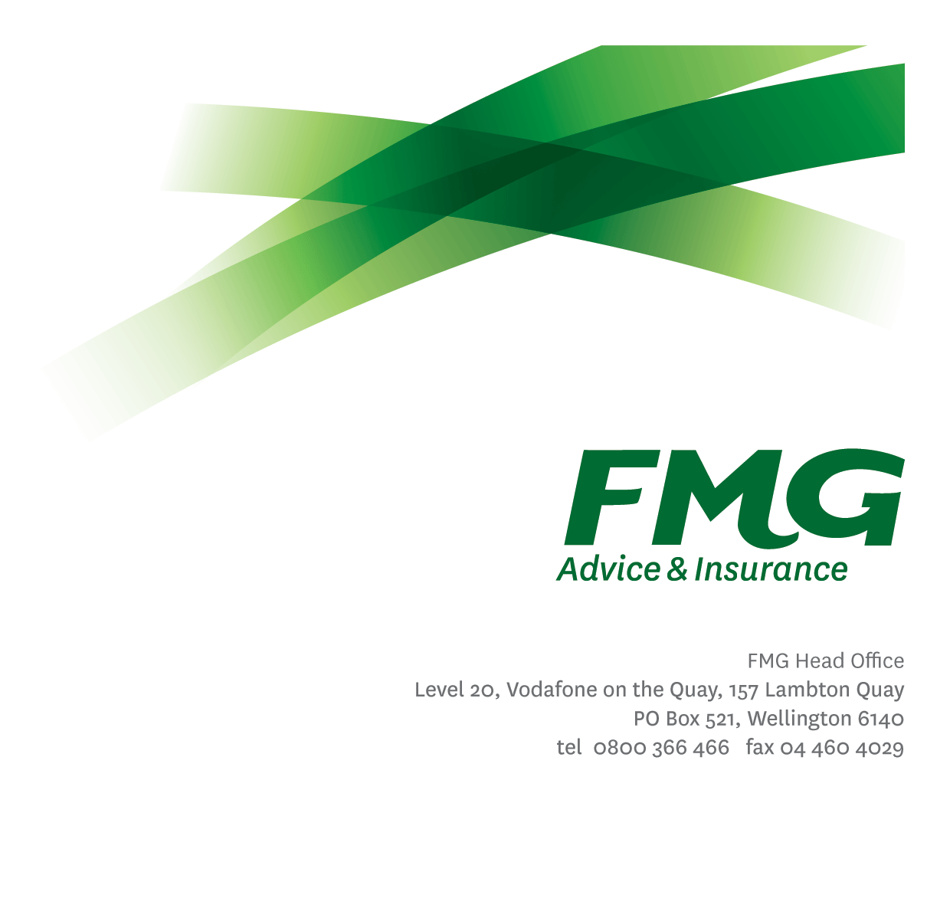
Executive Assistant
Position Description

Location: Wellington or Palmerston North
Reporting to: Head of Executive and Board Support (Principal EA)
Business Unit: Executive
Direct Reports: Nil
Date Last Reviewed: June 2026

About FMG
Formed by farmers for farmers over a century ago, FMG is New Zealand Aotearoa’s leading rural insurer providing risk advice and insurance solutions for farmers, growers, commercial businesses, the lifestyle sector and residential Clients.
FMG is proudly 100% New Zealand Aotearoa owned and operated, focused on helping Clients and Members achieve their goals. As a mutual, FMG’s Purpose is to provide “a better deal for Rural New Zealand Aotearoa”, and our Vision is to “help build strong and prosperous Rural communities”. Both involve reinvesting all profits back into the Mutual to ensure that FMG remains a sustainable and resilient Mutual insurer, capable of honouring our promises to current and future generations of farmers and growers.

FMG’s Values
FMG’s brand represents promises about what clients can expect from the Mutual and each FMG employee across our One Team is responsible for delivering on these promises. Living FMG’s Values means we all deliver the best brand experience for our clients. FMG’s Values are:
- Do what's right - Whāia te ara tika | - Make it happen - Whakatutukitia
- We're in it together - Ko tātau tātau | - Proud of who we are - Whakahīhī i te whakapapa

Work Environment
FMG seeks to provide an environment that promotes and fosters achievement, placing importance on career development and training to ensure employees have the opportunity to bring their best and whole self to work.
FMG’s Head Office is located in Wellington and accommodates FMG’s Executive Leadership Team (ELT), Marketing and Propositions, People and Culture, Finance, Insurance Solutions, Risk and Compliance teams.

FMG’s largest regional office is located in Palmerston North accommodating FMG’s Phone-based Sales and Service teams, Digital and Data, Claims, Facilities, Procurement and Payments functions. In addition to offices in Wellington, Palmerston North and Christchurch; FMG has offices in 30 regional locations throughout New Zealand Aotearoa.

Purpose of the role
To provide high-quality, proactive and confidential administrative support to Executive Leadership Team (ELT) Members, enabling effective day-to-day operations and the timely delivery of priorities. The role is responsible for managing schedules, coordinating activities and ensuring tasks and outputs are delivered accurately, on time and to a high standard. The Executive Assistant works with guidance to manage competing priorities, respond to changing business needs and provide reliable, organised support to ELT Members.

It is expected the role will support between two and three ELT Members and contribute as part of the Executive and Board Support team, working collaboratively and providing shared coverage as required.

Key Responsibilities
Area | Responsibilities
Executive Administrative Support | Assist in the achievement of FMGs strategic direction through the provision of confidential and efficient administrative support including but not limited to the following:  - Manage complex diaries and scheduling across multiple stakeholders, prioritising based on business impact, deadlines and dependencies.  - Prepare, review and quality-check executive correspondence, briefings, presentations and papers; ensure accuracy, clarity, and appropriate confidentiality.  - Maintain “single source of truth” records and filing standards for executive materials, ensuring version control and appropriate access/permissions.  - Coordinate meeting logistics, including scheduling, agenda preparation, distribution of papers, minute-taking and tracking of actions  - Lead small-to-medium projects at Executive/Business Unit level (e.g., event delivery, process improvement, reporting enhancements), including planning, stakeholder coordination and delivery to time/cost/quality.  - Provide operational support to planning activities by coordinating inputs, consolidating information, and tracking progress against milestones for key initiatives.  - Manage travel and logistics for complex itineraries; anticipate disruptions and make tactical changes to protect Executive time and commitments.  - Liaise across business units to ensure timely delivery of required inputs and outcomes; act as a key point of coordination between Executive stakeholders and internal teams.  - Monitor, reconcile and prepare expense reporting and invoice/payment processes with strong attention to coding accuracy, budget impacts and compliance requirements.  - Support Board logistics as required, working collaboratively with the Executive and Board Support team to coordinate meeting schedules, prepare and distribute materials, and assist with minute-taking and action tracking.
Compliance | - Coordinate and monitor compliance certificate requirements and due dates for the reporting manager and relevant stakeholders, escalating emerging risks and overdue items.  - Prepare and consolidate information required for compliance attestations/certificates, ensuring completeness and accuracy prior to review and sign-off.  - Support the reporting manager to manage remediation plans for compliance breaches, including documenting actions, tracking progress, and following up owners to closure.  - Maintain effective records and audit-ready evidence of compliance-related actions undertaken within the Executive office.  - Monitoring when DA requirements are due and prompts the reporting manager to ensure DA requirements are completed on time  - In consultation with the reporting manager, ensuring that changes and updates to compliance requirements are communicated at regular team meetings.  - Complies with company policies, guidelines and procedures
Customer Service | - Ensure exceptional levels of client service experience are provided to all internal and external stakeholders, representing ELT Members with professionalism, discretion and responsiveness.  - Act as a first point of contact for ELT Members as appropriate, triaging enquiries and determining required actions, timeframes and escalation pathways.  - Communicate clearly and proactively with stakeholders to manage expectations, resolve scheduling conflicts, and ensure timely follow-through on actions.  - Build and maintain effective working relationships with key stakeholders (e.g., ELT members and their teams, Executive Assistants, and external partners) to enable efficient outcomes.  - Identify opportunities to improve ELT Members “client service experience” (e.g., meeting pack quality, communications templates, consistency of processes) and implement improvements in collaboration with the wider EA community.
Team Membership | - Participate fully as a member of FMG and the Executive and Board Support Team, contributing positively to team culture of high performance and client centricity, and supporting a respectful, inclusive and confidential working environment.  - Collaborate with other Executive Assistants to ensure executive support requirements are delivered in a consistent and timely manner.  - Provide shared coverage and backup support (eg leave cover) as required within the Executive and Board Support Team.  - Contribute to Mutual wide (including ELT and Board) planning and coordination (including the developing of the Executive and Board Annual Calendar) by sharing information, tracking actions/deadlines where appropriate, and escalating risks or dependencies early.  - Take part in relevant ELT leadership team meetings (including but not limited to Committee and Steering Group Meetings) and associated activities as required, supporting delivery of agreed minutes and actions.  - Identify and contribute to improvements in team ways of working and business processes (continuous improvement), sharing learnings and standardising approaches where appropriate.
Risk and Quality | - Ensuring overall compliance with legislation regulations and FMG policies through the use of established systems
Wellbeing and Safety | - Complies with safety and wellbeing policy and procedures, including accident and incident reporting and hazard management requirements  - Works in a safe manner at all times and does not undertake activities without appropriate training

COMPETENCIES
*see competency framework for behaviours expected at each level | Expected Level
Client Driven (Internal & External)  A commitment to understanding the needs and best interests of both internal and external clients, in order to provide them with outstanding customer service and help them to make informed decisions. | Advanced*
Accountability  Taking Executive ownership of decisions, behaviour, and development, and being responsible for how these actions impact on the wider organisation and customers. | Intermediate*
Adaptability  Demonstrating a willingness to engage in a changing environment and being flexible and comfortable working with change. | Intermediate*
Motivation and Drive  The determination to achieve goals and strive for excellence. | Intermediate*
Relationship Building  Developing and maintaining positive, professional relationships that are built on mutual trust and respect. | Advanced*
Team Work  Making a positive contribution to the FMG team and collaborating effectively with others to achieve objectives. | Advanced*
Critical Analysis  The capability to identify key issues, trends, or important facts from information and to question and probe. | Competent

KNOWLEDGE
Qualifications | Relevant tertiary qualification and/or significant experience as a senior executive assistant supporting executive leaders in a complex environment. Governance and minute-taking experience (or demonstrated capability) is desirable
Business Awareness | Strong understanding of FMG’s operating environment, priorities and stakeholders; able to anticipate ELT Members needs, understand impacts across business units, and tailor support to enable timely decisions and delivery.
Risk/Insurance Knowledge | Understands risk and how to apply FMG's policies to situations; is knowledgeable about compliance requirements; understands the insurance process and how claims are managed; knows industry partners and competitors.
Legal Knowledge | Has legal knowledge e.g. indemnity, liability, the Privacy Act etc.

SKILLS
Written Communication Skills | Able to write clear and concise communications, and business reports.
Listening Skills | Demonstrates active listening skills through eye contact, paraphrasing, appropriate body language and checking understanding.
Technology Skills | Advanced capability across MS Office (Word, Excel, PowerPoint, Outlook) and collaboration tools; able to produce executive-ready packs, reporting, templates and process improvements (including document management and version control).
Risk Assessment Skills | Identifies and mitigates operational, reputational and confidentiality risks within ELT Members activities; applies sound judgement, escalates appropriately, and recommends practical controls and process improvements

Relationship
External | Internal | Committees/Groups
- Business Partners  - Business Contacts  - FMG Customers | - [Relevant ELT Member]  - Other FMG ELT Members  - FMG Executive Assistants  - [Relevant ELT wider Team]  - Finance and HR Business Partners | - [Relevant ELT Member LT]  - As directed as needs change across the Mutual

Financial Authority Levels
- As agreed and outlined in Appendix 1

People Advisory Authority Levels
- Not applicable

Agreement
I agree to the outline of the role as contained in this document and recognise that the contents may need to be amended from time to time to reflect changing business requirements.

I as job holder, allow my Manager to gather information from third parties where necessary for the purposes of performance management.

Executive Assistant’s Name:
Signature:
Date:

