- Organised, efficient and productive, autonomous / Independent.

Position Description
Business Analyst


Our purpose
Our long-term aspirations are to develop more long-term value-based relationships with our customers, and for our people to grow and develop so that they are better off working at the Co-operative.

Our values
Our values represent who we are, how we think, and how we behave to bring these to life every day. You’ll demonstrate behaviours that define our core values and support an inclusive culture with a strong teamwork spirit.
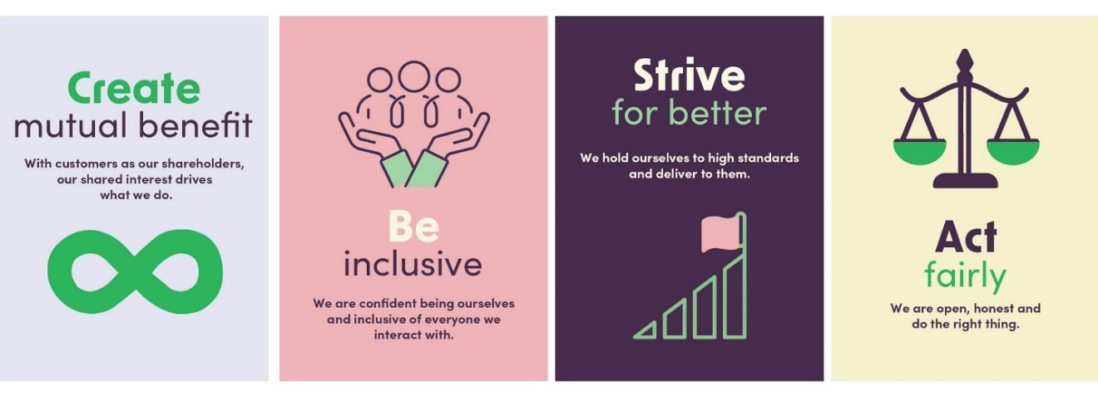

About the team
The Technology team is a diverse team of technology professionals spanning our bespoke Core Banking platform and processes, our key data platforms and data shipping processes, our customer and staff channels and, increasingly, our key third-party integrations.

We have exciting changes across our technology stack over the coming years, along with ensuring we keep everything safe, secure and serviceable.

Purpose of this position
To contribute to the development and execution of the Bank’s Technology vision, strategy and roadmap; which will in turn drive a materially significant transformation throughout the organisation.

This role will play a key part in the development of the Co-operative Bank’s Technology platforms and services. The focus is on driving innovative solutions to support our customers and support our people experience by driving change and continuous improvement.

The Business Analyst will use their knowledge of traditional banking business processes combined with their desire to keep things simple to really make a difference. Technology & Digital development experience and strong communication skills will support the end-to-end development of new solutions. Our Business Analysts will be:

- Passionate about product – constantly challenging and drawing on inspiration.
- A proxy for users – creates solutions that are loved and well used by truly understanding needs.
- Great at communicating – great at communicating both up and sideways, bridging the gap between technical and non-technical stakeholders.
- Commercial – link between what users do and how the company makes money.
- Comfortable with ambiguity – adept at working through uncertainty and a facilitator of clarity
- Focused on data - understands that data is key to making cases to stakeholders for prioritisation.

Position reports to: Business Analyst Manager

Challenges and opportunities of this role
- Innovation – to have a unique perspective and be confident sharing it; and find opportunities that generate value for the bank and its customers. Use data and user feedback to deliver outcomes that add value by solving existing problems in new ways.
- Stretch – having the spread of skills, knowledge and creativity to create solutions that consider the bigger picture. Use thought leadership, keeping in tune with up and coming technology and industry trends, connecting problems and opportunities across multiple realms.
- Courage – influence stakeholders by having courageous conversations – challenging their and your own thinking, to ensure that the design and development creates the best outcomes for our customers.
- Multi-tasking – collaboratively working with a team or project for complex analysis work, context switching between discovery and detail, and balancing this analysis activity with supporting others.

How you will contribute:
What you’ll do | Success will mean

Analysis and requirements
Lead development of requirements and user stories by defining the current and detailed target state to ensure our solutions are fit for purpose. | - Capture high-level requirements for opportunities and problems to be solved  - Undertake strategic analysis, options analysis and valuation of activities.  - Develop and refine requirements and user stories that are translated into solutions for our customers and our people.  - Influence and collaborate with key internal stakeholders to get the right outcomes for all users.  - Enable and deliver change across business systems and core banking.  - Involved internal and external customers at multiple stages of the development cycle.

Enhance our offering
Support and deliver detailed understanding and design of required new propositions. | - Support delivering elements of the technology roadmap including value and prioritisation of opportunities.  - Engage key parties in the business process designs and development activities, including cross-squad delivery for complex changes.  - Ensure any supporting processes to propositions are agreed and integrated appropriately.  - Identify and manage associated change management activities.

Business and process design
Research and understand existing banking processes and systems that are to be subject to change.  Contribute to process design with a user experience focus, with human centred design thinking | - Function as a facilitator and translator for internal disciplines of Product Management, Operational Risk, Marketing and Operations to ensure that business needs are recognised and accommodated within the technical solution design  - Add value during scoping and conceptualisation of business and process design, by thinking commercially and strategically.  - Help identify connections between work plans and outcomes sought across technology, to ensure solutions are re-usable, scalable and useful long term.  - Collaborate to understand impacts to performance and be agile in response.  - Solutions improve system agility, financial sustainability, and resilience.

User experience
Incorporate a deep understanding of our internal and external customers’ behaviours – the service & sales journeys, needs and preferences, and opportunities for improvement - into design | - Keep pace with developments in customer experience, digital trends and emerging technology trends.  - Understand and apply knowledge of banking practices and processes to build appropriate solutions.  - Use customer behaviour and insight from a range of sources to enhance data driven sales & service activities.

Other accountabilities
Involvement in squad and team delivery.  Works collaboratively with other members of the Team. | - Involvement in testing and technology remediation or incident resolution from time to time.  - Takes responsibility for activities within team, outside of core analysis activity, in order to support agile delivery.  - Team work is well-integrated, with team operating rhythms considered and team goals are achieved.  - Demonstration of behaviours that define our core beliefs

Healthy and safe work environments
Follow all health and safety policies, standards, emergency procedures and plans.  Participate in health and safety activities, training and meetings as required.  Reports hazards, near misses, injuries, incidents, and ideas for continuous improvement.  Cease work if an unsafe situation arises and seek assistance. | - Having healthy and safe ways of working.  - All workers feel empowered to and aware of opportunities to participate in health and safety activities.  - Our people can easily report hazards, near misses, injuries, incidents, and ideas for continuous improvement.  - Workers stop work if they feel unsafe and connect with their people leader or other workers for assistance.

Decision making and responsibilities
- Decisions and/or financial accountabilities:
Decisions able to be made within delegated authorities. This may include decisions around solution design standards or team working rhythm for example.
- Actions and decisions that are recommended to a higher level of management for approval:
Actions and decisions that are recommended to a higher level of management for approval. This may include solution design approval or substantive changes to current state

Qualifications and experience
- Sound knowledge in 2-3 of these domains
  - Cards & payment technical architecture;
  - Lending practices, decision automation & legislation;
  - Front end digital banking experience;
  - Core banking systems;
  - Insurance
- 3-5 years’ experience as a Business Analyst is desired, but not essential
- Previous experience in an agile delivery model within the context of large-scale or complex projects is desired, but not essential
- Tertiary qualification is desired but not essential.

Skills and attributes

Technical Skills
- Broad and practical knowledge of information technology, business process and digital technologies.
- Strong proficiency in SQL for querying and analysing data from relational databases
- Practical application of, and bias towards, test and learn approaches.
- Well established researching, analysis and interpretative skills.
- Experience with human-centred design preferable.

Conceptual Skills
- Possess very strong analytical and logical thinking powers spanning biggest-picture conceptual ideas down to a granular detail.
- Ability to develop user stories and requirements that are re-usable and useful across multiple platforms, and internal and external customers.
- Challenge and further develop ideas, problem statements, MVP and wider solutions and their role in adding genuine value to customers and business.
- Uses interpersonal skills (including listening skills) to achieve effective two-way information exchange, including writing clearly and concisely

Personality Attributes
- Adaptability: Can adapt to the changing needs of the business and has good learning agility.
- Courage: Think outside the norm, challenge and innovate – advocate for change.
- Results Driven: Sets goals and is focused on achievement, with strong influencing skills.
- Mindset: Has a genuine growth mindset.

Leadership Skills
You will be expected to demonstrate behaviours from our Leadership skills framework through your actions, the way you work and how you work with others.

