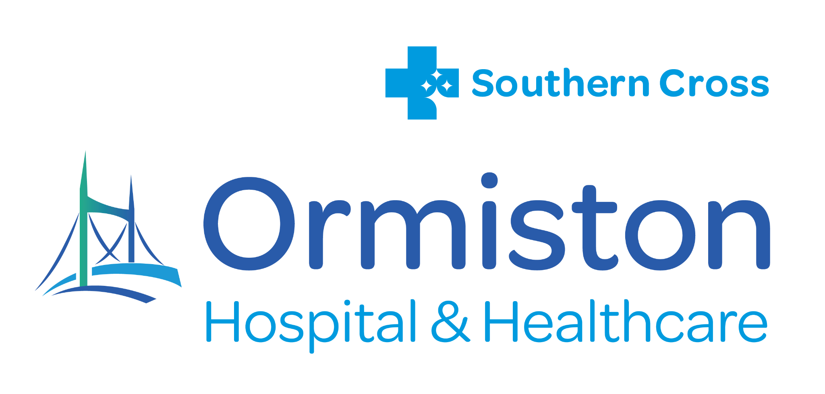

POSITION DESCRIPTION

Job Title: | Specialist Engagement Manager
Department: | Executive
Location: | Ormiston Hospital
Reports to: | Chief Executive Officer (CEO)
Direct Reports: | 1

Our Vision
“To be the healthcare hub of excellence chosen by our communities”

Our Values


PURPOSE
The Specialist Engagement Manager plays a pivotal role in strengthening Ormiston Hospital’s market position by driving growth in specialist services and ensuring an exceptional referral experience.
This role exists to connect referrers, specialists, and hospital teams in ways that deliver timely, efficient, and patient-focused access to care — while supporting the commercial success and sustainability of Ormiston’s specialist network.
The position leads the Ormiston Specialist Centre, ensuring specialists are well supported to establish, build, and sustain thriving private practices within the Ormiston network.

RELATIONSHIPS

Internal |  | External
CEO  Executive Leadership Team  Marketing  OSL Centre Manager and Staff |  | Specialist Surgeons and Physicians  General Practitioners and Primary Care Clinics  Referring Allied Health Providers  Funders and Insurers

KEY RESPONSIBILITIES

Strategic Responsibilities
- Partner with the CEO and Executive Leadership Team to design and implement specialist recruitment and retention strategies that deliver sustainable volume growth and align with Ormiston’s business goals.
- Lead the execution of marketing and communication initiatives that promote Ormiston’s specialists and reinforce its position as a leading private hospital in Auckland.
- Provide data-driven insights on referral trends, market dynamics, and specialist performance to support strategic decision-making.
- Contribute to the continuous enhancement of Ormiston’s referral pathways and specialist experience to support both clinical and commercial excellence.

Stakeholder Engagement
- Build trusted, enduring relationships with specialists, GPs, and referrers to strengthen referral loyalty and patient flow into Ormiston Hospital.
- Support the onboarding and integration of new specialists to ensure a seamless start to private practice.
- Partner with Practice Managers and referring clinicians to understand needs and identify opportunities for service or volume growth.
- Represent Ormiston as a professional, solutions-focused liaison who embodies the hospital’s brand values and commitment to excellence.

Commercial Development and Growth
- Identify new service opportunities, partnerships, and referral initiatives that increase utilisation of Ormiston’s specialist services and facilities.
- Develop business cases in collaboration with the CFO to evaluate ROI and prioritise high-impact opportunities.
- Support specialists with market insights, promotional activities, and practice development plans to grow case volumes and referral consistency.
- Develops sustainable GP CME sessions.

Leadership and Management
- Support the CEO in implementing change management processes that foster a positive team culture, while ensuring clinical safety is maintained at all times.
- Oversee HR matters, including managing staff performance, conducting timely performance reviews, addressing poor performance, and planning for training needs.
- Communicate and incorporate organisational values into all processes and actions to promote a teamwork approach.

Quality and Operational Excellence
- Oversee high-quality, efficient operation of the Ormiston Specialist Centre, ensuring an exceptional experience for specialists and patients alike.
- Monitor referral data, identify process improvements, and resolve referral delays or bottlenecks.
- Collaborate with internal teams to ensure that referral processes, scheduling, and communications align with Ormiston’s quality and performance standards.

Corporate and Brand Alignment
- Act as a brand ambassador for Ormiston Hospital, ensuring all interactions reinforce its reputation for excellence, responsiveness, and partnership.
- Contribute to a positive, professional organisational culture that supports innovation, accountability, and continuous improvement.
- Represent Ormiston at relevant professional and community events to promote its specialists and services.
Specialist Profiling and Practice Support

- Practice support will be provided by ensuring excellence in clinical care and customer service within the Ormiston Specialist Centre.
- Support the development of surgeon and specialist profiles for distribution to primary care and other referring networks
- Coordinate marketing activities that raise awareness of new or existing specialists within the market
- Assist surgeons in building sustainable private practices through referral support, market insights, and tailored onboarding
- Build and maintain strong relationships with specialists’ Practice Manager’s and their staff.

Referral Management and Coordination

- Manage the establishment of referral pathways.
- Maintain accurate records of referral data and performance metrics.
- Identify and resolve referral issues or delays minimising impact on patient care.

Process Improvement and Reporting

- Monitor referral trends and provide insights to inform service planning and development.
- Contribute to continuous improvement initiatives that enhance the referral experience

Quality

Key Accountabilities

- Contributes to the quality and continuity of patient care through effective workload management, teamwork and respecting the contributions of all team members.
- Identifies real/or potential risks to patients/staff and communicates risk appropriately through incident and accident reporting.
- Takes responsibility for own clinical practice being cost effective and financially prudent, eliminating unnecessary costs to patients and the organisation.

Occupational Health/Legislation

Key Accountabilities

- Ensures an understanding of the implementation of patient related legislative requirements by complying with Ministry of Health legislation and unit policies and pursuing further education as required.
- Is aware of and works within health and safety guidelines and parameters set.
- Take responsibility for own health needs and is responsive to self-care concepts in relation to their work practice. Seeks guidance where appropriate.

Corporate

Key Accountabilities

- Contributes to the development of Ormiston Hospital by demonstrating and promoting behaviour, skills and knowledge that creates a positive environment for all who work in or come to the unit.
- A professional appearance and image are maintained
- A positive, proactive learning environment is fostered and maintained.

PERSON SPECIFICATION

Experience and skills required:  • Minimum 10 years’ experience in healthcare, specialist services role.  • Proven experience working directly with medical specialists, including surgeons, in a professional or support capacity.  • Strong interpersonal and communication skills, with the ability to manage multiple stakeholders and build trusted relationships.  • Experience in the design and implementation of specialist growth plans.  • Excellent organisational and problem-solving abilities, with attention to detail and a proactive approach.  • Comfortable working with digital systems (e.g. CRM, patient management or referral software).  Experience and skills desirable:  •Experience in coaching ELT members to develop key relationships with specialists.  • Knowledge of the private healthcare sector and referral pathways in New Zealand.  • Experience in marketing or profiling of clinicians or health services.  • Established relationships with organisations such as the Royal College of GPs, physiotherapy groups and other primary care practitioners.  Understanding commercial drivers for specialist practice growth.  • Experience with arranging CME meetings, and other Business Development activities.  •Analytical and data-driven approach and reporting to understand and target key opportunities for specialist and referral growth. | Education and qualifications required:  - Tertiary qualification in health sciences, business, or a related field to establish credibility in role.  - Current New Zealand driver’s licence (role will involve site visits or stakeholder meetings).  Education and qualifications desirable:  - Post-Graduate Qualification in MBA or a Marketing-related degree.

Personal Attributes

- Consistency and determination in working towards goals
- Successful in completing projects
- Ability to get on with others
- Adaptability
- Flexibility
- Excellent time management
- Proactive by nature
- Supportive
- Thrives on a challenge
- Change agent
- Self-directed and works well under pressure
- Able to work autonomously and as a team member as the situation requires
- Demonstrated commitment to ongoing self-development and further education

The ROLE will be responsive to the needs of our customers so duties may change, and flexibility will be required from the jobholder.

Name:
Signature:
Date:

Chief Executive Officer:
Signature:
Date:

