Don’t Sell in Castle Hill
(until you’ve read this free book)
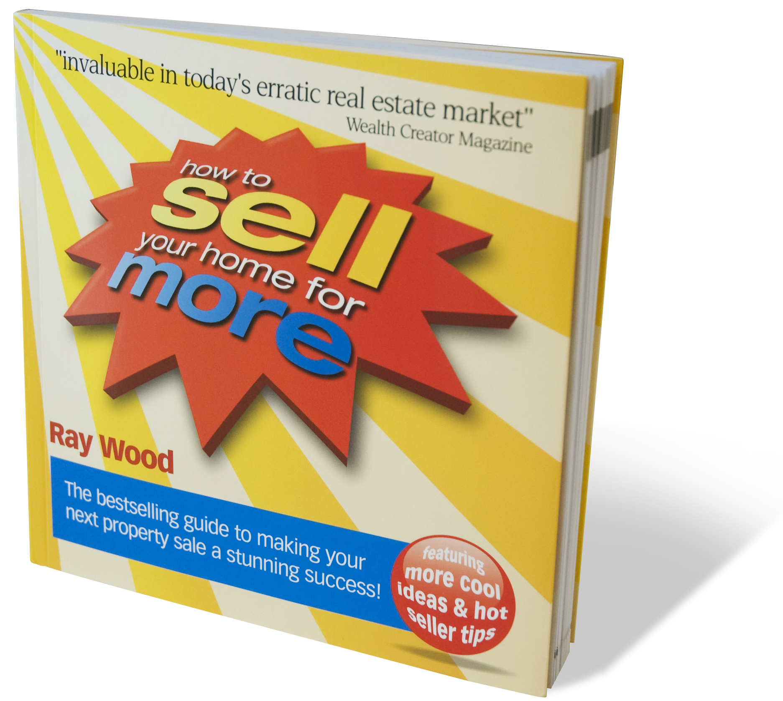
Dear Castle Hill Property Owner,

If you’re selling real estate soon, you might be interested to know your ultimate selling price is influenced by 5 key factors.

Every day property sellers risk ‘under-selling’ because they ignore the 5 essential factors that combine to create a great result.

However, every property seller has the power to influence their selling price and now with the help of this best selling real estate ‘How To’ guide, it’s never been easier.

How To Sell Your Home For More has helped over 200,000 property sellers achieve a higher sale price and it will do the same for you.

This best-selling How To Guide is essential reading and available on Amazon.com for $29.95. However, we’ve been able to secure a limited number and would like to offer you a copy with our compliments.

All you need to do is call our office on (mobile number) and mention you received this special offer.

Kind regards,

Alex Hall
LJ Hooker Castle Hill

PS: Free Copies of the book are limited so please call (mobile number) now to secure this offer

“A ‘How To’ Gem” The Age

“….a must read for intending property vendors”
The Australian Financial Review

“….offers readers very simple strategies for buying and selling property that can save significant amounts of money…. invaluable in today’s erratic real estate market.” Wealth Creator Magazine

“We saved $100,000 by learning real estate’s trade secrets. How To Sell Your Home For More was a guaranteed shortcut to success. Well done and many thanks.”
Paul and Jo Hickman

“We have just sold a property for 1.6 million dollars. The advice and suggested guidelines in How To Sell Your Home For More worked perfectly for us. I’m sure no other selling method would have achieved such a great result.”
Ken Morris

“How To Sell Your Home For More is every property seller’s dream come true. A tip to every page. A simple, practical and easy to read manual that every property seller will benefit from. The feedback from my clients has been fantastic.”
Murray McLean. Financial Planner

“I followed the steps set out in How To Sell Your Home For More and it seemed to have all the answers. I’m sure I achieved a result that was at least ten percent higher than I would have otherwise achieved. The book covered everything from presentation of my home to agent selection. My property sold in less than a month for a great price.” Jodie Blight

“Getting the best price for my property was extremely important to me. I only had one chance to get it right. The How To Sell real estate book broke everything down into simple steps. I just followed the steps to a great result.”
Fraser Martin

“Thanks for getting me a copy of your amazing book (How To Sell Your Home For More) I can see how it has truly added dollars to my sale price. The presentation suggestions are so effective. I’ve read dozens of how to property books but yours is by far the best. Thanks for everything!” Pamela Darling

“WOW! I had to see it for myself to believe it! How To Sell Your Home For More has changed the way I look at selling (and buying) real estate. In tough market conditions, the process, as explained in the book, worked brilliantly. Thanks for the best real estate experience I have ever had.” Mark Borthwick

