THE WINSTON CHURCHILL MEMORIAL TRUST OF AUSTRALIA

2015 Churchill Fellowship
Report
by
Ms Bronnie Mackintosh

PROJECT:

This Churchill Fellowship was to research the recruitment strategies used by overseas fire agencies to increase their numbers of female and ethnically diverse firefighters. The study focuses on the three most widely adopted recruitment strategies: quotas, targeted recruitment and social change programs.

DISCLAIMER

I understand that the Churchill Trust may publish this report, either in hard copy or on the internet, or both, and consent to such publication.

I indemnify the Churchill Trust against loss, costs or damages it may suffer arising out of any claim or proceedings made against the Trust in respect for arising out of the publication of any report submitted to the Trust and which the Trust places on a website for access over the internet.

I also warrant that my Final Report is original and does not infringe on copyright of any person, or contain anything which is, or the incorporation of which into the Final Report is, actionable for defamation, a breach of any privacy law or obligation, breach of confidence, contempt of court, passing-off or contravention of any other private right or of any law.

Date: 16th April 2017
Table of Contents
INTRODUCTION 4
EXECUTIVE SUMMARY 5
PROGRAMME 7
JAPAN 10
HONG KONG 18
INDIA 22
UNITED KINGDOM 31
Staffordshire 41
Cambridge 44
FRANCE 45
SWEDEN 47
CANADA 48
London, Ontario 48
Montreal, Quebec 51
UNITED STATES OF AMERICA 53
New York City 53
Girls Fire Camps 62
Los Angeles 66
San Francisco 69
Atlanta 71
Conclusions 72
Recommendations 73
Implementation and Dissemination 74

INTRODUCTION

I’ve been a firefighter with Fire and Rescue, NSW for 15 years. When I joined in 2002
I had no idea of the opportunities that would be created by simply doing something that I loved. I maximised these opportunities by working at different stations, changing roles and playing sport on Fire Brigade teams. I became interested in fire service diversity after attending a Women in Firefighting forum in 2006.

In 2012 I attended the Women and Firefighting Australasia (WAFA) conference in Adelaide and decided to “do more” after listening to female presenters from other Australian fire services. I joined WAFA, became a board member and the following year became President. The learning was exponential and I thrived in a network that was informative, empowering and committed to promoting and supporting diversity throughout the firefighting sector. In 2014 I became a Station Officer and made a conscious decision to explore “doing more” by attending and presenting at industry conferences.

Recognising the global trend in fire service recruitment, and the increasing expectation for more efficiency and community accountability, I applied for and won this Churchill Fellowship. This incredible honour and inclusion in a unique global fraternity, reflected a junction of my passion for difference, commitment to culture change and courage to step up and be part of a solution.

Like most fire service change, recruiting for diversity is challenging and emotionally charged. My intent is to provide information that helps our leaders ensure future sustainability. In doing so, I hope that greater understanding also leads to greater acceptance of the changes we all face as our fire services evolve.

I discovered that fire services around the world are all facing similar dilemmas in adapting their internal cultures whilst broadening their roles to serve changing communities. There is a lot of uncertainty and a diverse workforce is just one aspect of a myriad of changes we can expect. This trip and compilation of experiences has confirmed for me, that diversity at all levels in our organisations is imperative for navigating the other economic, operational and cultural changes we face.

I wish to acknowledge the unyielding support, encouragement and leadership of FRNSW Commissioner Greg Mullins, AFSM, (retired) for providing the professional reference and guidance for this Fellowship.

EXECUTIVE SUMMARY

Bronnie Mackintosh Bronnie.Mackintosh@fire.nsw.gov.au
Station Officer, Fire & Rescue, NSW

My Churchill Fellowship was to research the recruitment strategies used by urban fire agencies to increase their numbers of female and ethnically diverse firefighters. My travels encompassed Asia, Europe and North America to study quotas, targeted recruitment and social change programs as ways to recruit for diversity.

Highlights
- Making connections with firefighters and officers from all around the world
- Meeting Nirma Chaudhary & Sita Khatik in Rajasthan, India
- Marching with London Fire Brigade in London Pride
- Presenting to Chief Masse & the Executive leadership team of Montreal Fire Dept
- Touring the 9/11 memorial with Brenda Berkman
- Learning from all the representatives of Affinity/Support groups: Toshiko Hasegawa, Dany Cotton, Sally Harper, Nicola Lown, Susanna Klatt, Mona Hjortzberg, Anik St-Pierre, Louise Hine-Schmidt, Sarinya Srisakul, Regina Wilson, Aisha Krieger, Julie Mau
- Seeing my former campers from Camp Blaze volunteering as fire training instructors

Recommendations
- Develop a Government-directed national framework of recruitment targets
- Make diversity targets KPIs and selection criteria for management and promotion
- Use the three recruitment strategies (quotas, targeted recruitment and social change programs) in combination for sustained results
- Use data analytics and metrics to capture recruitment & retention information and understand barriers to equity
- Implement lateral entry or merit promotion for fire officers that recognise tertiary qualifications and external experience
- Provide youth programs such as cadet programs, work experience & girls’ fire camps
- Create and support internal networks and affinity groups that drive recruitment, community engagement & employee support
- Create visual representation of female firefighters in toys, books, videos, children’s television shows and cartoons
- Invest in targeted marketing and promotional resources using media appropriate to the target demographic

Implementation & Dissemination

- Australasian Fire And Authorities Council (AFAC) & Women And Firefighting Australasia (WAFA) Conferences 2016, Brisbane – Stepping Up & Standing Out.
- Fire Department Instructors Conference (FDIC 2017, Indianapolis) where I will be co-presenting a 4-hour workshop on “Stepping Up & Standing Out”, sharing world’s best practice & facilitating personal development tools for contributing to culture change and inclusion.
- I-Women 2017, Indianapolis – Speaker presentation on taking personal responsibility for inclusion.
- Japan Firefighter Women’s Conference (JFFW), June 2017, Kyoto.
- Research partnership with Monash University to further qualify and quantify the efficacy of the girls’ fire camps.
- Business case in draft for a girls fire camp in 2017
- Commitment to present at Fire Service Diversity Forum in Montreal, June 2017
- Academic journal articles and conference presentations
- Continued social media presence on Girls on Fire Facebook page https://www.facebook.com/GirlsOnFireTour/ and Utube channel https://www.youtube.com/channel/UC44kgZkGoka0rsc1RWVUXNA

PROGRAMME

My fellowship trip was eight weeks in total. I departed Australia for Tokyo, Japan on June 1st and conducted my last interview on July 28th in San Francisco, USA. Notably, both of these cities have had recruitment strategies that complied with government or court mandated quotas and consequently have two of the world’s highest percentages of female firefighters.

My aim was to investigate the three most widely used recruitment strategies and explore which could be described as “best practice”. My programme took eight weeks and consisted of an extensive itinerary that took me around the world. A number of fire departments had used more than one strategy and additional research I gathered provided information on how the chosen strategy had impacted cultural inclusion. The three most widely used recruitment strategies are:
- Quotas
- Targeted Recruitment
- Social Change Programs

The journey itself was an evolving network and a side outcome was being a conduit to connect people working in the recruitment and diversity space in each of my research destinations. It was obvious that everyone was facing similar issues with varying levels of financial, government and social pressures.
I chose a broad mix of fire services, from technologically advanced places like Tokyo and Sweden to the technologically challenged departments in rural India. I sought out the UK knowing that the majority of our processes and culture had evolved from the British system. I especially wanted to look at quotas and how this forced measure impacted inclusion. Targeted recruitment has been the accepted strategy here in Australia, but we lack data that accurately measures its success. I coined the term “Social Change programs” to be strategies that altered the public awareness of a firefighter’s role and appearance, as well as exposed potential candidates to the viability of firefighting as a career.

Below is a table that lists the fire departments and places I visited, the key people I met with or interviewed and the broad outcomes from what I had learned.

Places Visited and Key Outcomes
Country | Location | Contact Person | Key Outcomes
Japan | Tokyo Fire Dept | Kenichi Saeki | Quotas, Government policy & employment law
June 1-4 | Tokyo Fire Dept Training Academy | Masayoshi Tsuchiya | Residential requirements a barrier for women
 | Azabu Fire Station | Chief Satoko Sugimoto | Quotas, Visual Representation, Women in leadership
 | Japan Women Firefighters Network (JFFW) | Toshiko Hasegawa | Quotas, Support networks, JFFW
Hong Kong | Hong Kong Fire Dept | Anna Wu; Ka-wai Shen; Patrick Ng | Social status of firefighting as a career; Officer entry pathway
June 4-8
India | Mumbai Fire Brigade | Shubhangi Mandale | Govt quota 33% for all government jobs
June 8-13 | Tamil Nadu Fire & Rescue | Meenakshi Vijayakumar & Priya Ravichandran | Officer entry pathway
 | Rajasthan Fire Service | Nirma Chaudhary & Sita Khatik; Mahendra Kumar; Fire Chief Sanjay Sharma | Govt quota 33% for all government jobs
United Kingdom | London Fire Brigade | Dany Cotton | Positive Action Programs, Targeted recruitment for leadership development; Diversity & Inclusion Policy. Visibility in community events eg London Pride.
June 14-26 | Women in Fire Service (WFS) network | Dany Cotton, Nicola Lown & Sally Harper | Women's Support Network & training weekends
 | Staffordshire Fire & Rescue | Becci Bryant; Diane Dunlevey | Targeted recruitment, Equality Impact Assessments
 | Cambridge | Dr Dave Baigent | Cultural Change, Fitting In; Cultural Audits
 | East Sussex Fire & Rescue | Nicky Thurston | Equality Impact Assessments
 | Leicestshire Fire & Rescue Service | Andy Parkin | Support groups, Equality & Diversity Inclusion
France | Marseille Fire Brigade | Christophe Albert | Mandatory fitness testing, Alternate duties
June 27-30 | ENSOSP | Sylvain Rogissart

Sweden | Sodertorns Fire Department | Mona Hjortzberg & Sylvia Friden | Targeted recruitment, Support networks
July 4-6
Canada | Camp FFIT | Alison Vickerd | Girls Fire Camp as social change program that helps prepare women for recruitment
July 10-16 | Vaughan Fire Department | Chief Deryn Rizzi | Targeted recruitment
 | Montreal Fire Department | Chief Francoise Masse; Union Diversity group | Presentation to Executive leadership team; Panel discussion about recruitment & inclusion.
 | Fire Service Women Ontario | Louise Hine-Schmidt
USA
New York | FDNY | Laura Kavanagh | Targeted recruitment; Court mandates, social change programs
July 17-18 | United Women Firefighters | Sarinya Srisakul | Infinity groups & targeted recruitment
 | Vulcan Society | Regina Wilson | Infinity Groups; Court action
 | 9/11 Memorial | Brenda Berkman | Court action; Resilience
 | Phoenix Society | David Lin | Infinity groups & targeted recruitment
Fire Camps | Camp Fully Involved, New Hampshire Fire Academy | Jess Wyman | Social Change programs
July 19-23 | Camp Phoenix, Utica Fire Department | Andrea Sudjapun | Social Change programs
 | Camp Blaze, Washington State Fire Academy | Janet George | Social Change programs
California | San Francisco Fire Dept | Aisha Krieger, Julie Mau; Chief Raemona Williams | Quotas, Inclusion;
July 25-28 | United Firefighter Women | Julie Mau | Infinity groups
 | Los Angeles Fire Dept | Chief Alicia Welch, Capt Monica Hall | Targeted recruitment, Cadet programs
 | LAWFS | Tamara Chick | Infinity groups

I was also able to take interested followers along on my journey. I created a social media presence for the whole project called Girls on Fire and used Facebook, Instagram and Twitter to share, educate, connect and celebrate everything along the way. Check out the page at https://www.facebook.com/GirlsOnFireTour/ or else enjoy my highlights reel.

I have reported my research, experiences and learnings in order and direction of travel. The style is narrative with further academic writing to be produced from this research.

JAPAN

A pre-Churchill visit to Tokyo in April 2016, facilitated the building of a relationship with the Tokyo Fire Department. Culturally the Japanese build trust slowly, have rigid hierarchical processes and in general, do not have a culture of openly sharing their government information. This earlier visit proved vital in facilitating the meetings with key people during my Churchill trip.

It was challenging to access sensitive information about the recruitment of female firefighters in the Tokyo Fire Department (TFD). There was a significant language barrier which limited a richer investigation of the impacts of their recruitment strategies, particularly the impact of their gender quota on inclusion.

The TFD is the second largest fire department in the world with 18,700 firefighters working across ten fire districts with 81 fire stations. There are 1200 female firefighters which accounts for 6.4% of their operational force. This is well above the national average of 2.5% and also above any urban fire agency here in Australia. TFD also has 250 female Station Officers and 100 Senior Officers. These significant numbers of women in leadership can directly be attributed to the recruitment quota that was implemented over a 20-year period commencing in 1972. The first female fire station Chief was recruited in 1972 and promoted to Chief in 2006.

The recruitment quota was imposed in 1972 by a government labour law enacted to provide more opportunities for women. In 2005, the quota was removed when the desired percentage of 5% was reached. During the initial years of the quota, women were mainly hired to work in the fire prevention section. This section is a large division which includes building fire safety, fire education and fire investigation. Women were hired as uniformed staff, however they only executed light duties and had little involvement with response operations.

Since 2005, the number of female recruits has remained static. The TFD continues to maintain their percentage of women through natural selection. Being a firefighter is considered a ‘good job’ for both men and women, and additionally, the attraction of government benefits for lifelong employment makes it competitive.

Notwithstanding the similar number of applications to Fire & Rescue NSW of up to 8000 per annum, the TFD selects between 700-800 as opposed to our 120. During my visit, there were 580 recruits including 56 women who were undergoing their 6 months residential training at the TFD Fire Academy.

TFD is one of the organisations that has multiple pathways of recruit-level entry with three separate categories based on academic qualifications.

The only other recruitment strategy used by TFD is to provide a general career information forum at high schools and colleges. They have previously conducted a recruitment information seminar at the Sports University with the vision of attracting athletes. They do not do ‘targeted recruitment’ specifically for women, but they were very interested to know more ways to attract women into the job. The Tokyo Fire Chief, Jun Takahashi has a 10-year plan to increase the numbers of women to 8%. The Chief considered this figure will be easily achieved without introducing new strategies.

In April, a new employment law was enacted to increase recruitment and promotion opportunities for women as part of a government strategy to promote economic growth. The Promotion of Women’s Career Activities (PWCA) requires both government departments and private companies to compile data analysis on their gender composition at all levels and develop action plans for improvements with quantitative targets. This programme then rewards compliant departments and businesses with a certification, giving them access to preferential treatment for government procurements.

The TFD policies for maternity and family-care leave seem well implemented and utilised. I was shown statistics for the numbers of men accessing paternity leave both before and after childbirth which proved the cultural acceptance for men accessing family-related leave. Both male and female firefighters are able to work shorter day-time hours until their children go to school. Internally and structurally, the TFD allows for more lateral movement between the various roles of firefighter. Staff are moved every 2-8 years and every fire station has its own administrative section staffed by 5-10 uniformed firefighters working a five-day roster. This provides options for both men and women to work various rosters and manage parental and family needs. It also creates movement which appears to foster healthy station culture and inclusion. There is no grievance process for being moved, you serve wherever the Fire Chief requests.

My visit to Tokyo included a day as a recruit firefighter at the Tokyo Fire Academy, meetings with the leadership group of the Academy and several instructors, a station visit at Azabu Fire Station, a panel interview with the TFD recruitment team and a dinner with the Chairperson of the Japanese Women Firefighters Association. My main contact was Kenichi Saeki, a non-uniformed officer in the International Affairs Branch who coordinated all my meetings and attended with me to translate. His generosity, professionalism, linguistic skills and sense of humour were exceptional.

The TFD Academy was run like a military operation. Large groups of recruits in a drill yard the size of two football fields, performed evolutions of new skills with military precision, shouting and counting. I felt like a royal guest as I toured the facilities with four instructors, a female firefighter Martha, and Kenichi.

Watching the voluminous numbers of recruits performing their skills in such an orderly, disciplined and boisterous way, was inspiring. I participated in their activities and enjoyed wearing their structural firefighting ensemble, a design which was tailored for smaller physiques than the Australian norm.

The novelty of the hose trolley gained my attention. This apparatus was a bike with a hose tray on the back for laying out a water supply line which I gave a test run around the yard. I participated in the self-rescue drill from their vertical rescue tower using a harness made from tied rope and an Italian Munter hitch through a carabiner. I liked the simplicity of the system though it may not have met our Australian code of practice.

After the physical activities and tour of the Academy, I met with the Director, Masayoshi Tsuchiya and his Assistant Director of the Academy. We discussed their intention to increase the numbers of women at the college as well as the social barriers for Japanese
women.
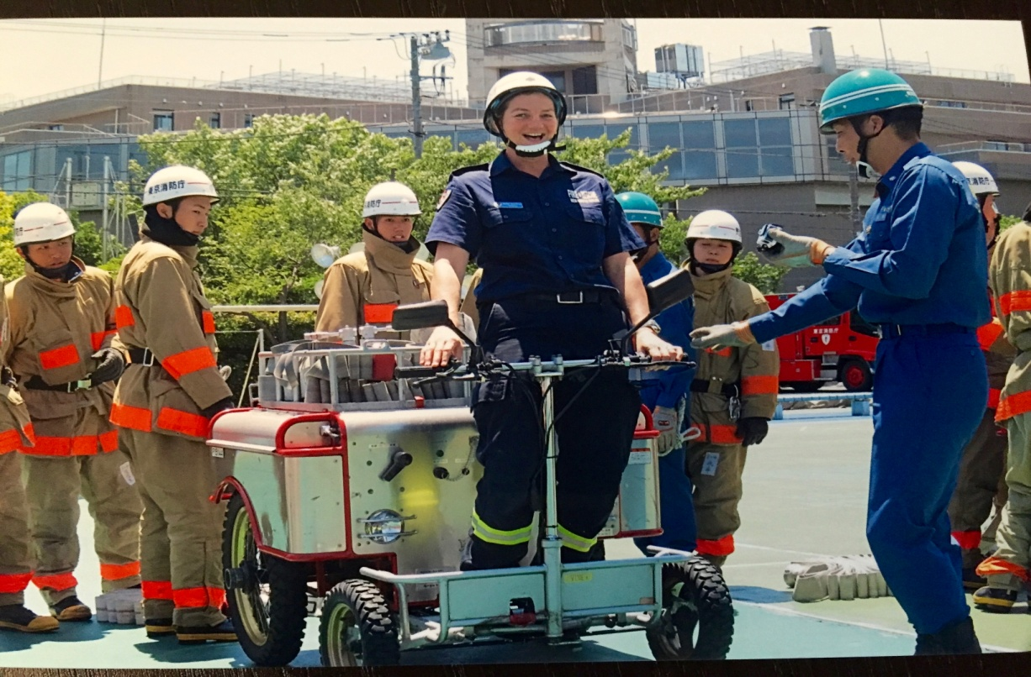

It appears the environment is difficult for the women due to the compulsory living arrangements for six months. Despite this, the recruits I met appeared to be very happy to be training. The nine female recruits I spoke with were very interested in my project and the Girls on Fire Facebook tour page. https://www.facebook.com/GirlsOnFireTour/
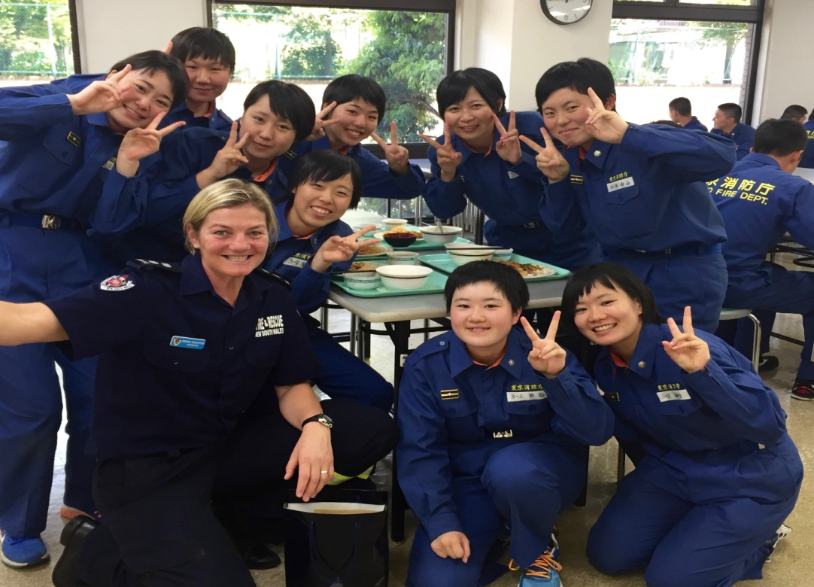

Joining the first of multiple lunch sittings, I learnt the academy has their own nutritionist who selects and plans the meals, provides quality control for all meals and monitors portion size. With the recruits living on campus and often doing ten hour days, the nutritional needs are significant.

Kenichi scheduled travel for us to Roppongi Hills and the Azabu Fire Station, arranging a meeting with the Station Chief, Toru Okamoto and a female Battalion Chief, Satoko Sugimoto. Navigating the Tokyo subway was an adventure in itself and I was grateful for having Kennichi to interpret the complex subway maps/

Azabu Fire station services the Roppongi Hills district, a relatively small station which has 140 personnel including eleven women. On this day, there were approximately 15 firefighters crewing the appliances with another 20 providing the administration and fire prevention services for the area. Chief Sugimoto, herself a pioneer and widely respected leader and mentor, had arranged a panel of female firefighters to speak with me and share their stories.

One of the women, Lieutenant Naoko Noguchi stated that more than 50% of all firefighters have a university degree prior to entry and that growing up with a female firefighter character in one of their children’s television shows had normalised the role for them. This visual representation of women performing the role fits the definition of a social-change strategy, although it had not been deliberately orchestrated.

One of the principal challenges experienced was the lack of facilities at most fire stations to accommodate women. At Azabu station, with a physically large building, the 11 women slept in a makeshift dormitory in the basement. It consisted of Japanese floor mats and partitions in a storage area of administrative paper files. Japanese law dictates that sleeping areas must be separate for men and women. However, a lack of financial resources has limited the modification of most fire stations.

Additionally, Japanese law limits the operational opportunities for female firefighters. Women are not allowed to respond to any calls of a CBR (Chemical, Biological, Radiological hazardous) nature. Consequently, they have never been deployed on an operational task force, such as the great Japanese earthquake of 2011, due to the lack of separate facilities and risk of exposure. Currently there are no women at any of the 10 rescue stations in TFD because none have been able to pass the physical test. At neighbouring Kawasaki Fire Department, the first female member of a rescue unit was appointed in April, 2016.

The female firefighters I met at Azabu stated they enjoyed their jobs and like us in Australia, joined the service for the variety offered by the role, to help others, the provision of long term security and conditions, and to use their tertiary qualifications which included degrees in psychology, paramedical science and fire investigation.
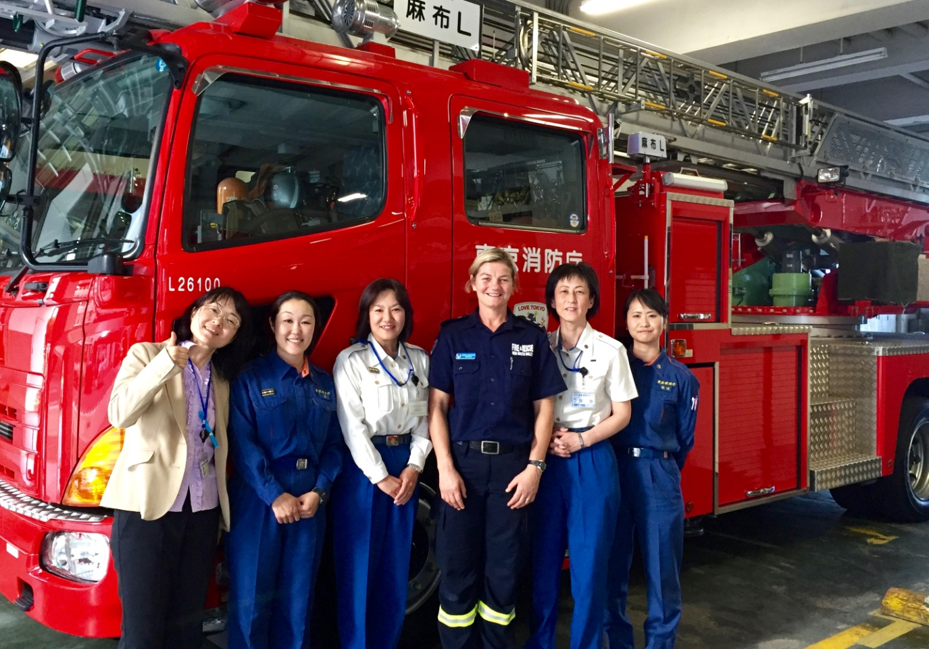
Chief Sugimoto and the female firefighters of Azabu Fire Station.

Chief Sugimoto stated the two prevalent issues for TFD for the recruitment of women is:
- the lack of facilities and
- inconsistencies in leadership committed to specifically targeting female applicants.

Upon meeting the TFD recruitment team, the Chief echoed some of the views I’d hear previously, that physical strength and government laws were a barrier for women. Remarkably, none of the female recruits perceived the six-month residential requirement a barrier.

One of my most significant meetings in Tokyo was over dinner with Toshiko Hasegawa, a firefighter of 32 years with TFD, who currently works in the Fire Prevention section. She is a member of the Japan Fire Fighting Women’s Network (JFFW) and is an involved mentor. Their association holds a national conference biennially with 200 delegates attending.

Toshiko is very connected with key stakeholders from around the world who are working to improve fire service diversity. She is involved with an annual cultural exchange between survivors of the New York 9/11 event and the 2011 Great (Fukushima) earthquake. In 2012 she met Brenda Berkman (See FDNY Report) and volunteered as an interpreter for her tour group involved in outreach mental health sessions. Toshiko previously volunteered in the recovery efforts after the 2011 earthquake, and seized the opportunity to be involved with such a meaningful exchange.

Toshiko’s proficient English and exposure to several fire agencies abroad, allowed an easy dialogue to share our experiences. She has worked in various roles, predominantly Fire Control and Fire Prevention, with aspirations to contribute to Community Safety with young people. As Chair of her women’s network, (JFFW), she stated her pride in facilitating opportunities for women to come together and learn from one other. She suggested that the rigid social expectations of gender roles in Japan, would extend the time frames required for regional areas to improve their gender equity scorecard.
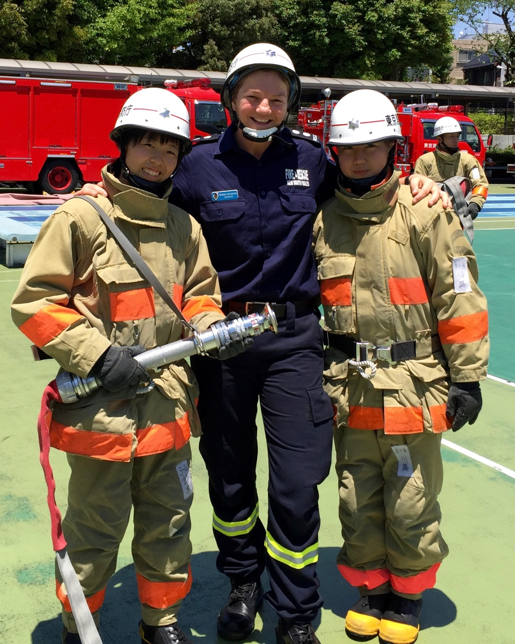

With two female recruits at Tokyo Fire Department Training Academy.

HONG KONG

I incorporated Hong Kong into my itinerary after reading an academic journal article written by Tam Tai-Keung. The article on the recruitment and selection of female firefighters in the Hong Kong Special Administrative Region is published by the University of Hong Kong <http://hdl.handle.net/10722/29549>. Hong Kong offers dual-entry pathways for firefighters and officers and has demonstrated typically low numbers of Chinese applicants in Australian fire services. I elected to explore these issues.

I met with the Recruitment Manager of the Hong Kong Fire Service (HKFS), Yeung Kai-wang, who explained they did not have a strategy to assist with the recruitment of women. Rather, the cultural issue of gender-appropriate roles in Hong Kong was the broadest barrier to the recruitment of female firefighters. Notably, all their recruitment and training literature referenced only the term ‘firemen’. Firefighting is considered a very general and low-valued job that most Hong Kong nationals do not want their daughter to do. Consequently, the Hong Kong Fire Service has zero female firefighters.

Conversely, it is different to becoming an officer in the department, which is viewed as a well-respected career. HKFS has 22 female officers, four of whom I met during my visit.

My first meeting took place at Tsim Sha Tsui fire station on the Kowloon side of Hong Kong. Two of the four female officers I met were the first women hired in Hong Kong 22 years ago. Despite some challenges with language, I was able to get a sense of the success of this recruitment strategy. The roles are considered to be different and an officer role deemed to be more suitable for women rather than the firefighter role. Fire officer candidates must obtain the same physical requirements as the operational fire fighter as well as pass a rigorous selection process. They undertake the same 12-week recruit training programme and then another 12-week officer development programme.

One of the women, Emily, aged 23 had just graduated from her officer training three months previously. Her father was also an officer. She holds a bachelor of arts degree and had spent some schooling years in the UK. Emily is stationed in the Hong Kong Command in the East Division and travelled a great distance to meet with us. She stated that other experienced women had greatly influenced and mentored her for this role.
Of her new career, Emily stated:

“There is lots of learn. My area has lots of elderly living there, dangerous goods storage so many combinations of jobs I will encounter. My first incident that I handled on my own was a vegetation fire that happened during a festival. It was only a small fire but still enough for my first one. The difficulties when I graduated from the centre was doing the paperwork. There is lots of administrative work. I am learning how to balance operations with administrative work”.

Madam Anna Wu, Deputy Commander of Kowloon South Division, was the first female hired as an officer and is Hong Kong’s highest ranking officer.

The female officers and the Yeung Kai-wang all agreed that culture and physical ability were the primary barriers to the success of females becoming firefighters. Culturally, the role of women remains linked to traditional life and they are either home-makers or they work in the markets, retail or food service industries. It is considered inappropriate for women to be in such a male-dominated workplace and be sharing common living spaces and amenities with men.

Physically, the women of Hong Kong are also not naturally built for the strength and fitness requirements of the job. Stereotypically, they are short, slight and possess minimal aptitude for aerobic fitness or sport. The recruitment manager said that female applicants have not been able to achieve the physical test. There are no development or support programmes to assist women with the physical preparation and no suggestion for any to be developed.

Conversely, the fire officer role provides separate living areas and amenities from the firefighters and it is considered more appropriate to lead and manage in the male-dominated workplace, as opposed to being at the same level. Similar to the backgrounds of Australian firefighters, the staff I met had strong sporting backgrounds. Of the four officers, two had been physical education teachers and one was formerly a corrective services officer.

Like Australian fire services, HKFS does not conduct any medical calls and at this stage not considering expansion into this role. Despite their communities being analogously diverse, they do not believe they need to pursue diversity in their workforce. Contrasting with Australia, they have mandatory fitness testing and are required to meet a graded fitness and strength test adjusted for rank every 12 months. If firefighters and officers fail the test they are given three months to train and be reassessed. In 2015, less than 3% required reassessment.

In addition to interviewing female fire officers and the HKFS recruitment manager, I was able to watch some on-shift search and rescue training in their engine bay. This was a very large station with 11 appliances and 120 firefighters (40 on each platoon). There were three rapid descent poles, a large shared sleeping quarters with no cubicles, walls or curtains, no recliner chairs or cable television. The entire station, including living and changing areas was spotless and well-ordered.

I was shown over the appliances and we discussed similarities and differences in our equipment. After touring Tsim Sha Tsui station, the newly promoted Station Officer, Madam Emily accompanied me to the New Territories (northern Hong Kong) where I had arranged another meeting with Divisional Officer, Patrick Tze Yuen Ng. (Divisional Officer is our Superintendent equivalent). Generous with his time, he showed me around his district, hosted us for lunch and discussed our NSW recruitment strategy of 50:50 recruit classes. He confirmed that culturally in Hong Kong, it is not acceptable for women to be firefighters.

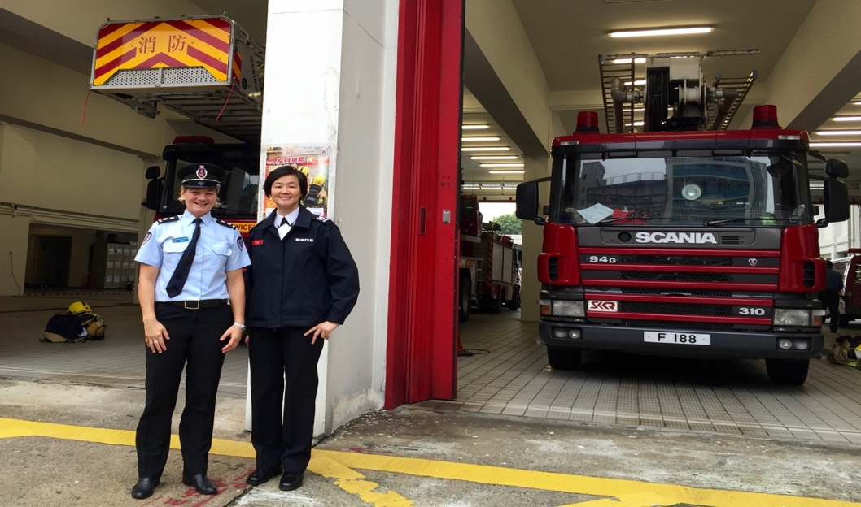
Divisional Officer, Ms Anna Wu is Hong Kong’s highest ranking officer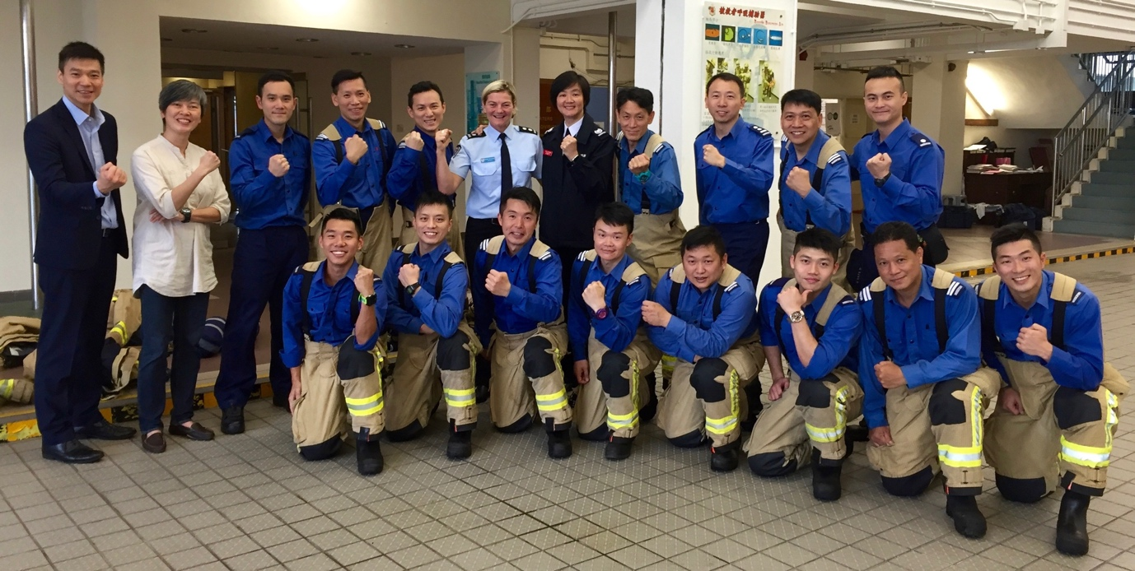
The two first female fire Officers of the Hong Kong Fire Department: Ms Anna Wu (middle) and Ms Shan (left) with firefighters at Tsim Sha Sui Fire Station.

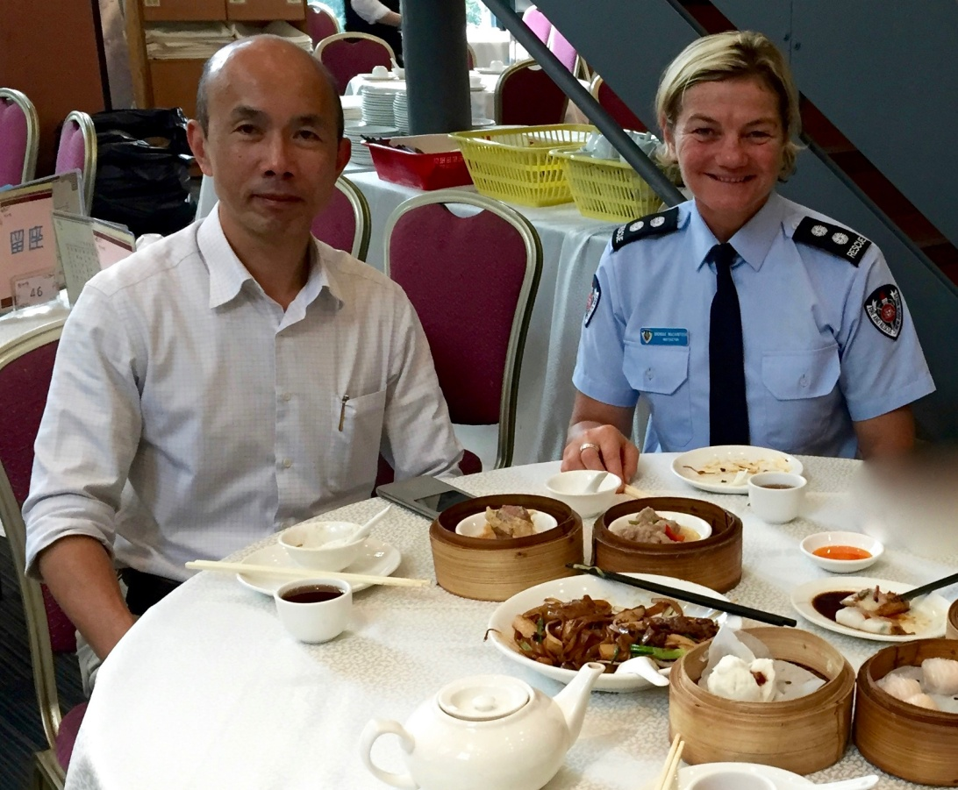

Mr. Patrick Tze Yuen Ng, the Divisional Commander in Tuen Mun of the New Territories (northern Hong Kong).

INDIA

India was included on my Churchill itinerary because the Government in a number of states are using quotas as a recruitment strategy to ensure fire services include women in their operational workforce. These quotas are generally set at 33%, and require women to fill this proportion of all government and administrative roles. These initiatives are aimed at improving the employment and social opportunities for women.

India’s patriarchal society is dominated by a discriminatory class system. This was a progressive attempt by the Government to raise the social position of women. This 33% quota extends to the Government-based fire agencies and the Government commission undertakes some targeted recruitment to provide access for women living in rural villages. My research in India was limited to some social media about the new quota in the northern state of Rajasthan where 65% of women from rural areas are sold as child brides. The Jaipur Fire Service had just recruited its first female firefighters in 2015.
It was very difficult to access information regarding these new recruitment policies due to the language barriers and bureaucracy. I therefore travelled to areas of India where I had found some evidence of the recruitment of women.

Relevant to researching India, was the provision of some insight into barriers for recruiting both men and women of ethnic diversity in Australia. Statistically we do not have many applicants of Asian ethnicity, hence my research to further understand whether this is because of social or structural barriers. With extensive research supporting the need for our fire service to reflect our community to provide better engagement, it is an issue we need to explore in further depth and breath. I visited three Fire Services in India: Mumbai Fire Brigades in Mumbai, Tamil Nadu Fire & Rescue Service in Chennai, and Rajasthan Fire Service in Jaipur.

The recruitment strategy to recruit 33% women was in stark contrast to what I experienced on the operational side of these fire services. The quota itself, in terms of numbers, was efficient. In Mumbai, each class of recruits had the set number of women and the firefighters whom I spoke to at the headquarters fire station, all answered positively to the inclusion of women at their station. However, it was obvious that the women were not performing the same operational tasks as their male colleagues and were steered into more support roles or developed for officer positions. Mumbai itself was completely chaotic in every aspect of its existence. The density of population, traffic, dilapidated buildings, pollution, poverty and generosity was overwhelming to experience.

Driving to the Fire Brigades headquarters was more thrilling than any theme park ride and all of my hard-wired risk management conditioning had to be left at the hotel. I could not close my eyes for fear of missing anything, my neck was sore from making 270 degree rotations the whole way, with my stomach churning from the visual overload both inside and outside the vehicle.
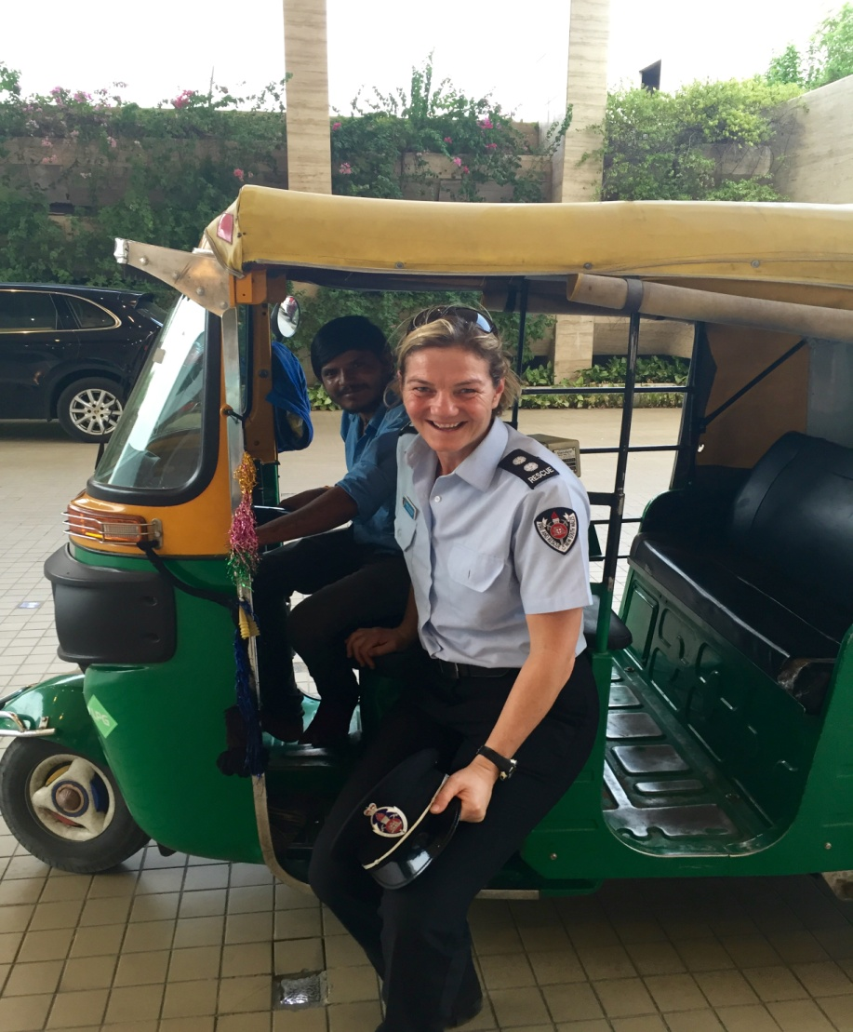

Every form of transport in India was thrilling but I especially loved the travel by rickshaw.

Headquarters was a step back in time, with the appliances originating from the 1960s and mostly donated from other fire services. Operating systems for call-outs were manually intensive and they still used rotary telephones. With no building codes, almost no installed fire protection, overcrowded dwellings and lots of open fire cooking, the department was very busy. This demand however was not met by adequate resources and the extinguishment and safety resources for the firefighters were quite frankly alarming.

In Mumbai (Maharashta), I met with Assistant Station Officer Shubhangi Mandale who was recruited under the female quota and just recently promoted to the first officer rank. They currently have three female fire officers and 13 female firefighters. Despite the progress with women in firefighting roles, the recruitment process and fitness testing still seemed archaic and not reflective of the job.

When Shubhangi joined in 2012, she was required to run 800 metres in four minutes, jump 10 metres into a giant pillow and do some activities like discus throwing and long jump. She believes that there are many challenges for women undergoing training at the fire school. She said that there were no female instructors and that female recruits had to stop training when they menstruated.

I spent an afternoon touring the headquarters fire station in Mumbai and videoing the equipment and responses of their appliances. In their Fire Control Centre I witnessed an open room full of ringing rotary phones and firefighters answering them simultaneously, then operating an old switch board to respond the relevant resource. In a city that is over-populated with no building codes or installed fire protection, the fire response jobs are unyielding.

In Chennai, the Tamil Nadu Fire & Rescue Service seemed a lot more contemporary and in addition to the 33% quota, also offered lateral entry Officer positions. Tamil Nadu FRS was the first Indian fire service to recruit women. In 2003, women were permitted to take the highly competitive Government Commission examination. The highest-ranking candidates in this exam are offered officer roles in any of the Government departments. The first woman to be employed from the 2003 exam was Meenakshi Vijayakumar. Like all officers who enter at that rank, Meenakshi had an esteemed academic background and was previously an Assistant Professor of English at a tertiary college. When I met with Meenakshi, she was delighted to share her experiences as a woman in a fierce male domain and talked about the importance of networks and personal leadership development.

Her take on the use of a quota was that with social systems such as theirs, a forced manipulation of numbers was essential in order to create the necessary change. She had encountered little resistance on her journey because she had the credentials and capability to do the job and lead her teams. Her education and background meant she was more qualified than most of her colleagues and subordinates and she paid careful attention to her development as a leader in the field. She shared with me some great ideas and philosophies about leadership and highlighted her perception of gender influence in her role:

“Once you become an officer, you must think of yourself in this way. You are not a woman anymore. You are an officer.”

“Use the fourth dimension, your empathy. Bring life and that empathy to a situation. Bring that instinct within you. That is how you save your men. You tell them not to move when it is dangerous. And you talk to them. You bring them together.”

“It is not just about a man or a woman in leadership situations. A man can also make mistakes in his decision making. It’s not because you are a man that you automatically make good decisions.”

Her beliefs about building strength in the teams she leads:

“I bring them together for feedback sessions. Have your own input, hear from others and choose the best for the team. You might not always get the truth but that’s OK. Make your own informed decisions”.

“Women are strong. You can use your instinct, your work knowledge, your ability to multi-skill. Keep at it.”
“When you have people able to make the right decisions at the right time who also have the ability to communicate what you want at the right time, people do listen to you.”

I learnt about her personal leadership when I asked her if being recruited on a quota at officer rank was met with any resistance from her followers:

“The first thing to remember is people are going to doubt you. And people will think you are not going to do well. The second thing is they may not listen because the idea of listening to a woman is new to them. But the third thing, is if you are focused and serious and they want to get the job done, they have to listen to you.”

“Good leadership is understanding, communicating and most importantly, being strong in your position. You have to be strong, confident, prove yourself and believe in yourself to get the job done.”

Whilst in Chennai, I also met with Priya Ravichandran, a Divisional Fire Officer based at Headquarters of the Tamil Nadu Fire Service. Priya spoke extensively about the contribution to fire service reform by Chief Minister Jayaram Jayalalithaa (Jaya). Chief Jaya was instrumental in negotiating the implementation of women’s access to employment and social opportunities by way of Government quotas after previous success with a similar initiative in the Tamil Nadu Police Service.

The second stage of this fire service reform is to begin recruiting female firefighters. Meenakshi stated the recruitment strategy was to recruit gradually to ensure success for the change rather than risk setting women up for failure if implemented prematurely. It was evident that both these officers were well respected by their male crew and staff. Whilst I did not interview any of the crew working for the Divisional Officers, I spent four hours in Headquarters with Priya Ravichandran, during which time I witnessed the communication, tasking and rapport between her and ten employees. From that slight assessment, a high level of respect (for her authority and education) was evident.

Both Meenakshi and Priya were generous with their time and resources. They both arranged drivers to collect me for meetings and to tour Chennai. Meenakshi also arranged a guide to meet me upon arrival at New Delhi, when I travelled up to Northern India.
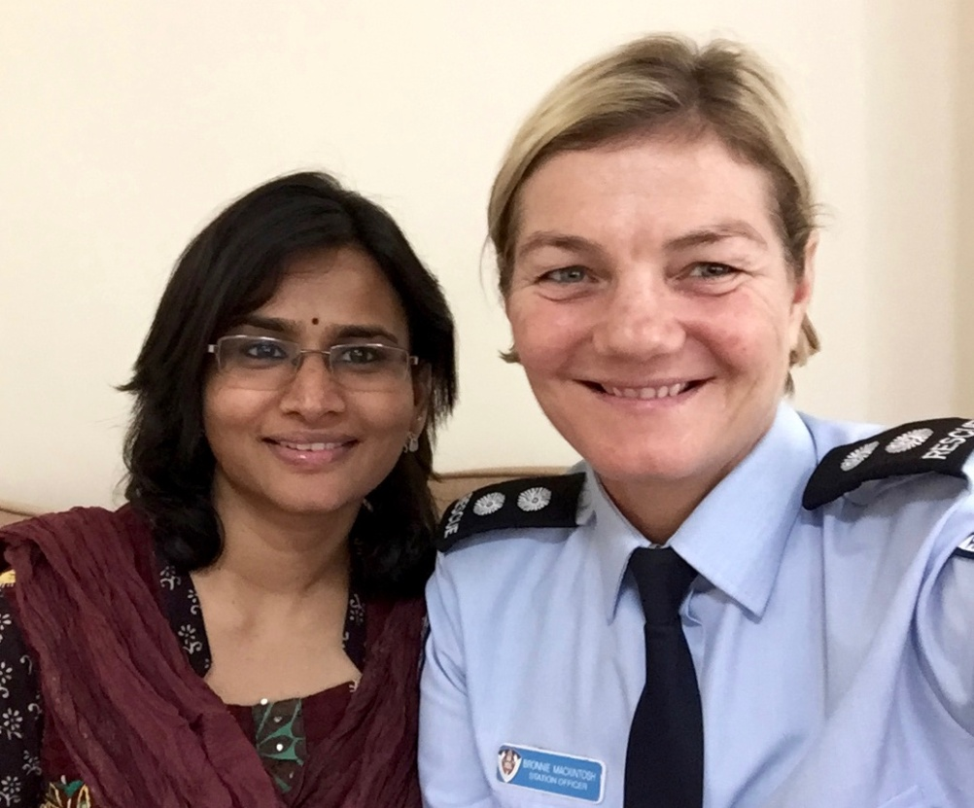
Priya Ravichandran from Tamil Nadu Fire & Rescue shared her leadership wisdom and taught me how to eat Indian food with my hands.

My final stop in India was in Jaipur, the capital of the northern state of Rajasthan where the 33% quota was implemented in February 2015. Now 155 female firefighters have been recruited for stations throughout the state. These firefighters included Nirma Chaudhary and Sita Khatik who had both been stationed at Nagar Nigam fire station.
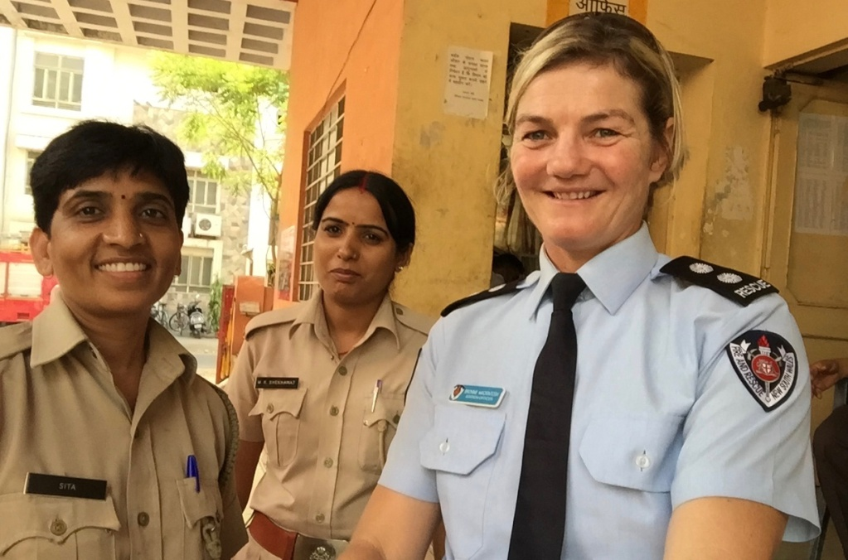
Meeting Sita Khatik and Nirmal Chaudhary in Rajasthan was a trip highlight

Once again language, transport and lack of online information made the mission challenging but so rewarding. Fortuitously, I arrived at Nagar Nigam fire station on the day that potential applicants were completing their final stage interviews. The station was full of young men hopeful of being hired. Thankfully, there was one recruit who spoke some English and was able to help manage the swarming of curiosity around me as a result of being a “strange white, female firefighter”, sweating in her dress uniform and tie in the 45-degree heat. His name was Mahendra Kumar and he became my translator for the visit.

I met both Nirma and Sita, however, due to a very limited ability to communicate, I was unable to inquire much about their experiences. I felt very emotional to meet these women and from what I experienced at their fire station, I could only imagine the challenges they face. They too were excited to meet me and be photographed. In a country where women’s workforce participation is only 22%, affirmative action policies have been imperative for dispelling sexist attitudes and dismantling customs like child marriage. Meeting the female firefighters of Rajasthan was one of my trip highlights.

I did ask Nirma Chaudhary if she had any different duties at the fire station to which she replied: “In a uniform, there is no man or woman, we are saving lives and work as a team”.
You can see a Documentary of Nirma Chaudhary’s journey from her rural village and salvation from a socialised pathway as a child bride here.

After lots of photos, swapping of hats and as many questions as possible (both to them and from them), Mahendra doubled me on his motorbike to his fire station about 10 km away. Weaving through the horn-happy traffic, I closed my eyes and imagined for 30 seconds what responding and working in their conditions would be like. I toured Mahendra’s station at Bani Park and enjoyed looking at the scant inventory of their 1960s fire trucks. Their primary response pumping appliance had one breathing apparatus (single set), five lines of hose and an axe.
I was so shocked at the lack of equipment and the age of appliances. Once again, the firefighters could not have been friendlier and they too enjoyed the novelty of my visit.

I met with the Chief Fire Officer, Sanjay Sharma. He arranged afternoon tea with two of his senior officers and we talked about the implications of the female quotas and how the female firefighters are being accepted. He clarified that the women are not doing all frontline roles but are mostly doing station work, community interactions and “small fire stuff”.

He explained that these initiatives give women opportunities they otherwise wouldn’t have which he said is good for India overall. The physical requirements were different for men and women and from what I could tell at all three services, none of the requirements were accurate reflections of the functional demands of the job. About the quotas he said:

“There’s nothing we can do, it’s mandatory by the government”.
“There are no issues and the men are helping the women to be able to do the job. It’s difficult sometimes because sometimes the women say they need to leave early or come later because of something”.
I assumed this inferred childcare and parenting needs.

I asked Mahendra what he thought about the recruitment of women and he and his colleagues believed it to be a good thing. They said:

“It is a good change and is helping to move our fire service forward because we are very behind in many ways”.

It appeared that female firefighters do not enter structure fires or attend frontline roles, where their physicality may be a limiting factor. I was unable to establish the cultural or capability reasoning for this, but since no one seemed to wear breathing apparatus and such limited personal protective equipment was used (other than a helmet and sometimes gloves), this was not surprising. None of the fire stations I attended were modified to accommodate female firefighters, except for separate toilets. The working roster for firefighters in Rajasthan is three by eight hour shifts, with women only allowed to work the morning and afternoon shifts.

Overall, it was challenging to gauge how effective the government quotas were and what improvements to service delivery were made by having female firefighters. Language and time prohibited any depth of understanding of how station life was affected, but it was evident that men and women behave and are treated very differently to one other. This disparity appears unlikely to change for some time.

I gained a sense that in Chennai, where highly educated and strong women are employed as fire officers, that women are improving the service delivery and capability of the service. Divisional Officer Meenakshi Viyakumar agreed, stating: “there is a need for women to be available to treat and help female victims and casualties. Women are the creators of life and therefore we are the preservers of life and should be there to help victims. Women have the empathy and protecting mindset to make the right decisions for helping people and keeping their crew safe”.

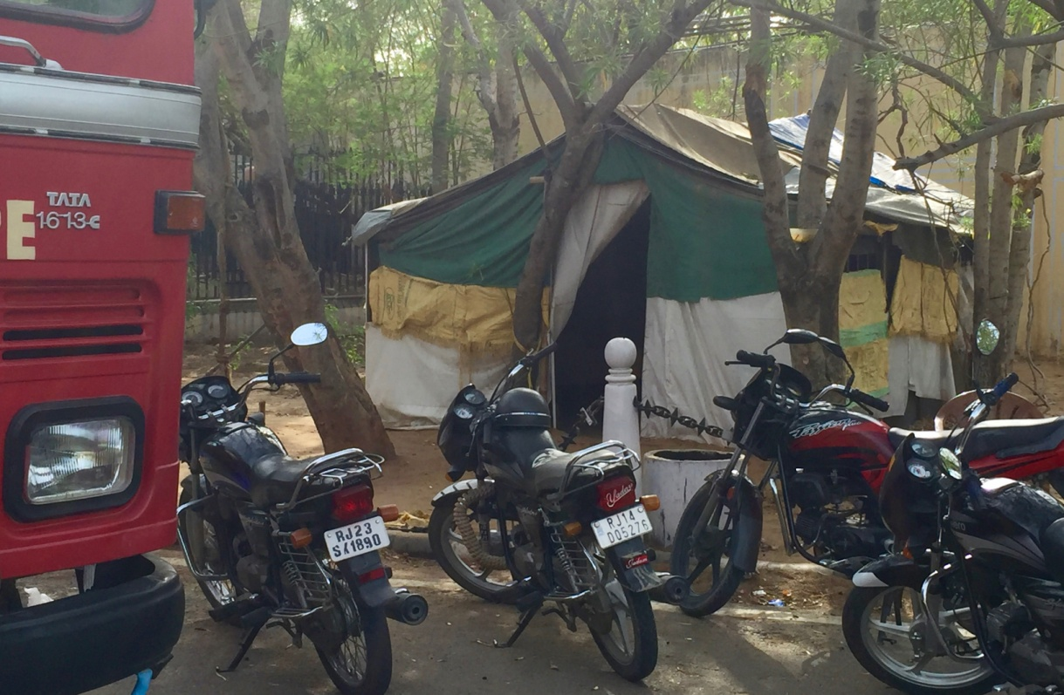
One of the out-post stations between Nagar Nagim and Bani Park fire stations. Firefighters were inside resting from the 45 degree heat.

UNITED KINGDOM

As described by former Her Majesty’s Chief Inspector of Fire Services, Sir Graham Meldrum in his foreword to Dalai Smiley’s Report on Diversity and Positive Action Programs in the UK, “ the journey to equality and diversity started with the cultural shift to prevention and community safety. This changing landscape of fire service roles and levels of engagement now requires the fire service to be part of the community. Thus, for this engagement to be effective, the service needs to reflect the people it serves”.

In England, I witnessed fire and rescue services making dedicated commitments to leverage diversity in the workforce for better engagement in the community and a more inclusive workplace for all. It is difficult to capture the varied experiences in a single synopsis because each UK service is different by size, structure & community. Best I can do is describe the parallels, the shared barriers, and highlight a few of the most impressive strategies I’ve seen for achieving diversity and facilitating inclusion.

Given our historical ties to the London Fire Brigade in practice and culture, and their history of positive action programs in Police & Fire services, I anticipated finding world’s best recruitment practice. Surprisingly, there was almost no current recruitment in any of the fire services throughout the country at this time. Recruitment, and, in some places, the whole diversity agenda, had been temporarily ceased due to government cutbacks and austerity measures.

In January 2016, the UK Fire Service was placed under the direction of the Home Office and prior to my arrival in June, the then Home Secretary Theresa May, announced her plans for major Fire Service Reform.

Ms May acknowledged the achievements of UK fire services in saving costs by closing stations and reducing personnel. Additionally, she stated her plans to improve accountability and diversity, and to remove the “toxic and corrosive culture in some parts of the fire and rescue services.” She further acknowledged the “fine traditions and profound affections” enjoyed by firefighters despite having “poor governance, a workforce lacking diversity and bound by many old ways of working.”

Generally, the fire service agreed that reform was needed, and as stated by the Fire Brigade Union General Secretary Matt Wrack for “an independent inspectorate to ensure accountability in a standardised fashion”. Mr Wrack noted that since 2010, 7000 firefighter positions have been cut and the diversity targets from the Positive Action programs were removed. Thus, signalling “that diversity was being downgraded.”

Parallel No. 1:
The fire service, as a government department is a political creature, subject to the agenda of the government of the day. Sometimes the more things change, the more things stay the same.

Barrier No. 1:
Consistency in diversity policies across fire Services. Objectively, it would appear prudent for the government to set diversity targets underpinned by key performance indicators.

Thus, due to no current UK recruitment, my research was directed towards the Inclusion Piece of the diversity issue, being critical for cultural change. Inclusion is a term used to describe the synergistic mixing of the personnel ingredients so that individual differences are massaged together to create a social capital that solves problems efficiently and makes communities safer. It’s well evidenced that diversity recruitment on its own will not provide the end state of inclusion for fire services.

Efforts by a number of UK Fire and Rescue Services have identified industry leaders with dedicated teams for diversity, equality and inclusion with embedded strategies for diversity within their workforce. These practices serve and protect diverse populations.

In April 2011, a measurement tool called Equality Impact Assessments was effected by the public-sector Equality Duty. This public-sector requirement emerged from the Equality Act 2010 to ensure public bodies consider the needs of all individuals with regards to shaping policy, delivering services for their employees.

Witnessing the extent of governance in support of equality and diversity was inspiring. The extent of such focus in the UK for community engagement and workforce inclusion was impressive. The narrow focus of recruitment through a statistical lens was expanded by a fish eye lens to expose the depth of work we still need to do in Australia and I believe, worldwide.

Some impressive UK services and people I experienced on this trip were in Staffordshire , Leicestershire and East Sussex Fire and Rescue Services. I imagine these smaller services are easier to mobilise for change than the larger services such as London, Tokyo and New York Fire Brigades. Nonetheless, it was evident that the values for equality and inclusion resonate at all levels of these services, not just spruiked at the top in response to legislative requirements.

My UK component included a training weekend, meetings with directors, diversity and inclusion officers, recruitment managers, station managers, firefighters, a Chief of department, several academics and a retired fire officer. I made a station visit to Croydon Fire Station in London, spent a day with the Staffordshire Fire and Rescue Service, did a road trip around England that took in Stafford, York, Cambridge, Gloucestershire and Brighton and marched with the London Fire Brigade in the London Pride march.

I was fortunate to be joined for most of this trip with a good friend from Montreal, Ms. Anik St-Pierre, an Instructor at College Montmorency, the firefighting college of the Montreal fire department, Service de Securite Incendie de Montreal.

What I was most impressed with in the UK, was how advanced they appeared with their policies and procedures for all matters regarding diversity and inclusion. The two services I spent the most time with, London Fire Brigade and Staffordshire Fire and Rescue, both had comprehensive equality and inclusion strategies and performance requirements pinned to promotion.

I planned the UK part of my trip so that I could attend the annual training weekend of Women in the Fire Service which is held at the national training centre, Fire Service College in Gloucestershire. Women in the Fire Service (WFS) is a UK Women Firefighters network with 374 members from six countries and representing 56 different fire services. Out of 56 UK fire services, 36 are member agencies. In my preliminary research, it was obvious that the agencies that were progressing their diversity agenda usually had strong links to support associations. Women in the Fire Service is one of the oldest such associations and is chaired by Dany Cotton, who has recently promoted to become the first female Fire Commissioner of the London Fire Brigade.

This was the 15th such training weekend for WFS and was an excellent networking opportunity for my trip. In meeting delegates from The Netherlands, Germany, Sweden, Switzerland, Canada and throughout the UK, I was able to expand my research. The programme had a mix of hands-on practical sessions plus theoretical & technical classes. The delegates were firefighters, fire officers as well as non-uniformed administrators and a lot of equality & diversity officers.
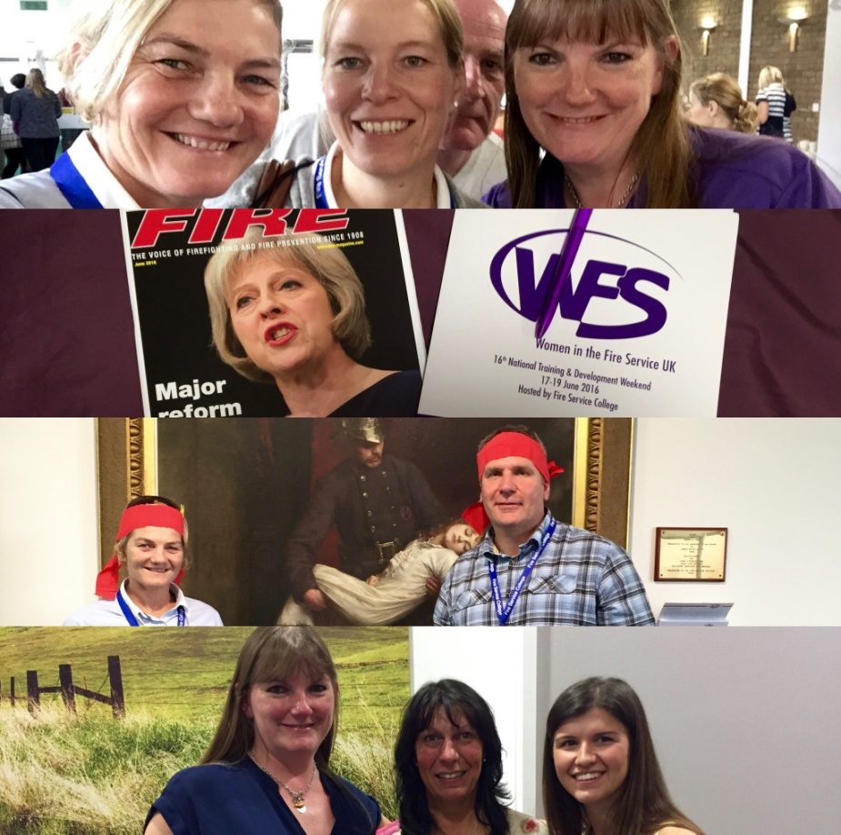

Many firefighters (both male & female) attend to develop their operational skills, try new skills which are unavailable to them in their agencies and work with subject matter experts to deepen their knowledge. The weekend also included group fitness sessions, teambuilding, facilitated networking and regional meetings in which geographically-grouped delegates discussed relevant changes, improvements and challenges. There were 12 international delegates for this meeting and we shared the progress our agencies were making and how we compared to others. Station Manager Nicola Lown facilitated our session and ensured we shared what has worked. Of particular interest from this session was the work of The Hague Fire Service in the Netherlands and the diversity recruitment initiatives being driven by their female Chief Commander, Ester Lieben.

During the weekend, I was able to interview Dany Cotton and another Station Manager Sally Harper, two pioneers of the London Fire Brigade who have led the change for female participation and diversity. They joined together in 1988 under a period of Positive Action Programs and were identified as potential leaders early in their career. As mentioned earlier, Dany has now progressed through the ranks to become the current Commissioner, undoubtedly the pinnacle of her 28-year career.

London Fire Brigade (LFB) has also invested time and resources into changing their internal culture by informing, educating and including all firefighters in open forums about changes the organisation is implementing. Over an 18-month period, the LFB have rolled these forums out to all firefighters and have found this to be one of the simplest and most effective supports for building staff engagement.

The idea for these groups was developed by two LFB officers as part of their Executive Leadership program. A number of stations meet at a central place with a trained facilitator (non-rank) and senior officer (to demonstrate leadership). The groups are mixed with firefighters of different ranks as well as support and admin staff. This approach has been rolled out to the entire workforce.

Dany and Sally were involved with these forums and said that no topic was off-limit and a lot of myth busting and educating was done. This gave everyone a greater understanding on why organisational changes were being made and because people felt valued and included in the process, changes were easier to make. Dany said that having this open-door policy and talking things through at all levels of the organisation went a long way in fostering a positive and supportive culture. Having the supportive culture has helped LFB to drive change particularly through a period of huge government reform and imposed austerity measures.

“It wasn’t always as open, free and perhaps useful as it is now”, Dany said, “In the beginning, people would go and not engage at all. A stumbling block was the low levels of trust within the workforce itself due to budget and staffing cuts. Everyone would sit with arms crossed and be resistant to talking for fear it would be used against firefighters”.

The continuous feedback loops were vital to the success of the groups and began breaking down the barriers between management and station-level staff. After 6 months, feedback reports confirmed that the engagement was done in a positive way. This allowed participants time to trust in the process as well as to be able to open up at their own pace. Sally agreed saying that “as a result, the talks that are going on now are so different. People are open and aren’t afraid to share their thoughts. People are coming forward with ideas. In some cases, it’s less a case of encouraging conversation as wondering when it will stop”.

Dany explained that firefighters will always feel a bit better about things if they’ve had the ability to converse, air their opinions, discuss their challenges and say what they feel. Facilitators made a conscious effort to ensure that all participants felt like they could share without the fear of being shut down through proper facilitation. As an additional outcome, Dany said the organisation got some really quick wins from the forums as well. Sometimes really valid suggestions were made that were taken and addressed. This also built trust that change wasn’t always negative and could be beneficial for all.

Sally explained that the approach was integral to the success of the forums. “This is feedback from the ground up. There is no preaching from facilitators or a senior officer in these forums. There will be messages and themes, but the discussions are inclusive. They give firefighters ownership of the solutions to organisational problems. For example, the last theme for discussion was on training. It gave firefighters opportunities to design their own training profile relative to their own personal goals. We also ask them about the future. We go armed with a blank sheet of paper and ask them what they want to see. Involving the people in the process of changing the role of firefighters helps get clarity.”

For the LFB, the intent was broader than just to address inclusion issues associated with diversity. The rationale is underpinned by future sustainability of the fire service and adapting to social and economic changes. The role has changed so much and firefighters are now doing work that was not in their original role. Because of the investment made with these forums, firefighters are more actively involved with fire prevention and community engagement because they understand the implications for outsourcing and job loss if they don’t build more connection with the community.

“Previously, people were asking why we were fitting smoke alarms. Now that doesn’t happen. Our workforce is even more proactive now about doing prevention work and getting on board with it. Apart from a few dinosaurs, everyone understands the need to do more work with the public funding. And that if we don’t we will do ourselves out of business. They relish the opportunity to do more, to be in the public’s homes, as a trusted partner”, says Dany. “Why can’t we be doing slips, trips and falls assessments for our community?

One of the biggest organisational changes recently implemented by the LFB has been doing medical support for the ambulance service. Whilst it has had large challenges, generally speaking, the firefighters are happier to be doing more work and maintaining an important community role. Again, attitude and choosing the experiences for the workforce make all the difference in the reinvention of the modern LFB, as Sally Harper explains.

“This is how people’s attitudes are changing. In some stations, it’s (medical response) not going down that well. It can be very hard for the people. They’re going to the wrong calls and as a result, it’s not a very positive experience. But the change in attitude is changing how we respond in these situations. Before you may have said it’s not a positive experience, it’s not right, let’s stop it, we’re not doing it. Now people are solution-orientated. Instead, it may be a case of saying ‘it’s not working, so can we have some more training, some more support’ and asking generally ‘how can we fix these problems?’ This is all because of a change in culture. The attitude is much more positive and open to doing things better.”

Dany Cotton has also witnessed a change in attitude and culture, attributed to an open-door policy of information sharing and workforce inclusion. “People are engaging with the problem. They’re not saying they don’t want to do it. They’re saying we want to do it effectively and in the right way. We want to be professional and don’t want to be there without the proper training or skills to support that”. The LFB is currently implementing programs for the added critical stress that firefighters will endure by co-responding with the ambulance.

Whilst I was visiting with the LFB they had just announced their first recruitment campaign in five years. Because of budgetary reform there had been no recruitment and all efforts were focused on the culture and transitioning the roles of firefighters. The organisation and roles within have become more professional, which has carried over into recruitment. Potential and future members of the fire service are seeing a different range of career options within the fire service and many are entering with tertiary qualifications and considering it a real career path.

As part of their targeted recruitment initiatives, LFB had a graduate entry program. Unfortunately, there was some cultural backlash to this positive action program by firefighters who weren’t accepting of firefighters who had come in on an accelerated program. In another targeted initiative, LFB ran a Target Development program aimed to develop people with leadership potential. Anyone could apply, but people were selected for their ability to be engaged with others and examples of community and team contribution. It wasn’t dependent on any exams. This was a successful program and Sally Harper was one of the candidates who promoted through it.

Dany and Sally both agreed that providing ongoing support throughout the careers of female firefighters is vital for promotional success. They have witnessed high success rates regarding promotion when there has been group information and mentoring sessions held in the lead up. These sessions are run by women’s support groups (WFS & Union-based support group) and all women are invited to discuss the process, anything they’re worried about. LFB management gives these sessions its full support by arranging meetings on shift time.

What I also found really progressive here, was that there are department-based support groups as well as union-based support groups. These support groups are well established for women, LGBT and BEM (black ethnic minority). They all work in collaboration with each other to ensure open communication and agreement on shared goals and outcomes. The management of LFB also commits resources to allow these groups to function. This support usually allows firefighters to come off shift to work together on solutions to identified
problems affecting firefighters. I see this as fundamental to the success of the support groups and have included this in my recommendations.

Dany demonstrated the commitment of the LFB executive leadership group in relation to the WFS training weekend. “London Fire Brigade has sponsored 45 delegates to come to this training weekend. Meals, accommodation and time off work are included. The Commissioner literally says ‘make it happen and do what you need to do.’ He’s that supportive of the Women’s Fire Service network and progress overall.”
Similarly, the department has been resourcing the Asian firefighters support group. The Asian Fire Services Association (AFSA) will have their conference in London later this year. The Commissioner has put 10,000 pounds into hosting and resourcing it properly. This kind of top-down leadership is instrumental in setting the platform on which to build a reformed culture.

Another important lesson that Dany shared was the failure experienced by employing external diversity and equality trainers. She explained the negative impact this had on firefighters because the non-uniformed staff were not well-received despite the quality of their content. This confirmed the intensity of the culture and that changes to it have to happen from within rather than from an external influence. Anecdotally, I heard from firefighters, that the most successful changes were those the firefighters had input to or been consulted in the process which made them feel heard and valued. I was amazed and humbled to see Dany and Sally leveraging off their positions and rank to do more for the greater good.
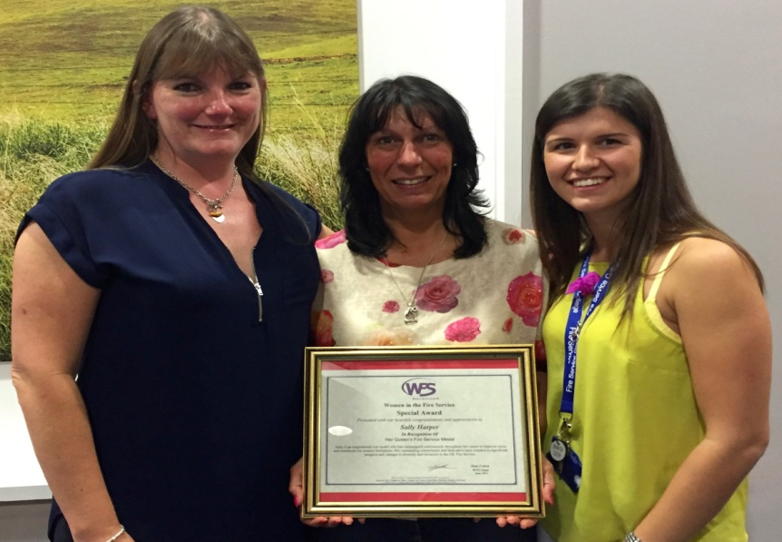
(L-R) London Fire Brigade Commissioner Dany Cotton with Sally Harper and Sally’s daughter Katie, also a firefighter in London.

While I was in London, the London Gay Pride event was on and I took an opportunity to march with the London Fire Brigade float. It’s one of the key fixtures on the diversity calendar and the London firefighters and their supporters rose to the occasion. Here I also met representatives from other UK fire agencies that are working in the diversity and inclusion space. One such male champion was Andy Parkin who is a Diversity coordinator for Leicestershire Fire & Rescue. He told me of the range of outreach programs they are running to ensure inclusion for all firefighters.

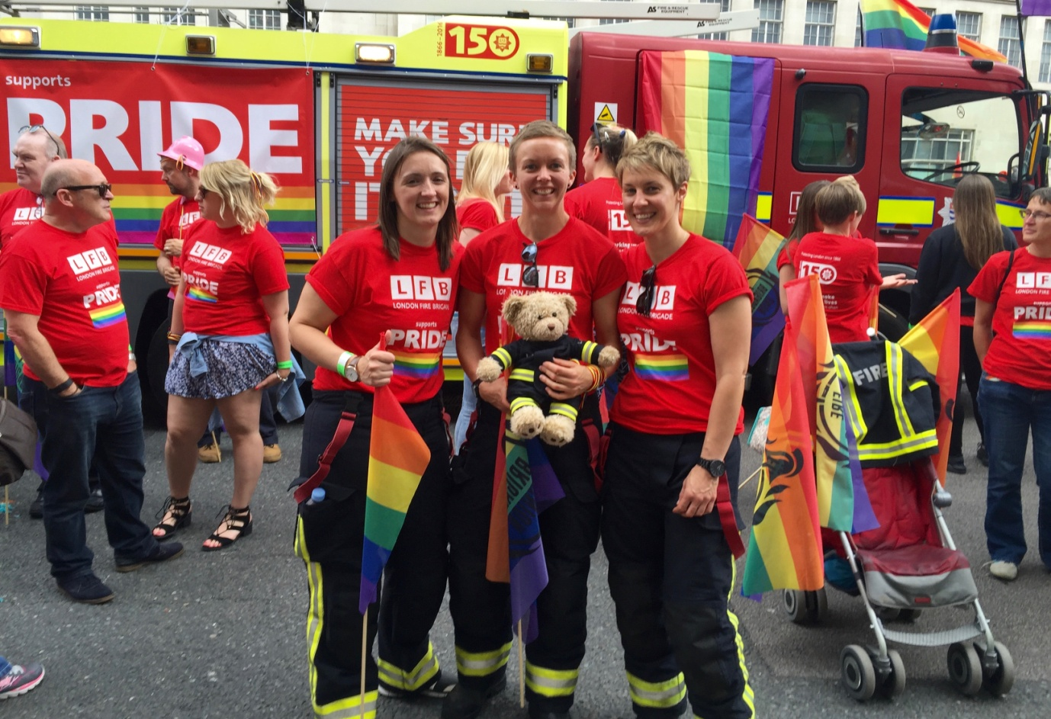

London Fire Brigade firefighters and their supporters at the start of the 2016 London Pride March.

Staffordshire

I spent a day with Staffordshire Fire & Rescue Service (SFRS) in the vastly diverse demography of the West Midlands region of England. I planned this visit after hearing the UK’s first ever female fire chief, Becci Bryant speak to a Women’s Development Conference hosted by South Yorkshire Fire & Rescue in 2015. Speaking as the Deputy Chief prior to promotion to Chief in April 2016, Becci said “there is no business case for diversity separate to our business. It is either the way we do things in our organisation or not”. She spoke about the many changes she had witnessed in her 22 years and made me think of this diversity journey as just one of the cogs turning in a slow moving machine towards effectiveness and sustainability.

Just like in London, the hiring freezes meant there were no active recruitment strategies. Instead there was an opportunity to see how the positive action strategies of the past had worked and how economic pressures were influencing change internally. It was here in Stafford, that the penny dropped for me about how diversity fits within fire service governance reform and community engagement. That diversity facilitates the shift from a response culture to one of prevention & preparedness.

“Moving to the prevention agenda where we are delivering outcomes on a daily basis that are changing people’s lives and improving health outcomes”, said Chief Bryant.
Here I could see evidence of the cultural shift to prioritise prevention whilst still meeting response requirements. In all published doctrine, from the Equality and Inclusion Strategy, to the Leadership Message and the existence of “Community Fire Stations”, SFRS are addressing equality and diversity within their main focus to change fire service culture.

Chief Bryant proudly reported that since the UK’s austerity measures were introduced by government reform in May 2016, SFRS have not had any compulsory redundancies or station closures. Their percentage of women sits at 8% and their numbers of ethnically diverse employees has increased due to hiring bilingual staff for fire prevention and community engagement.
Because of the significant numbers of Hindi & Pakistani speakers in the city of Stoke on Trent, SFRS have navigated the law to hire bilingual firefighters to speak to these communities. As part of the cultural inclusion piece, all staff wear the exact same duty-wear uniform and without any rank epaulettes.

Diane Dunlevey is the Equality & Diversity Manager for SFRS. In her 12 years she has seen the successes and failures of recruitment strategies. “I think in the beginning, we encouraged a lot of non-traditional people to join but then when they got here we treated them exactly like white men, the cultural norm. This led to a disconnect and many people left”.

Staffordshire also stood out for its collaborative relationships with other service providers. The Fire Service works closely with Police, Ambulance, aged care and government housing services to close “risk loops” in the community. During the big freeze of last winter, fire crews conducted “safe and well visits” and any risk factors identified were passed on to the relevant authorities. For example, medical and home safety issues were passed on to home care, housing department or the national health service. Other concerns were passed onto Police so as to mitigate the risk of possible emergencies in the future. This collaboration between the services not only prevented fire emergencies, but engaged the community to make their homes and families’ safer.

Another progressive engagement and recruitment strategy is their community engagement program that targets women as the key custodians for family safety. This one-day workshop/expo is free for all and showcases speakers and case studies that impact the lives of the residents. Another example of Staffordshire’s commitment to prevention and community engagement are their new Community Fire Stations, one of which I visited during my stay. These purpose-built facilities have a fire station on one side of the building and space for multi-purpose use by community and charity groups. This makes the fire station more accessible to the public and allows for much more engagement in prevention and preparedness.

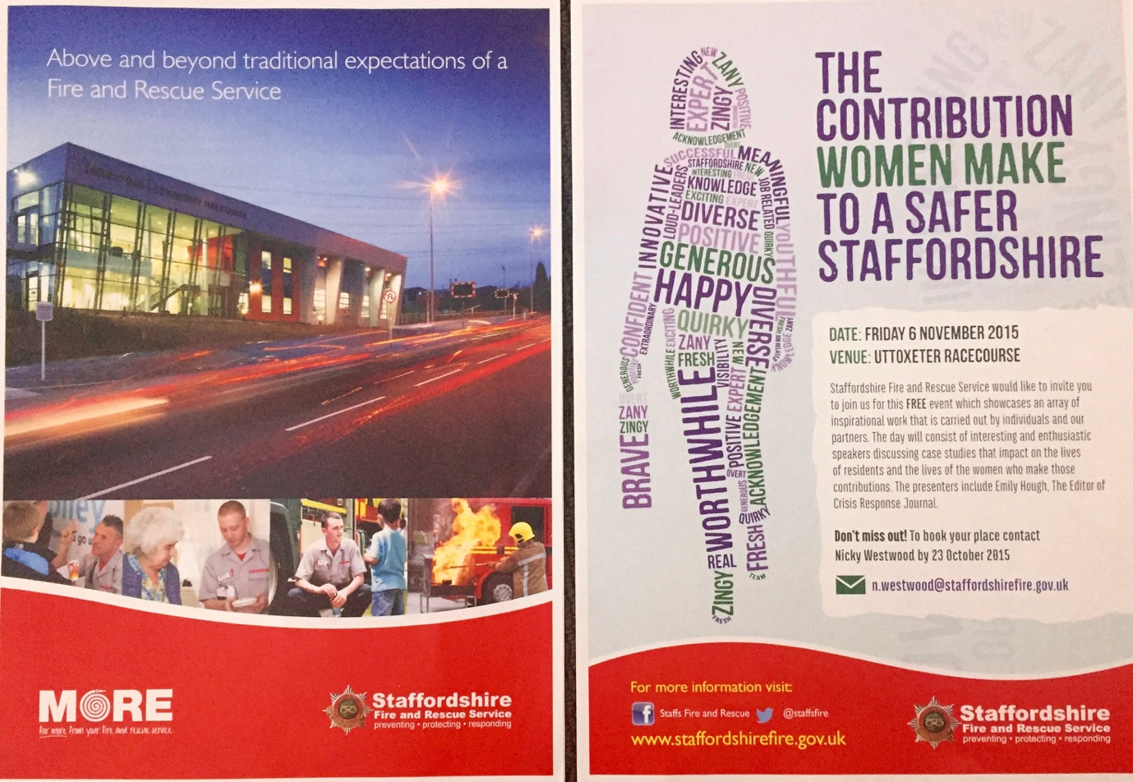

It was very evident that Chief Bryant’s leadership message is clear and creates a shared vision and purpose for all. “Moving to the prevention agenda where we are delivering outcomes on a daily basis, is changing people’s lives and improving health outcomes”.
“Whilst we have to segment our workforce for government reporting, our approach at Staffordshire is much more around creating an environment where everybody can be the best that they can be regardless of where they come from.”

Cambridge

From Staffordshire, my very English road trip meandered through academia. My learnings confirmed the importance of linking academic research to the problems so as to properly define the issues and measure the impacts of solutions. One of the most influential academics in the field of fire service culture and inclusion is Dr Dave Baigent.
Dr Baigent is now a City Councillor for Cambridge City Council but spent 31 years as a firefighter and fire officer with the London Fire Brigade. He also has a Doctorate from Anglia Ruskin University and wrote his thesis about fire service culture and the concept of “fitting-in” to the dominant white male paradigm. His work as an academic and organisational change consultant is world renowned and anyone who has researched gender and inclusion in the fire service knows of his work. Although our time together was short, he provided further references to guide my research and encouraged me to stay resilient for the arduous process of culture change.

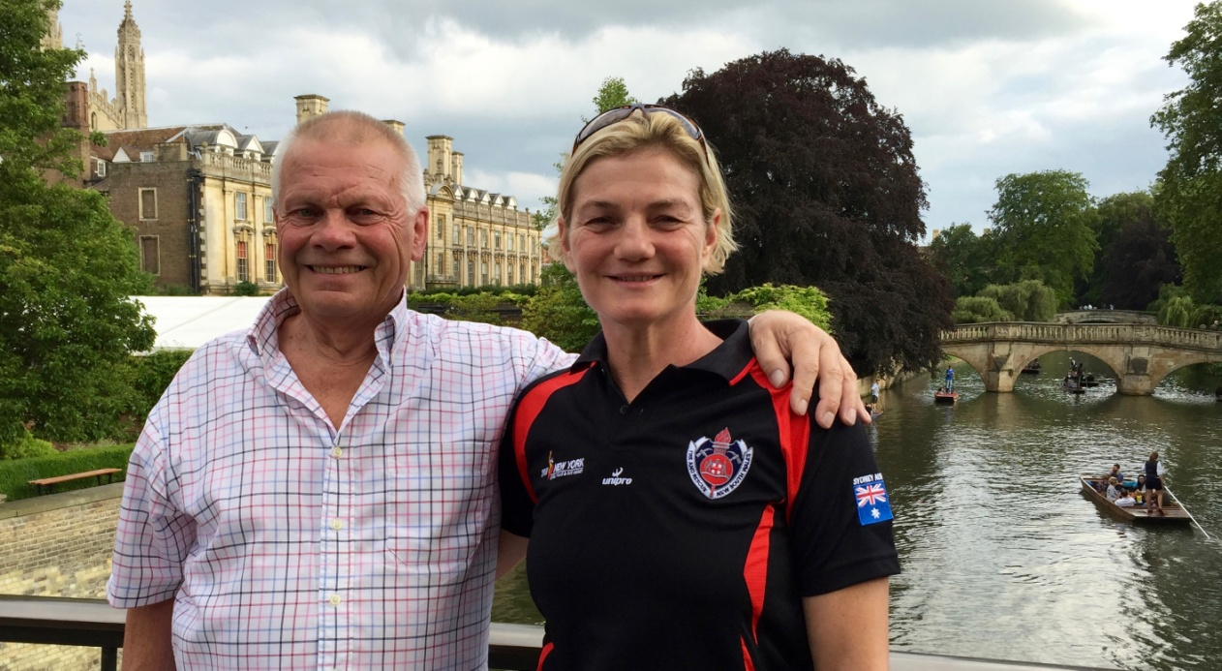

Dr. Dave Baigent at his home in Cambridge. Dave is a retired Station Officer from London Fire Brigade, a research academic and a Cambridge City Councillor.

FRANCE

I knew that France had some female firefighters but my preliminary research into their whereabouts was limited. Language again inhibited what I was able to find out but I was told that their national average is 4.8% for women.

There are three Fire Services in France – two provided by the military (Army in Paris, and Navy in Marseille) and one government service. In Marseille, the Fire Brigade is part of the Navy and is called Bataillon de marins-pompiers de Marseille, or BMPM.

There are currently 20 female firefighters out of 2000. Interestingly they have the most stringent physical fitness requirements with yearly fitness tests and firefighters can only stay operational until the age of 45. After they turn 45, firefighters are steered into non-operational roles such as training and fire safety.

BMPM are also very committed to performance management with all firefighters given a four-year renewable contract with the military. If at any stage the firefighter is not performing, or maintaining physical requirements, their contracts are not re-signed.

The physical requirements for entry into BMPM include a shuttle run (9 for women, 12 for men), 150 sit-ups, a timed 100m swim plus 10 m underwater, a 28 metre ladder climb at a 68-degree incline, a written psychology test and an interview. Although there are no female chiefs in Marseille there are three fire officers.

In Marseille, I visited with Christophe Albert who is a principal instructor at the Navy Firefighter School. All firefighters are accommodated in an apartment complex attached to the main fire station. Christophe also arranged for me to meet Sophie, a 26-year-old firefighter who has been in the BMPB for six years. Sophie worked as a volunteer prior to seeing a recruitment notice at her University in Normandy, where she completed a Sport Science degree.

What I was most interested in learning about in France was their lateral entry pathway for fire officers. At their world-class training facility – ENSOSP (Ecole nationale superieure des officiers de sapeurs-pompiers) in Aix-en-Provence, all fire officers for the three fire services undergo a range of training programs. Officers are recruited from a variety of backgrounds and must have tertiary qualifications.
From all accounts, the lateral entry strategy has facilitated an injection of diverse skill sets into the leadership ranks. However, there has been cultural issues with inclusion, because there is resistance from operational firefighters who disagree with these officers holding a rank beyond their years of service.

Overall in France, whilst only 2.9% of their firefighters are women, the percentage of fire officers is 6.4%. This supports a recommendation made later in this report, that lateral entry pathways contribute to diversity.

SWEDEN

I included Sweden in the itinerary because they are fire service leaders in many techniques and equipment. I made the assumption that their progressive social status would carry over into their fire service. I had also read Dave Baigent’s involvements with the project, Fire Station for all (En brandstation for all 2010-2014) through Karlstand University. However, because of the summer break, all the people involved in the project were on leave. Instead, I had a small glimpse of one of Stockholm’s fire services, Sodertorn Fire & Rescue with my firefighter host, Mona Hortzberg.
I had also read reports on social media that Swedish fire departments were being sued for discriminating against Swedish men during targeted recruitment drives to hire more women and people of diverse ethnicity. I was unable to investigate further, but this points to the barrier for inclusion once minority groups are recruited.

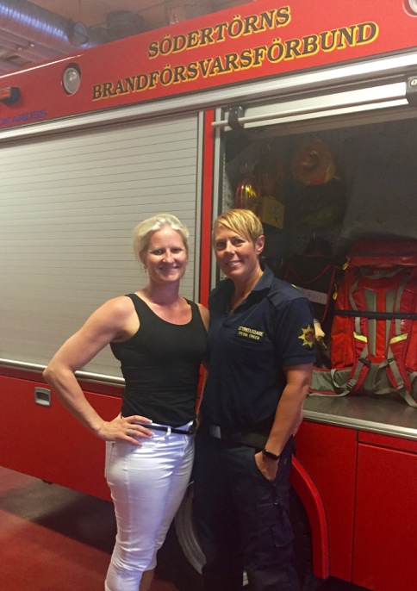
Station Commander Sylvia Friden and Mona Hortzberg, from Sodertorn Fire & Rescue Service.

Station Officer Sylvia Friden speaks about the diverse operations of her fire service here.

CANADA

Canada was an obvious choice for my itinerary since they are proving to be a world leader across a range of human rights and social justice issues.

Ms. Anik St Pierre from Montreal, who had accompanied my research trip in England, invited me to present my findings to her Fire Chief and his senior executive leadership group. Chief Masse from the Montreal Fire Department (Service de securite incendie de Montreal) had been wanting someone to help convince his key decision-makers of the need to be more strategic with recruitment and actively recruit more diversity into their workforce. As well as that commitment, I also knew of Camp FFIT – a girls' fire camp that originated in Ottawa and now runs camps in London and Hamilton, Ontario. I hoped to connect with one of the Canadian women’s support networks, Fire Service Women of Ontario (FSWO), who have been really active in targeted recruitment, support programs and leadership development for female firefighters in Canada.

London, Ontario

Loosely I grouped all the girls fire camps into the research of my third recruitment strategy – Social Change Programs. These camps effectively lead to a change in social beliefs and attitudes about women doing traditionally male roles. The changes in both the participant and the wider community are well documented and form part of further academic study I’m now engaged in with Monash University.
Camp FFIT (Firefighter in Training) in Ottawa, Ontario is one of the original Canadian girls' fire camps and is run by Fire Service Women of Ontario. (FSWO) The Camp FFIT that I attended is a subsidiary of the original and is held in London, Ontario with the same format. It’s a day camp for 20 school girls from around the province, aged between 15-19 and a local women’s university, Brescia College, provides accommodation for participants and their families.

Having volunteered at Camp Blaze (another established girls' firefighter camp), in 2009, I was familiar with the objectives of such a program and had experienced firsthand the impact such training and team-based activities has on the personal development of the participants. What was most fascinating about incorporating the various fire camps in my itinerary was quantifying the impact on recruitment into fire services. Interestingly, there has been very little data captured over the time of these camps to demonstrate a correlation between camp participation and future employment in the fire and emergency sector. Until this year.

Camp FFIT, London was started by Firefighter Allison Vickerd and modeled on Camp FFIT, Ottawa. Allison was attracted to ideas such as ‘Girls in Gear’, a two-day program that helps promote emergency services as a viable career option to young women. The program gives school-aged girls some hands-on exposure for fire and rescue, the police, coast guard, military and paramedic care. However, Allison wanted to ensure that participants had opportunities to develop the soft skills of team work, interdependence, decision-making and confidence.

At the five-day non-residential camp, the girls take part in physical fitness training and a range of operational experiences including hose work, wearing breathing apparatus and live-fire training. As part of their team-building and self-efficacy, they complete circuit training of core firefighter skills. They work together in groups to learn about teamwork and what it means to work in the Canadian fire service. These young women learn about PPE (Personal Protective Equipment), SCBA (Self Contained Breathing Apparatus), and fire ground skills such as ventilation, search and rescue, hose control, proper carrying techniques and use of ladders, vehicle rescue, rappelling and tying knots. The camp also makes use of technology such as virtual reality, to allow camp participants to experience driving a fire truck. It is as close to the real deal as education and simulation can take you.

Allison’s hard work has won numerous awards and even inspired other female participation initiatives within the fire service. In between being the Camp Director, supervising activities and inspiring us all with the clarity of her vision and confidence of her capacity, I interviewed Allison about how this program contributes to her organisation or other fire agencies in general. She explained that the wins weren’t measured with accolades or even recruitment itself. The most obvious outcome is the self-development of each of the participants and their boost in self-esteem that comes from achieving goals and overcoming the physical and mental challenges.

I asked Allison to describe the most rewarding aspect of the camps. She answered, “The increase in confidence that every camper experiences. You can see each girl arrive somewhat tentative at the beginning. We have a great group of volunteers who help the girls blow past their mental barriers and let them see what they can accomplish when they work as teams.”

I also asked why she thought the tangible experiences of camp were important to engaging with the future female firefighters of the world.

“You can’t be what you can’t see”, she said. “So the more we put female firefighters front and centre, the more the public will take notice”. Allison also believes that current firefighters, their champions and the fire service leaders should play a role in increasing female participation and diversity. “We need strong mentors to step forward and present what firefighting is all about”.

One of the other outcomes of Camp FFIT is to develop the volunteers, who help all week as instructors or platoon leaders. The camp helps them build resume experience for the arduous task of being hired by a fire department.

Similar to Australia, getting employed by a fire service is a fiercely competitive process and in Canada most people spend a minimum of two years at a vocational college studying fire science or a related field, prior to applying. Preference is also given to candidates who have spent time as a volunteer firefighter or had some other operational experience. There is a huge success rate of people who have volunteered at girls’ fire camps going on to be given permanent positions with urban fire agencies.

At Camp FFIT, I interviewed several volunteers who were in the process of trying to get hired as well as a few who had previously been volunteers and now had permanent positions. (https://www.facebook.com/GirlsOnFireTour/videos/207022126362388/)
Rayel Anthony (https://www.facebook.com/GirlsOnFireTour/videos/207018946362706/)
was one of the platoon leaders at the camp and had just completed 12 months of pre-service training at Lambton College, Ontario. As well as mentoring and influencing her team of five girls, Rayel cultivated her own leadership skills, developed capacity in managing a team of mixed personalities and built some valuable networks that potentially will lead to employment opportunities.

A value-added benefit that was obvious in these girls’ fire camps, is the career-building experience it provides for the instructors. There were tremendous examples of volunteerism since the 20-30 instructors and platoon leaders all volunteered their time, some for a day only, and others for the whole week. They were a mix of uniformed & non-uniformed men and women, of all ranks and many were students at the pre-employment colleges in the area. At Camp FFIT, I interviewed several instructors who were in the process of trying to get hired and a few who had previously been volunteers and then been hired permanently in their area. The male volunteers were especially inspiring. These volunteers all spoke of the professional skills they had developed through their camp involvement. They listed leadership skills, cultural competence, team-building for diverse personalities and networking as ways the camp had assisted their careers.

Montreal, Quebec

I had accepted an invitation from Anik St- Pierre to give a presentation to the Chief of the Montreal fire department about what was already being done by fire services around the world. Chief Francoise Masse had been working closely with Anik, to research best practice and start the internal communication about why their service needed to recruit for diversity. Like all large urban fire services, their internal culture had led to a number of examples of inappropriate behavior and government stakeholders had begun recommending gender & ethnic diversity as a strategy for cultural improvement.

My presentation was made to Chief Masse and his executive leadership team, a few senior officers in charge of recruitment and Louise Hine-Schmidt, a Station Commander from Ottawa Fire Dept. and President of Fire Service Women Ontario. Louise had brought Assistant Deputy Chief James Narraway with her, himself a Male Champion for fire service change and gender equity.

It was such a beautiful gathering and apart from the magnificence of all the French interludes and commentary, I was energised by the enthusiasm of the high ranking officers who were genuinely interested in how they could improve their practices. Montreal has since run some targeted recruitment programs as well as their own girls fire camp. As a result, they now have the most women ever enrolled at Montmorency Fire Service College in their 45 year history.

I shared what the Australian experience had been and included the ways in which fire services around the world were addressing the same cultural issues with diversity recruitment. They were especially interested in the gender balance scorecard produced by WAFA and the progressive strategy of FRNSW to undertake 50:50 recruitment.

The presentation for the Chief then rolled into a retirement presentation for the first woman hired by the Montreal Fire Department, Joane Simard who had served for 30 years. It was a fitting end to a day of diversity discussions and celebrations of women in the fire service.
Afterwards, Anik arranged a meeting with Union representatives and the department’s working group for diversity. It was an informal discussion in which they shared their concern that governments could soon close fire stations to save money. They hope to educate firefighters that diversity will help provide better service delivery. They also try to encourage collaboration between the union and the department, to review policies and to put diversity into every decision-making process. Their recruitment now aims to target people who are happy to accept the diversity of the role which could soon be including medical calls.

UNITED STATES OF AMERICA

The USA experience dominated most of the pre-travel research I did into diversity and the recruitment of women in urban fire agencies. As I found 20 years earlier, whilst playing women’s rugby at Florida State University, women in America – at least sporting, educated women – enjoyed infinitely more opportunities to participate in traditionally male careers and activities, with less social judgment and more acceptances, than most other places in the world. When I became a firefighter in 2002, I was not surprised to discover that a large number of my American rugby friends had also become firefighters.
In the infancy of this research, I can only put that down to time and the fact that the US (or at least parts of) has had more time for social change to occur.

Currently, the US Department of Labour has a national working committee looking at ways to ensure that emergency services look more like their communities. The group has been gathering statistics, reviewing strategies and plans to have a white paper prepared by 2017 on ways to reach 17% for women in the fire service – a number that has been suggested will “normalise” the role for women.

New York City

FDNY is the world’s largest urban fire agency and a department that has endured a number of legal challenges in its 150-year history.

Currently, FDNY has 58 women, which represents less than 0.5% of their 10,000 operational firefighters and one of the lowest percentages in the country. In 2001, FDNY was 98% white male and glaringly obvious to all, that this was not reflective of the diverse demography of New York City. However, in the past 18 months, the FDNY has resourced extensive programs to address this diversity deficit. Under the direction of Deputy Commissioner, Laura Kavanagh, FDNY appointed a dedicated team to address the barriers to recruitment. With the support of the affinity groups, FDNY expanded their presence by mobile academies, block parties, CPAT preparation programs, boot camps and participation in LGBTQ Pride month and heritage days for African-American, Puerto Rican, Dominican and West Indian communities.

Prior to my arrival in New York City, I had met two key change-makers who were instrumental in helping me access information. These were Sarinya Srisakul, the first Asian-American woman to be hired by FDNY in 2005, and Regina Wilson who joined in 1999 and became the first woman president of the Vulcan Society (African-American Firefighters Association) in 2015.

Both these women have advanced the position of other women in the organisation and been very active in recruitment efforts and the physical preparation for female applicants.

Sarinya is the President of the United Women Firefighters, a member of the FDNY Phoenix Society (for Asian Americans) and recently passed her Lieutenant’s promotion exam. She has been a huge proponent for culture change in the FDNY which she describes as “hardened”. She feels that a lot of the improvement in recruitment efforts has been driven by the affinity (support) groups such as Vulcan Society, United Women and the Phoenix Society. These groups help support the diversity aims of the department. They bring people with shared circumstances, goals and challenges together to learn from each other. This network helps ease some of the isolation experienced in being a small number in a large force. The social and recruitment activities all play a role in changing the face of FDNY. Listen to my interview with Sarinya here.

I asked Sarinya about her experience with women not wanting to be part of a women’s association and she said it’s definitely one of the barriers to change.

“In any female culture, there are women who won’t want to participate in female to female support. They may feel uneasy with the idea as it makes them stand out in a male dominated workplace. Or they don’t understand the benefits. Or they may not play well with other women. It can be tempting when the numbers are stacked against you to want to blend in or ignore supports in case it somehow makes you a target or deemed less capable”.

She said all these reasons are valid, but that the more women work together and support each other, the more normalised our presence and inclusion becomes. “We’re stronger when we stand together,” she said. “We all face the same problems. We face them in any traditionally male-dominated workplace. Women can think that isolation is a way to protect themselves, to not stand out. But the more you share, the more you learn about how others have dealt with the same issues.”

Sarinya’s analogy is that small turns of the screw can make big differences. She feels that some of the seemingly small things ultimately contribute to the most significant changes. The examples she gave that she is pushing for in FDNY were:

- Including female bathrooms within the fire stations where only women can go. Women are given keys to their own bathroom to keep them clean and free of harassment. It’s about providing a space for women just as much as it is a practical need. Since the first edition of this report, the FDNY has completed their Women’s Bathrooms in Firehouses project. (December, 2016). The three-year, 47 million construction program completed renovations in 47 fire houses. There is now women’s bathrooms/changing facilities in all of the 214 active firehouses in New York City. Outstanding.
- Using the media, TV and film to provide the community with visual representation of women participating in the fire service and to show diversity within the workforce.
- Having study groups and mentoring support to improve the success of female recruits at the academy.
- Women accepting their strengths and weaknesses on the job and playing to those strengths in a supportive environment.
Some of the targeted recruitment programs that Sarinya has been directly involved in include:
- Physical preparation program for women – a CPAT (Candidate Physical Aptitude Test) preparation training program run by the United Women Firefighters and made possible by sponsorship from New York Sports Clubs (NYSC) and a grant from the New York Women’s Foundation.
- FDNY Summer Block Parties – based at a firehouse where FDNY members hold demonstrations, provide fire safety education, teach CPR & talk to residents about becoming a firefighter
- “Woman Firefighter for a day” at Randalls Island
- FDNY Women’s History Month Outreach Event
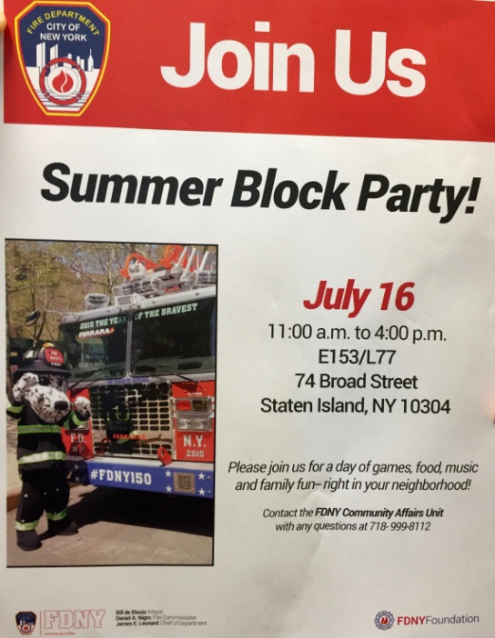

Another famous change-maker I wanted to meet during my New York visit was Brenda Berkman – whose landmark lawsuit resulted in FDNY hiring their first women in 1982. Her story, her struggle, her career, her 9/11 experiences, her retirement years, were all fascinating, inspiring and, at times shocking. Brenda hosted me for a day in New York and in the course of that day we discussed everything from history, her legal battle, the backlash from society when women were first hired which included public demonstrations that “women’s liberation had gone too far” and that “girls shouldn’t be doing men’s jobs!” She gave me a personally guided tour of the 9/11 memorial site, sharing her experiences in attending and pausing to honour each of the names of firefighters and officers she had worked with.
Her role in altering the course of history for the FDNY commands absolute respect. Understanding the intensity of fire service culture makes her courage even more commendable because of what she endured. In winning the landmark Supreme court case that proved discriminatory hiring practices, Brenda had to sign an agreement that she would join the service. She did so with 41 other women in 1982 and told me the early years were a constant barrage of ostracism, being ridiculed & physically threatened and she even received death threats. Despite all this, she loved being a firefighter and worked hard throughout her career to not only be excellent in her job, but to also build support networks so other women didn’t have to experience what she did. She founded the United Women Firefighters and was President from 1982-1986.

Brenda Berkman’s take on recruitment strategies was to make targeted efforts, run support programs to better prepare candidates, encourage the operations of affinity support groups and leveraging off their work to recruit diverse applicants.

She agrees there is benefit from the girls’ fire camps as a tool for social change, but questions the value that is returned from the large investment in resources. Her critique is also that some of the camps appear to be perpetuating the recruitment of white women and not a broader diversity spectrum. She thinks doing shorter programs such as “Firefighter for a day” and hands-on practical days are far more effective. She told me about a program the FDNY ran for a little while called “take your daughter to work day” in which daughters came and did “ride-alongs” at the fire station. This evolved into more of a career day for women who were preparing to take the entrance exam.

“With less than 4% women in most urban fire services, we should be doing targeted recruitment and the girls that go to these camps should be of an age or inclination where they get funneled into a job and not just volunteering”. Berkman says.

Brenda believes that one of the destructive barriers to inclusion in the fire service is the lack of cohesion amongst the women themselves. To that end, she said that “as women, we are the only marginalised group that sides with their oppressors”. She also says there is often conflict between conservative women and more left-thinking women making diversity within gender a barrier to progress.

Brenda also believes that litigation is very important in the change process. The Vulcan Society won a lawsuit in 2015 which resulted in a court-mandated quota for the recruitment of African-Americans. There had been talk in the early stages of including women in the action, but unanimous support was not given. The women must still push for change themselves. Brenda feels that at least an “amicus brief” was appropriate and may have assisted any future proceedings that looked at discriminatory hiring practices.

Undoubtedly, Brenda Berkman has left a legacy and continues her work for firefighters. She is active in the support group for 9/11 survivors and has recently been involved in PTSD (Post traumatic stress disorder) support tours to Japan for survivors of the Great Earthquake of 2011. In recognition of her achievements, Brenda has received a list of awards from the National Organisation for Women and Colombia University. Her 9/11 experiences have been featured in the book Women at Ground Zero: stories of courage and compassion and the documentary Taking the Heat.

I was fascinated to learn more about how a department the size of FDNY, with its entrenched cultural norms of firefighter masculinity, was planning to build a diversity more reflective of its community stakeholders.

One of my key meetings in New York was with Deputy Commissioner, Laura Kavanagh, working in Government Affairs and Special Programs of the FDNY. She had arranged other key decision makers for the meeting so as to provide broad-based answers for my research. These women were Nafeesah Noonan, Director of Recruitment and Retention, Terryl Brown, Deputy Commissioner for Legal Affairs and Kat Thomson, Assistant Commissioner for Management Analysis and Planning. This team were impressive by their synergistic combination of data analytics, targeted recruitment strategies and legal compliance.

Nafeesah believes that part of the underrepresentation of minorities in the FDNY is due to minorities being unaware of the career opportunities that exist for them. One of the biggest focus areas for FDNY has been in targeting young people and exposing them to firefighting as a career from a young age. There is an FDNY high school in Brooklyn jointly run by FDNY and the Department of Education. It’s called the FDNY Captain Vernon A. Richards High School for Fire and Life Safety. The school aims to prepare students for college, but also seeks to expand career options for African-American and Latino youths by introducing them to jobs in the fire department.

Another popular youth program is the FDNY Exploring Program which helps city residents aged 14-20 with education and fitness preparation for becoming a firefighter.

I asked Nafeesah about the FDNY philosophy to recruiting through a diversity lens.

“I think what is important with our recruitment campaign, is leading with the diversity that we have. So you will see that with our recruitment posters and flyers, and as we change our website, you see that we lead with our diversity”.Diversity banners for 2017 recruitment campaign

Since 9/11, FDNY have been doing a lot more recruitment and this has been good for diversity. In the past year, the overall diversity of recruit classes has been around 40% which is much higher than the overall workforce.

During the meeting, Kat Thomson spoke about the importance of data analytics in establishing their department’s position and understanding the barriers in the process. She has assembled a team to analyse all the different components of the hiring process and to measure the impacts of every program they run. They are working to understand why people leave and why people stay. They also seek to identify when in the process people drop out and what measures can be taken to reduce the drop-out rate of women and minorities. This quantification of everything also assists with compliance, especially under the orders enacted by the 2015 Vulcan Society court case. A panel of lawyers now oversees everything that they do.

Other targeted recruitment programs they have used in the past 12 months include:

- Block parties – to inform & educate in target communities. FDNY shut the street in a certain block, play music, serve food, have fun and try to be as inclusive of all people as possible. Residents are then able to connect with their firefighters and it has helped with community engagement and safety as well as recruitment.
- Firefighter for a Day – introduction to station life and the various roles of firefighters in community.
- Mobile academies – to show off the physical aspects of the job, participating in simulations and handling equipment. FDNY Mobile Academy

The recruitment team also stressed the importance of having government backing. Because diversity recruitment is a City government initiative, they have been very supportive and kept these issues at the top of their agenda. Because fire departments throughout the United States tend to be quite conservative, it has been helpful to have an external force bringing the issues to the public attention and helping FDNY move forward.

They’ve also studied the efforts of the New York Police Dept. who have much greater diversity in their workforce. They believe this is due to them starting their targeted campaigns much earlier and have already endured the scrutiny the fire department is now experiencing. They are also adopting some of the NYPD recruitment programs such as their cadet program and a marketing company to assist with targeted communication pieces.

At the time of meeting, FDNY were in the middle of a recruitment campaign and running somewhere between 100 and 150 different targeted events each week. Their events include the popular summer block parties, concerts, community events, subway hubs, personnel with backpacks & clipboards reaching out to candidates face to face. Wherever they can see a huge population of young people of colour, FDNY ensure a presence with marketing materials and firefighters to interact with them. They cast the net wide to attract people during what they call the “filing” period. Because this recruitment period only comes around every five years, successful candidates can be on a list for that long.

They also use very selective media and are currently assessing the best options on social media for targeting people of colour. There is no shortage of applicants and growing the pool of applicants doesn’t necessarily help them meet their targets. On average, 40,000 people apply to take the entrance exam and applicants will wait between 2-6 years to get through the process. They acknowledge that this long period is one of the barriers to workforce diversity. One of the reasons for this, is the state regulations that require the testing process to be a civil administrative services exam which must be conducted under the supervision of the United States District Court.

As part of this campaign, FDNY did focus groups for all of their target populations (women, African-Americans, Hispanics, Asians). Overwhelmingly, the feedback they received was that people were unsure of being welcomed since they didn’t see many firefighters who looked like themselves. They called this the “chicken and the egg problem” where people would feel more welcome if there were larger numbers of women or minorities in the firehouses, but they have a hard time recruiting the numbers because of the perception of the department.

Laura made an interesting observation from her research internationally. She noticed that often an interest in non-traditional jobs is developed early in middle school or high school. She has found that people’s level of tolerance for waiting through the recruitment process is relative to how long they have thought about joining the service. Conversely, candidates that are discovered during targeted recruitment events, have sometimes only just been exposed to the job and their tolerance for waiting is not as high. Because of this, she believes they need a quicker process but also need to work on the pipeline programs which introduce the job to young people.

It’s evident FDNY is also investing the resources for this mammoth recruitment task. They provide extensive online resources for all candidates preparing for testing. Study guides, frequently asked questions, CPAT preparation and even a “Probie Manual” are available. A mentoring program is provided to all candidates who have filed for testing.
As part of the 2015 legal settlement, FDNY agreed to develop educational and other opportunities to enhance the ability of young people in NYC to become firefighters. A cadet program has been developed that provides two years of coursework in an internship setting in which candidates are placed on a fast-track civil service hiring list upon completion. This cadet program will be open to all candidates and not just underrepresented groups. Unfortunately, the FDNY Union, the United Firefighters Association, is opposing this program, citing potential for reverse discrimination.

In November 2016, Fire Commissioner Daniel Nigro welcomed a new class of FDNY firefighters – the most diverse (41%) in the history of the department. This class was 22% Hispanic and 15% African-American and 3% Asian-American/Pacific Islander. The class included five women, taking the total number of female firefighters to 58.
He has also made Diversity and Inclusion one of the five goals in the FDNY Strategic Plan, pledging to increase diversity in the upper ranks & management through mentoring and leadership programs.

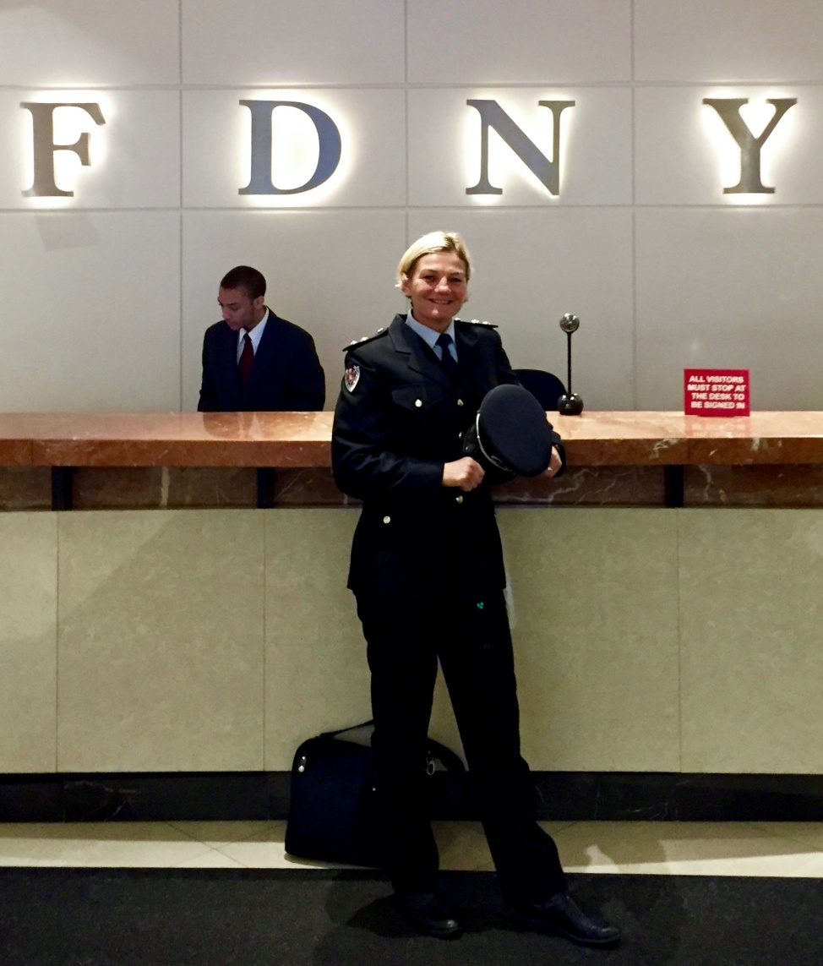

Girls Fire Camps

After New York, I spent two weeks visiting three other girls fire camps. I perceived that these camps were one of the most effective recruitment strategies based on my pre-Churchill research and my experience volunteering at Camp Blaze in 2011.
However, I discovered that very little formal quantitative research has been conducted to support the direct impact of camp participation on fire service recruitment. Anecdotally, there is lots to support that these camps are a social-change tool and that they have a significant impact on changing the perceptions and attitudes about the role of firefighters.

I visited Camp Fully Involved in Concord, New Hampshire, a five day residential camp hosted at the New Hampshire Fire Academy. Camp Director, Lieutenant Jess Wyman started the camp 10 years ago and runs it in partnership with the Explorer, Learning for Life program. There are up to 20 participants every summer, and the camp focuses heavily on the physical aspects of the job. They do a lot of live fire training with in breathing apparatus and moving hose through the structure-fire training prop. They also participate in vertical rescue, ladder drills, roof ventilation and forcible entry.
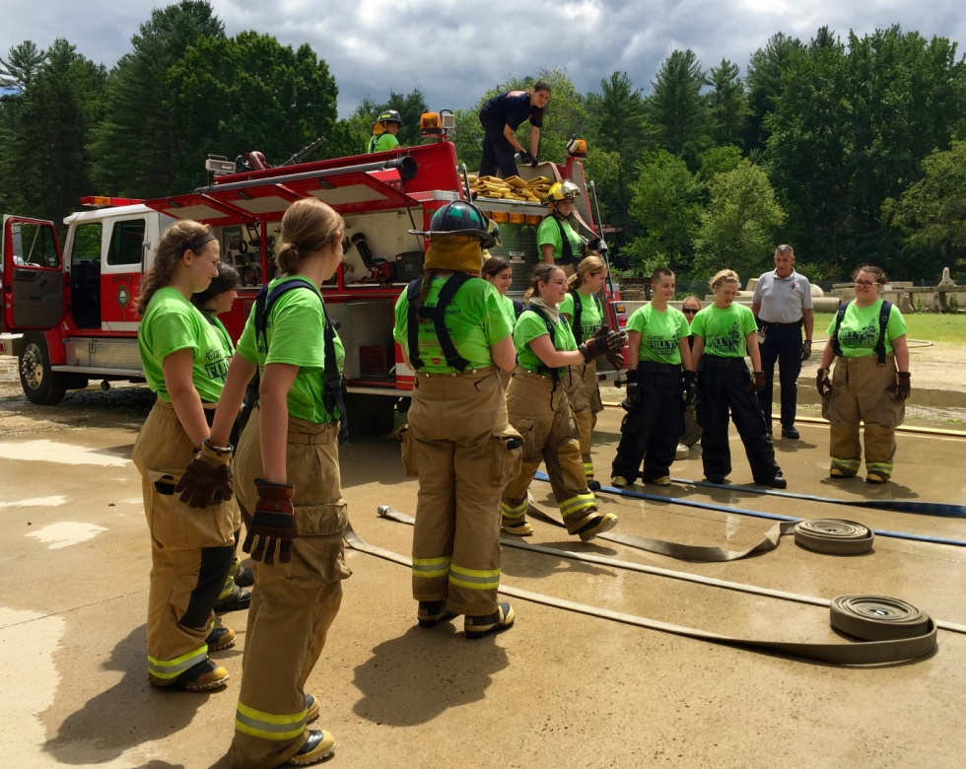
Camp Fully Involved consciously staffs their program with male and female volunteers. Jess believes it’s important to teach the girls that firefighting is a male-dominated workplace, and that they will be some of your best mentors and role models. One of the unique things about Camp Fully Involved, is they get participants from all over the world and have previously had girls from Canada, Japan and France. One of the volunteers this year was a woman from France who had previously attended as a camper. They have also had participants with disabilities including deafness and autism.

Jess incorporates bullying and harassment education into the program. She explains the realities of the changing landscape of the fire service, and the importance of understanding the difference between firehouse “shenanigans” and humour and inappropriate behavior such as sexual innuendos, disrespect and harassment.

Jess is also convinced that these camps are an important recruitment strategy for departments to align with. She talked about a few girls who have received employment offers while they’ve been at camp and she often receives calls from fire departments asking about former campers that have applied for volunteer or career positons. The mentoring from volunteers at the camp also provides participants with valuable resume content and the network continues to support applicants as they progress to interview. Jess is especially proud that in Southern Maine, many of the pre-service colleges take attendance at Camp Fully Involved, into consideration when processing applications, indicating a professional respect for their program.

Without any longitudinal studies to accurately quantify the relationship between camp attendance and fire service employment, Jess believes that between 55- 65% of campers have followed some form of fire or emergency service pathway. That includes Exploring, pre-service colleges, volunteer and career departments. She estimated the amount to drop to 15% for those who secured jobs as career firefighters. I interviewed one of the campers who has been planning her education around a future career as a firefighter. Listen to it here.

I then travelled to Utica, New York to spend a few days at Camp Phoenix, one of the earliest girls’ fire camps, established and run by the Fire Service Women of New York. The camp is held at the Utica Fire Academy in upstate New York and campers come from around the state. Just like Camp Fully Involved, Camp Phoenix is a week-long live-in camp and participants experience all aspects of a firefighter’s role. The camp also supports the cadet programs of fire departments in the area such as the Rochester Fire Department.

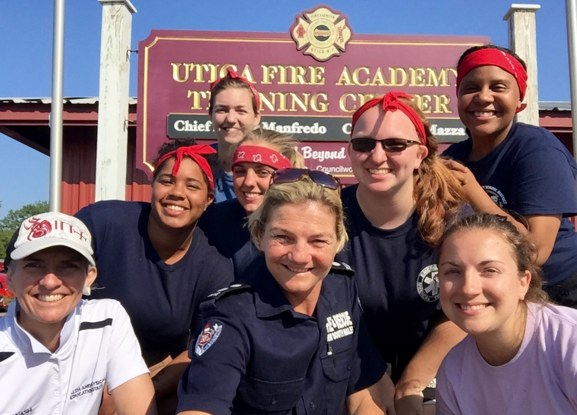
Happy campers in between sessions at the Utica Fire Academy Training Centre.

A number of instructors are current or retired members of the FDNY and make the camp a permanent fixture on their calendar. One of the camp directors, Chief Rochelle Jones (Rocky) was one of the first women hired by FDNY and she openly shares the challenges of her journey with everyone. It’s evident that fire service culture has evolved a lot since her early days and the diversity of experiences that are shared by other instructors ensures a realistic exposure for the participants. I spoke with most of the campers and a few instructors and there is no doubting that the learnings and the overall experience was positive for everyone involved. The campers repeatedly told of their satisfaction in performing physical tasks using techniques appropriate for their different sizes and strength levels. They confirmed that personal development skills were learnt during the activities and the challenges increased their self-esteem, self-confidence and self-efficacy. Working in teams for all activities, allowed for growth in communication skills, leadership and problem solving. Once again, the relationship with the hosting fire department, Utica Fire, was evident. On one of the days I was there, the Utica Fire Chief, Russell Brooks, came and spent a morning watching and engaging with the campers and instructors.

My final camp visit was to Camp Blaze at the Washington State Fire Academy in Bend, Washington. I had previously volunteered as an instructor at Camp Blaze in 2011 and helped out with the live fire evolutions. This camp is extraordinary for the level of resources involved in its set up. All campers are sponsored to attend and the organising board of directors spend two years fundraising for it to happen.

Once again, partnerships with fire departments are integral to the Camp’s success and volunteers attend from many different departments. Seattle, Los Angeles, Oakland and San Francisco Fire Departments all represent every year and the volunteers are a community within themselves. This year, eleven former campers returned to volunteer at the camp, including four from my camp in 2011. The vision of Camp Blaze is for the experiences to focus on personal and team leadership for campers as well as volunteers. There is a lot of traditional US Summer Camp experience woven into the programme and platoons of campers form strong bonds with each other through singing and chanting “Jodies” that they have made up as unifying theme songs.

It was interesting to look at the various formats and business models of the different camps. I gathered a lot of information from the impact on the participants, but also the benefits for the volunteers. Volunteers all cited personal gains in the form of satisfaction, community contribution and soft skill developments in communications, teaching and group dynamics. Almost all cited professional gains in leadership, team-based skills, networking and confidence in their own capabilities. The involvement of local fire stations and the departments where training takes place has also opened dialogue about changing culture and fostering new workplace attitudes.

As a result of this Churchill research, I have forged a partnership with Monash University to quantify the impacts of such fire camps on future recruitment for career firefighters. Once such data is collected and analysed, we will be better able to understand the relationship between social-change programs and recruitment for diversity.

Los Angeles

In 2014 Los Angeles City Mayor, Eric Garcetti requested a review of the hiring practices of the Los Angeles Fire Department (LAFD). The end result was the Rand Report that addressed Goal 8 of the LAFD Strategic Plan – to recruit, develop and retain a professional and diverse workforce.

LAFD Fire Chief, Ralph Terrazas, then appointed Battalion Chief Alicia Welch to implement the recommendations and generously committed a large amount of resources to the project. Every aspect of recruitment was reviewed and Chief Welch proudly claims that data analytics have been the biggest factor for identifying the barriers for minority populations, as well as quantifying the areas in which candidates need support.

Of all the fire departments I visited on this trip, I found that the targeted recruitment work done by Chief Welch and the LAFD was the most comprehensive. As the second largest fire department in the country, LAFD serves a very diverse population. Like most large fire services there is no shortage of applicants – 10,000 in the last campaign – but they have less than 3% women, a number that hasn’t changed since 1995. Because state law forbids any type of employment quota, Chief Welch needed to develop a targeted recruitment strategy that would provide opportunities for women and ethnic minorities. These opportunities engaged community groups in career expos, community fairs and support programs that helped applicants through each stage of the process.

A new marketing strategy also complemented the recruitment campaign which provided visual representation of all targeted populations, centralised the dissemination of recruitment information and created a LA Firefighter brand. Marketing materials were pushed out using print, radio and social media and a designated LAFD hiring website plus a smart device application (Smart phone APP) were created. The recruitment APP was given to existing staff so they could also share recruitment information and include any potential candidates on the hiring database which was regularly sent information. The benefits were two-fold – the net for applicants was cast wider and current employees were invested in assisting with recruitment. Other information materials and sessions provided include:
- Applicant Orientation programs – held weekly at various locations so applicants can try on PPC (personal protective clothing), handle equipment, practice the physical test & learn about the job and the testing requirements.
- LAFD firefighter candidate fitness guide – Candidate Assistance Program
- Oral interview preparation guide and coaching

In conjunction with the marketing and recruitment information, LAFD then invested in their communication pieces to ensure a level playing field for all potential applicants. This overview of their new recruitment process was significant for its reach into areas and communities with very little previous awareness of the fire department as a possible career.
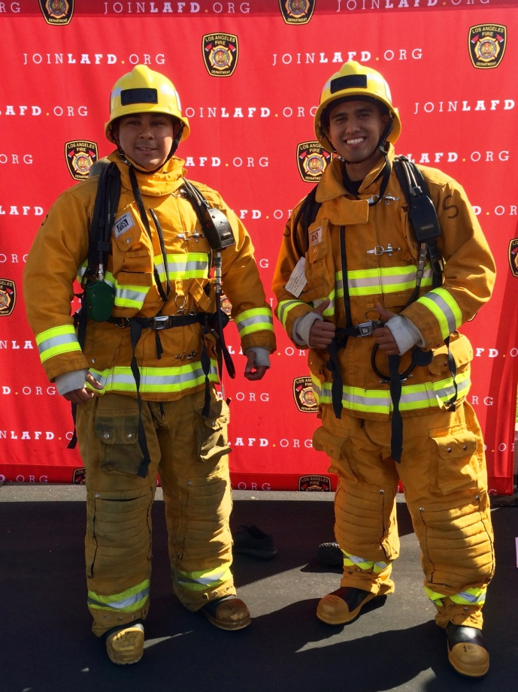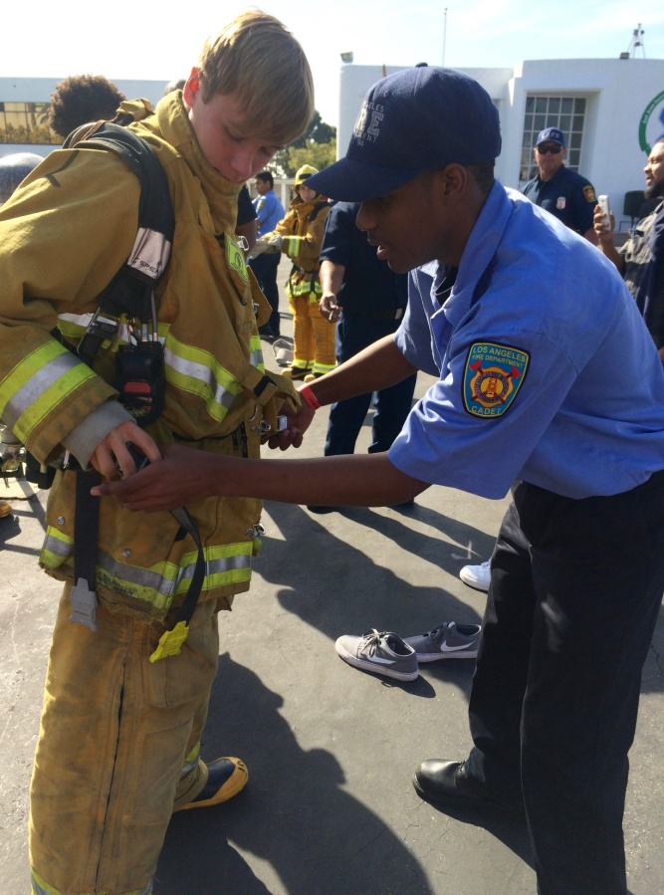
Participants try on PPC and picture themselves as firefighters at a recruitment expo in Sth Central L.A.

In support of general recruitment, LAFD also runs a number of social change programs to inspire young people to consider firefighting as a career. They have a youth academy, high school magnet and cadet programs, in which teenagers can participate voluntarily through their school and learn the basics of firefighting. These programs, like the girls fire camps, also develop personal skills in teamwork, discipline, fitness and self-confidence. Magnet Program and Cadet Program.

When I met with Chief Welch, one of her most important messages was the importance of data analytics. She had painstakingly collected data on every aspect of the recruitment process to understand what the barriers were to achieving diversity. With each program, she has ensured that data is again collected and people are tracked to measure the impacts of the program and provide assistance to candidates where necessary. Using technology such as Google forms and the App has also facilitated the collection and reporting of this data.

During my visit in Los Angeles I was fortunate to attend a career exposition in South Central Los Angeles, one of Chief Welch’s targeted recruitment programs. It was co-hosted with the Los Angeles Police Department and was a hands-on practical exposure to both policing and firefighting. Participants received information from personnel that included LAFD Chief Terrazas, Chief Welch, station Lieutenants and Captains from the area and also probationary firefighters that reflected the ethnic mix of participants.

As an observer, I could see how the participants approached the personnel with which they felt an association or connection to. I interviewed a few of them who said they felt more comfortable asking questions of someone who looked like themselves. In an adjacent carpark, participants could get dressed in turnout gear, practice the CPAT (Candidate Physical Aptitude Test used by most US departments), look over an appliance and speak with on-duty firefighters. All of the affinity support groups had stalls and several colleges had information available for completing EMT (Emergency Medical Technician) training which is a pre-requisite for LAFD. Taking part in everything that day made ME want to join and made me feel proud to be in this great profession. And on top of that, a magnificent lunch of fresh tacos was provided for everyone.

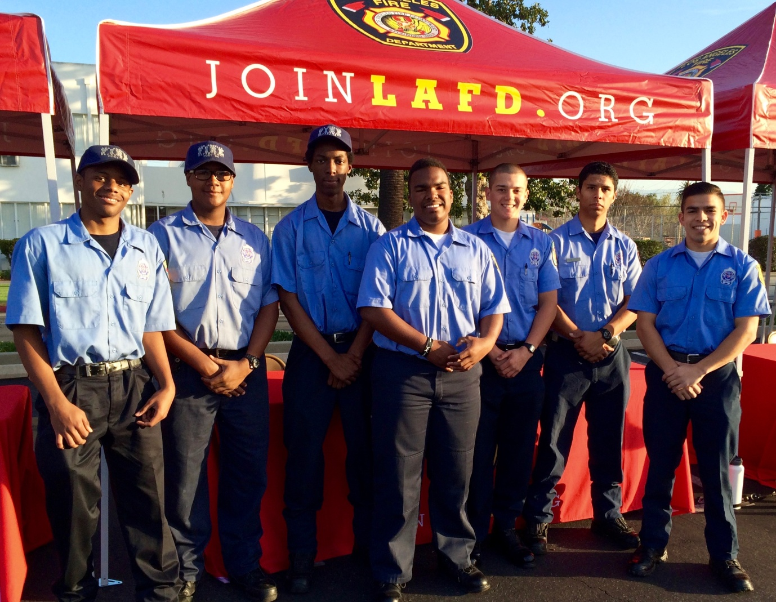
LAFD cadet program volunteers provided assistance to participants throughout the day.

As this report is being written, the LAFD have just recruited the most diverse class of firefighters in their history and Chief Welch’s team have run their first girls fire camp.
LAFD's first girls fire camp

San Francisco

No research trip on fire service diversity would be complete without a stop in San Francisco – one of the most diverse cities in the world and also one of the most diverse fire services.

For a decade between 1988 and 1999, the San Francisco Fire Department (SFFD) was under a consent decree (quota) to recruit women to 10% of its operational workforce and for 50% of those women to be of colour. This court mandate was enacted after litigation against the City and County of San Francisco for illegal hiring practices. SFFD currently has one of the highest rates of female firefighters in the world at 16%.

Once again, some networks made earlier in the year proved invaluable in getting access to key people in the organisation. Whilst presenting at the I-Women (International Women Firefighters Association) conference in Sacramento at the beginning of 2016, I met Aisha Krieger, a San Francisco fire officer who has written one of the most comprehensive reports on the impacts of SFFD’s consent decree and why the positive results have not been sustained since its cessation. Aisha has been a firefighter for 18 years, has an extensive background in training and spent two years as a Recruitment coordinator. You can read Aisha’s report here.

SFFD was also one of the first departments to have a female Fire Chief, Joanna Hayes-White who has also been influential in the recruitment of diversity.
I visited several fire stations, the training academy on Treasure Island and attended one of Aisha’s community safety training programs, NERT. (Neighbourhood Emergency Response Team). Everywhere I went, the diversity was as conspicuous as the non-diversity of most other fire departments I had visited. I was not able to investigate the recruitment strategies currently used by SFFD nor any information regarding their targeted promotional programs.

The affinity groups and support networks are very active here and they seem to be responsible for most of the targeted recruitment and support programs provided in their communities. The Asian Firefighters Association (AFA) coordinate events that incorporate all Asian festivals, Chinese New Year and dragon boat racing events. The women’s firefighter network (United Firefighter Women) also provides support for female applicants through the recruitment process, although in a less formal way than both New York City and Los Angeles.

During my visit to the SFFD training academy, I got to speak with Lieutenant Julie Mau, president of United Firefighter Women and member of the Asian Firefighters Association (AFA). She also volunteered at Camp Blaze and is an Instructor at the SFFD Academy.

Positive action programs and selections are also evident and I spoke with women and people of colour who had been promoted in this way. There is no doubt that inherent diversity exists throughout the rank structure and the recruit classes at the academy on the day of my visit also reflected this. However, anecdotally there appears to be uncertainty amongst firefighters and officers about the consistency of recruitment and promotion processes in the organisation. Verifying this would require a much deeper study into the impacts of positive recruitment programs on cultural inclusion.

Atlanta

In a fitting end to the eight-week research tour, I visited the Human Rights Museum in Atlanta. I tried to draw some parallels to other significant movements for change in our lifetime. The journey of the Civil Rights movement and the work of Martin Luther King reminded me, that it takes time and courage to change a dominant paradigm. History tells us we must question the so-called “natural order” of social hierarchies, educate everyone about human rights and that equity and equality are measured differently. Looking back at this time too, I see that it takes everyone taking personal responsibility to make a contribution. It also takes public pressure to challenge laws and change government policy to ensure fairness.
The Churchill Fellowship Wrap.
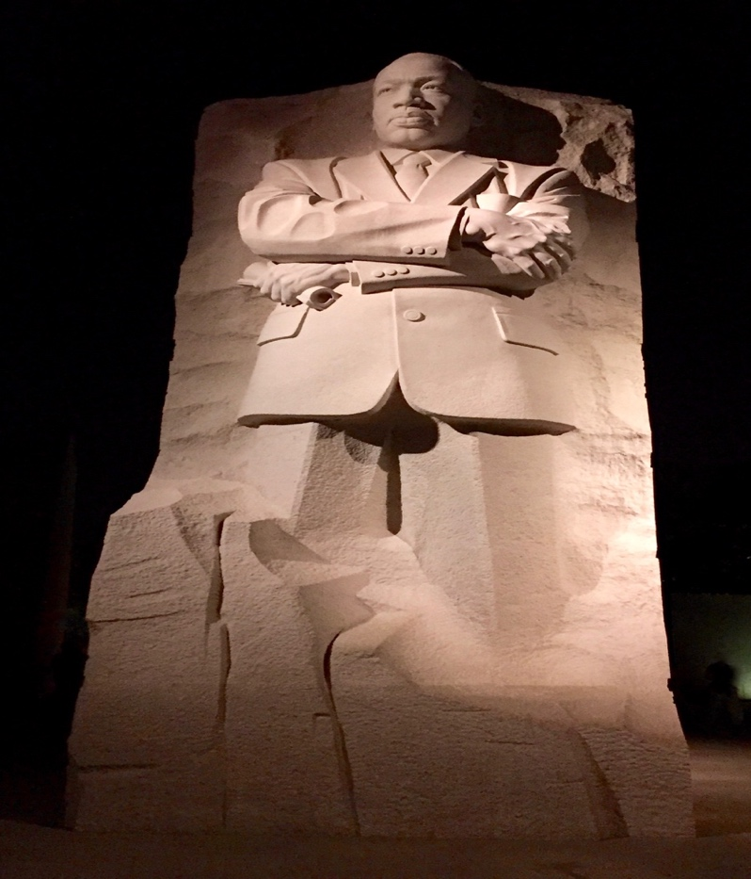

Conclusions

This research project has provided a solid and broad foundation upon which further academic study can and should be pursued. The expansive itinerary only allowed for a sampling of some complex issues regarding recruitment for diversity, but nonetheless, a platform upon which to delve deeper to quantify recruitment strategies and qualify the impact on inclusion.

There is enough evidence to support the use of all three recruitment strategies since they all obtain results in the short and long term. Quotas and court-ordered targets allow for short term results and the fire departments with the highest diversity statistics are testimony to this. The impact of quotas on cultural inclusion and retention needs to be researched further. Targeted recruitment is an absolute imperative. Fire departments must have specific targets for diversity as well as specific data metrics that indicate where they sit on a gender balance scorecard and as a reflection of their community stakeholders. Social-change programs are the long term solution to leveling a playing field that has traditionally favored a white male paradigm. The future sustainability lies in creating fire and emergency services pathways for ALL people who aspire to serve the community in a team-based, physical and emotionally astute way, regardless of diversity traits.

The research into recruitment opens up further discussion regarding the changing role of firefighters and the global shift for agencies to be doing more with fewer resources. Most fire services are complementing their ambulance services with some kind of medical or community-first response. Many fire services have had compulsory redundancies and station closures to mitigate fiscal pressures. An organisational focus on diversity has often become tangled in a fear-driven perception of political-correctness and diluting of the primary role of firefighting. Hence the need for education and statistics, that quantify the levels of community engagement and inform both internal and external stakeholders of the need for reform.

Future-proofing our fire agencies by a diverse workforce also requires a concerted effort to improve internal culture so that workplaces are inclusive of diversity. The key here is education and investing resources in marketing, communication and education pieces that make everyone feel part of the journey. Often times the communication about change strategies is non-existent, or worse, non-transparent.

So my recommendation is to implement all three recruitment strategies. Government intervention is needed to set a framework that absorbs some of the social risk in implementing quotas and making a dedicated commitment to help all emergency services address the issue of diversity. Then let each fire agency commit sufficient resources to run targeted recruitment programs that cast a wide net, support applicants from non-traditional groups and continually review the validity of recruitment and testing processes. Make sure everything is transparent. And finally, inspire local governments and community groups to run social-change programs that not only inspire our youth to pursue a firefighting career, but also contribute to making simply better humans through the mentoring and empowering constructs of camps, cadet and work experience programs.

I make the following recommendations as the way forward:

Recommendations

- Development of a National framework with consistent nation-wide Government directed recruitment targets
- Make diversity targets a key performance indicator and criteria for management and promotion
- Use a combination of all three recruitment strategies in a sustained and long-term plan.
- Use specific data analytics to capture recruitment & retention information & facilitate the understanding of barriers throughout the recruitment process.
- Adopt lateral entry pathways for officers that recognise tertiary qualifications & external experience.
- Implement youth development programs such as Cadets and Work Experience programs.
- Encourage and support networks and affinity groups that drive recruitment, community engagement & employee support.
- Provide resources for girls’ fire camps – leadership & self-development camps.
- Run regular Firefighter for a Day & Expos in target demographic areas.
- Conduct exit interviews and capture retention data.
- Continuously review policies that affect carers responsibilities.
- Provide firefighter forums for myth-busting & education about diversity & cultural change (a more personalised strategy for collection of workplace engagement data).
- Use talent identification for leadership opportunities & mentoring for women i.e. Target Development program used by London Fire Brigade.
- Support the functioning and contribution of support groups through allowing participation on shift or allocated leave hours.
- Government legislation for inclusion to improve representation of women & minority groups in the emergency services sector.
- Ensure visual representation of female firefighters in toys, books, videos, children’s television shows, cartoons.
- Consider the UK’s – equality impact assessments – Equality duty act.
- Consider Japan’s – federal employment law to endorse and monitor government departments for their gender equity and support programs for women.
- Develop partnerships with existing youth development organisations for the establishment of youth programs.
- Embed diversity principles into core culture and management systems.
- Promote and educate the community using human & audio-visual resources that reflect the diversity of the community.

Implementation and Dissemination

As soon as I won the Churchill Fellowship, I began taking every opportunity to inform and educate internal and external stakeholders in the fire and emergency services sector. I have presented at a number of Australian and International conferences on my findings and commenced further academic research into the social-change programs.
As well as presenting and sharing my learning, I have also been included in working groups for revising department recruitment strategies and equity and inclusion policies. Speaking and presenting engagements to disseminate my research have included:
- EMC 2015, Melbourne – Speaker presentation on Support networks for women and the role of Women And Firefighting Australasia (WAFA).
- AFAC Conference 2015, Adelaide – Poster presentation “Roadmap to Diversity”
- Churchill Convention 2015, Sydney – Project presentation
- I-Women Conference 2016, Sacramento – Stepping Up & Standing Out
- Montreal, 2016 – Churchill presentation to Executive Leadership Team
- AFAC Conference 2016, Brisbane – Stepping Up & Standing Out
- WAFA Conference 2016, Brisbane – Stepping Up & Standing Out
Future opportunities for dissemination include:
- FDIC 2017, Indianapolis where I will be co-presenting a 4-hour workshop on “Stepping Up & Standing Out”, sharing world’s best practice & facilitating personal development tools for contributing to culture change and inclusion.
- I-Women 2017, Indianapolis – Speaker presentation on taking personal responsibility for Fire Service Inclusion.
- Japan Firefighter Women Conference, June 2017, Kyoto.
- Research partnership with Monash University for quantitative research into the impacts of girls’ fire camps.
- Business case development for a girls' fire camp in 2017.
- Commitment to present at Fire Service Diversity Forum in Montreal, June 2017
- Academic journal articles and conference presentations
Special thanks to The Winston Churchill Memorial Trust for this life-changing opportunity.

