What kind of story are you telling?
What you should do:
- In groups of 3, discuss your dataset with your peers, tell them:
  - What dataset you chose
  - The context of the data (see The 5 ws on the back page)
- Use this worksheet to guide your discussion:
  - Go through each ‘story type’ (middle pages) for your dataset
  - Use the data-elements cards below. Which data-elements can be used for which of your stories? You should identify your best stories, and the data-elements that underpin them for your AT2 – you will use more than one story in your assignment!
  - Check: Do you know how to do your analysis? Are there any other story types you’ve identified?
  - You should keep your copy of this worksheet to help you in completing your AT2.
- Open the assignment in Turnitin, and use your discussion to complete your review, and provide feedback (we will check these! The task requires you to submit both a draft and meaningful feedback)

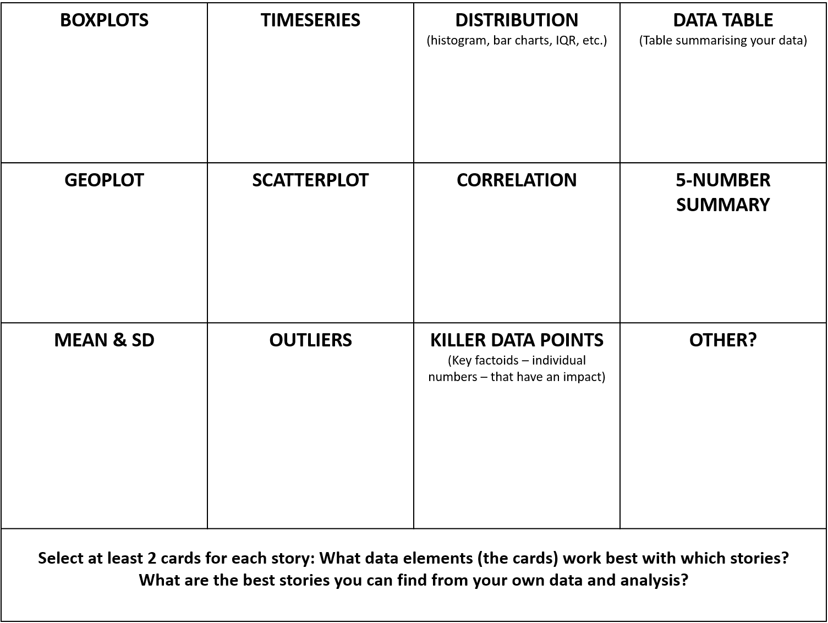
Data elements cards!
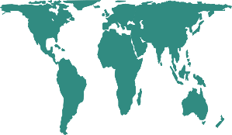
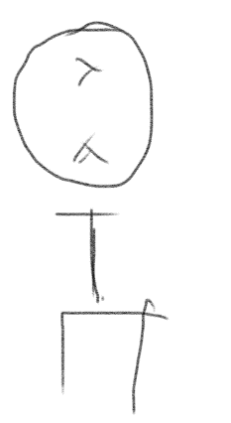
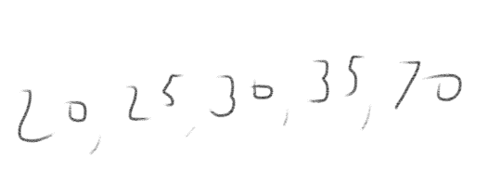
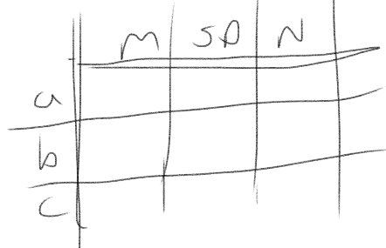
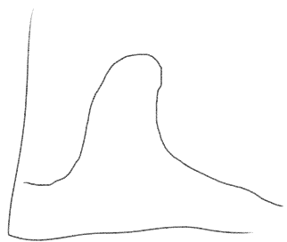
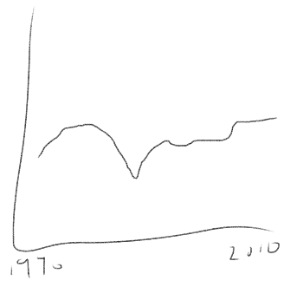
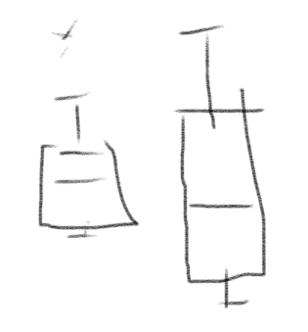

Finding a “Factoid” Story
Sometimes in large sets of data you find the most interesting thing is the story of one particular piece of information. This could be an “outlier” (a data point not like the others), or it could be the data point that is most common. A detail about one particular piece of your data can fascinate and surprise people. It can also give them an easier way to start thinking about the whole set of data.

One factoid is that

This stands out from the rest of the data because

We want to tell this story because

Finding an “Interaction” Story
When aspects of your data seem related, you can tell a story about how they interact. The fancy name for this is “correlation”. If one measure goes up, the other goes up too. If one goes down, the other goes down. If other cases, they might interact as opposites (when one goes up, the other goes down). You need to be careful not to guess about reasons for the interaction, but noticing the relationship itself can be a good story that connects things people otherwise don’t think about together.

The pieces of the data that interact are:

and

The interaction is

We want to tell this story because

Finding a “Comparison” Story
Comparing between sections of your data can a good way to find a story to tell. Often one part of your data tells one story, but another part tells a totally different story. Or maybe there is a smaller portion of your data that serves as an example of an overall pattern. You can compare different groups, or look at how your data is distributed.

The data to compare are

and

Comparing these things shows that

We want to tell this story because

Finding a “Change” Story
People like to think about how things change over time. Telling a story a story about change over time appeals to people’s interest in understanding what causes change, and they can often remember seeing the differences.

The data show a change in

The data changed from

to

We want to tell this story because

How will you tell your data story?
Remember to give the context for your data (the 5 ws):
- What’s in the data, what is it about?
- Who is the data about? And who collected the data?
- Where is the data from? E.g. What region does it cover?
- When does the data cover? Is the data recent or old? Is it annual, or more frequent?
- Why was the data collected, and why should we care about it?
Have you selected your key facts, numbers, and charts? Remember, you shouldn’t just tell us what the numbers are, you should explain what the numbers mean; what does your analysis show?

Writing with, and about, numbers: Examples from AEI
“Any data that you are referencing needs to be scrutinized. Taking this data set at face value you could believe that sub-Saharan Africa is consistently the biggest consumer of coal. Only by interrogating the data you can find that this is brought about by only one country and there is no data available for most countries.”
This is a great point, and data does need to be scrutinized. You could add information on why there’s no data for other countries, and what might be different about S.Africa, perhaps drawing on research or other sources.
“From the histogram, most countries around the world consume little amount of coal per capita. Through the geo chart as well as filtering the outliers from the chart, high income and upper middle income countries consumed the most amount of coal per capita in 2009.”
Also some interesting points, think about pulling out the key points in the histogram/geochart. Where should the reader look, what will they see (maybe give some specific numbers), and what is the significance of this?
“The median coal usage globally is 0.2806. This data produced no lower outliers, but an astonishing 11 upper outliers. The impact of these outliers is felt when the mean coal usage per region is examined; only 2 regions averaged below the median, while all others scored above it to varying degrees. What this means is that policy and alternative energy solutions enacted in these outlying countries will have a disproportionately positive effect on total coal usage globally. These countries (particularly Australia) are urged to reexamine their energy infrastructure to accommodate cleaner energy sources.”
Good to see some numbers being referred to. There’s some emotive language (“astonishing”), but it isn’t clear how we should interpret this (why is it unusual to have lots of upper outliers?). But, great to see some wider implications being drawn out; these could be backed up with research/external sources too!
“Whilst leading economies like China, the USA and India lead the pack in terms of raw coal consumption, there is much to be discovered when normalizing this data. Calculating coal consumption per Capita, it is in fact less economically dominant countries with lower populations that have the highest coal consumption per capita. Calculating consumption this way changes the highest coal consumers over all income levels. There are a few questions one might ask regarding the data presented. Firstly, only raw coal consumption is documented, not the amount of energy extracted from said coal, which can vary. ....”
Nice explanation based on the data, but could use specific numbers and charts to support the claims.
“The regional area of East Asia and Pacific's average coal consumption per capita was 0.8375 MTOE in 2011, greater than the global average of 0.5723 MTOE. Australia, Taiwan then China were the top per capita coal consumers in the region. The smallest coal consumers per capita were the Philippines, then Thailand and Vietnam. Whilst in 2011 Australia consumed 1.9988 MTOE coal per capita, the Philippines consumed a comparatively very small 0.0877 MTOE.”
Great to use the numbers, and pull out some key features. But what do they mean? Combining this para with the previous one might bring the best of both of them out!
“Based on the box plot generated from the data above it is apparent that the east Asia and pacific region has a large inter-quartile range which highlights a large difference in coal consumption between the countries in the region. From this data it could be argued that this large disparity is a product of the greatly differing income levels of the countries within the region. ….”

Again good to see the data being explained, and drawing on the boxplot to do this (maybe give the numbers too to help contextualise), and flag wider implications drawing on research to do so.

